**Data Quality- REDCap – How-To Guide**

**Data Quality**

This application will allow you to execute data quality rules upon your project data to check for discrepancies in your data. Pre- defined data rules that are already developed for you in the application are for such things as missing values, field validation errors and outliers for numerical fields.

A “data quality rule” is a calculation expression that must evaluate to True or False. When a rule is executed on your project data any records for which the expression evaluates False can be viewed and potentially corrected.

The **Data Quality** page includes detailed instructions.

*Execute Rules*

Execute rules one at a time using **Execute**, or all together using **All**.

The **Clear** button refreshes the view to the state before any rules have been executed.

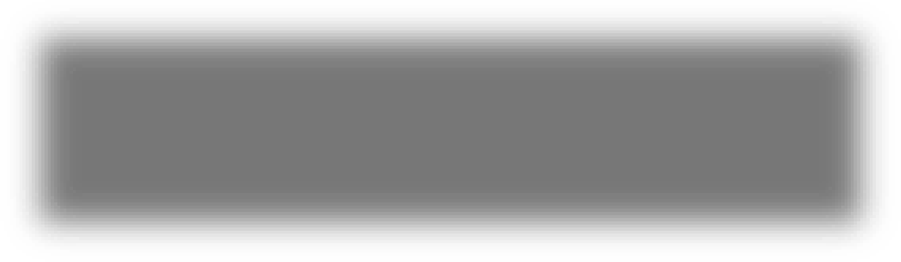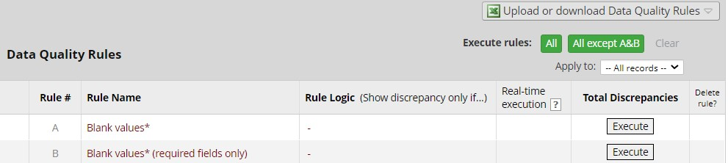

*Discrepancies*

Rules that identify discrepancies (i.e. where your project contains data for which the calculation expression returns False) are highlighted in red.



* Click **view** to see the records that fail the test.

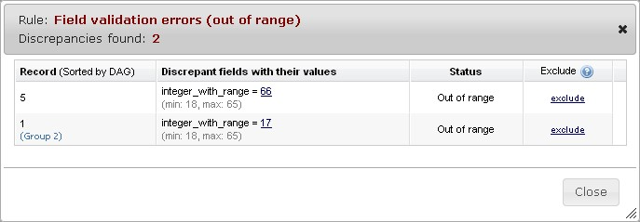

* Navigate to the record / form that contains the discrepant value by clicking on the value

* Clicking **exclude** will mark a discrepant value as not to be included as a discrepancy in future executions of this rule *Add a New Rule*

Add a new rule by entering a description of the rule and the calculation expression. Then click **Add**.

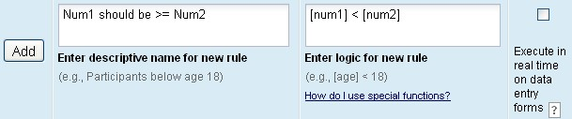

For more information on calculation expressions see Calculated Fields. Remember that data quality rule expressions must evaluate to True or False.

**Important Tip!** If your expression includes a “less than” sign (<), ensure that you include a space after it (as shown above). This stops the page thinking that you’re entering a potential harmful HTML tag and stripping out the remainder of your expression! Using “Less than or equal to“ (<=) is fine – this problem does not occur.

*Real Time Execution*

Ticking the **Execute in real time** option is a useful mechanism for performing cross-field validation checks during data entry. Rules where this option is ticked will be execute each time you save a data entry form that contains a field that is part of the expression.

Note that the rules are executed on **data entry forms only**: NOT when importing data via Data Import or API, and NOT during survey data entry.