

**Field Comment Log- REDCap – How-To Guide**

**Field Comment Log**

An application that lists all field comments for all records/fields. Field comments can be keyword searched and filtered. When entering data into a data form, you may have comments or caveats concerning specific fields. If this is the case, you may utilize the Field Comment Log. To first create your comment, click the speech bubble next to the field in the record you are working on. Enter your comment and click “Save.” You will notice that the speech bubble icon is now lit, indicating that a comment exists for that field.

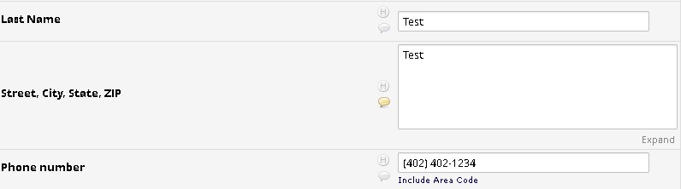

To view the collective comments for all records, click the Field Comment Log module in the left-side toolbar. Comments are linked to their corresponding records, along with the user who made the comment, and the date/time at which the comment was made. You may sort through the comments with various filters, as well as export the comment log to a .CSV file.

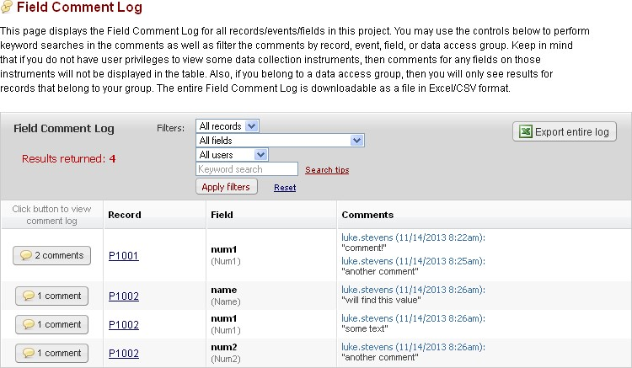

Notes: 

* Note the different filter options to help you narrow the scope of comment records included in the view
* You may **Export entire log** in CSV format
* Unfortunately, it is currently not possible to change the month/day/year date format
* Clicking on the Record link for a field will open the associated data entry form and record