

**Logging- REDCap – How-To Guide**

**Logging**

The **Logging** module is where you can view audit trail information, i.e. a log of data changes in your project. You can view and reconstruct a history of record creations, updates and deletions and review the activity of your project’s users.

This will list the date and time and user or survey respondent who made changes made to the project. This includes dataexports, data changes and the creating or deletion of users.

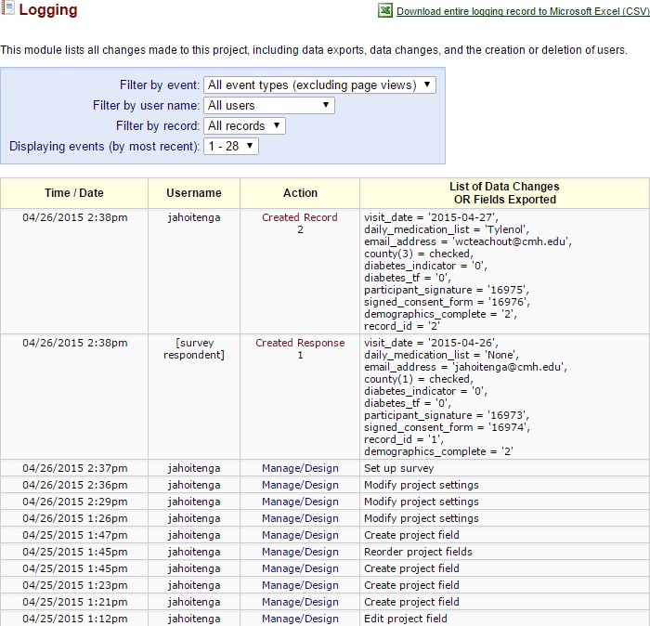



**Note:** It does not give you the details of the changes made.

* Note the different filter options to help you narrow the scope of log records included in the view

* You may **Download the entire logging record**, just be aware that this may take some time for large or very active projects.