**My Projects- REDCap – How-To Guide**

**Organising Your Projects**



This is where you will find all of the projects that you have been assigned to or created.

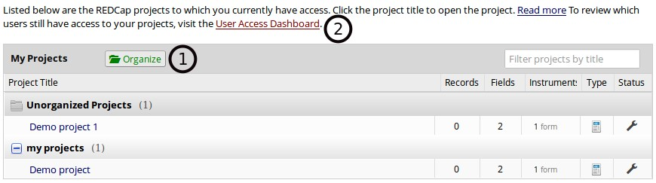

1. **Organise** - You can organise your projects by allocating them a folder.
2. The **User Access Dashboard** - If you have access to manage user roles this can assist you in the management of users assigned to your project.