

**New Project- REDCap – How-To Guide**

**Create a New REDCap Project**

There are 3 main project types:

1. Survey(s)
2. Data Entry Forms
3. Survey + Data Entry Forms

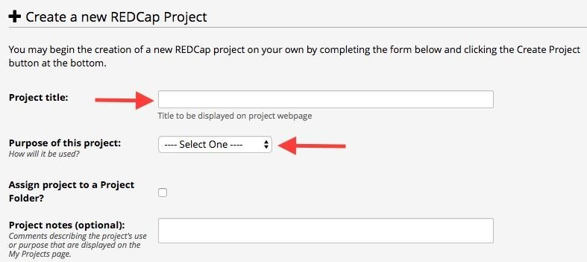Click on the “New Project” tab:



**Project Title:** Enter a title for your project (this can be changed later if needed)

**Purpose of this project:** Use the drop down and select the purpose

* **Practice/Just for Fun:** use this to practice creating a project
* **Operational Support:** use this for tracking specific department information processes
* **Research:** if this is an IRB approved project, you will be prompted to enter the PI information and the IRB#
* **Quality improvement:** use this for projects that help with goals and performance improvement
* **Other:** if you choose this option, please specify purpose



**Start from scratch project or begin with a template project:** it is recommended to “Create an empty project” until you become familiar with REDCap. However, there are many templates available that have forms designed already, which can be added to and modified to fit your project’s needs. This is not the only opportunity you will have to access these general forms: during the process of project design, you may also visit the Shared Library to add template forms to your project.

Once you are ready, click “Create Project”

