

**Beginner – Online Designer**

# Design your data collection instruments (forms/surveys)

**Online Designer:** Click Online Designer to start building your data collection instruments

**Data Dictionary:** Alternatively, you may upload your data dictionary via an Excel csv file in order to build your data collection instruments. **Note:** This is considered an advanced step and should not be used unless you are an experienced user.

# Online Designer

REDCap will begin your project with a data collection instrument titled “My First Instrument”. To change the title, click the “Choose action” button. To add additional data collection instruments, click on the Create icon. Click on Add Instrument here and enter a name for the new instrument.

To begin building your data collection instrument, click on the instrument name.

# Record Identifier

The very first field in the first data collection instrument must be used as the record identifier and must be unique. The record identifiers can be automatically sequentially- generated or user-entered. The record identifier field cannot be deleted however you may rename this field by clicking on the pencil icon. It is strongly recommended to not use any PHI as the unique identifier to preserve confidentiality.

# Add Fields to Your Data Collection Instruments

Click the Add Field button  and select one of the several field types available:

The following pages give an explanation of each field and examples for each field.

# 

# Examples of Field Types

Text Box (Short Text) with a validation of Date (M-D-Y)

This field can be used for text, dates, numbers, email addresses, phone numbers etc. Use the Validation drop down (date format, email, phone, time, letters only, SS#, zip code, integer, number-with/without decimals) to restrict how data should be entered.

# Notes Box (Paragraph Text)

# Calculated Field

This field can perform real-time calculations based on the data from other fields. For an example, you could create a calculation based off the start time and end time of a test to see how much time elapsed.



# 

# Multiple Choice – Drop Down List (Single Answer)

This field will display your answer choices as a drop-down list. When a field contains multiple answer choices, you must give each answer choice a variable name. If you do not, REDCap will automatically assign them for you.



# 

# Multiple Choice – Radio Buttons (Single Answer)

This field will display your answer choices as radio buttons

# Checkboxes (Multiple Answers)

This field will display your answer choices as check boxes and will allow more than one answer. **Note:** I added a field note that states “Check all that apply”.

# Yes–No

This field will display Yes and No as radio button answer choices.

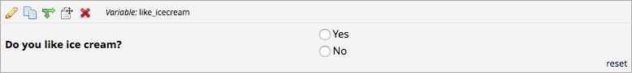

# 

# True – False

This field will display True and False as radio button answer choices.

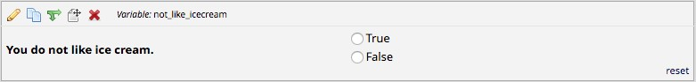

# 

# Signature (draw signature with mouse or finger)

This field will allow the participant to add their signature using their mouse or the finger (if using a tablet or touch screen device)



# File Upload (for users to upload files)

This field gives the participant the ability to upload a file or image



# Slider Visual Analog Scale

This field gives you a scale with three answer choices. If you select “Display number value (0-100)”, it will code the answer given.

# Descriptive Text (with optional Image/File Attachment)

This field will allow you to add text such as instructions or additional information. It also gives you the option to add an image as a link or as an inline image.

**Link:**

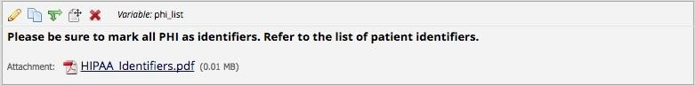

**Inline Image:**

# Begin New Section (with optional text)

This field is used as a section header. You can add text or leave blank.

With optional text:



With no text:



# 

# Add Matrix of Fields

If you have a group of questions that all have the same answer choices, you can create a Matrix of Fields. Instead of clicking Add Field, you would click Add Matrix of Fields. You would add an optional header, your field labels and variable names, indicate which fields are required, add your answer choices and select whether these fields should be a single answer (radio button) or multiple answers (checkboxes). If you would like only one answer choice to be selected per column, enable ranking. You must also give your matrix a group name.

# Edit/Copy/Move/Delete a Field

**Edit:** To edit a field, click on the pencil icon

**Copy:** To copy a field, click on the double paper icon



**Move:** To move a field, click on the paper with pointer icon. You can also move a field by click and hold field and drag the field to a different location.

**Delete:** To delete a field, click on the red X icon 

# Add Branching Logic

Branching logic is used when you have a field/question that you would only like to appear when a specific answer is given. To enable branching logic, click on the double green arrows on the field you want to hide.

For an example, I only want the “If Other, please specify” field to show if the answer to the question above it was Other.

After clicking on the double green arrows, scroll through the list of field choices and drag and drop the field you want to base your branching logic on. Click Save once finished.

The field now alerts me that branching logic exists. If I want to view or modify the existing branching logic, I would click on the double green arrows.



# Add Piping Logic

Piping gives you the ability to insert answers and place it in various places within REDCap.

For an example, I have a field that asks the participant “What kind of ice cream do you like?”. I then have another field that asks the participant “How often do you eat ice cream?”. I have added piping logic in my second question so that it will insert the answer from the first question.

**Before:**

One the participant answers the first question; the answer is then inserted into my next question.

**After:**

To add piping, all you have to do is add the variable name of the field you want to pipe in. The variable name must be inserted into square brackets [ ].

Piping can be used in many different places in REDCap such as:

* Field Labels
* Field Notes
* Section Headers
* Survey Instructions and Survey Acknowledgment Text