**REDCap Overview - REDCap – How-To Guide**

**Definition**

REDCap = **R**esearch **E**lectronic **D**ata **Cap**ture

REDCap is a secure, web-based application for building and managing online surveys and

database. You can think of it as a tool to collect and disseminate data.

**Why use REDCap?**

**Secure** – Full user authentication (log-on/password), customizable user rights restrictions, realtime data validation, centralized & secure data storage, data de–identification options, and a full audit trail.

**Web-based** – Enter data or build your database from anywhere in the world over a secure web connection with authentication and data logging.

**Fast –** Quick project start–up. Clinical report forms can be implemented without the need for a programmer. Concept to production-level database is possible in less than one day.

**Easy** – Intuitive user interface and work flow, readily available online training materials, and assistance from the Center for Health Insights (CHI) make it easy to get started.

**Fully customizable** – You are in total control of shaping your database.

**Autonomous utilization** – Research groups have complete autonomy and control to add new users and set several levels of specific user rights.

**Data export** – Seamless data downloads to common statistical packages (including SPSS, SAS, Stata, and to the .csv (comma separated values) format, the most common import and export format for spreadsheets and databases.

**Data import** – Data import capability through Microsoft Excel

**Advanced features** – File uploading, auto–validation, branching logic, calculated fields, signature, Dynamic Query (SQL) and more!

# Diagram



Study

Design

Create

Project

**Development**

**Mode**

IRB

Approval

Design Data

Forms

(

Instruments

)

Testing

Submit

Request for

Prod

Deploy

**Production**

**Mode**

Draft

Mode

Inactive Mode

Delete

Project

Complete

Project

Archive

Project

**Archive**

**Mode**

**or**

**Delete**

**Study Design**: Before beginning a REDCap project, you should formulate a general study design. Ex: Who or what are you planning to study? What kind of data are you measuring? Will your study be cross- sectional or longitudinal? Have you discussed your study design with a statistician?

**IRB Approval**: If your study is a research project with human subjects or involving Protected Health Information (PHI), you likely need the documented approval of your Institutional Review Board. All research projects with PHI data should go through IRB. On the other hand, projects focused on Quality will not require IRB approval but you are strongly advised to contact IRB and get confirmation.

**Design Data Forms**: In order to effectively collect and order your data, you must first design the data collection forms to do so. This step is the highlight feature of REDCap: immensely customizable, expandable, fluid data forms.

**Testing**: You should test data collection forms to verify all needed data are collected correctly before committing to production mode. If possible, designate one person to perform the build and another to perform the testing.

**Deployment**: Once your study enters Production Mode, you may enter, review, and analyze real data. In Production Mode, it is more difficult and risky to make major changes to your data entry forms, which is why thorough testing is strongly encouraged.

**Draft Mode**: If you enter production and find that you do need to modify an element of your data entry forms, you may enter Draft Mode and submit changes to be approved by a REDCap Administrator. Data activities can continue during this mode.

**Inactive Mode**: No data entry or update may take place in this mode, although you may view and analyze data. You can initiate this mode if you want to ensure that no new data entry will occur, but you would still like to access all of your data easily.

**Archived Mode**: If you have completed data analysis, moved your project to indefinite hiatus, or simply decided you no longer wish to use it, you may move the project to archived status as an alternative to full deletion. Archived projects incur fee as well. You can un-archive your project at any time.

**Delete Project**: After completion of the project, it is highly recommended that you delete the project. However, we recommend you to download the project data dictionary along with its data and save safely in UNMC cloud environment (Box or OneDrive). After this step, delete the project from REDCap. In case if you need to restore the project at a later point of time, you can import the data dictionary with or without data.

# REDCap Terminology

Arms: groups of events. You may want to employ multiple arms when using different treatment groups (control, experimental) or conducting a multi-site study, for instance.

Branching Logic: may be employed when fields/questions need to be hidden for data entry under certain conditions. For instance, you may want to hide the question “How many hours per week do you watch TV?” until a “Yes” answer is checked for a previous question, “Do you watch TV?”

Data Access Groups: restrict viewing of data within a database, for instance in a double-blind or multi-site study.

Data Collection Instrument: a form created to capture data. This term is essentially interchangeable with “data entry form.”

Data Dictionary: a specifically formatted .csv spreadsheet containing the metadata used to construct data collection instruments and fields.

“Development” vs. “Production” Modes: study status modes. In Development Mode, you are still working through the design of your data forms and testing them with mock data; you may make any changes to the forms at any time. In Production Mode, you have deployed your forms and you are collecting real data; changes to your forms are more difficult to implement once you have launched into Production Mode. (See also: Development vs Production Modes.)

Event: used in longitudinal designs. An event is a scheduled (or unscheduled) occurrence during which data is captured using your REDCap data instruments (forms).

Field: a singular data entry, such as age or height.

Form Status: status of the record’s data form completeness, denoted with a color; red – incomplete; yellow – unverified; green – complete.

Logging: the audit trail of modification occurrences in the project.

Record: the set of information for a unique participant or subject. Each record is composed of a number of fields (pieces of data), which can be spread across multiple forms (instruments) per record.

Record ID: a unique key that can identify each record in the database. (You may label this differently in your project, but the ID must remain the first field in the first data form.)

User Rights: the customized privileges that research team members have in terms of data form modification, data entry, and data access. P.I.s may create “Roles” for groups of team members to ensure consistency in specified user rights.

Variable Name: the name of the variable that is stored in the REDCap database (not visible during data entry).

# Begin your Project

Signing in to REDCap for the first time

The first time you log in to your institute REDCap, it will prompt you for your basic information in order to verify your account.

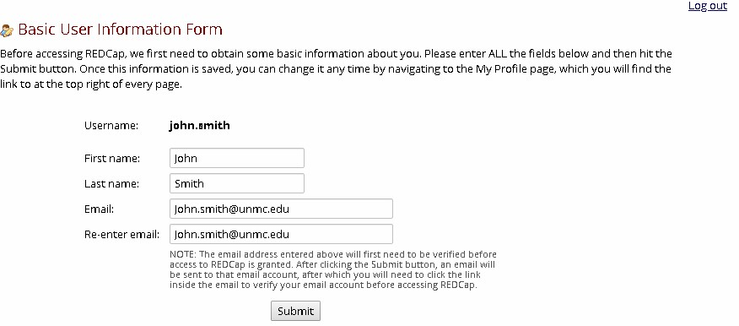

Once you submit this information, an e-mail will be sent to your account. Click the link included in that e-mail to verify your account, and you’ll be all set to use REDCap!

