**Profile- REDCap – How-To Guide**

# Accessing REDCap

1. To access REDCap, enter the URL into your internet browser: https://redcap.wakehealth.edu/
2. Login using your current Medical Center ID **(without @wakehealth.edu)** and current password
3. FAQ’s and tutorial videos are available within the navigational bar by clicking on Help

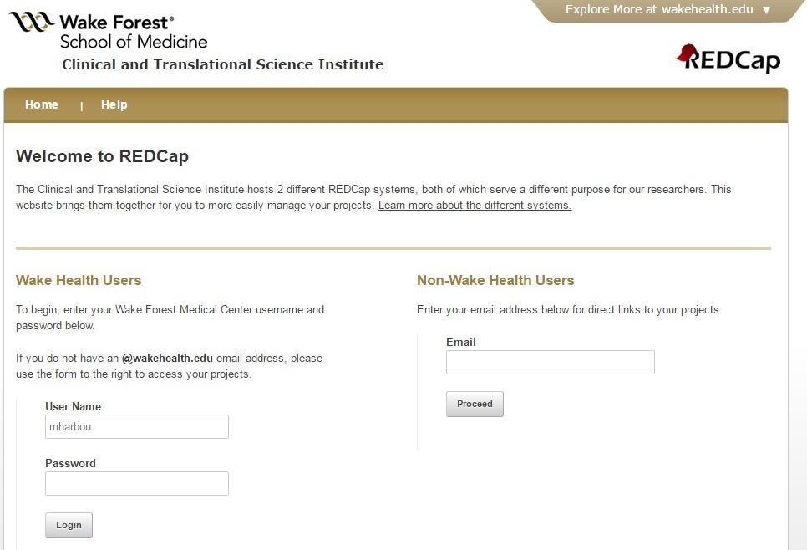

# Choosing the Correct System

**Internal System** - Projects to be accessed only on the Wake Forest network (not including guest networks). The Internal System is still accessible through VPN.

**External System** - Projects to be accessed outside of the Wake Forest network. For example, surveys that will be emailed to participants.

The *REDCap System Comparison* hyperlink will provide additional detail on the available systems.

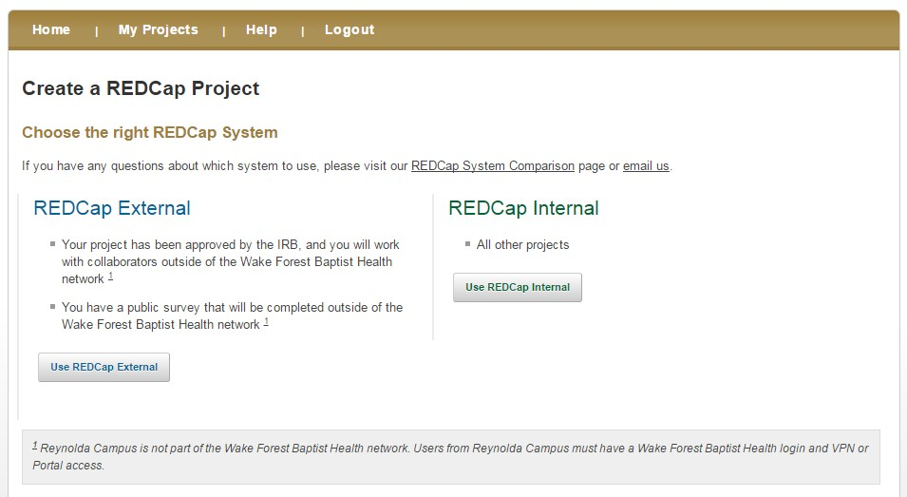

# Account Settings

To change the email address associated with your account, to add additional email addresses that you want

associated with your account, or to change the name associated with your account, see the steps below.

1. Log into REDCap
2. Go to the Home tab or My Projects tab and click on ‘My Profile’ in the top right corner (see below)

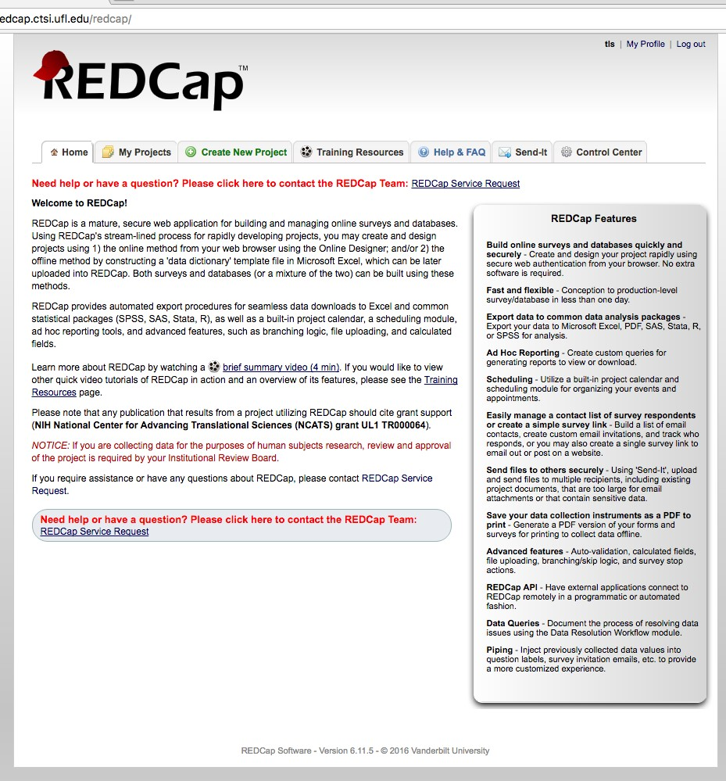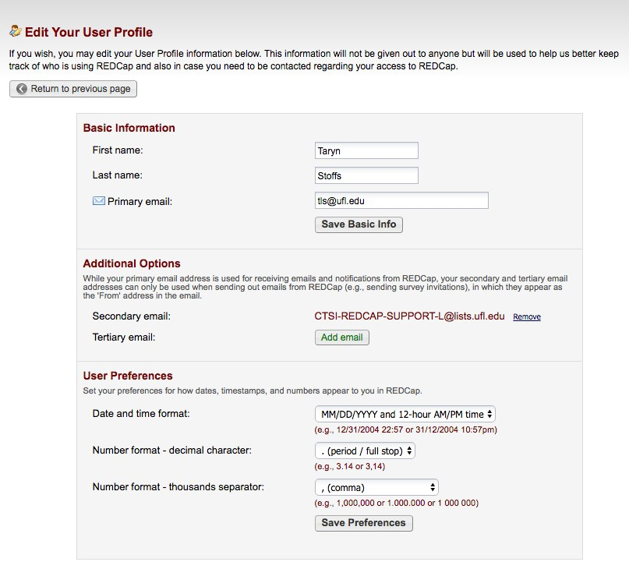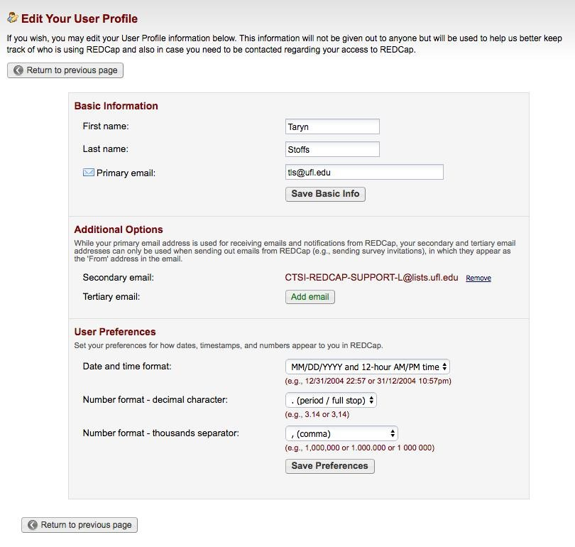

1. To change the primary email account associated with your REDCap account (the email address where REDCap will send you emails/notifications) enter a new email address into the Primary email line.
2. To add additional email accounts, click on Add email under Additional Options and type in a secondary email address.
3. To add a third email address, click on Add email again and type in a tertiary email address.
4. Click on Save Preferences.