

**Beginner – Profile**

# Accessing REDCap

REDCap accounts are not universal across all instances. If you are an Atrium Health or Wake Health employee, your system credentials are your REDCap credentials, so you'll simply use them to log into your legacy institution's REDCap instance for the first time to activate your account:

**Atrium Health Main:** <https://redcap.atriumhealth.org/redcap/>| https://rces.atriumhealth.org/redcap/

**Wake Health Main:** <https://redcap.wakehealth.edu/redcap/>

**Wake Health CCC:** <https://redcap.wakehealth.edu/redcapccc/>

**Atrium Health BCC:** https://rc2.atriumhealth.org/redcap/| <https://rc2e.atriumhealth.org/redcap/>

If you are not an Atrium Health or Wake Health employee, then you will need to complete the respective External User Access Request Form:

External user needing access to an Atrium instances?: <https://redcap.link/AHExtU>

External user needing access to an Atrium instances?: <https://redcap.link/WHExtU>

|  |  |  |
| --- | --- | --- |
| **User / Instance** | **Access AH** | **Access WH** |
| **Internal AH** | Log in to REDCap Homepage with system | Complete WH External User Request Form |
| **Internal WH** | Complete AH External User Request Form | Log in to REDCap Homepage with system |
| **External Both** | Complete AH External User Request Form | Complete WH External User Request Form |

# Account Settings

To change the email address associated with your account, to add additional email addresses that you want associated with your account, or to change the name associated with your account, see the steps below.

1. Log into REDCap
2. Go to the Home tab or My Projects tab and click on ‘My Profile’ in the top right corner (see below)

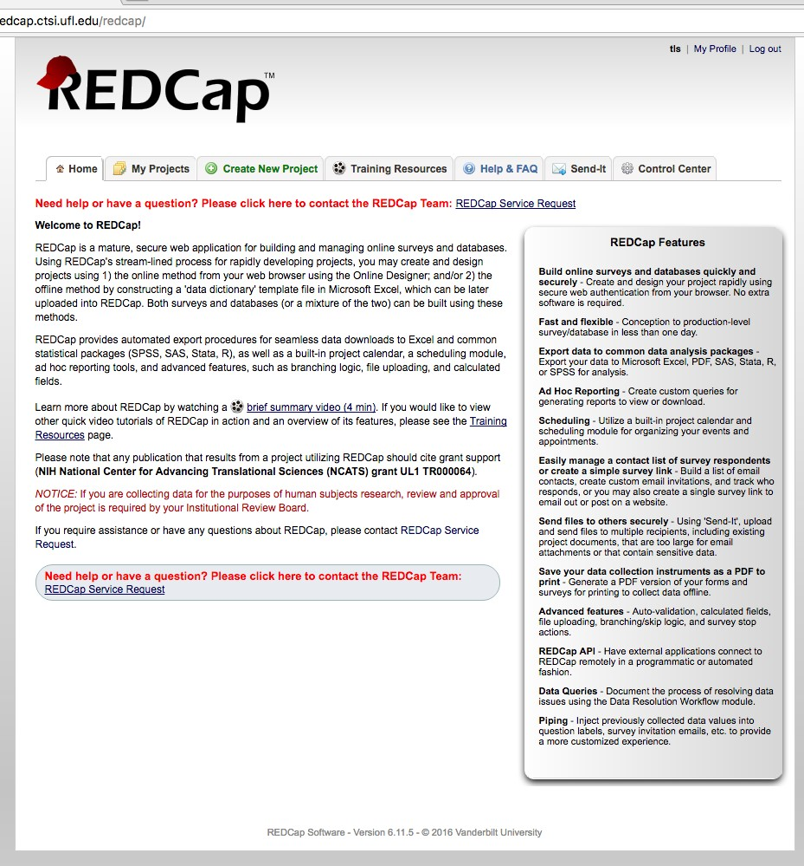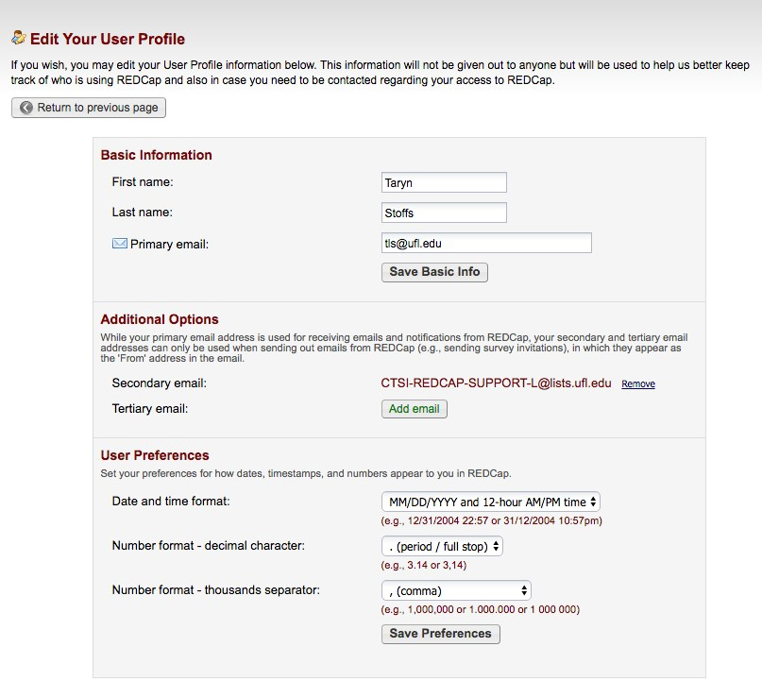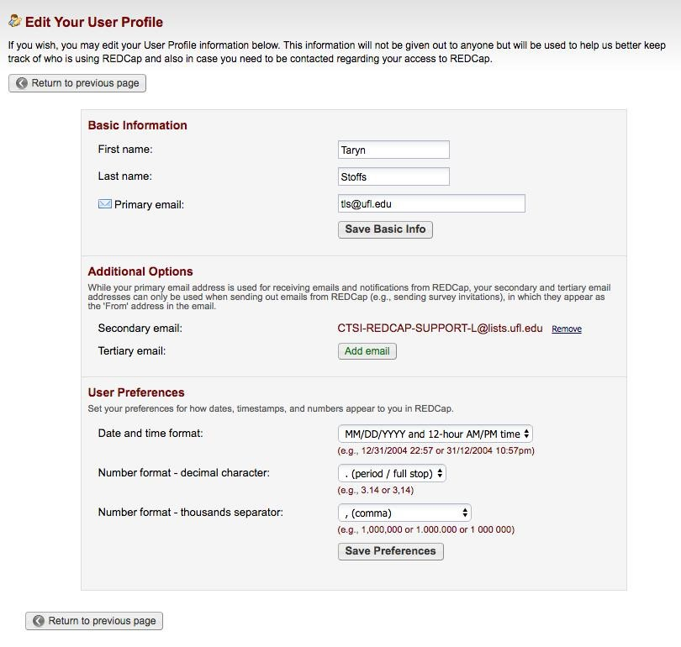

1. To change the primary email account associated with your REDCap account (the email address

where REDCap will send you emails/notifications) enter a new email address into the Primary

email line.

1. To add additional email accounts, click on Add email under Additional Options and type in

a secondary email address.

1. To add a third email address, click on Add email again and type in a tertiary email address.
2. Click on Save Preferences.