**Templates- REDCap – How-To Guide**

**Templates**

When users create new projects using the green New Project link, they can choose to utilize a template to help them get started.



Before the project is created, you’ll need to select the *Use a template* option. These templates are standardized in accordance with our institutional policies.

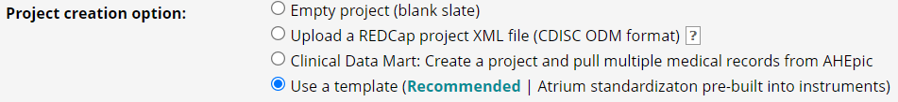

You can choose only one template per project. A description is available for each of them. Users can scroll to find a number of different templates that are designed to be bases for projects relating to surveys, quizzes, randomized trials and more.

