**Project Revision History- REDCap – How-To Guide**

**Project Revision History**

REDCap logs actions taken by a project’s users and survey respondents. The **Project Revision History** allows users to review the project’s status changes and revisions to the data dictionary.

The history can be found by going to the **Project Revision History** tab, when on the project’s homepage.



On this page, REDCap will create a table that details the date and time when the project was created, status changes were made, and changes were made to the data dictionary.

Users can download every iteration of the data dictionary by clicking on the green *Download data dictionary* links.

To compare two of the snapshots, click on a button in the far-left column to select the first snapshot.



This will allow you to select the second snapshot.

The comparison includes information relating to types of revisions broken down by field information and instruments. The table detailing the changes between the dictionaries can be downloaded as a csv file.

The data dictionary snapshots can be hidden by clicking on the button at the top right of the table.



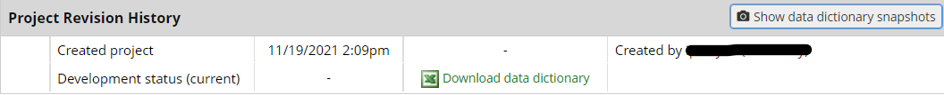

This page also shows how much time has elapsed since the project’s creation as well as revision statistics.

