**Scheduling Module- REDCap – How-To Guide**

# Scheduling

The **Scheduling** module is optional for longitudinal projects. It works in conjunction with the events you have created to enable you to generate an event schedule for each individual project record. Typically, this is a calendar of a participant’s study visits.

# Enable Scheduling module

To make use of the scheduling module, you must first enable the feature on the Project Setup page under Enable optional modules and customizations:

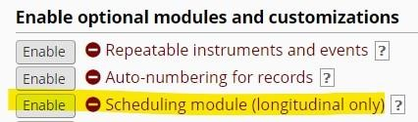

Once it is enabled, you will be able to access it via the **Scheduling** button in the left-hand menu in the Data Collection section:

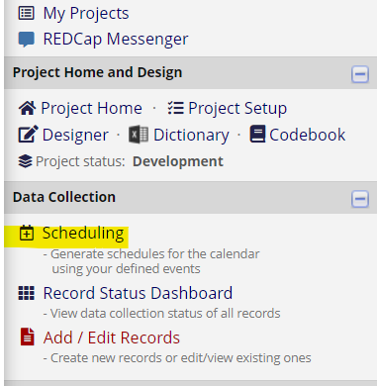

**Create a Schedule**

Create participant schedules on the **Create Schedule** tab.



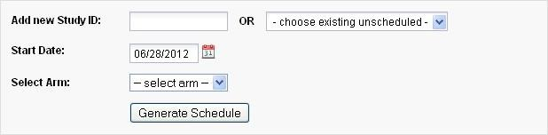

Notes:

* You can create a new record here by entering a new record identifier in the text entry box: be sure to select the correct arm if your project has multiple arms.

* Start Date is the baseline date for the schedule: the date from which each event’s offset days is calculated.

A “projected schedule” is generated and displayed, allowing you to adjust event dates and times (avoiding weekend visits, for example). The schedule is not saved until you click **Create Schedule**.

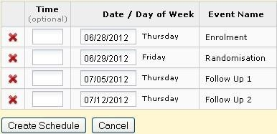

**Automatic Generation of Schedules**

# View or Edit Schedule



Select the relevant record to view the associated schedule.

* Edit ( ): edit the date, time, status or notes for the schedule event
* Delete ( ): remove the schedule event. **Be careful: there is no ‘Undo’!**



* View ( ): Open the schedule event in a dialog box. Also permits editing.

Do not delete event records unless you really mean to!

Schedule events across all records in your project may be viewed in a calendar format using the Calendar module.

# Calendar

The **Calendar** module integrates with REDCap’s scheduling functionality to provide a calendar-based view of participant events.

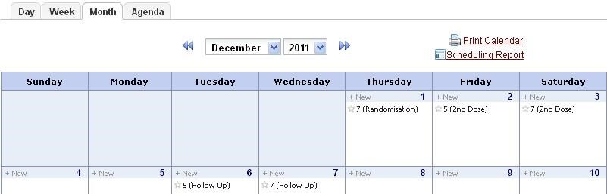

* Select the **Day**, **Week** or **Month** to view the events for that period

* **Agenda** shows a list of the events for the period in date order

* The **+ New** button will add a new ad-hoc event to the calendar, but you cannot associate data entry forms with adhoc events

# Calendar Events

* Click on an event to view and make edits to the calendar event

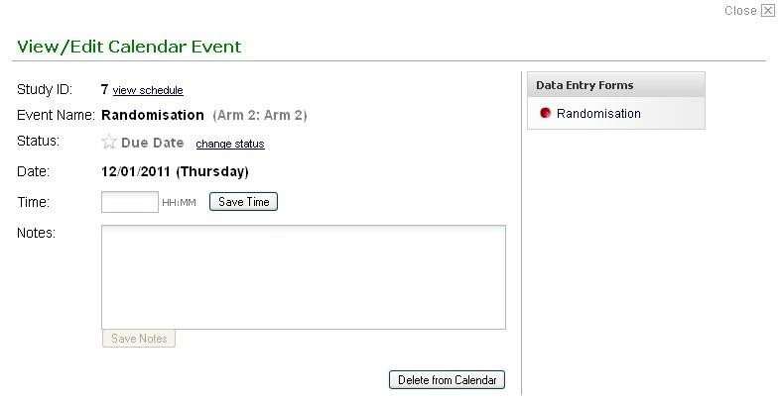

* Note the link to the data entry forms that are associated with the study event. Click the link to go to the form for data entry.

* The **Event Status** field has five settings:
* Due Date 
* Scheduled 
* Confirmed  • Cancelled 
* No Show 

The colored event status indicator changes (as shown) according to the status of the event.

REDCap ascribes no particular significance to the status of an event, which means that you can use these status flags in any way that suits you. The wording of the label does not bind you to any specific meaning.