**Proficient - Project Bookmarks**

**Create Bookmark**

The bookmark module will allow you to set up project bookmarks, or custom links, that point to web-pages that exist either inside REDCap (i.e., other REDCap projects) or outside REDCap (i.e., web-pages on a different server on the web).

Any user with **project design & setup** rights can add bookmarks to that particular project.

▪ Go to the **Project Setup** screen and locate the box labeled **Set up project bookmarks (optional)**



▪ Click on **Add or Edit Bookmarks**



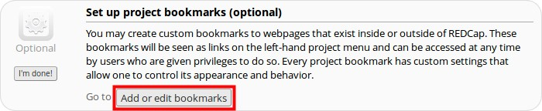

▪ Add a Label & Link URL/Destination (for instance, https://www.google.com).

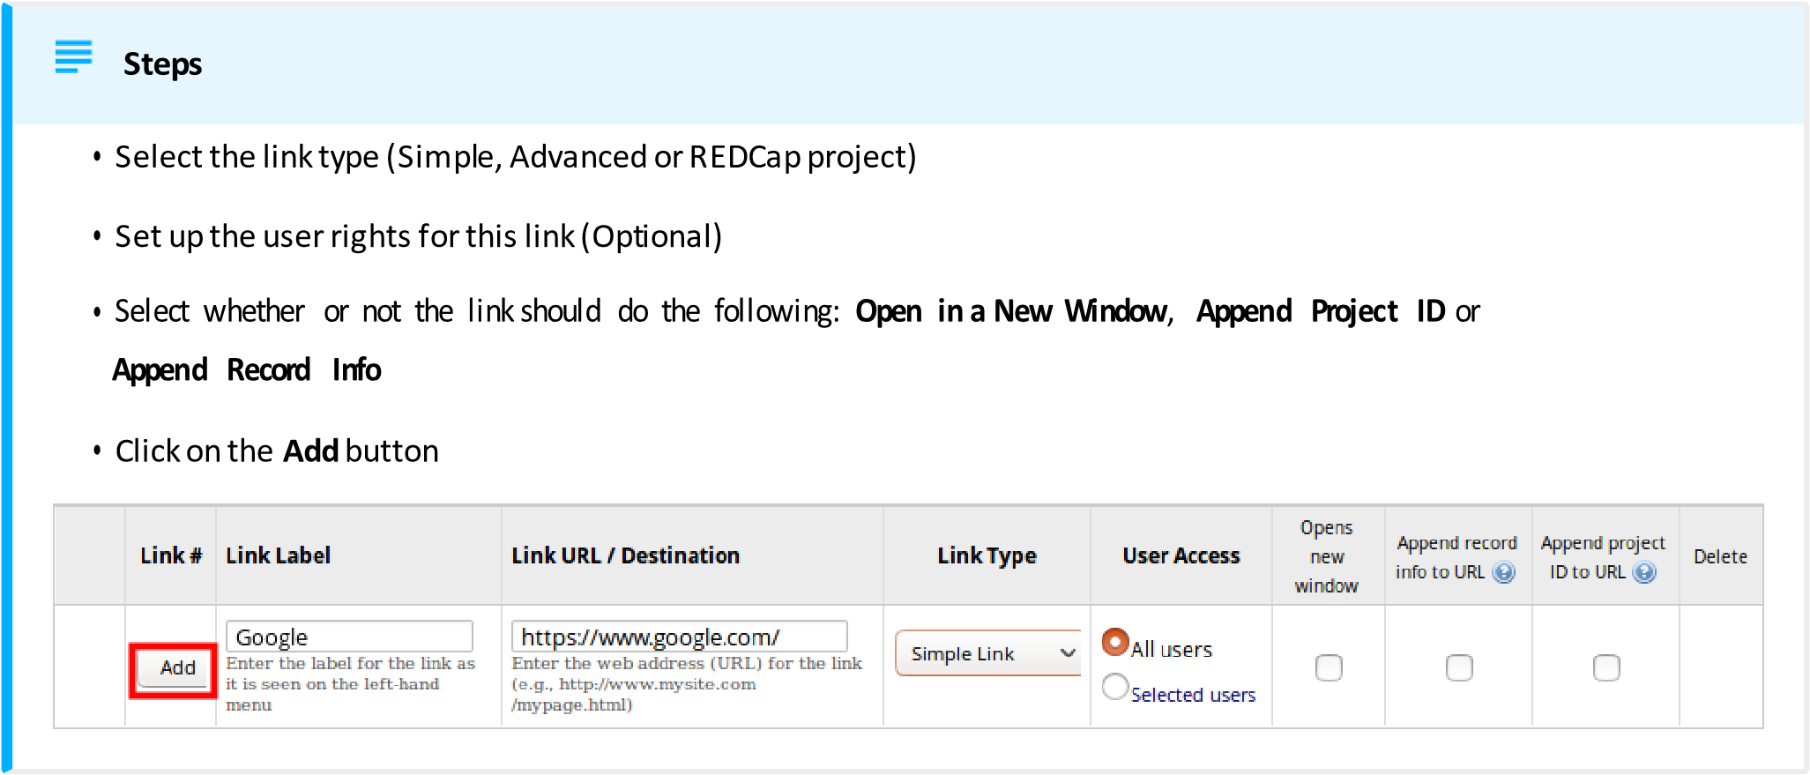

▪ Your link should now appear on the left hand side in the application window



