**Proficient – Field Embedding**

* Field Embedding is the ultimate way to customize surveys and data collection instruments to make them look exactly how you want. Field Embedding is a Shazam-like feature that allows you to reposition field elements on a survey page or data entry form so that they get embedded in a new location on that same page. Embedding fields gives users greater control over the look and feel of your instrument. Users may place fields in a grid/table for a more compact user-friendly page, or they can position fields close together in a group if they are related.
* To use Field Embedding, users simply need to place the REDCap variable name of a field inside braces/curly brackets - e.g., {date_of_birth} - and place it in the Field Label, Field Note, Section Header, or Choice Label of any other field on that same instrument. Field embedding will not work across instruments but only on the current instrument/survey being viewed. If on a multi-page survey, then the embedded field must be on the same survey page as its host field.
* No action tags or custom HTML is required to use Field Embedding. Users can simply use the rich text editor in the Online Designer to design their layout and then place the field variables inside that layout. The layout does not have to be a table/grid (although tables are common for this), and fields can be embedded inside *any* field type (not just Descriptive fields).
* Note: When installing or upgrading to v10.0.0, a new project “Field Embedding Example Project” will be automatically added as a project template to allow users and admins to easily see some examples of Field Embedding in action.

Example of setting up an embedded field in the Online Designer using a table in a Descriptive field's Field Label:

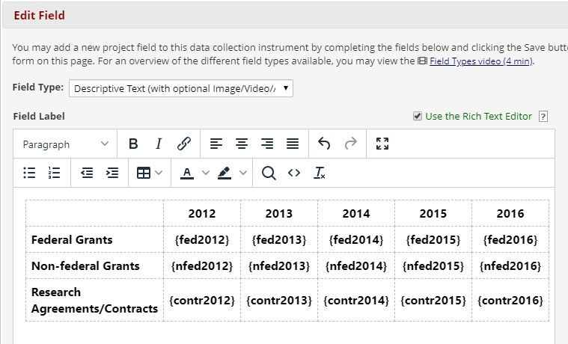

# EXAMPLE 1

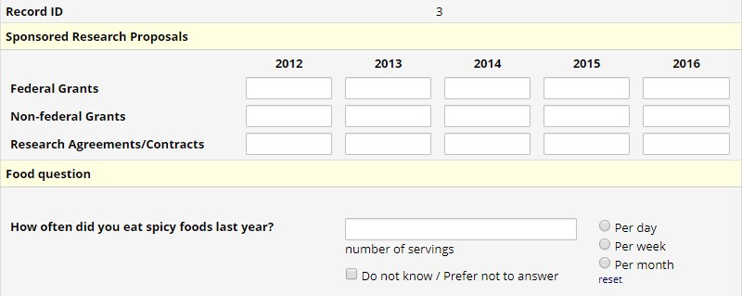

# EXAMPLE 2

