

**Proficient - Sponsor Dashboard**

# Sponsor Dashboard

The person requesting an external user account is listed as the external user’s sponsor. The sponsor is the person who grants the external user access to projects. Additionally, the sponsor will see a Sponsor Dashboard at the top of their My Projects page:

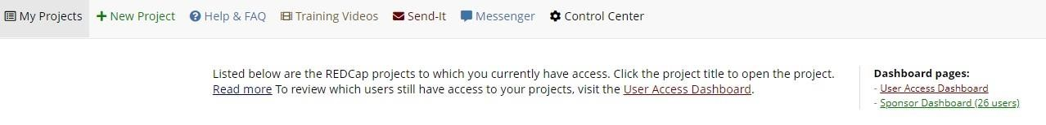

Once in the Sponsor Dashboard, the sponsor will see a list of all external users for whom he/she is a sponsor. From this page, the sponsor can:

* Trigger the REDCap account creation email to be re-sent to the external user
* Trigger a password reset link for the external user
* Set the account expiration date for the external user
* Extend the account expiration for the external user
* Un-suspend the external user
* Suspend the external user

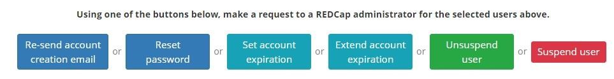

This is a useful tool if you need to perform one of those actions for many users at the same time. In most cases a PI will not be managing the above tasks, which is why the sponsor is typically someone other than the PI.

# External User account expiration notifications

Most external user accounts are set to expire after one year. Two weeks prior to this account expiration, the external user and the sponsor will receive an email notifying them of this fact. The sponsor has the right to request that the account be extended. The sponsor can make that request by replying to the expiration notification email or via the Sponsor Dashboard (see above.)

# Project Management tip: pre-emptively extend external user’s account expiration

If you are a sponsor and have many external user accounts which might expire around the same time (because you requested the account creations around the same time), you will get multiple account expiration notification emails – one per external user. You can pre-empt the account expiration notification process by going to the Sponsor Dashboard, sort by expiration date and look for the users whose accounts will expire soon. If you want to extend any of them, you can bulk select them and click the Extend account expiration button. A REDCap administrator will finalize the request and you will therefore avoid you and your external users receiving the account expiration notification emails.



# Account access vs. Project access

A local user (Atrium Health Wake Forest Baptist) will have access to their accounts and projects as long as they are employed or an active student at their Atrium Health Wake Forest Baptist. External users are given a limited time period during which they have a REDCap account (typically one year.) The sponsor of the external user is given the opportunity to extend the REDCap **account**. They can make that request via email or via the Sponsor Dashboard. The project creator can additionally set an expiration date for how long a person has access to their project. REDCap administrators do not set expiration dates on a **project**. The project owner is responsible for that.

## Passwords

Please note: Atrium Health Wake Forest Baptist requires that you change your institute password once a year. If you do not change your password, your institute ID will become inactive and you will not be able to login to REDCap. You will have to call ITS to reactivate it.

**External users** have the option to set up password recovery in the My Profile section of

REDCap. Once that is set up, they can click on the ‘Forgot Your Password’ link on the login page. That will trigger a password reset link to be emailed to them. It is HIGHLY RECOMMENDED that the external user set this up. That way they are not dependent on waiting until business hours to receive a response from their sponsor or the REDCap administrator.

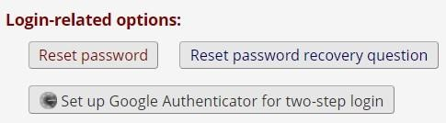

If an external user does not have password recovery set up, they can email their Atrium Health Wake Forest Baptist sponsor (the person who requested their account) or

ctsiredcap@wakehealth.edu and request a password reset. The sponsor has the ability to reset the password via the Sponsor Dashboard on their My Projects page.