**Background:**

The United States Clean Air Act is a federal law that was first passed in 1970 and amended in 1977 and 1990(1). The Clean Air Act requires the United States Environmental Protection Agency (EPA) to set National Ambient Air Quality Standards (NAAQS) for six air pollutants termed “criteria air pollutants”:  ground-level ozone, particulate matter, carbon monoxide, lead, sulfur dioxide, and nitrogen dioxide(1).

Air pollution is recognized as being harmful to human health. The establishment of federal limits on ambient exposures, however, requires the formulation of quantifiable exposures with acceptable risk profiles. The Clean Air Act also calls upon the EPA to periodically review and revise air pollution standards, reducing permissible levels if further scientific advances support such revisions (2). A key component of these reviews is the examination of risk/exposure assessment studies which provide insights into relationships between air pollutant exposures and human health effects.

For this project, we propose to use air quality monitoring information on ambient air pollution levels from the EPA-maintained AirData system, which reports air quality monitor measurement for locations across the United States. We then plan to examine relationships between criteria air pollutant levels and regional differences in chronic respiratory disease mortality rates at the county level.

**Data Sets:**

***Air Quality***

AirData is a website maintained by the EPA that provides public access to air quality data collected at more than 4000 outdoor monitors across the United States, Puerto Rico, and the United States Virgin Islands (3). AirData has available for download annual and daily summary data tables for measurements of criteria gases, particulates, meteorological conditions (wind, temperature, pressure, barometric pressure, and RH/dewpoint), toxics, ozone precursors, and lead measurements (4). These measurements are indexed by monitor site (state, county, monitor identification number) for the years from 1980-2017.

***Respiratory Health***

We propose to merge information on air quality with data on the United States Chronic Respiratory Disease Mortality Rates by County for the period 1980-2014. This aggregated data set is available through the Global Health Data Exchange. Age-standardized mortality rate for both sexes combined, reporting deaths per 100,000 people in the population.

Institute for Health Metrics and Evaluation summary of data set [5]:

“ IHME research produced estimates for age-standardized mortality rates by county from chronic respiratory diseases. The estimates were generated using de-identified death records from the National Center for Health Statistics (NCHS); population counts from the U.S. Census Bureau, NCHS, and the Human Mortality Database; the cause list from the Global Burden of Disease Study (GBD); and the application of small area estimation models. This dataset provides estimates for age-standardized mortality rates by disease type and sex at the county level for each state, the District of Columbia, and the United States as a whole for 1980-2014, as well as the changes in rates for each location during this period. Also included are data on the 10 counties with the highest and lowest mortality rates for each disease type in 2014. Study results were published in JAMA in September 2017 in "Trends and patterns of differences in chronic respiratory disease mortality among US counties, 1980–2014.”

**Variables:**

> combined_mort_y = data[,5]

Age-standardized county-level annual mortality rate from chronic respiratory diseases given as the rate per 100,000 persons in the population per year. Estimates were generated using death records obtained from the National Center for Health Statistics, population counts from the U.S Census Bureau, the National Center for Health Statistics, and the Human Mortality Database. Continuous variable.

> male_mort_y = data[,10]

As for combined gender rate above, age-standardized county-level annual mortality rate from chronic respiratory diseases given as the rate per 100,000 men in the population per year. Continuous variable.

> female_mort_y = data[,8]

As for combined gender and male rates above, age-standardized county-level annual mortality rate from chronic respiratory diseases given as the rate per 100,000 women in the population per year. Continuous variable.

> location = data[,3]

Categorical label comprised of the state and county names combined. Each gives a unique location for which mortality rate data and air quality data are available during the period 1980 – 2014. County-level mortality data and EPA air quality data are matched by location and year for predictive analysis in this project.

Categorical variable, n = XX.

> x1_year = data[,11]

Year of observation data collection.

> days_with_AQI = data[,12]

Annual air quality summary data for each location and year is used here. In each annual summary file, the number of days on which data was recorded for each location is given – not every day of every year has a measurement for each location.

The Air Quality Index (AQI) is a summary metric used to report air quality. The EPA establishes and monitors compliance with national air quality standards. An AQI value below 100 corresponds to pollutant levels below the regulatory standard, with values below 50 being optimal.

AQI values above 100 are considered to be of increasing concern, with values in the range of 300-500 considered hazardous for the entire population.

Daily Air Quality Index (AQI) measurements may be viewed online: <https://airnow.gov/index.cfm?action=airnow.mapcenter&mapcenter=1>. AQI is reported for both combined and individual criteria pollutants.

For this analysis, we used the yearly AQI summary data files, which include counts of the number of recorded days on which measurements fell into each of the AQI categories, as well as counts of days on which the AQI was attributed to each criteria pollutant. These records also include the maximum, 90th percentile, and median AQI for that location and year.

> x2_good_days_ratio = data[,13]

The proportion of days recorded where combined AQI was between 0-50.

> x3_mod_days_ratio = data[,14]

The proportion of days recorded where combined AQI was between 51-100.

> x4_unhealth_sens_ratio = data[,15]

The proportion of days recorded where combined AQI was between 101-200.

> x5_unhealth_ratio = data[,16]

The proportion of days recorded where combined AQI was between 201-300.

> x6_very_unhealth_ratio = data[,17]

The proportion of days recorded where combined AQI was between 301-400.

> x7_hazardous_ratio = data[,18]

The proportion of days recorded where combined AQI was between 401-500.

> x8_maxAQI = data[,19]

The maximum recorded overall AQI for that location and year.

> x9_90percentileAQUI = data[,20]

The 90th percentile overall AQI for that location and year.

> x10_median_AQI = data[,21]

The median overall AQI for that location and year.

> x11_CO_ratio = data[,22]

Count of days on which the AQI was attributed to CO pollution.

Carbon monoxide (CO) is generated by combustion. Inhaling CO in high concentrations impairs the oxygen-carrying ability of the blood. This reduces the amount of oxygen being transported to the tissues of the body and places stress on the cardiovascular system.

> x12_NO2_ratio = data[,23]

Count of days on which the AQI was attributed to NO2 pollution.

Nitrogen dioxide is a reactive gas generated mainly from fuel combustion. Inhalation of high concentrations can cause respiratory irritation and respiratory symptoms such as coughing, wheezing, or shortness of breath. These effects may aggravate symptoms from pre-existing respiratory conditions. Prolonged exposure to nitrogen dioxide may contribute to the new development asthma and may increase risk of respiratory infection. Nitrogen oxide reactions also contribute to ground-level ozone levels.

> x13_ozone_ratio = data[,24]

Count of days on which the AQI was attributed to ozone pollution.

Ground-level ozone is generated as result of chemical reactions between nitrogen oxides and volatile organic compounds present in the air. Industrial emissions, fuel vapors, and vehicle exhaust are among potential sources of nitrogen oxides and volatile organic compounds. Ozone reactions are catalyzed by sunlight, so longer, brighter days may have higher ozone levels. Ozone inhalation may provoke respiratory symptoms and worsen symptoms due to pre-existing respiratory disease.

> x14_SO2_ratio = data[,25]

Count of days on which the AQI was attributed to SO2 pollution.

Sulfur dioxide is one of a number of sulfur oxide gases and is monitored and regulated as an indicator of sulfur oxides as a group. Sulfur oxide are released as a result of fuel combustion. Inhalation of sulfur oxides can result in respiratory system irritation and respiratory symptoms. Reactions between sulfur oxide and other compunds in air can generate particulate air pollution, which is further irritating to the lungs and may contribute to a number of health effects.

> x15_PM2.5_ratio = data[,26]

Count of days on which the AQI was attributed to PM 2.5 pollution.

Particulate air pollution includes a mixture of compounds present in air as small particle or liquid droplets. Fine particles (PM 2.5) are defined as those particles of diameter less than 2.5 micrometers. These very small particles are particularly hazardous, as their small size allows them to penetrate deeply into the progressively smaller air conduits in the lungs and potentially pass into the bloodstream. Previous research has linked particle air pollution exposure with adverse cardiovascular and respiratory effects, including increased symptoms from pre-exisiting conditions and increased risk of death.

> x16_PM10_ratio = data[,27]

Count of days on which the AQI was attributed to PM 10 pollution.

Particulate air pollution includes a mixture of compounds present in air as small particle or liquid droplets. Small particles (PM 10) are defined as those particles of diameter less than 10 micrometers. Particles of such small size may penetrate deeply into the lungs. As a general rule, the smaller the particle, the more potential it has for contributing to adverse health effects.

**Problem Statement:**

We are trying to predict annual respiratory mortality using air quality data.

This information is useful for such applications as

* Predicting the health impacts of new proposed industrial developments
* Selecting facility sites serving sensitive populations, such as schools for children or residential care facilities for older adults
* Predicting the benefits of more stringent air quality regulations
* Predicting health impacts of relocation

We can also use this data set to investigate historical impacts of air quality improvements following the establishment of regulations under the clean air act.

**Methods**

**Regression**

**Variable Summaries:**

> summary(data)

X index Unnamed..0

Min. : 0 Min. : 0.0 new york_suffolk : 33

1st Qu.: 7850 1st Qu.: 222.0 colorado_arapahoe : 32

Median :15530 Median : 443.0 montana_rosebud : 32

Mean :15561 Mean : 461.4 ohio_cuyahoga : 32

3rd Qu.:23354 3rd Qu.: 686.0 virginia_fauquier : 32

Max. :31017 Max. :1077.0 california_alameda: 31

(Other) :23072

FIPS both_gender_resp_mort cause_id

Min. : 1001 Min. : 15.18 Min. :508

1st Qu.:17179 1st Qu.: 45.81 1st Qu.:508

Median :30031 Median : 54.13 Median :508

Mean :29542 Mean : 55.31 Mean :508

3rd Qu.:42013 3rd Qu.: 63.36 3rd Qu.:508

Max. :56045 Max. :133.79 Max. :508

cause_name female_resp_mort

Chronic respiratory diseases:23264 Min. : 7.865

1st Qu.: 32.928

Median : 42.167

Mean : 42.931

3rd Qu.: 51.743

Max. :114.820

location_id male_resp_mort Year Days.with.AQI

Min. : 574 Min. : 17.67 Min. :1980 Min. : 1.0

1st Qu.:1260 1st Qu.: 63.79 1st Qu.:1991 1st Qu.:209.0

Median :2184 Median : 74.88 Median :2000 Median :355.0

Mean :2095 Mean : 75.47 Mean :1999 Mean :280.4

3rd Qu.:2833 3rd Qu.: 85.64 3rd Qu.:2007 3rd Qu.:365.0

Max. :3714 Max. :227.42 Max. :2014 Max. :366.0

Good.Days Moderate.Days

Min. :0.0000 Min. :0.0000

1st Qu.:0.5827 1st Qu.:0.1068

Median :0.7348 Median :0.2082

Mean :0.7103 Mean :0.2224

3rd Qu.:0.8767 3rd Qu.:0.3170

Max. :1.0000 Max. :0.8607

Unhealthy.for.Sensitive.Groups.Days Unhealthy.Days

Min. :0.00000 Min. :0.00000

1st Qu.:0.00000 1st Qu.:0.00000

Median :0.02459 Median :0.00000

Mean :0.05150 Mean :0.01353

3rd Qu.:0.07377 3rd Qu.:0.01370

Max. :0.66120 Max. :1.00000

Very.Unhealthy.Days Hazardous.Days Max.AQI

Min. :0.000000 Min. :0.000e+00 Min. : 0.0

1st Qu.:0.000000 1st Qu.:0.000e+00 1st Qu.: 100.0

Median :0.000000 Median :0.000e+00 Median : 147.0

Mean :0.002108 Mean :3.784e-05 Mean : 148.9

3rd Qu.:0.000000 3rd Qu.:0.000e+00 3rd Qu.: 185.0

Max. :0.438356 Max. :7.812e-02 Max. :20646.0

X90th.Percentile.AQI Median.AQI Days.CO

Min. : 0.00 Min. : 0.00 Min. :0.00000

1st Qu.: 54.00 1st Qu.: 30.00 1st Qu.:0.00000

Median : 73.00 Median : 40.00 Median :0.00000

Mean : 77.42 Mean : 39.14 Mean :0.03228

3rd Qu.: 98.00 3rd Qu.: 46.00 3rd Qu.:0.00000

Max. :347.00 Max. :200.00 Max. :1.00000

Days.NO2 Days.Ozone Days.SO2

Min. :0.00000 Min. :0.0000 Min. :0.0000

1st Qu.:0.00000 1st Qu.:0.0000 1st Qu.:0.0000

Median :0.00000 Median :0.4294 Median :0.0000

Mean :0.04059 Mean :0.4421 Mean :0.1515

3rd Qu.:0.00000 3rd Qu.:0.8221 3rd Qu.:0.1328

Max. :1.00000 Max. :1.0000 Max. :1.0000

Days.PM2.5 Days.PM10

Min. :0.0000 Min. :0.00000

1st Qu.:0.0000 1st Qu.:0.00000

Median :0.0000 Median :0.00000

Mean :0.1955 Mean :0.13803

3rd Qu.:0.2816 3rd Qu.:0.04098

Max. :1.0000 Max. :1.00000

**Full Model Regression:**

Combined Mortality Rate: R2 = 0.8876; Adjusted R2 = 0.88

Male Mortality Rate: R2 = 0.9093; Adjusted R2 = 0.9032

Female Mortality Rate: R2 = 0.8826; Adjusted R2 = 0.8747

This model includes location, but we have a high number of unique location categories.

**Best Subset Selection:**

Best subset selection using regsubsets with all variables generates an error.

Regsubsets Error:

in leaps.exhaustive(a, really.big) :

Exhaustive search will be S L O W, must specify really.big=T

In addition: Warning message:

In leaps.setup(x, y, wt = wt, nbest = nbest, nvmax = nvmax, force.in = force.in, :

1 linear dependencies found

For regression, then, we will leave out location as a variable.

**Data Exploration (location left out as factor)**

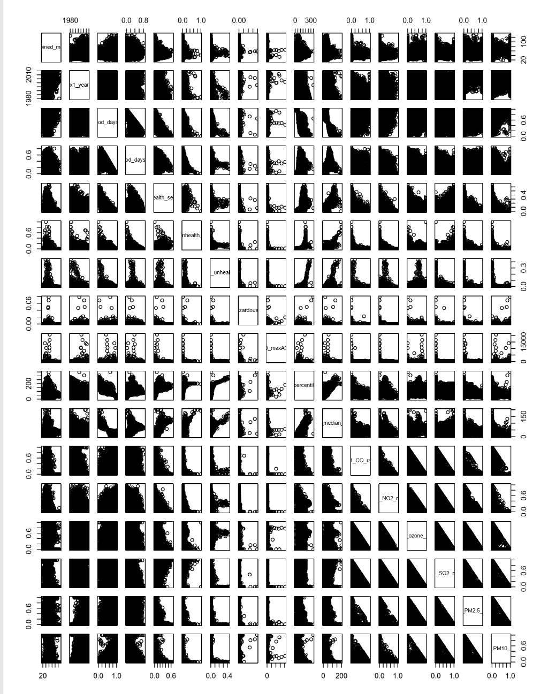

|  |
| --- |
| **Correlations**  combined_mort_y male_mort_y female_mort_y x1_year  combined_mort_y 1.000000000 0.830652712 0.906617398 0.407998564  male_mort_y 0.830652712 1.000000000 0.528057746 -0.048225326  female_mort_y 0.906617398 0.528057746 1.000000000 0.652105303  x1_year 0.407998564 -0.048225326 0.652105303 1.000000000  x2_good_days_ratio 0.078452467 0.041302393 0.066004030 0.132646776  x3_mod_days_ratio 0.014263054 -0.035095992 0.072342165 0.065360143  x4_unhealth_sens_ratio -0.174396615 -0.020327314 -0.236116169 -0.362482242  x5_unhealth_ratio -0.146302990 -0.035678167 -0.196578943 -0.280955885  x6_very_unhealth_ratio -0.072992464 -0.044394862 -0.074784933 -0.140188474  x7_hazardous_ratio 0.002308101 -0.006947582 0.005659898 0.008548379  x8_maxAQI -0.048833338 -0.047691197 -0.033706092 -0.041687125  x9_90percentileAQUI -0.160439335 -0.049160399 -0.186548988 -0.297990753  x10_median_AQI -0.075247485 -0.060812452 -0.052706273 -0.090577366  x11_CO_ratio -0.142913898 -0.068919585 -0.160980540 -0.243917041  x12_NO2_ratio -0.170521623 -0.137321015 -0.145033097 -0.155995469  x13_ozone_ratio -0.053922525 -0.129042483 0.019325506 0.090237317  x14_SO2_ratio -0.131930168 0.075226010 -0.255410108 -0.366563808  x15_PM2.5_ratio 0.224932595 0.003035080 0.334602473 0.481726839  x16_PM10_ratio 0.075263053 0.161651795 -0.014430715 -0.112596991  days_with_AQI -0.119773280 -0.195356641 -0.026148277 0.043649240  x2_good_days_ratio x3_mod_days_ratio  combined_mort_y 0.07845247 0.014263054  male_mort_y 0.04130239 -0.035095992  female_mort_y 0.06600403 0.072342165  x1_year 0.13264678 0.065360143  x2_good_days_ratio 1.00000000 -0.888459503  x3_mod_days_ratio -0.88845950 1.000000000  x4_unhealth_sens_ratio -0.75676330 0.407037139  x5_unhealth_ratio -0.51141177 0.143784884  x6_very_unhealth_ratio -0.24409313 0.072898445  x7_hazardous_ratio -0.03887775 0.014809544  x8_maxAQI -0.15289233 0.110736279  x9_90percentileAQUI -0.84250994 0.580485918  x10_median_AQI -0.89102873 0.719713598  x11_CO_ratio -0.02286350 0.033456762  x12_NO2_ratio -0.15404206 0.129996822  x13_ozone_ratio -0.06686925 0.054125210  x14_SO2_ratio -0.19019573 -0.006490388  x15_PM2.5_ratio -0.06779723 0.258146914  x16_PM10_ratio 0.39256423 -0.384815254  days_with_AQI -0.33702875 0.288951374  x4_unhealth_sens_ratio x5_unhealth_ratio  combined_mort_y -0.174396615 -0.146302990  male_mort_y -0.020327314 -0.035678167  female_mort_y -0.236116169 -0.196578943  x1_year -0.362482242 -0.280955885  x2_good_days_ratio -0.756763303 -0.511411769  x3_mod_days_ratio 0.407037139 0.143784884  x4_unhealth_sens_ratio 1.000000000 0.651815860  x5_unhealth_ratio 0.651815860 1.000000000  x6_very_unhealth_ratio 0.206325857 0.308255870  x7_hazardous_ratio 0.031726829 0.045777207  x8_maxAQI 0.138126416 0.099937233  x9_90percentileAQUI 0.825674848 0.697480702  x10_median_AQI 0.730860115 0.609515665  x11_CO_ratio -0.007747638 -0.003640731  x12_NO2_ratio 0.105393515 0.080123302  x13_ozone_ratio 0.055632889 0.030602406  x14_SO2_ratio 0.442184101 0.272400384  x15_PM2.5_ratio -0.251118637 -0.165285698  x16_PM10_ratio -0.256658948 -0.148550709  days_with_AQI 0.282703979 0.164735178  x6_very_unhealth_ratio x7_hazardous_ratio x8_maxAQI  combined_mort_y -0.07299246 0.0023081008 -0.048833338  male_mort_y -0.04439486 -0.0069475819 -0.047691197  female_mort_y -0.07478493 0.0056598984 -0.033706092  x1_year -0.14018847 0.0085483791 -0.041687125  x2_good_days_ratio -0.24409313 -0.0388777508 -0.152892329  x3_mod_days_ratio 0.07289844 0.0148095440 0.110736279  x4_unhealth_sens_ratio 0.20632586 0.0317268287 0.138126416  x5_unhealth_ratio 0.30825587 0.0457772066 0.099937233  x6_very_unhealth_ratio 1.00000000 0.0372569203 0.065159947  x7_hazardous_ratio 0.03725692 1.0000000000 0.267848842  x8_maxAQI 0.06515995 0.2678488423 1.000000000  x9_90percentileAQUI 0.38846272 0.0797407524 0.189093877  x10_median_AQI 0.32343525 0.0385251289 0.129456957  x11_CO_ratio 0.02917345 -0.0005531548 0.005023113  x12_NO2_ratio 0.16102289 -0.0077553366 0.031835165  x13_ozone_ratio 0.05603399 -0.0184283109 0.071499075  x14_SO2_ratio -0.01247065 -0.0131565355 0.037343746  x15_PM2.5_ratio -0.07069531 -0.0156222995 -0.064747598  x16_PM10_ratio -0.05337440 0.0539418753 -0.069622960  days_with_AQI 0.07304694 0.0029415329 0.128017055    x9_90percentileAQUI x10_median_AQI x11_CO_ratio  combined_mort_y -0.160439335 -0.075247485 -0.1429138980  male_mort_y -0.049160399 -0.060812452 -0.0689195845  female_mort_y -0.186548988 -0.052706273 -0.1609805402  x1_year -0.297990753 -0.090577366 -0.2439170410  x2_good_days_ratio -0.842509935 -0.891028733 -0.0228635024  x3_mod_days_ratio 0.580485918 0.719713598 0.0334567622  x4_unhealth_sens_ratio 0.825674848 0.730860115 -0.0077476376  x5_unhealth_ratio 0.697480702 0.609515665 -0.0036407310  x6_very_unhealth_ratio 0.388462724 0.323435250 0.0291734463  x7_hazardous_ratio 0.079740752 0.038525129 -0.0005531548  x8_maxAQI 0.189093877 0.129456957 0.0050231131  x9_90percentileAQUI 1.000000000 0.796693834 -0.0044619778  x10_median_AQI 0.796693834 1.000000000 0.0074898973  x11_CO_ratio -0.004461978 0.007489897 1.0000000000  x12_NO2_ratio 0.151651814 0.149555108 0.0222259820  x13_ozone_ratio 0.241733620 0.253802171 -0.1225320910  x14_SO2_ratio 0.261628306 0.050846873 -0.0523775156  x15_PM2.5_ratio -0.186913003 -0.026407818 -0.1334417386  x16_PM10_ratio -0.401344587 -0.388707274 -0.0668960343  days_with_AQI 0.365195233 0.331837777 0.1367568701    x12_NO2_ratio x13_ozone_ratio x14_SO2_ratio  combined_mort_y -0.170521623 -0.05392253 -0.131930168  male_mort_y -0.137321015 -0.12904248 0.075226010  female_mort_y -0.145033097 0.01932551 -0.255410108  x1_year -0.155995469 0.09023732 -0.366563808  x2_good_days_ratio -0.154042056 -0.06686925 -0.190195732  x3_mod_days_ratio 0.129996822 0.05412521 -0.006490388  x4_unhealth_sens_ratio 0.105393515 0.05563289 0.442184101  x5_unhealth_ratio 0.080123302 0.03060241 0.272400384  x6_very_unhealth_ratio 0.161022888 0.05603399 -0.012470652  x7_hazardous_ratio -0.007755337 -0.01842831 -0.013156535  x8_maxAQI 0.031835165 0.07149908 0.037343746  x9_90percentileAQUI 0.151651814 0.24173362 0.261628306  x10_median_AQI 0.149555108 0.25380217 0.050846873  x11_CO_ratio 0.022225982 -0.12253209 -0.052377516  x12_NO2_ratio 1.000000000 -0.06407119 -0.014715465  x13_ozone_ratio -0.064071190 1.00000000 -0.363048569  x14_SO2_ratio -0.014715465 -0.36304857 1.000000000  x15_PM2.5_ratio -0.137217225 -0.37536865 -0.267835841  x16_PM10_ratio -0.129264837 -0.43720622 -0.182976432  days_with_AQI 0.239040479 0.24206144 0.271393292  x15_PM2.5_ratio x16_PM10_ratio days_with_AQI  combined_mort_y 0.22493259 0.07526305 -0.119773280  male_mort_y 0.00303508 0.16165179 -0.195356641  female_mort_y 0.33460247 -0.01443071 -0.026148277  x1_year 0.48172684 -0.11259699 0.043649240  x2_good_days_ratio -0.06779723 0.39256423 -0.337028753  x3_mod_days_ratio 0.25814691 -0.38481525 0.288951374  x4_unhealth_sens_ratio -0.25111864 -0.25665895 0.282703979  x5_unhealth_ratio -0.16528570 -0.14855071 0.164735178  x6_very_unhealth_ratio -0.07069531 -0.05337440 0.073046937  x7_hazardous_ratio -0.01562230 0.05394188 0.002941533  x8_maxAQI -0.06474760 -0.06962296 0.128017055  x9_90percentileAQUI -0.18691300 -0.40134459 0.365195233  x10_median_AQI -0.02640782 -0.38870727 0.331837777  x11_CO_ratio -0.13344174 -0.06689603 0.136756870  x12_NO2_ratio -0.13721723 -0.12926484 0.239040479  x13_ozone_ratio -0.37536865 -0.43720622 0.242061442  x14_SO2_ratio -0.26783584 -0.18297643 0.271393292  x15_PM2.5_ratio 1.00000000 -0.21335672 -0.145676387  x16_PM10_ratio -0.21335672 1.00000000 -0.539965205  days_with_AQI -0.14567639 -0.53996521 1.000000000 |
|  |
| |  | | --- | | **Initial Regression (location variable left out)** | |

Linear regression was performed using the combined male and female age-adjusted respiratory mortality rate, the male age-adjusted mortality rate, and the female age-adjusted mortality rate as dependent variables in three separate regressions. Summary outputs are presented below. Statistically significant coefficients are highlighted and R2 values are highlighted.

Observations:

R2 and adjusted R2 are quite different when comparing regression that use male versus female respiratory mortality rates. The overall AQI day ratio coefficients do not have strong t-statistics in comparison with the counts of days on which AQI is attributable to specific criteria pollutants. We know that we have a fair amount of correlation between our predictor variables, so this is not surprising.

> summary(full_comb)

Call:

lm(formula = combined_mort_y ~ x1_year + x2_good_days_ratio +

x3_mod_days_ratio + x4_unhealth_sens_ratio + x5_unhealth_ratio +

x6_very_unhealth_ratio + x7_hazardous_ratio + x8_maxAQI +

x9_90percentileAQUI + x10_median_AQI + x11_CO_ratio + x12_NO2_ratio +

x13_ozone_ratio + x14_SO2_ratio + x15_PM2.5_ratio + x16_PM10_ratio +

days_with_AQI, data = dataf)

Residuals:

Min 1Q Median 3Q Max

-50.957 -7.325 -0.565 7.018 84.050

Coefficients: (1 not defined because of singularities)

Estimate Std. Error t value Pr(>|t|)

(Intercept) -1.168e+03 1.338e+02 -8.735 < 2e-16 ***

x1_year 5.881e-01 1.124e-02 52.323 < 2e-16 ***

x2_good_days_ratio 4.977e+01 1.312e+02 0.379 0.705

x3_mod_days_ratio 4.517e+01 1.312e+02 0.344 0.731

x4_unhealth_sens_ratio 2.841e+01 1.312e+02 0.217 0.829

x5_unhealth_ratio 9.443e+00 1.312e+02 0.072 0.943

x6_very_unhealth_ratio 2.798e+01 1.313e+02 0.213 0.831

x7_hazardous_ratio -5.976e+01 2.051e+02 -0.291 0.771

x8_maxAQI -7.266e-04 4.611e-04 -1.576 0.115

x9_90percentileAQUI 6.184e-02 7.647e-03 8.087 6.44e-16 ***

x10_median_AQI 9.659e-02 1.441e-02 6.703 2.09e-11 ***

x11_CO_ratio -5.812e+00 7.299e-01 -7.963 1.76e-15 ***

x12_NO2_ratio -1.336e+01 8.060e-01 -16.577 < 2e-16 ***

x13_ozone_ratio -5.824e+00 3.792e-01 -15.360 < 2e-16 ***

x14_SO2_ratio -3.127e-01 4.518e-01 -0.692 0.489

x15_PM2.5_ratio -3.479e+00 3.821e-01 -9.104 < 2e-16 ***

x16_PM10_ratio NA NA NA NA

days_with_AQI -1.238e-02 9.564e-04 -12.942 < 2e-16 ***

---

Signif. codes: 0 ‘***’ 0.001 ‘**’ 0.01 ‘*’ 0.05 ‘.’ 0.1 ‘ ’ 1

Residual standard error: 11.84 on 23247 degrees of freedom

Multiple R-squared: 0.205, Adjusted R-squared: 0.2045

F-statistic: 374.7 on 16 and 23247 DF, p-value: < 2.2e-16

> summary(male_comb)

Call:

lm(formula = male_mort_y ~ x1_year + x2_good_days_ratio + x3_mod_days_ratio +

x4_unhealth_sens_ratio + x5_unhealth_ratio + x6_very_unhealth_ratio +

x7_hazardous_ratio + x8_maxAQI + x9_90percentileAQUI + x10_median_AQI +

x11_CO_ratio + x12_NO2_ratio + x13_ozone_ratio + x14_SO2_ratio +

x15_PM2.5_ratio + x16_PM10_ratio + days_with_AQI, data = dataf)

Residuals:

Min 1Q Median 3Q Max

-62.213 -11.027 -0.757 9.582 154.860

Coefficients: (1 not defined because of singularities)

Estimate Std. Error t value Pr(>|t|)

(Intercept) -2.305e+01 1.898e+02 -0.121 0.9034

x1_year -2.898e-02 1.595e-02 -1.816 0.0693 .

x2_good_days_ratio 1.584e+02 1.863e+02 0.851 0.3950

x3_mod_days_ratio 1.452e+02 1.862e+02 0.780 0.4355

x4_unhealth_sens_ratio 1.097e+02 1.862e+02 0.589 0.5557

x5_unhealth_ratio 7.306e+01 1.862e+02 0.392 0.6948

x6_very_unhealth_ratio 7.518e+01 1.863e+02 0.404 0.6865

x7_hazardous_ratio -5.975e+01 2.912e+02 -0.205 0.8374

x8_maxAQI -1.289e-03 6.544e-04 -1.970 0.0489 *

x9_90percentileAQUI 1.262e-01 1.085e-02 11.626 < 2e-16 ***

x10_median_AQI 2.273e-01 2.045e-02 11.111 < 2e-16 ***

x11_CO_ratio -1.138e+01 1.036e+00 -10.987 < 2e-16 ***

x12_NO2_ratio -2.116e+01 1.144e+00 -18.499 < 2e-16 ***

x13_ozone_ratio -9.618e+00 5.382e-01 -17.873 < 2e-16 ***

x14_SO2_ratio 3.524e+00 6.413e-01 5.495 3.95e-08 ***

x15_PM2.5_ratio -5.994e+00 5.423e-01 -11.053 < 2e-16 ***

x16_PM10_ratio NA NA NA NA

days_with_AQI -2.689e-02 1.357e-03 -19.812 < 2e-16 ***

---

Signif. codes: 0 ‘***’ 0.001 ‘**’ 0.01 ‘*’ 0.05 ‘.’ 0.1 ‘ ’ 1

Residual standard error: 16.81 on 23247 degrees of freedom

Multiple R-squared: 0.08257, Adjusted R-squared: 0.08194

F-statistic: 130.8 on 16 and 23247 DF, p-value: < 2.2e-16

> summary(female_comb)

Call:

lm(formula = female_mort_y ~ x1_year + x2_good_days_ratio + x3_mod_days_ratio +

x4_unhealth_sens_ratio + x5_unhealth_ratio + x6_very_unhealth_ratio +

x7_hazardous_ratio + x8_maxAQI + x9_90percentileAQUI + x10_median_AQI +

x11_CO_ratio + x12_NO2_ratio + x13_ozone_ratio + x14_SO2_ratio +

x15_PM2.5_ratio + x16_PM10_ratio + days_with_AQI, data = dataf)

Residuals:

Min 1Q Median 3Q Max

-44.798 -6.136 -0.403 6.001 59.518

Coefficients: (1 not defined because of singularities)

Estimate Std. Error t value Pr(>|t|)

(Intercept) -1.846e+03 1.151e+02 -16.046 < 2e-16 ***

x1_year 9.373e-01 9.670e-03 96.928 < 2e-16 ***

x2_good_days_ratio 1.625e+01 1.129e+02 0.144 0.885567

x3_mod_days_ratio 1.727e+01 1.129e+02 0.153 0.878429

x4_unhealth_sens_ratio 9.407e+00 1.129e+02 0.083 0.933578

x5_unhealth_ratio -8.110e+00 1.129e+02 -0.072 0.942718

x6_very_unhealth_ratio 2.416e+01 1.129e+02 0.214 0.830561

x7_hazardous_ratio -1.024e+02 1.765e+02 -0.580 0.561918

x8_maxAQI -2.295e-04 3.967e-04 -0.579 0.562853

x9_90percentileAQUI 4.215e-02 6.579e-03 6.406 1.52e-10 ***

x10_median_AQI 2.111e-02 1.240e-02 1.702 0.088702 .

x11_CO_ratio -2.127e+00 6.280e-01 -3.387 0.000708 ***

x12_NO2_ratio -7.771e+00 6.934e-01 -11.207 < 2e-16 ***

x13_ozone_ratio -3.888e+00 3.262e-01 -11.918 < 2e-16 ***

x14_SO2_ratio -2.725e+00 3.887e-01 -7.009 2.46e-12 ***

x15_PM2.5_ratio -2.440e+00 3.287e-01 -7.424 1.17e-13 ***

x16_PM10_ratio NA NA NA NA

days_with_AQI -4.012e-03 8.228e-04 -4.876 1.09e-06 ***

---

Signif. codes: 0 ‘***’ 0.001 ‘**’ 0.01 ‘*’ 0.05 ‘.’ 0.1 ‘ ’ 1

Residual standard error: 10.19 on 23247 degrees of freedom

Multiple R-squared: 0.4363, Adjusted R-squared: 0.4359

F-statistic: 1125 on 16 and 23247 DF, p-value: < 2.2e-16

Before we move on to model selection, we can examine some hypotheses about relationships between our predictors, too. This gives us an idea of how predictor variables may be changing over the period of our study.

**Criteria Pollutants versus Year**

R2 values for these regressions are not particularly high (highlighted in outputs). Not all criteria air pollutants demonstrate a negative linear association with increasing year. 95% confidence intervals for the coefficients of year for the outcome variables of interest in these simple linear regressions are presented. Note that year does not have a negative coefficient in regressions for ozone, PM2.5, and female mortality.

> confint(lm.CO)

2.5 % 97.5 %

x1_year -0.003355114 -0.003028917

> confint(lm.NO2)

2.5 % 97.5 %

x1_year -0.001974636 -0.001677451

> confint(lm.ozone)

2.5 % 97.5 %

x1_year 0.003154478 0.00419721

> confint(lm.SO2)

2.5 % 97.5 %

x1_year -0.01165493 -0.01091862

> confint(lm.PM2.5)

2.5 % 97.5 %

x1_year 0.01597084 0.01673545

> confint(lm.PM10)

2.5 % 97.5 %

x1_year -0.00414651 -0.0033018

> confint(lm.male_mort)

2.5 % 97.5 %

x1_year -0.1122382 -0.06504892

> confint(lm.female_mort)

2.5 % 97.5 %

x1_year 0.913105 0.9408038

> confint(lm.medAQI)

2.5 % 97.5 %

x1_year -0.1854171 -0.1395058

> summary(lm.CO)

Call:

lm(formula = x11_CO_ratio ~ x1_year, data = dataf)

Coefficients:

Estimate Std. Error t value Pr(>|t|)

(Intercept) 6.413e+00 1.663e-01 38.55 <2e-16 ***

x1_year -3.192e-03 8.321e-05 -38.36 <2e-16 ***

---

Signif. codes: 0 ‘***’ 0.001 ‘**’ 0.01 ‘*’ 0.05 ‘.’ 0.1 ‘ ’ 1

Residual standard error: 0.1211 on 23262 degrees of freedom

Multiple R-squared: 0.0595, Adjusted R-squared: 0.05946

F-statistic: 1472 on 1 and 23262 DF, p-value: < 2.2e-16

> summary(lm.NO2)

Call:

lm(formula = x12_NO2_ratio ~ x1_year, data = dataf)

Coefficients:

Estimate Std. Error t value Pr(>|t|)

(Intercept) 3.691e+00 1.515e-01 24.36 <2e-16 ***

x1_year -1.826e-03 7.581e-05 -24.09 <2e-16 ***

---

Signif. codes: 0 ‘***’ 0.001 ‘**’ 0.01 ‘*’ 0.05 ‘.’ 0.1 ‘ ’ 1

Residual standard error: 0.1104 on 23262 degrees of freedom

Multiple R-squared: 0.02433, Adjusted R-squared: 0.02429

F-statistic: 580.2 on 1 and 23262 DF, p-value: < 2.2e-16

> summary(lm.ozone)

Call:

lm(formula = x13_ozone_ratio ~ x1_year, data = dataf)

Coefficients:

Estimate Std. Error t value Pr(>|t|)

(Intercept) -6.905486 0.531700 -12.99 <2e-16 ***

x1_year 0.003676 0.000266 13.82 <2e-16 ***

---

Signif. codes: 0 ‘***’ 0.001 ‘**’ 0.01 ‘*’ 0.05 ‘.’ 0.1 ‘ ’ 1

Residual standard error: 0.3872 on 23262 degrees of freedom

Multiple R-squared: 0.008143, Adjusted R-squared: 0.0081

F-statistic: 191 on 1 and 23262 DF, p-value: < 2.2e-16

> summary(lm.SO2)

Call:

lm(formula = x14_SO2_ratio ~ x1_year, data = dataf)

Coefficients:

Estimate Std. Error t value Pr(>|t|)

(Intercept) 22.7125741 0.3754552 60.49 <2e-16 ***

x1_year -0.0112868 0.0001878 -60.09 <2e-16 ***

---

Signif. codes: 0 ‘***’ 0.001 ‘**’ 0.01 ‘*’ 0.05 ‘.’ 0.1 ‘ ’ 1

Residual standard error: 0.2734 on 23262 degrees of freedom

Multiple R-squared: 0.1344, Adjusted R-squared: 0.1343

F-statistic: 3611 on 1 and 23262 DF, p-value: < 2.2e-16

> summary(lm.PM2.5)

Call:

lm(formula = x15_PM2.5_ratio ~ x1_year, data = dataf)

Coefficients:

Estimate Std. Error t value Pr(>|t|)

(Intercept) -32.492760 0.389884 -83.34 <2e-16 ***

x1_year 0.016353 0.000195 83.84 <2e-16 ***

---

Signif. codes: 0 ‘***’ 0.001 ‘**’ 0.01 ‘*’ 0.05 ‘.’ 0.1 ‘ ’ 1

Residual standard error: 0.2839 on 23262 degrees of freedom

Multiple R-squared: 0.2321, Adjusted R-squared: 0.232

F-statistic: 7029 on 1 and 23262 DF, p-value: < 2.2e-16

> summary(lm.PM10)

Call:

lm(formula = x16_PM10_ratio ~ x1_year, data = dataf)

Coefficients:

Estimate Std. Error t value Pr(>|t|)

(Intercept) 7.5822229 0.4307267 17.60 <2e-16 ***

x1_year -0.0037242 0.0002155 -17.28 <2e-16 ***

---

Signif. codes: 0 ‘***’ 0.001 ‘**’ 0.01 ‘*’ 0.05 ‘.’ 0.1 ‘ ’ 1

Residual standard error: 0.3137 on 23262 degrees of freedom

Multiple R-squared: 0.01268, Adjusted R-squared: 0.01264

F-statistic: 298.7 on 1 and 23262 DF, p-value: < 2.2e-16

**Median AQI versus Year**

> summary(lm.medAQI)

Call:

lm(formula = x10_median_AQI ~ x1_year, data = dataf)

Coefficients:

Estimate Std. Error t value Pr(>|t|)

(Intercept) 363.88064 23.41063 15.54 <2e-16 ***

x1_year -0.16246 0.01171 -13.87 <2e-16 ***

---

Signif. codes: 0 ‘***’ 0.001 ‘**’ 0.01 ‘*’ 0.05 ‘.’ 0.1 ‘ ’ 1

Residual standard error: 17.05 on 23262 degrees of freedom

Multiple R-squared: 0.008204, Adjusted R-squared: 0.008162

F-statistic: 192.4 on 1 and 23262 DF, p-value: < 2.2e-16

**Respiratory Mortality by Gender versus Year**

> lm.male_mort = lm(male_mort_y ~

+ x1_year, data = dataf)

> summary(lm.male_mort)

Call:

lm(formula = male_mort_y ~ x1_year, data = dataf)

Coefficients:

Estimate Std. Error t value Pr(>|t|)

(Intercept) 252.65513 24.06234 10.500 < 2e-16 ***

x1_year -0.08864 0.01204 -7.364 1.85e-13 ***

---

Signif. codes: 0 ‘***’ 0.001 ‘**’ 0.01 ‘*’ 0.05 ‘.’ 0.1 ‘ ’ 1

Residual standard error: 17.52 on 23262 degrees of freedom

Multiple R-squared: 0.002326, Adjusted R-squared: 0.002283

F-statistic: 54.23 on 1 and 23262 DF, p-value: 1.846e-13

> lm.female_mort =lm(female_mort_y ~

+ x1_year, data = dataf)

> summary(lm.female_mort)

Call:

lm(formula = female_mort_y ~ x1_year, data = dataf)

Coefficients:

Estimate Std. Error t value Pr(>|t|)

(Intercept) -1.810e+03 1.412e+01 -128.1 <2e-16 ***

x1_year 9.270e-01 7.066e-03 131.2 <2e-16 ***

---

Signif. codes: 0 ‘***’ 0.001 ‘**’ 0.01 ‘*’ 0.05 ‘.’ 0.1 ‘ ’ 1

Residual standard error: 10.29 on 23262 degrees of freedom

Multiple R-squared: 0.4252, Adjusted R-squared: 0.4252

F-statistic: 1.721e+04 on 1 and 23262 DF, p-value: < 2.2e-16

**Can a linear model predict respiratory mortality from yearly air quality?**

**Step 1 – Select a model using forward and backward stepwise subset selection and Lasso.**

**Forward Stepwise Subset Selection:**

> step(null_comb, scope=list(lower=null_comb, upper=full_comb), direction="forward",level="0.01")

Call:

lm(formula = combined_mort_y ~ x1_year + days_with_AQI + x12_NO2_ratio +

x13_ozone_ratio + x11_CO_ratio + x15_PM2.5_ratio + x3_mod_days_ratio +

x5_unhealth_ratio + x9_90percentileAQUI + x4_unhealth_sens_ratio +

x10_median_AQI + x2_good_days_ratio + x8_maxAQI, data = data)

Coefficients:

(Intercept) x1_year days_with_AQI

-1.141e+03 5.885e-01 -1.267e-02

x12_NO2_ratio x13_ozone_ratio x11_CO_ratio

-1.315e+01 -5.653e+00 -5.628e+00

x15_PM2.5_ratio x3_mod_days_ratio x5_unhealth_ratio

-3.361e+00 1.748e+01 -1.817e+01

x9_90percentileAQUI x4_unhealth_sens_ratio x10_median_AQI

6.103e-02 4.222e-01 9.785e-02

x2_good_days_ratio x8_maxAQI

2.206e+01 -8.814e-04

> step(null_male, scope=list(lower=null_comb, upper=male_comb), direction="forward",level="0.01")

Call:

lm(formula = male_mort_y ~ days_with_AQI + x14_SO2_ratio + x12_NO2_ratio +

x16_PM10_ratio + x3_mod_days_ratio + x2_good_days_ratio +

x9_90percentileAQUI + x10_median_AQI + x15_PM2.5_ratio +

x4_unhealth_sens_ratio + x8_maxAQI + x7_hazardous_ratio,

data = data)

Coefficients:

(Intercept) days_with_AQI x14_SO2_ratio

-1.923e+01 -2.775e-02 1.355e+01

x12_NO2_ratio x16_PM10_ratio x3_mod_days_ratio

-1.101e+01 9.810e+00 7.284e+01

x2_good_days_ratio x9_90percentileAQUI x10_median_AQI

8.676e+01 1.327e-01 2.303e-01

x15_PM2.5_ratio x4_unhealth_sens_ratio x8_maxAQI

3.562e+00 3.739e+01 -1.464e-03

x7_hazardous_ratio

-1.789e+02

> step(null_female, scope=list(lower=null_comb, upper=female_comb), direction="forward",level="0.01")

Call:

lm(formula = female_mort_y ~ x1_year + x16_PM10_ratio + x3_mod_days_ratio +

x12_NO2_ratio + days_with_AQI + x6_very_unhealth_ratio +

x5_unhealth_ratio + x9_90percentileAQUI + x13_ozone_ratio +

x2_good_days_ratio + x4_unhealth_sens_ratio + x10_median_AQI,

data = data)

Coefficients:

(Intercept) x1_year x16_PM10_ratio

-1.917e+03 9.378e-01 2.516e+00

x3_mod_days_ratio x12_NO2_ratio days_with_AQI

8.408e+01 -5.241e+00 -4.160e-03

x6_very_unhealth_ratio x5_unhealth_ratio x9_90percentileAQUI

9.108e+01 5.848e+01 4.173e-02

x13_ozone_ratio x2_good_days_ratio x4_unhealth_sens_ratio

-1.368e+00 8.303e+01 7.541e+01

x10_median_AQI

2.374e-02

**Backward Stepwise Subset Selection:**

> step(full_comb, data = dataf, direction="backward",level="0.05")

Call:

lm(formula = combined_mort_y ~ x1_year + x2_good_days_ratio +

x3_mod_days_ratio + x4_unhealth_sens_ratio + x6_very_unhealth_ratio +

x8_maxAQI + x9_90percentileAQUI + x10_median_AQI + x11_CO_ratio +

x12_NO2_ratio + x13_ozone_ratio + x15_PM2.5_ratio + days_with_AQI,

data = dataf)

Coefficients:

(Intercept) x1_year x2_good_days_ratio

-1.160e+03 5.888e-01 4.049e+01

x3_mod_days_ratio x4_unhealth_sens_ratio x6_very_unhealth_ratio

3.589e+01 1.885e+01 1.907e+01

x8_maxAQI x9_90percentileAQUI x10_median_AQI

-8.093e-04 6.114e-02 9.802e-02

x11_CO_ratio x12_NO2_ratio x13_ozone_ratio

-5.631e+00 -1.316e+01 -5.664e+00

x15_PM2.5_ratio days_with_AQI

-3.366e+00 -1.268e-02

> step(male_comb, data = dataf, direction="backward",level="0.05")

Call:

lm(formula = male_mort_y ~ x1_year + x2_good_days_ratio + x3_mod_days_ratio +

x4_unhealth_sens_ratio + x8_maxAQI + x9_90percentileAQUI +

x10_median_AQI + x11_CO_ratio + x12_NO2_ratio + x13_ozone_ratio +

x14_SO2_ratio + x15_PM2.5_ratio + days_with_AQI, data = dataf)

Coefficients:

(Intercept) x1_year x2_good_days_ratio

53.365299 -0.030277 84.636132

x3_mod_days_ratio x4_unhealth_sens_ratio x8_maxAQI

71.570949 36.156277 -0.001632

x9_90percentileAQUI x10_median_AQI x11_CO_ratio

0.125156 0.226474 -11.348707

x12_NO2_ratio x13_ozone_ratio x14_SO2_ratio

-21.066126 -9.536502 3.569725

x15_PM2.5_ratio days_with_AQI

-5.946726 -0.026866

> step(female_comb, data = dataf, direction="backward",level="0.05")

Call:

lm(formula = female_mort_y ~ x1_year + x2_good_days_ratio + x3_mod_days_ratio +

x4_unhealth_sens_ratio + x6_very_unhealth_ratio + x7_hazardous_ratio +

x9_90percentileAQUI + x10_median_AQI + x11_CO_ratio + x12_NO2_ratio +

x13_ozone_ratio + x14_SO2_ratio + x15_PM2.5_ratio + days_with_AQI,

data = dataf)

Coefficients:

(Intercept) x1_year x2_good_days_ratio

-1.855e+03 9.374e-01 2.451e+01

x3_mod_days_ratio x4_unhealth_sens_ratio x6_very_unhealth_ratio

2.547e+01 1.760e+01 3.231e+01

x7_hazardous_ratio x9_90percentileAQUI x10_median_AQI

-1.059e+02 4.204e-02 2.176e-02

x11_CO_ratio x12_NO2_ratio x13_ozone_ratio

-2.121e+00 -7.766e+00 -3.894e+00

x14_SO2_ratio x15_PM2.5_ratio days_with_AQI

-2.716e+00 -2.433e+00 -4.060e-03

**Ridge Regression**

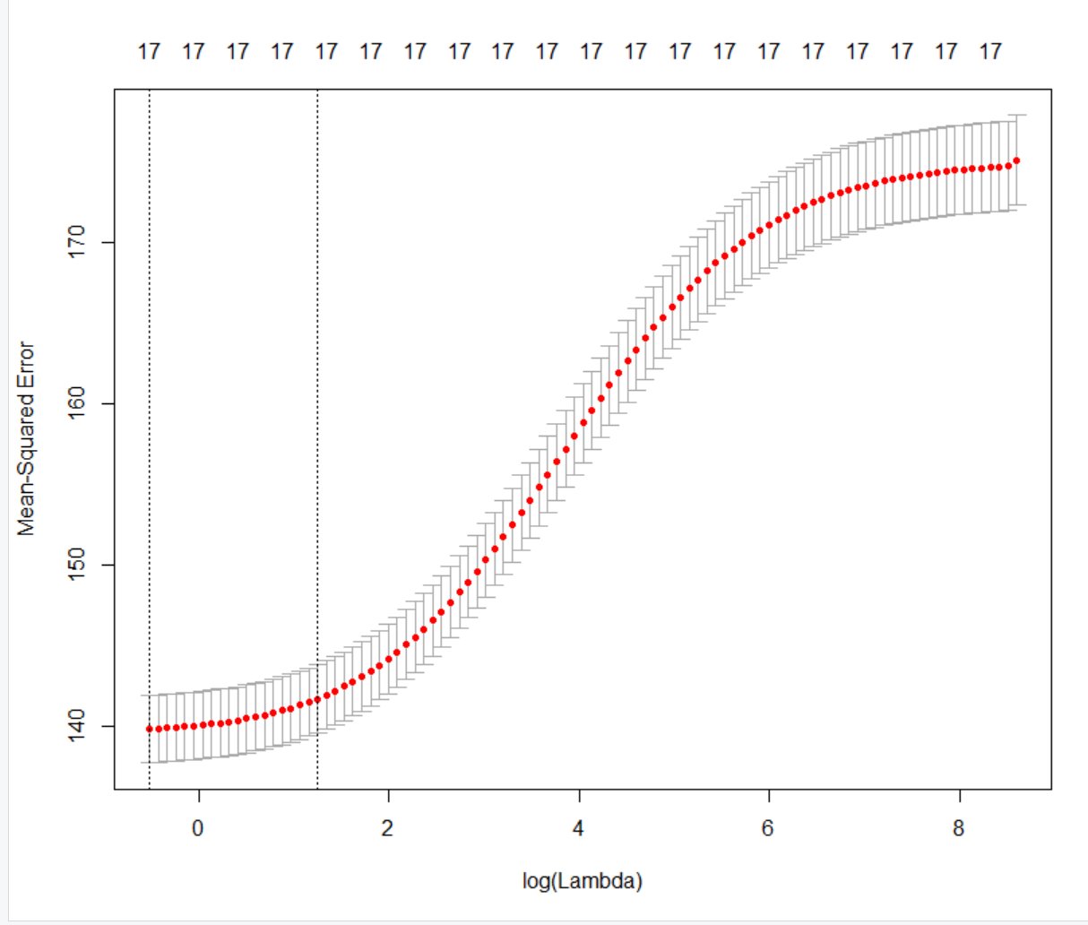

**Combined respiratory mortality**

> bestlam=cv.out$lambda.min

> bestlam

[1] 0.5971866

> ridge.pred=predict(ridge.mod, s=bestlam, newx=x[test,])

> mean((ridge.pred-y.test)^2)

[1] 141.577

> out=glmnet(x,y,alpha=0)

> predict(out, type="coefficients", s=bestlam)[1:19,]

(Intercept) (Intercept) x1_year

-1.021282e+03 0.000000e+00 5.383199e-01

x2_good_days_ratio x3_mod_days_ratio x4_unhealth_sens_ratio

1.107954e+00 1.693433e+00 -9.473412e+00

x5_unhealth_ratio x6_very_unhealth_ratio x7_hazardous_ratio

-2.105888e+01 -3.601318e+00 -5.486378e+01

x8_maxAQI x9_90percentileAQUI x10_median_AQI

-8.368965e-04 2.666447e-02 4.535376e-02

x11_CO_ratio x12_NO2_ratio x13_ozone_ratio

-3.568211e+00 -1.028769e+01 -1.856889e+00

x14_SO2_ratio x15_PM2.5_ratio x16_PM10_ratio

1.911653e+00 9.467993e-02 2.874644e+00

days_with_AQI

-1.033569e-02

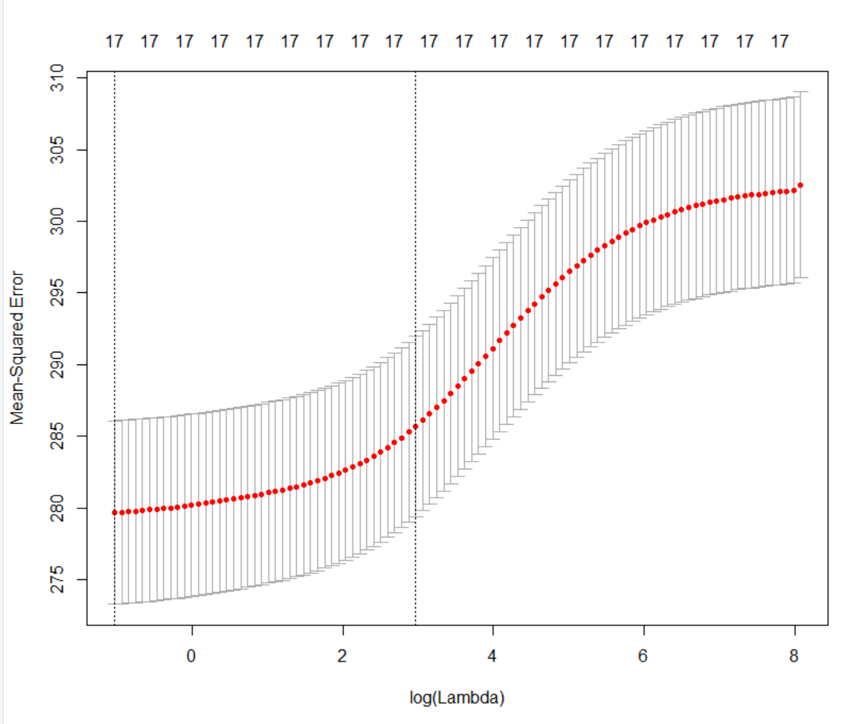

**Male respiratory mortality**

> bestlam=cv.out$lambda.min

> bestlam

[1] 0.3552032

> ridge.pred=predict(ridge.mod, s=bestlam, newx=x[test,])

> mean((ridge.pred-y.test)^2)

[1] 286.8669

> out=glmnet(x,y,alpha=0)

> predict(out, type="coefficients", s=bestlam)[1:19,]

(Intercept) (Intercept) x1_year

1.388993e+02 0.000000e+00 -3.451204e-02

x2_good_days_ratio x3_mod_days_ratio x4_unhealth_sens_ratio

5.851006e+00 9.906756e-02 -2.677949e+01

x5_unhealth_ratio x6_very_unhealth_ratio x7_hazardous_ratio

-5.406903e+01 -5.112200e+01 -1.982218e+02

x8_maxAQI x9_90percentileAQUI x10_median_AQI

-1.681878e-03 8.354906e-02 1.475071e-01

x11_CO_ratio x12_NO2_ratio x13_ozone_ratio

-6.972678e+00 -1.630263e+01 -4.015698e+00

x14_SO2_ratio x15_PM2.5_ratio x16_PM10_ratio

7.230254e+00 -1.468097e+00 4.344960e+00

days_with_AQI

-2.545165e-02

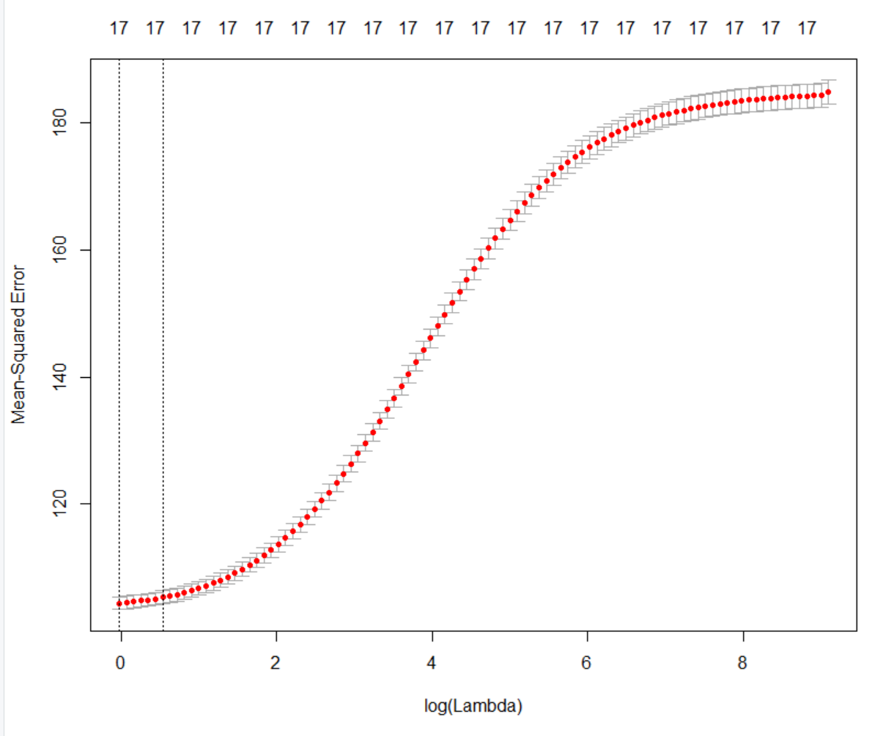

**Female respiratory mortality**

> bestlam=cv.out$lambda.min

> bestlam

[1] 0.9765151

> ridge.pred=predict(ridge.mod, s=bestlam, newx=x[test,])

> mean((ridge.pred-y.test)^2)

[1] 104.5619

> out=glmnet(x,y,alpha=0)

> predict(out, type="coefficients", s=bestlam)[1:19,]

(Intercept) (Intercept) x1_year

-1.608256e+03 0.000000e+00 8.258597e-01

x2_good_days_ratio x3_mod_days_ratio x4_unhealth_sens_ratio

-6.786916e-01 2.912720e+00 -3.676532e+00

x5_unhealth_ratio x6_very_unhealth_ratio x7_hazardous_ratio

-1.485452e+01 1.369839e+01 -4.680835e+01

x8_maxAQI x9_90percentileAQUI x10_median_AQI

-2.487873e-04 1.317417e-02 8.824142e-03

x11_CO_ratio x12_NO2_ratio x13_ozone_ratio

-1.615451e+00 -6.004540e+00 -8.067617e-01

x14_SO2_ratio x15_PM2.5_ratio x16_PM10_ratio

-1.094516e+00 1.037653e+00 2.086712e+00

days_with_AQI

-1.507977e-03

**Lasso**

We saw that Ridge can outperform least squares for predicting mortality rates. We now apply Lasso to determine if we can identify a more accurate or interpretable model.

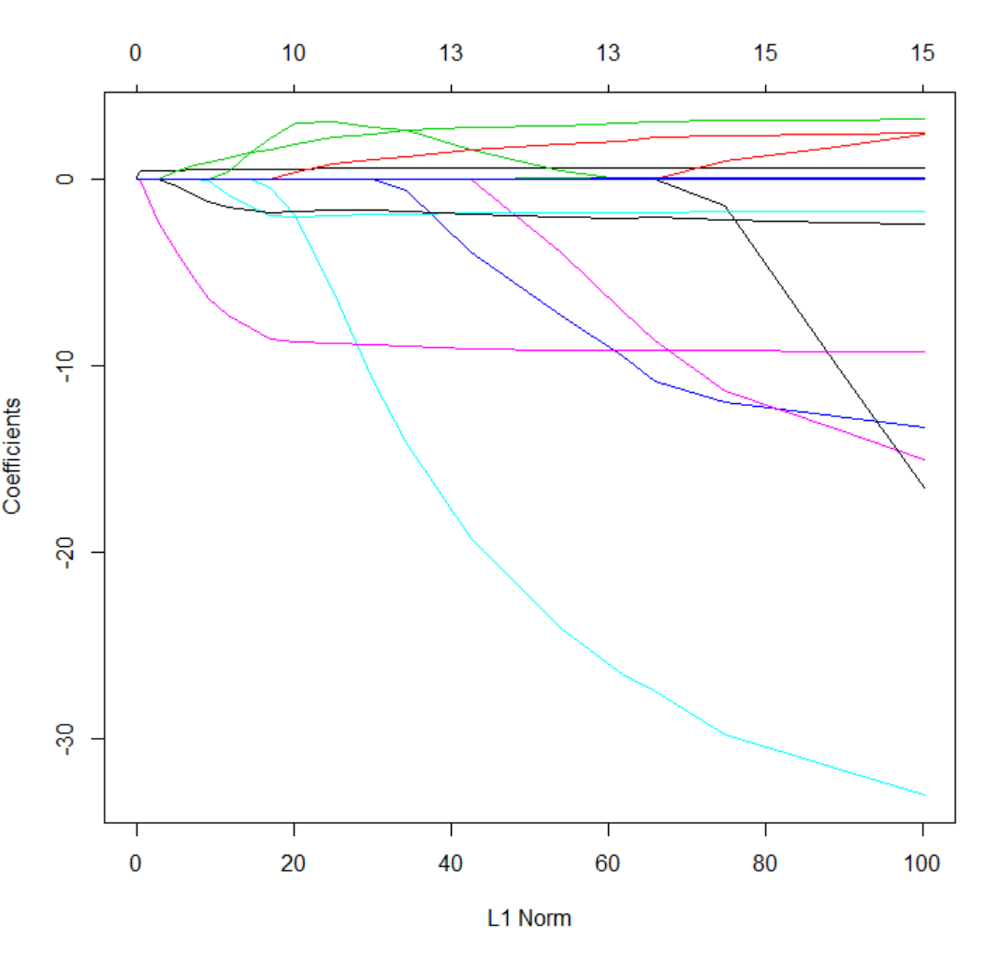

> lasso.mod = glmnet(x[train,],y[train], alpha=1, lambda=grid)

> plot(lasso.mod)

(combined mortality rate)

**Combined Respiratory Mortality**

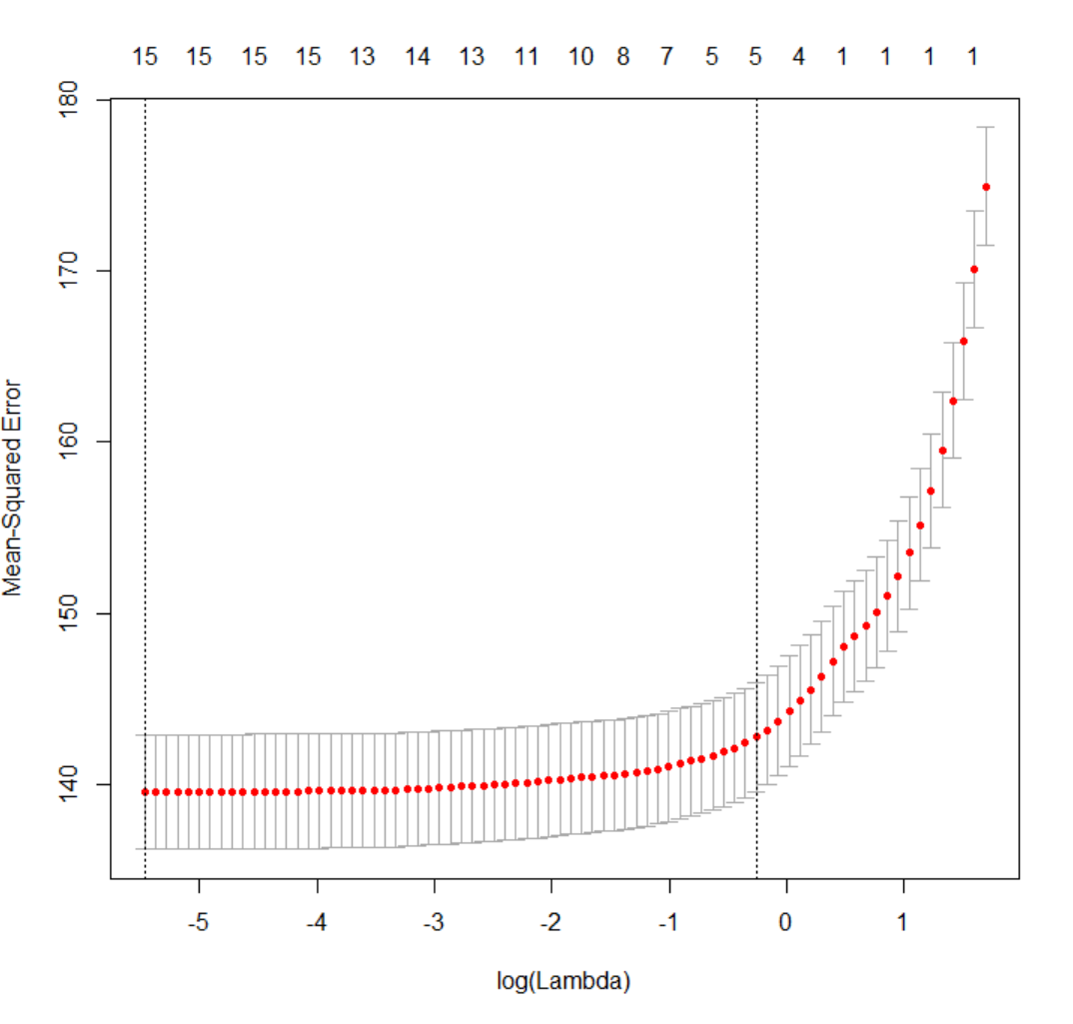

> mean((lasso.pred-y.test)^2)

[1] 268.9173

> lasso.coef

(Intercept) (Intercept) x1_year

-1.117770e+03 0.000000e+00 5.851923e-01

x2_good_days_ratio x3_mod_days_ratio x4_unhealth_sens_ratio

2.423071e+00 0.000000e+00 -1.472461e+01

x5_unhealth_ratio x6_very_unhealth_ratio x7_hazardous_ratio

-3.079316e+01 -1.166931e+01 -9.654342e+01

x8_maxAQI x9_90percentileAQUI x10_median_AQI

-8.289708e-04 5.010716e-02 7.430389e-02

x11_CO_ratio x12_NO2_ratio x13_ozone_ratio

-2.329848e+00 -9.792814e+00 -2.025703e+00

x14_SO2_ratio x15_PM2.5_ratio x16_PM10_ratio

2.972398e+00 0.000000e+00 3.418261e+00

days_with_AQI

-1.209842e-02

Note that the moderate days ratio and PM2.5 ratio are assigned zero coefficients in this model.

**Male Respiratory Mortality**

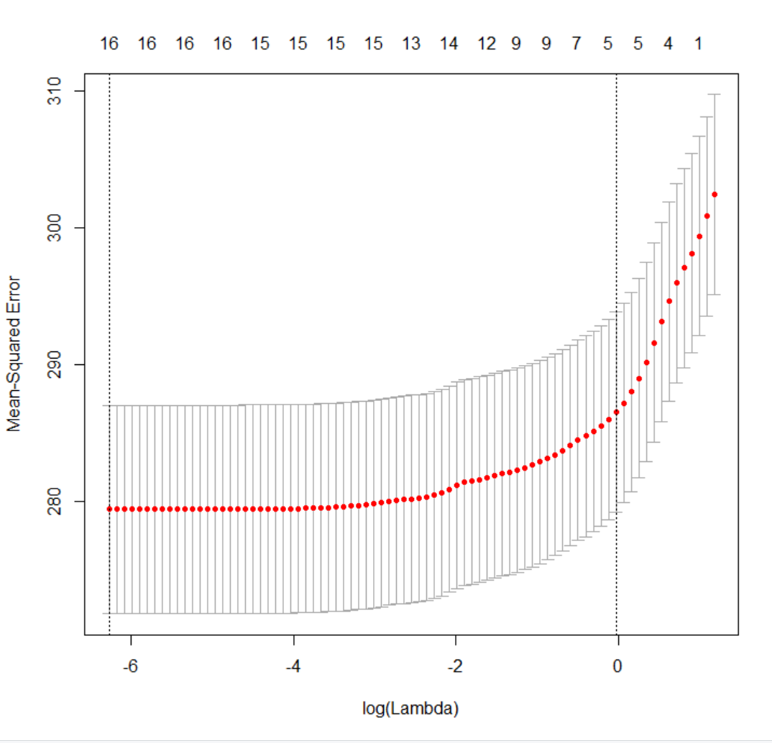

> mean((lasso.pred-y.test)^2)

[1] 1265.471

> lasso.coef

(Intercept) (Intercept) x1_year

1.176809e+02 0.000000e+00 -2.823352e-02

x2_good_days_ratio x3_mod_days_ratio x4_unhealth_sens_ratio

1.097300e+01 0.000000e+00 -3.354436e+01

x5_unhealth_ratio x6_very_unhealth_ratio x7_hazardous_ratio

-6.710369e+01 -6.447628e+01 -2.401990e+02

x8_maxAQI x9_90percentileAQUI x10_median_AQI

-1.654329e-03 1.150446e-01 2.042818e-01

x11_CO_ratio x12_NO2_ratio x13_ozone_ratio

-5.264371e+00 -1.498156e+01 -3.255491e+00

x14_SO2_ratio x15_PM2.5_ratio x16_PM10_ratio

9.408075e+00 0.000000e+00 5.979231e+00

days_with_AQI

-2.668347e-02

Again moderate days ratio and PM2.5 are assigned zero coefficients in this model.

**Female Respiratory Mortality**

> mean((lasso.pred-y.test)^2)

[1] 104.0363

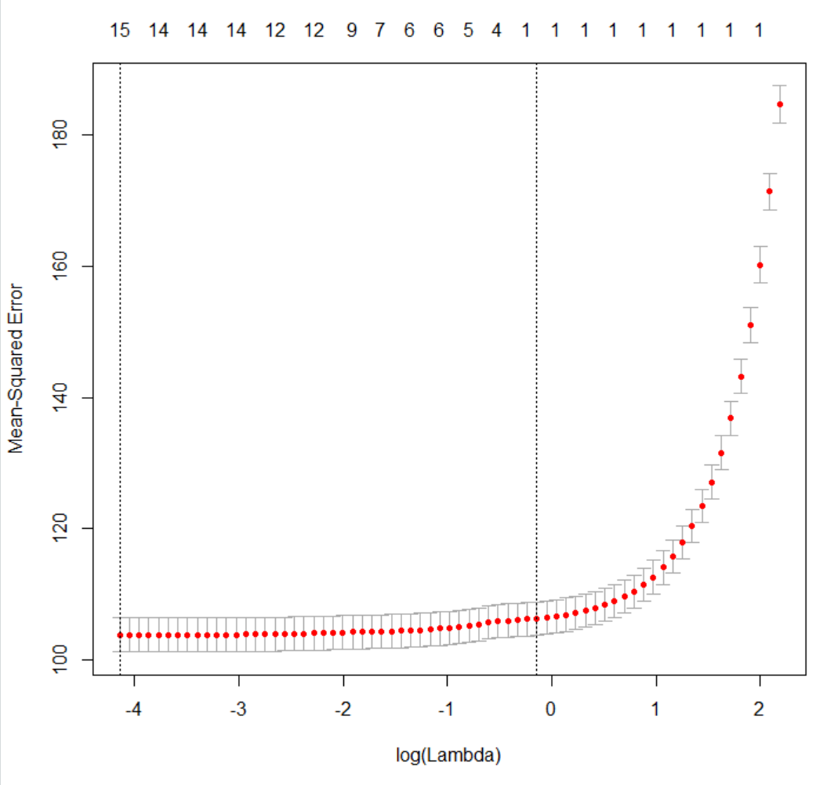

> mean((lasso.pred-y.test)^2)

[1] 104.0363

> lasso.coef

(Intercept) (Intercept) x1_year

-1.824775e+03 0.000000e+00 9.335795e-01

x2_good_days_ratio x3_mod_days_ratio x4_unhealth_sens_ratio

0.000000e+00 2.848291e+00 -2.800187e+00

x5_unhealth_ratio x6_very_unhealth_ratio x7_hazardous_ratio

-1.746902e+01 1.318261e+01 -8.841096e+01

x8_maxAQI x9_90percentileAQUI x10_median_AQI

-2.262383e-04 3.031276e-02 1.698825e-03

x11_CO_ratio x12_NO2_ratio x13_ozone_ratio

5.182185e-01 -4.737965e+00 -7.206051e-01

x14_SO2_ratio x15_PM2.5_ratio x16_PM10_ratio

0.000000e+00 4.041797e-01 2.760086e+00

days_with_AQI

-3.725950e-03

Lasso identifies different coefficients as predictors of female respiratory mortality. Here the only predictors assigned zero coefficients are the ratio of good days and the ratio of days elevated sulfur dioxide contributes to elevated AQI.

Of particular note, air pollution data achieves lower test MSE when used to predict female respiratory mortality in comparison with predicting male respiratory mortality.

**Regression Summary**

Linear regression was performed using the combined male and female age-adjusted respiratory mortality rate, the male age-adjusted mortality rate, and the female age-adjusted mortality rate as dependent variables in three separate regressions. In the initial regression analysese, R2 and adjusted R2 were observed to be quite different. The summary AQI day ratio coefficients do not have strong t-statistics in comparison with the counts of days on which AQI is attributable to specific criteria pollutants. Forward and backward best subset selection were then tried. Ridge and Lasso regression were tried to see if least squares regression could be outperformed for prediction. In these models, we found that there were slight differences in the predictors selected for male and female respiratory mortality rates and that female respiratory mortality could be more accurately predicted from yearly air pollution data, as reflected by test MSE.