Brandon Salazar
CSE-020
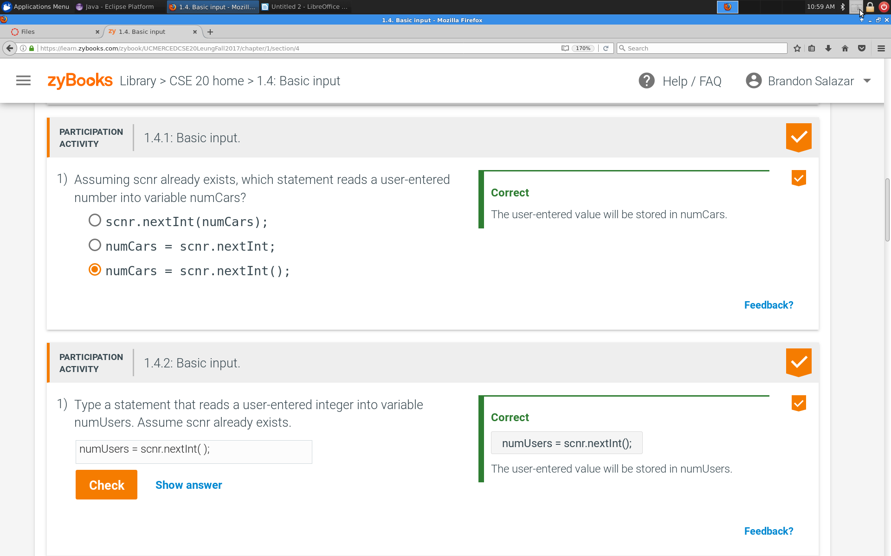
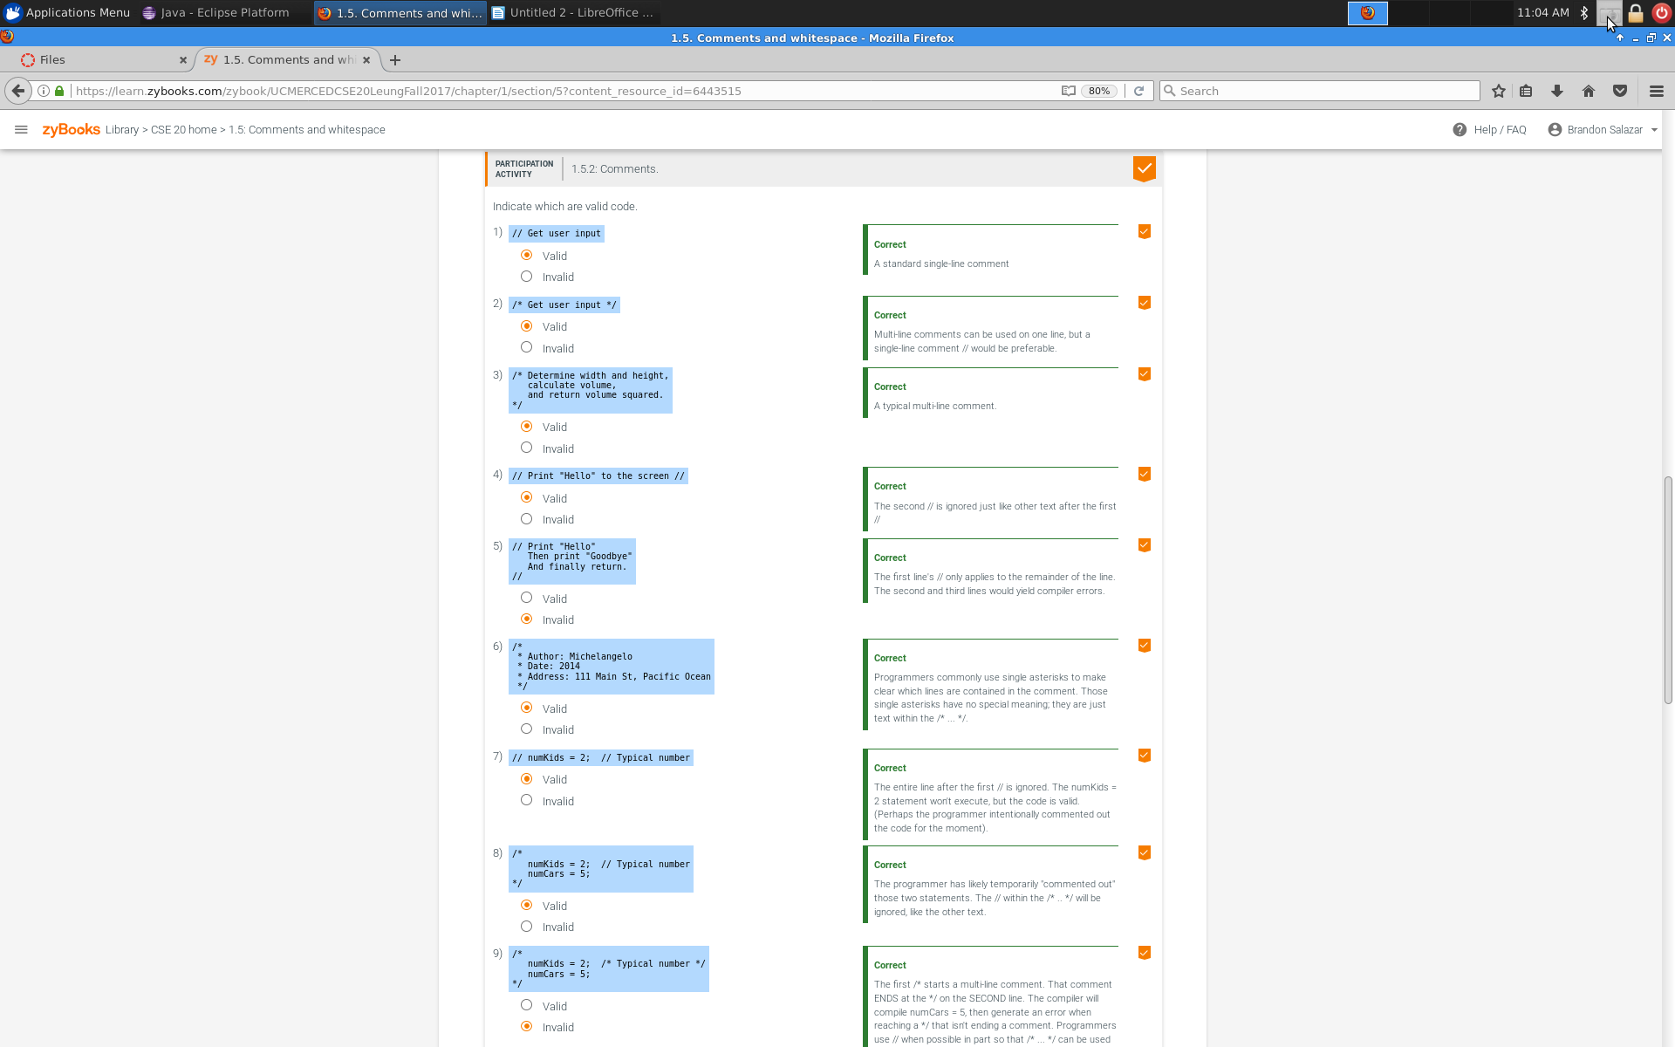
September 12th 2017

How many types of errors were there?

There where many errors, the major ones where syntax error, meaning=g they messed up the spelling of the word.

How do you know when you have found every error(bugs)?

I know I have found every error in my coding once I am able to run the program properly.

Is naming convention important to avoid errors?

Yes, if you mess it up, then your program will display erro and it won’t run at all

