**1) What are the minimal changes required to instantiate ShopArr and invoke run() on it?**

One only needs to change Shop shop = new Shop(); to ShopArr shop = new ShopArr();

**2) We can also use a <something>.length instead of max. What is the valid <something> to use in ShopArr.java?**

We can use cheese.length instead of max or max.length, because the array is the size of max.

**3) How can we tell which instantiation (new Cheese) corresponds to which constructor definition inside the Cheese class?**

You just have to look at what method you are calling and with what parameters you are calling it.

**4) How can we identify a mutator method call?**

Mutators don’t have any data type return and only have a parameter or two.

**5) What would be the result if we added this line right after Swiss is created:**

**cheese[2].setName("Wrong Name"); ?**

It would replace the string “Alterac Swiss”

**6) Why is the init() method both private and void?**

It is Private and void because it is a constructor, we don’t need a return statement, and we don’t want more than one object being created at a time.

**7) What are the distinguishing features of constructor methods? (i.e., How do we tell them apart from other methods?)**

They are usually public, but can be private as well. They can either have parameters or not. They do not return any data type, and it can have the same name as the the class.

**8) How can we figure out the number of required iterations for each loop?**

We just make a for-loop that looks like this ---> for(int i = 0; i < cheese.length; i++){...},

Since cheese[] is global variable, this works.

**9) Should we pass in Cheese array pointer (cheese[]) as arguments into calcSubTotal or**

**itemizedList? (Why or why not)**

That is an unnecessary step since cheese is shared by the whole class, it can be accessed at any given moment, in any given method you want to use it.

**10) What value will be printed by RunShop for “Ran with Cheese Total”? (fixed number or a formula)**

It ran with 10, it is a fixed number

**Activity 7.10.4**

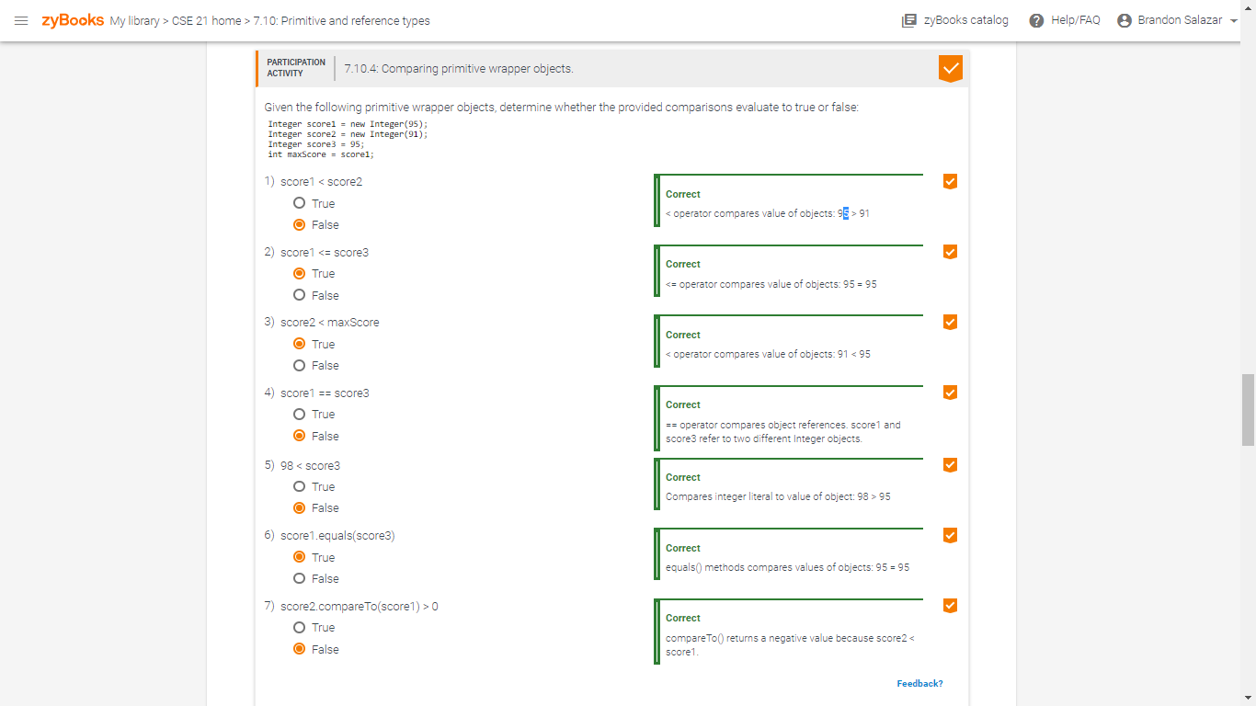

**Activity 7.11.3**

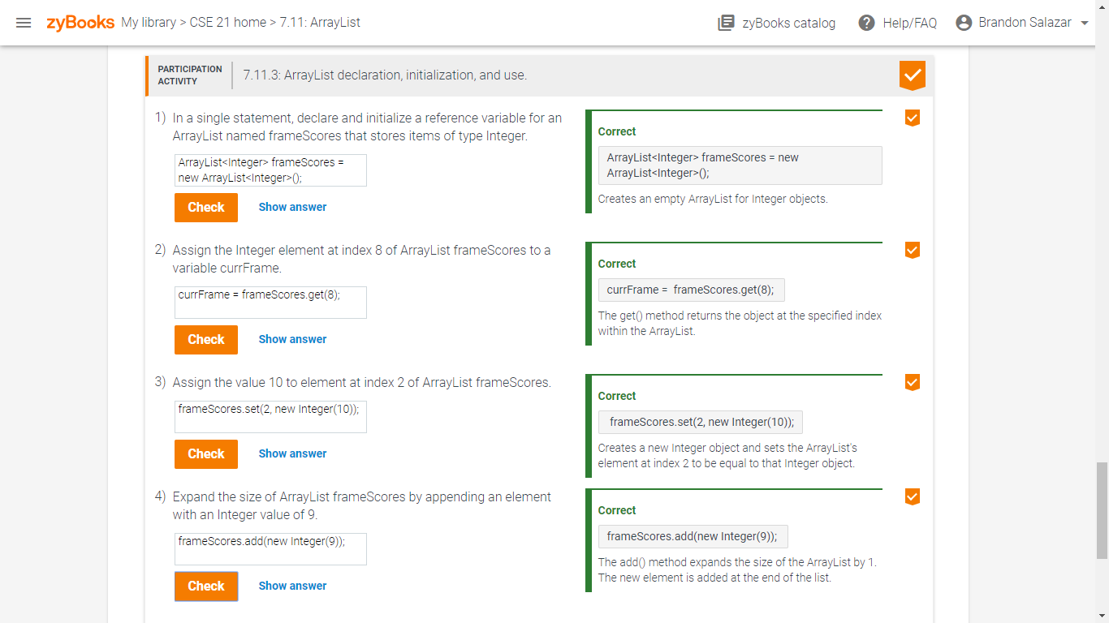

**Activity 7.12.2**

