
MENU
Home
About Us
Products & Services
Brands
Join Us
Contact

HOME
Request Quote Tab
WhatsApp icon
CENTER SLIDES – showcasing Brands and Products (TruMove, FRESHONES, Boxprintz, LET’s BOX, Corruga)
For Brands: We help provider companies grow in Institutional, Corporate, Retail and HoReCa market through structured enterprise sales
For End Users: We help them choose Reliable and Quality Products and services at a right value. BrandSethu plays a vital role into Procurement and Purchase Planning working with Top Quality Brands at most competitive price range without compromising on Quality, helping users access to Better products and Services

What We Do:
For Brands For End Users : B2B – B2C
Enterprise Sales Setup Access to Quality Product & Service
Institutional Market Access Ease of Buying
Key Account Management Competitive and Reliable source
Revenue Growth Value for Money
Owners, Founders, CFO Procurement, Purchase, CFO, CEO

ABOUT US

BrandSethu is an enterprise sales growth partner that connects product brands with institutional and corporate buyers
Founded by professionals with strong experience in sales and business development, BrandSethu focuses on building structured market access and driving revenue growth for brands
We act as an extended sales and business growth arm for our partner brands and help them expand into key markets while building long-term customer relationships

Services BrandSethu Offers to Brands
Partner with BrandSethu to expand your reach in Institutional Market
Joint Go-To-Market activity into Focused Territory and Names Accounts
Dedicated Project and Sales team
Market Access
Key Customer Acquisition
Revenue Growth Planning and Achievement
New Product Launch

BrandSethu for Buyers / End Users
Reliable supply of Quality and Best of Industry Products and Services
Ease of Buying Competitive and Latest Products
Bulk Order Support
Pricing Support for Effective Saving to support company’s Bottom line
Access to Dedicated team for Every Product and Solution Procurement

Vision:
To become the most trusted bridge between product brands and institutional markets, driving sustainable growth through strong partnerships with brand and its End Users

Mission
To build and execute structured sales channels that enable brands to acquire customers, expand markets and grow revenue.

Team
BrandSethu is founded by experienced sales professionals with strong expertise in Enterprise, SME, Startups and Institutional business. The team specialises in building giving credible insight and connect to focused market access, driving revenue growth and creating long-term partnerships for product brands and its End Users
If you are a self-motivated, go-getter professional with a passion for sales and growth, and the drive to make your own mark, we invite you to be part of BrandSethu’s journey in building and scaling businesses. “Join Us” tab taking to career page

Career Page

HoReCa – Partner Account Manager, Mumbai (India Market)
Corporate Sales – Account Director, Mumbai, Bangalore, Delhi (Large, SME, Startup)
Inside Sales Support - Mumbai
Billing Executive – Mumbai
Operation Manager – Factory

Products and Services

Logistics - TruMove
Hygiene Products – FRESH ONES
Packaging Solutions – LET’S PAC
Giftings – CORRUGA, MATRIX
Export – NKB (fmcg)

Logistics: TruMove
Offering Pan India Level Transportation services through Full Truck Load and Part Truck Load under Surface and Air mode – B2B
- 400+ Owned Fleet of CBC Trucks 32Ft, 24Ft & 20Ft for FTL,
- 18000+ Pincode Door to Door PTL Network reach
- 100+ On-roll Riders for LastMile Projects
- 0.8M Sq Ft space of Warehouse Management
- 70K Sq Ft Corrugation Carton Manufacturing Inhouse Setup
​At TruMove, we truly believe in Customization, 24 x 7 Support and Personalized Service to all our clients
Best of Transit TAT, 24 x 7 Control Tower, On-time Delivery to Retailers, Distributors, Malls, Appointment, Quick Commerce, CSD Canteen
Widest Partner Network to cater to any Transport movement activity for all Industries

Hygiene Personal Care Products - FRESHONES
Offering Make-in-India brand FRESHONES Tissue products across Institutional, Corporate, HoReCa, Quick commerce segment. Top Quality, All size, all GSM, from Facial Tissues to Napkins, Rolls, HRT, GRT products. Also offering sustainable BAMBOO Tissues products under CSR initiative. Ever since its beginnings in 1986, Tainwala has maintained its innovative spirit and user-friendly focus to create high quality healthcare products for its customers. Recently, the new urban population has greatly increased their use of personal care products, in terms of both quantity as well as variety. Some of our known brand includes FRESHONES, Taina, Kotton, Black&White, Steri+ and Casper.
Our Brand presence is widely seen and accepted across D’Mart, Reliance Fresh, Reliance Smart, Hypercity, spencer’s, Shakari Bhandar
Products includes: Facial Tissues, Pocket Tissues, Bathroom Rolls, Kitchen Towel, Napkins, Paper Towels, Wet Wipes, Liquid, Coil, Mats, Machines, Chalk

Packaging and Office Storage Solutions: LET’S PAC

It’s never easy finding a good box to send materials to your customer. It’s never easy storing and organize your year end financials. It’s never easy to deliver your amazing homemade food to your first customer.
We’re here to make your life easier for you. Let’s Pac is here to solve all your daily packaging and storage needs
We have 3 Categories
Postobox – for your daily shipping needs
Durobox – for all your storage, packaging and organizing needs
Freshobox – for all your food packaging needs
6 Reasons to choose Let’s Pac for your Organising and Packaging needs
- Minimum Orders works
- DIY
- No Tape
- No Glue
- Aesthetic
- Durable and Reusable
For our Bulk Corporate, Warehousing and Packaging Industry client we offer 3PLY, 5PLY, 7 PLY all Sizes and Specification Corrugated Carton Boxes with Printing work
Latest German Machinery, Trained Staff, Owned Manufacturing setup spread across 2 Lacs Sq Ft.

Giftings – CORRUGA, MATRIX
(we need to pick up website Corruga.in)
Export – NKB Content to be decided

Brand Association

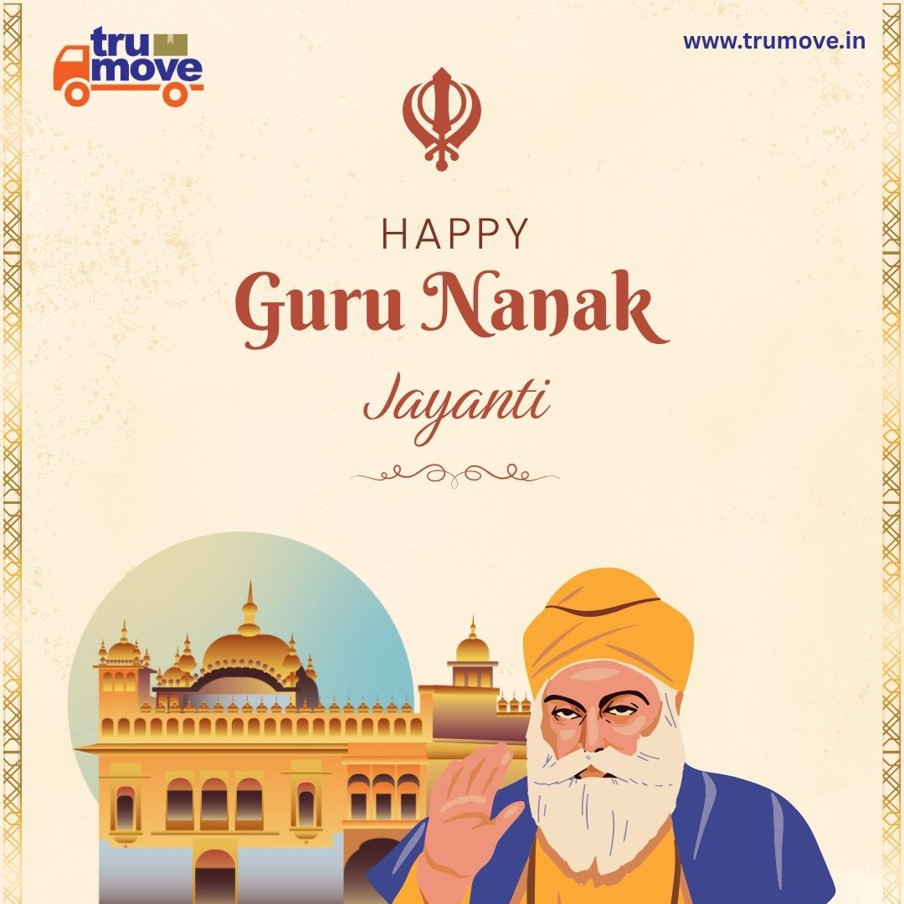 www.trumove.in (hyperlink to be created)

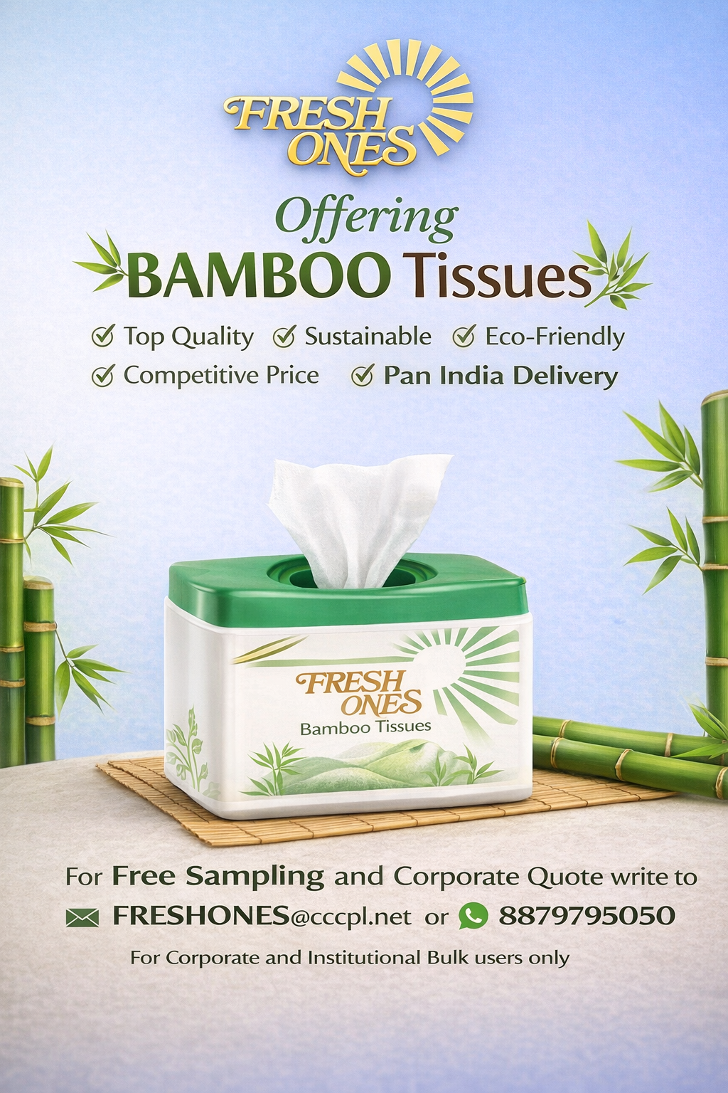 www.tainwala.net

 www.letspac.in

 www.corruga.in

Contact Us

Get In Touch
Request a Quote
Tell us about your requirements and our team will get back to you within 24 hours with a tailored proposal.
Email Us
business@brandsethu.in
Call Us
+91 9920989333
WhatsApp Us
+91 9920989333
Our Website
www.brandsethu.in

Linked In Icon
Insta Page Icon
WhatApp Tab

