Requirements
- Eclipse Eclipse 3.0M8
- Tomcat launcher Eclipse plugin (http://www.sysdeo.com/eclipse/tomcatPlugin.html)
- Tomcat4 patch for JSP debugging (http://www.sysdeo.com/eclipse/tomcatPlugin.html)
- Recent Tomcat4.1 distribution (e.g., 4.1.30)

Installation
- Install the Eclipse plugin and the Tomcat4 patch (The patch is binary, so no recompilation of Tomcat needed)
- Use Window -> Preferences... to activate the Tomcat plugin (see image below)

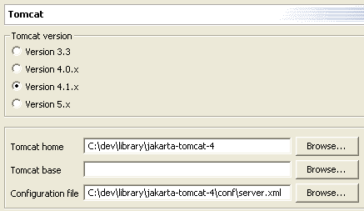

- Create a new Tomcat Project (e. g. GSProject, context name=”/gridsphere”, web application root=”/webapps/gridsphere”, see image below).

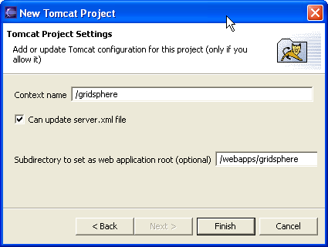
- In the project's settings (see image below)

- Can update server.xml
- Don't be a reloadable context (It messes up anyway)
- Redirect context logger to Eclipse

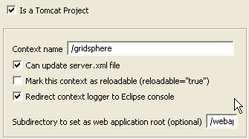

- Check out as an existing project

- Host: portal.aei.mpg.de
- Repository path: /home/repository
- User: anonymous
- Password: < leave blank >
- Connection type: pserver
- CVS Module: gridsphere

- Setup Java Build Path in Project Properties

- Add source folder gridsphere/src and gridsphere/tests (see image below)

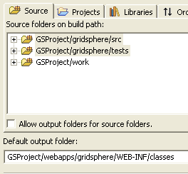

- Add the libraries in gridsphere/lib (see image below)

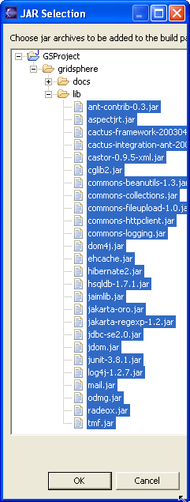

- Extend the variable TOMCAT_HOME
  - Add the activation.jar from Tomcat common/lib
  - Add the ant.jar from Tomcat common/lib
  - Add the jta.jar from Tomcat common/lib
  - Add the xercesImpl.jar from Tomcat common/endorsed
  - Add the XmlParserAPIs.jar from Tomcat common/endorsed

- Export the libraries and the source folders (Order and Export tab, select all, Ok)

- Right Click on GSProject/gridsphere/config/build/eclipse.build.xml and selection “Run Ant” (see images below)

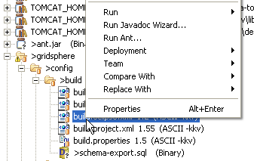

- Ant resource: GSProject/gridsphere/config/build/eclipse.build.xml
- Working directory: GSProject/gridsphere
- Parameters:
  - -Dcatalina.home=/path/to/tomcat/installation
  - -catalina.base=/path/to/gridsphere project (note the use of slash “/” instead of backslash “\”.)
  - -Declipse.build=${workspace_loc:/GSProject/path/to/build/directory}

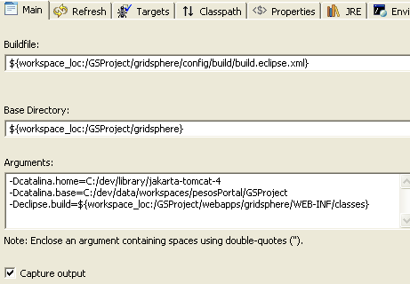

- Targets (in this order, order matters): eclipse-deploy, eclipse-create-database, eclipse-resources
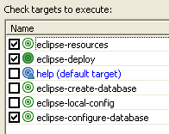

- Click Run, you should see something in the console like below.

Buildfile: C:\dev\data\workspaces\pesosPortal\GSProject\gridsphere\config\build\build.eclipse.xml
eclipse-resources:
[mkdir] Created dir: C:\dev\data\workspaces\pesosPortal\GSProject\webapps\gridsphere\WEB-INF\classes\gridsphere
[copy] Copying 1 file to C:\dev\data\workspaces\pesosPortal\GSProject\webapps\gridsphere\WEB-INF\classes\gridsphere
[copy] Copying 10 files to C:\dev\data\workspaces\pesosPortal\GSProject\webapps\gridsphere\WEB-INF\classes\gridsphere\resources
eclipse-deploy:
eclipse-configure-database:
[mkdir] Created dir: C:\dev\data\workspaces\pesosPortal\GSProject\webapps\gridsphere\WEB-INF\persistence
[copy] Copying 1 file to C:\dev\data\workspaces\pesosPortal\GSProject\webapps\gridsphere\WEB-INF\persistence
[copy] Copying 192 files to C:\dev\data\workspaces\pesosPortal\GSProject\webapps\gridsphere
eclipse-configure-database:
[copy] Copying 1 file to C:\dev\data\workspaces\pesosPortal\GSProject\webapps\gridsphere\WEB-INF\persistence
eclipse-create-database:

[echo] Successfully created new database
eclipse-resources:
BUILD SUCCESSFUL
Total time: 6 seconds

- If you add the following 4 lines to the GSProject\gridsphere\config\log4j.properties file, you see hibernate logging which tells you the specifics of the database set up. I recommend doing this.

  - log4j.logger.net.sf.hibernate=DEBUG
  - log4j.logger.net.sf.hibernate.cfg.Binder=debug
  - log4j.logger.net.sf.hibernate.cfg.Environment=debug
  - log4j.logger.net.sf.hibernate.util.DTDEntityResolver=DEBUG

Sample Hibernate Logging:
SchemaExport - Running hbm2ddl schema export
SchemaExport - writing generated schema to file: schema-export.sql
SchemaExport - exporting generated schema to database
DriverManagerConnectionProvider - Using Hibernate built-in connection pool (not for production use!)
DriverManagerConnectionProvider - Hibernate connection pool size: 20
DriverManagerConnectionProvider - using driver: org.hsqldb.jdbcDriver at URL: jdbc:hsqldb:C:/dev/data/workspaces/pesosPortal/GSProject/webapps/gridsphere/WEB-INF/database/gridsphere
DriverManagerConnectionProvider - connection properties: {poolsize=40, user=sa, password=}
DriverManagerConnectionProvider - total checked-out connections: 0
DriverManagerConnectionProvider - opening new JDBC connection
DriverManagerConnectionProvider - created connection to: jdbc:hsqldb:C:/dev/data/workspaces/pesosPortal/GSProject/webapps/gridsphere/WEB-INF/database/gridsphere, Isolation Level: 1

- Check that the database is installed in the right place. You should have 2 files in the \GSProject\webapps\gridsphere\WEB-INF\database directory.

- gridsphere.properties
- gridsphere.script

- You should see a dir structure like the image below.

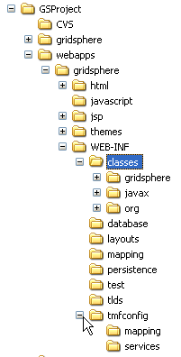
- Refresh the Eclipse project
- From the project context menu -> Tomcat -> update server.xml (see image below)

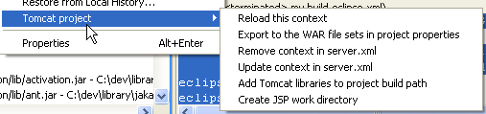

- Go to server.xml (e.g., jakarta-tomcat-4\conf\server.xml) and adjust the generated Context so that it includes the crossContext="true" attribute. See sample below.

<Context crossContext="true" path="/gridsphere" reloadable="false" docBase="C:\dev\data\workspaces\pesosPortal\GSProject\webapps\gridsphere" workDir="C:\dev\data\workspaces\pesosPortal\GSProject\work\org\apache\jsp" >

- In Window -> Preferences -> Tomcat add the project (here GSProject) to the Tomcat Classpath. Also change the Tomcat 4.1.x launch configuration to start in the Debug perspective (see image below)

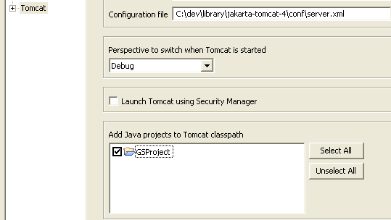

- Start Tomcat and enter http://127.0.0.1:8080/gridsphere/gridsphere in a brower

- You should see the following in your browser window.

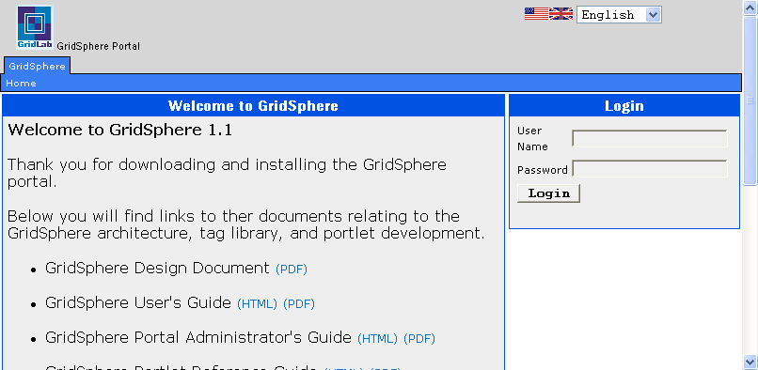

- If you followed my advice about above the Hibernate logging, then your console will contain the following information – very useful.

instantiating session factory with properties: {

hibernate.connection.username=sa,
hibernate.connection.poolsize=40,
hibernate.connection.password=,
hibernate.dialect=net.sf.hibernate.dialect.HSQLDialect, hibernate.connection.url=jdbc:hsqldb:C:/dev/data/workspaces/pesosPortal/GSProject/webapps/gridsphere/WEB-INF/database/gridsphere,
hibernate.show_sql=false,
hibernate.connection.driver_class=org.hsqldb.jdbcDriver
}

