Astro Runners Game Design Document (GDD)

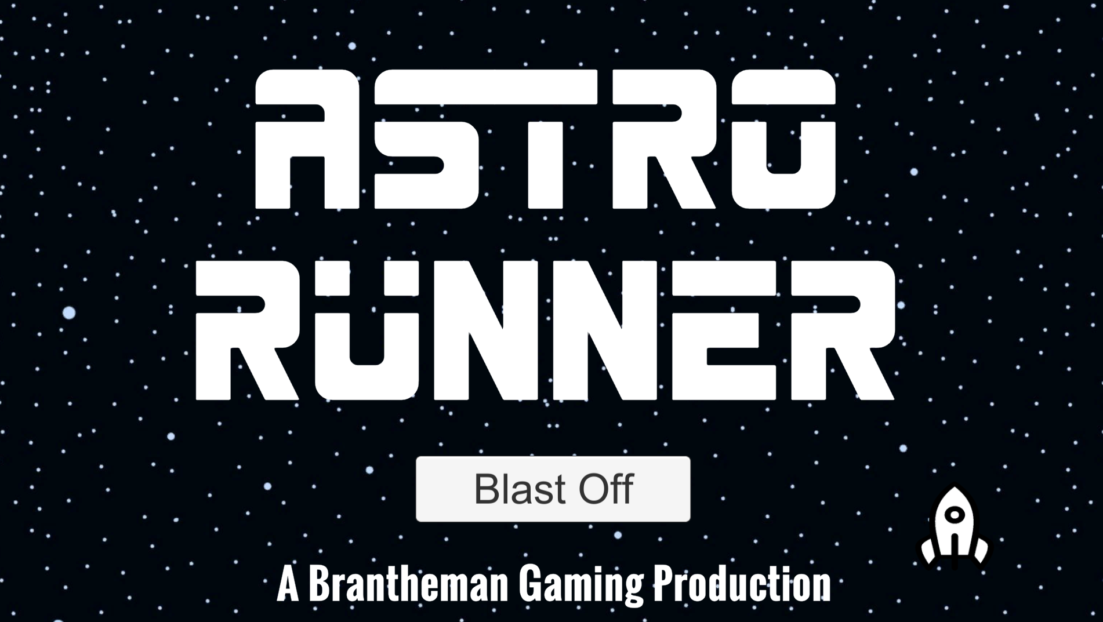

***‘Run among the stars!’*** - Brantheman Gaming

This page: Table of Contents and Team Member Listing

|  |  |  |
| --- | --- | --- |
| Table of Contents  [1 Game Overview](https://n-xovwktmtjsnaxyc2mwes2xu7pohqedmdm6zjw5q-2lu-script.googleusercontent.com/userCodeAppPanel)  [2 High Concept](https://n-xovwktmtjsnaxyc2mwes2xu7pohqedmdm6zjw5q-2lu-script.googleusercontent.com/userCodeAppPanel)  [3 Unique Selling Points](https://n-xovwktmtjsnaxyc2mwes2xu7pohqedmdm6zjw5q-2lu-script.googleusercontent.com/userCodeAppPanel)  [4 Platform Minimum Requirements](https://n-xovwktmtjsnaxyc2mwes2xu7pohqedmdm6zjw5q-2lu-script.googleusercontent.com/userCodeAppPanel)  [5 Competitors / Similar Titles](https://n-xovwktmtjsnaxyc2mwes2xu7pohqedmdm6zjw5q-2lu-script.googleusercontent.com/userCodeAppPanel)  [6 Synopsis](https://n-xovwktmtjsnaxyc2mwes2xu7pohqedmdm6zjw5q-2lu-script.googleusercontent.com/userCodeAppPanel)  [7 Game Objectives](https://n-xovwktmtjsnaxyc2mwes2xu7pohqedmdm6zjw5q-2lu-script.googleusercontent.com/userCodeAppPanel)  [8 Game Rules](https://n-xovwktmtjsnaxyc2mwes2xu7pohqedmdm6zjw5q-2lu-script.googleusercontent.com/userCodeAppPanel)  [9 Game Structure](https://n-xovwktmtjsnaxyc2mwes2xu7pohqedmdm6zjw5q-2lu-script.googleusercontent.com/userCodeAppPanel)  [10 Game Play](https://n-xovwktmtjsnaxyc2mwes2xu7pohqedmdm6zjw5q-2lu-script.googleusercontent.com/userCodeAppPanel)  [10.1 Game Controls](https://n-xovwktmtjsnaxyc2mwes2xu7pohqedmdm6zjw5q-2lu-script.googleusercontent.com/userCodeAppPanel)  [10.2 Game Camera](https://n-xovwktmtjsnaxyc2mwes2xu7pohqedmdm6zjw5q-2lu-script.googleusercontent.com/userCodeAppPanel)  [10.2.1 HUD](https://n-xovwktmtjsnaxyc2mwes2xu7pohqedmdm6zjw5q-2lu-script.googleusercontent.com/userCodeAppPanel)  [10.2.2 Maps](https://n-xovwktmtjsnaxyc2mwes2xu7pohqedmdm6zjw5q-2lu-script.googleusercontent.com/userCodeAppPanel)  [11 Players](https://n-xovwktmtjsnaxyc2mwes2xu7pohqedmdm6zjw5q-2lu-script.googleusercontent.com/userCodeAppPanel)  [11.1 Characters](https://n-xovwktmtjsnaxyc2mwes2xu7pohqedmdm6zjw5q-2lu-script.googleusercontent.com/userCodeAppPanel)  [11.2 Metrics](https://n-xovwktmtjsnaxyc2mwes2xu7pohqedmdm6zjw5q-2lu-script.googleusercontent.com/userCodeAppPanel)  [11.3 States](https://n-xovwktmtjsnaxyc2mwes2xu7pohqedmdm6zjw5q-2lu-script.googleusercontent.com/userCodeAppPanel)  [11.4 Weapons](https://n-xovwktmtjsnaxyc2mwes2xu7pohqedmdm6zjw5q-2lu-script.googleusercontent.com/userCodeAppPanel)  [12 Player Line-up](https://n-xovwktmtjsnaxyc2mwes2xu7pohqedmdm6zjw5q-2lu-script.googleusercontent.com/userCodeAppPanel)  [13 NPC](https://n-xovwktmtjsnaxyc2mwes2xu7pohqedmdm6zjw5q-2lu-script.googleusercontent.com/userCodeAppPanel)  [13.1 Enemies](https://n-xovwktmtjsnaxyc2mwes2xu7pohqedmdm6zjw5q-2lu-script.googleusercontent.com/userCodeAppPanel)  [13.1.1 Enemy States](https://n-xovwktmtjsnaxyc2mwes2xu7pohqedmdm6zjw5q-2lu-script.googleusercontent.com/userCodeAppPanel)  [13.1.2 Enemy Spawn Points](https://n-xovwktmtjsnaxyc2mwes2xu7pohqedmdm6zjw5q-2lu-script.googleusercontent.com/userCodeAppPanel)  [13.2 Allies / Companions](https://n-xovwktmtjsnaxyc2mwes2xu7pohqedmdm6zjw5q-2lu-script.googleusercontent.com/userCodeAppPanel)  [13.2.1 Ally States](https://n-xovwktmtjsnaxyc2mwes2xu7pohqedmdm6zjw5q-2lu-script.googleusercontent.com/userCodeAppPanel)  [13.2.2 Ally Spawn Points](https://n-xovwktmtjsnaxyc2mwes2xu7pohqedmdm6zjw5q-2lu-script.googleusercontent.com/userCodeAppPanel)  [14 Art](https://n-xovwktmtjsnaxyc2mwes2xu7pohqedmdm6zjw5q-2lu-script.googleusercontent.com/userCodeAppPanel)  [14.1 Setting](https://n-xovwktmtjsnaxyc2mwes2xu7pohqedmdm6zjw5q-2lu-script.googleusercontent.com/userCodeAppPanel)  [14.2 Level Design](https://n-xovwktmtjsnaxyc2mwes2xu7pohqedmdm6zjw5q-2lu-script.googleusercontent.com/userCodeAppPanel)  [14.3 Audio](https://n-xovwktmtjsnaxyc2mwes2xu7pohqedmdm6zjw5q-2lu-script.googleusercontent.com/userCodeAppPanel)  [15 Procedurally Generated Content](https://n-xovwktmtjsnaxyc2mwes2xu7pohqedmdm6zjw5q-2lu-script.googleusercontent.com/userCodeAppPanel)  [15.1 Environment](https://n-xovwktmtjsnaxyc2mwes2xu7pohqedmdm6zjw5q-2lu-script.googleusercontent.com/userCodeAppPanel)  [15.2 Levels](https://n-xovwktmtjsnaxyc2mwes2xu7pohqedmdm6zjw5q-2lu-script.googleusercontent.com/userCodeAppPanel)  [15.3 Artificial Intelligence NPC](https://n-xovwktmtjsnaxyc2mwes2xu7pohqedmdm6zjw5q-2lu-script.googleusercontent.com/userCodeAppPanel)  [15.4 Visual Arts](https://n-xovwktmtjsnaxyc2mwes2xu7pohqedmdm6zjw5q-2lu-script.googleusercontent.com/userCodeAppPanel)  [15.5 Audio](https://n-xovwktmtjsnaxyc2mwes2xu7pohqedmdm6zjw5q-2lu-script.googleusercontent.com/userCodeAppPanel)  [15.6 Minimum Viable Product (MPV)](https://n-xovwktmtjsnaxyc2mwes2xu7pohqedmdm6zjw5q-2lu-script.googleusercontent.com/userCodeAppPanel)  [16 Wish List](https://n-xovwktmtjsnaxyc2mwes2xu7pohqedmdm6zjw5q-2lu-script.googleusercontent.com/userCodeAppPanel)   |  | | --- | |  | | Game Development Team Members    PRODUCER  Brantheman Gaming    PRODUCTION MANAGER  Brantheman Gaming    PRODUCTION COORDINATOR  Brantheman Gaming  GAME DESIGNERS  Brantheman Gaming  SYSTEMS/IT COORDINATOR  Brantheman Gaming  PROGRAMMERS  Brantheman Gaming  TECHNICAL ARTISTS  Brantheman Gaming  AUDIO ENGINEERS  Brantheman Gaming  UX TESTERS  Brantheman Gaming |

|  |
| --- |
|  |

Team Members:

Brandon Altamirano, Brandon Tang, Dominik Skulec, James Thomas

# 1 Game Overview

Title: Astro Runner

Platform: PC Standalone

Genre: Endless Runner

Rating: (10+) ESRB

Target: Casual gamer (aging from 12 - 30)

Release date: December 10, 2020

Publisher: Brantheman Gaming

Description: This game will be a 3D endless runner game with inspirations from “Temple Run” and Among Us.” Some features that may differ from the generic endless runner are an inventory and quests. Quests may show up after clearing various parts of the game and an inventory will be used to pick up items for power ups.

# 2 High Concept

# 3 Unique Selling Points The inspiration of this game comes from the most recent popular game “Among Us.” It contains designs and effects unique to the original multiplayer game. It also contains an endless course filled with obstacles and playing style similar to the famous application “Temple Run.”

# 4 Platform Minimum Requirements

# 5 Competitors / Similar Titles - Among Us - Temple Run - Temple Run 2

# 6 Synopsis

# 7 Game Objectives The astronaut must run through the endless course while dodging obstacles in his way. Due to the limited oxygen supply, you must pick up more O2 tanks while running to ensure you don’t run out of air! Don’t forget to collect coins to increase your score faster.

# 8 Game Rules The player must collect coins, pick up O2 tanks, and not crash into obstacles in order to survive.

# 9 Game Structure

Main Menu -> Gameplay -> Game over/Play again screen

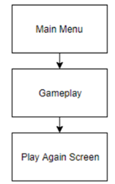

# 10 Game Play

## 10.1 Game Controls

* ‘A’ key for moving left
* ‘D’ key for moving right
* Mouse to select in the menus

## 10.2 Game Camera 3D point of view aiming at the astronaut’s back and the trail ahead of them.

### 10.2.1 HUD

### 10.2.2 Maps

# 11 Players

## 11.1 Characters

## Playable character- The Astronaut

## 11.2 Metrics

## 11.3 States

# 12 Player Line-up

# 13 NPC

## 13.1 Enemies Not applicable.

### 13.1.1 Enemy States

### 13.1.2 Enemy Spawn Points

# 14 Art

## 14.1 Setting The setting is a space station with similar characteristics as the one from the game “Among Us.”

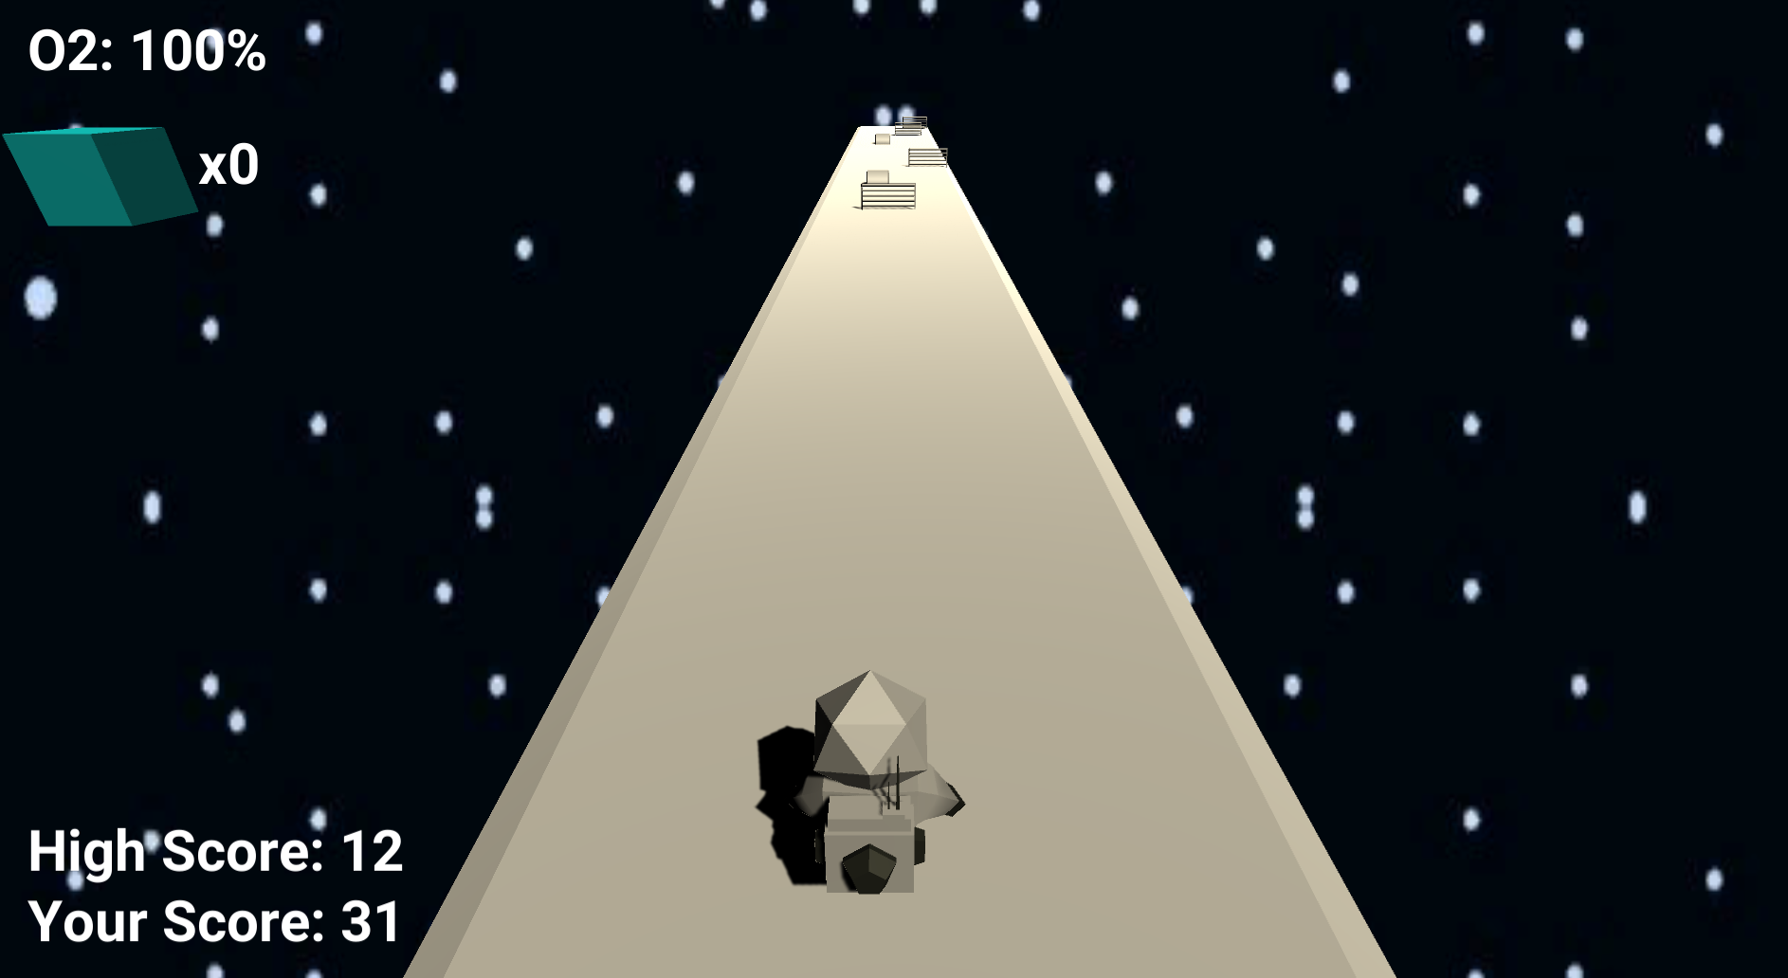

## 14.2 Level Design

## 14.3 Audio

Menu Screen Background music:

LAKEY INSPIRED - Blue Boi

Playing Game Background music:

LAKEY INSPIRED - Chill Day.

Spaceship Launch SFX: <https://www.youtube.com/watch?v=zXYrHB86Kg0&ab_channel=Xilith117>

Alert SFX: https://freesound.org/people/guitarguy1985/sounds/57806/

Button Push SFX: Koenig, M. (2009, May 24). Retrieved from <http://soundbible.com/419-Tiny-Button-Push.html>

# 15 Procedurally Generated Content

## 15.1 Environment Space

## 15.2 Levels

* Infinitely looping map with some variance

## 15.3 Artificial Intelligence NPC

## 15.4 Visual Arts

## 15.5 Audio

* Main menu soundtrack
* Starting game sound
* Emergency task alarm
* Picking up task coins sound effect
* Death sound effect

## 15.6 Minimum Viable Product (MPV)

# 16 Wish List

* Different levels / level selection
* More pickups
* More power ups

Preliminary Bibliography

Art :

Background art: Brantheman Gaming

Free Tools Kit (December 16,2019). Speedway. Retrieved from <https://assetstore.unity.com/packages/3d/props/tools/free-tools-kit-155875>. (December 8, 2020).

Spaceship By Timothy Dilich, US <https://thenounproject.com/term/spaceship/13581/>

Image by Radoan Tanvir from Pixabay <https://pixabay.com/illustrations/fire-flame-burning-combustion-heat-5679380/>

backdrop: <https://www.pikist.com/free-photo-vwyhm>

sFuture Modules Core Pack (Free old version). (January 9, 2018). Natsugo99. Retrieved from <https://assetstore.unity.com/packages/3d/environments/sci-fi/sfuture-modules-core-pack-free-old-version-98684>. (December 8, 2020).

Stylized Astronaut. (March 29, 2018). Pulsar Bytes. Retrieved from <https://assetstore.unity.com/packages/3d/characters/humanoids/sci-fi/stylized-astronaut-114298>. (December 8, 2020).

Font:

Spacebar by Geronimo Font Studios https://www.dafont.com/spacebar.font

Music:

Alert SFX: <https://freesound.org/people/guitarguy1985/sounds/57806>

Button Push SFX: Koenig, M. (2009, May 24). Retrieved from <http://soundbible.com/419-Tiny-Button-Push.html>

LAKEY INSPIRED - Blue Boi (2018). Retrieved from

<https://soundcloud.com/lakeyinspired/blue-boi>

Menu Screen Background music:

Playing Game Background music:

LAKEY INSPIRED - Chill Day. Retrieved from https://soundcloud.com/lakeyinspired/chill-day

Spaceship Launch SFX: <https://www.youtube.com/watch?v=zXYrHB86Kg0&ab_channel=Xilith117>

Scripts:

All scripts: Brantheman Gaming