Introduction to using the SDWBA in acousticTS
Brandyn M. Lucca
2020-04-01

General Introduction
The purpose of acousticTS is the calculate the acoustic target strength (TS, dB re: m²) of a given scatterer, such as bubbles or euphausiids. Euphausiid TS is generally modelled using the distorted Born wave approximation (DWBA), which is a function of acoustic frequency (Hz), material properties (soundspeed, , and density, , contrast compared to ambient seawater), body morphometrics (shape, , length, , and curvature, ), and orientation relative to the sea surface (). This model is used because it can be calculated for all frequencies, orientations, and animal shapes. The model treats each animal as a series of of bent cylinders that are generally weakly scattering ( 5%). We use a special formulation of the model known as the SDWBA, which adds an additional phase deviation term () that accounts for imperfections in how sound scatters off of each cylinder. This model is mathematically expressed as:
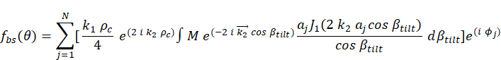
where is the number of cylinders comprising each animal shape, is an imaginary number, is the acoustic wave number of seawater adjusted for animal orientation whereby broadside incidence is 90/270, is the acoustic wave number inside each cylinder adjusted for orientation, is the position matrix which represents the x, y, and z coordinates of the animal shape, is the radius for cylinder , is equal to 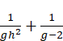, is the density contrast (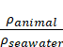), is the soundspeed contrast (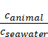), is the Bessel function of the first kind of order 1, is the radius of curvature, and is the stochastic phase variability term for each cylinder which provides a multiplicative term drawn from a standard normal distribution: 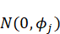. The TS of the scatterer is then calculated via 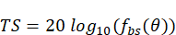.

Package installation
The acousticTS package can be found on GitHub at https://github.com/brandynlucca/acousticTS and was built using R version 3.6.1. The package is actively updated, so updates and new features can be tracked via this repository. R is an open-source, statistical programming-language commonly used for data analysis across many fields. Updated versions of R can be installed on Windows, MacOS, and UNIX platforms from https://r-project.org. This package has four dependencies: elliptic (integration of complex numbers) and parallel/foreach/doParallel (parallelized functions for improved model performance).
To install and call the latest version of acousticTS from the development GitHub repository:
#install.packages("devtools") #if needed, uncomment this line and install devtools
require(devtools) #call in devtools
install_github("brandynlucca/acousticTS@test-branch")
Full documentation is provided for all functions (e.g., ?jl provides the help documentation for the built-in spherical Bessel function of the first kind).

Model syntax and setup
The TS of an individual scatterer can be calculated using the SDWBA(...) (see: ?SDWBA) function which requires a fluid-filled scatterer (FFS) (see: ?FFS) class object, which is a S4 object that comprises the target’s position matrix (), radius (), material properties (, ), orientation (), body curvature (), body curve (a boolean TRUE or FALSE), body length (), and number of cylinders (). A sample shape can be called via data(mcgehee) (see: ?mcgehee), which calls in the shape file and other model parameters reported in McGehee et al. (1998) for Euphausia superba, which has been commonly used for TS modelling efforts for krill. There are four ways to calculate TS using SDWBA(...), which provides flexibility depending on users’ needs, data format, and coding preferences:
- Manually parameterizing the model.
#Let's call in the package
require(acousticTS)
#First we will create vectors for the x-, y-, and z-axis.
x <- seq(1,10,1)*1e-3; y <- rep(0,10); z <- c(seq(1,5,1),rev(seq(1,5,1)))*1e-4
#Now we will assign a radius vector
a <- z/2
#Material properties
g <- 1.036; h <- 1.0279
#Fill out the remaining model parameters
c <- 1500 #sound speed, m/s
freq <- 120e3 #frequency, Hz
#Now let's calculate the TS of this hypothetical shape at 120 kHz and ambient sound speed of 1500 m/s
SDWBA(c=c, frequency=freq, x=x, y=y, z=z, a=a, g=g, h=h)
#> [1] -114.0107
- Manually creating a FFS-object using FFSgenerate(...) (see: ?FFSgenerate) and FFSwrite(...) (see: ?FFSwrite).
#We will use the same information we used before to generate our new scatterer
target <- FFSgenerate(x=x,y=y,z=z,a=a,g=g,h=h)
#We can look at the structure to get an idea about what the FFS scatterer object looks like
str(target)
#> Formal class 'FFS' [package "acousticTS"] with 9 slots
#> ..@ rpos : num [1:3, 1:10] 1e-03 0e+00 1e-04 2e-03 0e+00 2e-04 3e-03 0e+00 3e-04 4e-03 ...
#> .. ..- attr(*, "dimnames")=List of 2
#> .. .. ..$ : chr [1:3] "x" "y" "z"
#> .. .. ..$ : NULL
#> ..@ a : num [1:10] 0.00005 0.0001 0.00015 0.0002 0.00025 0.00025 0.0002 0.00015 0.0001 0.00005
#> ..@ g : num 1.04
#> ..@ h : num 1.03
#> ..@ theta: num 1.57
#> ..@ curve: logi FALSE
#> ..@ pc : num 0
#> ..@ L : num 0.01
#> ..@ ncyl : int 10
#Now let's run the model on the object
SDWBA(target, c=c, frequency=freq)
#> [1] -114.0107
#If we want to save this object for later modelling efforts, we can create a data.frame and write a *.csv file that is properly formatted
#Note that the FFSwrite(..., filename) defaults to saving this file in your current working directory. Name this file accordingly.
#FFSwrite(target)
- Calling in a *.csv formatted file to create a FFS-object using FFSread(...) (see: ?FFSread).
#We will call in a sample krill shape reported by McGehee et al. (1998) from the GitHub repository, but this can be applied to any *.csv file with the correct filepath.
target_premade <- FFSread("https://raw.githubusercontent.com/brandynlucca/acousticTS/test-branch/data/mcgehee.csv")
#We can see that the file structure is the same as the previous "target" scatterer, just filled with different values
str(target_premade)
#> Formal class 'FFS' [package "acousticTS"] with 9 slots
#> ..@ rpos : num [1:3, 1:15] 0.0411 0 0 0.0395 0 ...
#> ..@ a : num [1:15] 0 0.000233 0.0007 0.001217 0.001455 ...
#> ..@ g : num 1.04
#> ..@ h : num 1.03
#> ..@ theta: num 1.57
#> ..@ curve: logi FALSE
#> ..@ pc : num 0
#> ..@ L : num 0.0411
#> ..@ ncyl : int 15
#Now let's run the model on the object
SDWBA(target_premade, c=c, frequency=freq)
#> [1] -67.40053
- Using both arbitrary and pre-generated FFS-object parameters.
#Let's say we are interested in a very different set of material properties!
SDWBA(target_premade, c=c, frequency=freq, g=1.01, h=1.005)
#> [1] -79.56342

FFS-object manipulation
In the previous section it was assumed that all of the scatterers we not curved and were straight from rostrum-to-telson. In these cases, a more traditional form of the model was used that discounts . An animal can be curved by either setting SDWBA(..., curve=T) or using the Shapely(...) (see: ?Shapely(...)). If curve=TRUE, the default (i.e., pc) is 3.0 unless it is otherwise defined.
#Let's take a look at the str of our target. We can see that "curve" is set to False, and the radius of curvature (pc) is set to 0.0.
str(target_premade)
#> Formal class 'FFS' [package "acousticTS"] with 9 slots
#> ..@ rpos : num [1:3, 1:15] 0.0411 0 0 0.0395 0 ...
#> ..@ a : num [1:15] 0 0.000233 0.0007 0.001217 0.001455 ...
#> ..@ g : num 1.04
#> ..@ h : num 1.03
#> ..@ theta: num 1.57
#> ..@ curve: logi FALSE
#> ..@ pc : num 0
#> ..@ L : num 0.0411
#> ..@ ncyl : int 15
#So we can force the object to do our bidding and curve it.
target_curved <- Shapely(target_premade, curve=T, pc=3.3)
#Now let's calculate the TS using both of the described methods, which will yield the same answer
SDWBA(target_curved, c=c, frequency=freq)
#> [1] -68.92558
SDWBA(target_premade, c=c, frequency=freq, curve=T, pc=3.3)
#> [1] -68.92558
The Shapely(...) function can also be used to change the orientation angle (Shapely(..., theta=angle)) and resize both the matrix and vector based on a new length (Shapely(..., length=new_length)). The identical alternative is available by manually inputting a new orientation value into SDWBA(...), but the shape manipulation requires Shapely(...). For the purpose of convenience, the degrad(...) (see: ?degrad) function is available for readily converting degrees to radians, and vice versa.
#First let's change the orientation of the object
target_angle <- Shapely(target_curved, theta=pi)
SDWBA(target_angle, c=c, frequency=freq)
#> [1] -75.02295
SDWBA(target_curved, c=c, frequency=freq, theta=pi)
#> [1] -75.02295
#If our orientation values are in degrees, we can use degrad(...) to convert!
angle_radians <- degrad(90,"deg") #degrees to radians
angle_radians
#> [1] 1.570796
angle_degrees <- degrad(angle_radians,"rad") #degrees to radians
angle_degrees
#> [1] 90
#We can also resize our target shape; the new length is in m
target_resize <- Shapely(target_angle, length=30e-3)
target_resize
#> An object of class "FFS"
#> Slot "rpos":
#> [,1] [,2] [,3] [,4] [,5] [,6]
#> [1,] 0.03 0.0288278843 0.02663194 0.023006878 0.020824876 0.01840187
#> [2,] 0.00 0.0000000000 0.00000000 0.000000000 0.000000000 0.00000000
#> [3,] 0.00 0.0007205438 0.00140502 0.001926098 0.001910328 0.00192566
#> [,7] [,8] [,9] [,10] [,11] [,12]
#> [1,] 0.01619190 0.013848692 0.01188047 0.010046800 0.008240512 0.006625002
#> [2,] 0.00000000 0.000000000 0.00000000 0.000000000 0.000000000 0.000000000
#> [3,] 0.00180271 0.001762846 0.00160872 0.001452185 0.001322226 0.001323467
#> [,13] [,14] [,15]
#> [1,] 0.005203116 0.002327658 0.000000000
#> [2,] 0.000000000 0.000000000 0.000000000
#> [3,] 0.001617555 0.001936977 0.002785363
#>
#> Slot "a":
#> [1] 0.0000000000 0.0001702612 0.0005107837 0.0008888337 0.0010623074
#> [6] 0.0011358293 0.0012488501 0.0012141699 0.0012933137 0.0014894207
#> [11] 0.0013753778 0.0012925106 0.0010822394 0.0008652512 0.0004341223
#>
#> Slot "g":
#> [1] 1.0357
#>
#> Slot "h":
#> [1] 1.0279
#>
#> Slot "theta":
#> [1] 3.141593
#>
#> Slot "curve":
#> [1] TRUE
#>
#> Slot "pc":
#> [1] 3.3
#>
#> Slot "L":
#> [1] 0.0410898
#>
#> Slot "ncyl":
#> [1] 15
#So we have resized our target from a 41 mm krill to 30 mm, which adjusted both the position matrix, rpos, and our radius vector, a.
SDWBA(target_resize, c=c, frequency=freq)
#> [1] -77.20959

Stochastic/vectorized model inputs
Up until now, we have not added in the phase deviation term () that is set via SDWBA(..., phase=0.0). As noted, this sets the standard deviation term to draw from a standard normal distribution that is drawn from rnorm(1,0,phase). We can see that this can have a negligible-to-large effect depending on how large is set.
set.seed(1000)
#Normal DWBA, phase = 0.0
SDWBA(target_resize, c=c, frequency=freq)
#> [1] -77.20959
#phase = 0.04
SDWBA(target_resize, c=c, frequency=freq, phase=0.04)
#> [1] -77.13713
#phase = 0.07
SDWBA(target_resize, c=c, frequency=freq, phase=0.07)
#> [1] -76.86836
#phase = 0.22
SDWBA(target_resize, c=c, frequency=freq, phase=0.22)
#> [1] -77.51262
#phase = 0.50
SDWBA(target_resize, c=c, frequency=freq, phase=0.50)
#> [1] -79.27305
#phase = 0.77
SDWBA(target_resize, c=c, frequency=freq, phase=0.77)
#> [1] -76.9252
Because this is a stochastic variable, it makes more sense to simulate over more than a single iteration. This can be achieved using SDWBA.sim(...) (see: ?SDWBA.sim), specifically defining SDWBA.sim(..., nrep=NULL):
#Let's generate 10 iterations using the phase deviation, phi, of 0.77. This will print a bunch of values with their respective parameters.
set.seed(1000)
SDWBA.sim(target_resize, c=c, frequency=freq, phase=0.77, nrep=5)
#> iteration c frequency g h theta pc curve phase
#> 1 1 1500 120000 1.0357 1.0279 3.141593 3.3 TRUE 0.77
#> 2 2 1500 120000 1.0357 1.0279 3.141593 3.3 TRUE 0.77
#> 3 3 1500 120000 1.0357 1.0279 3.141593 3.3 TRUE 0.77
#> 4 4 1500 120000 1.0357 1.0279 3.141593 3.3 TRUE 0.77
#> 5 5 1500 120000 1.0357 1.0279 3.141593 3.3 TRUE 0.77
#> length TS
#> 1 0.0410898 -77.15729
#> 2 0.0410898 -77.62018
#> 3 0.0410898 -80.10818
#> 4 0.0410898 -81.54719
#> 5 0.0410898 -76.92520
#This can also be parallelized, if desired and available to your computer by setting SDWBA.sim(..., parallel=T) and defining the number of cores you'd like to use via SDWBA.sim(..., n.cores=number); the default number of cores will revert to the number of cores available to your computer.
set.seed(1000)
SDWBA.sim(target_resize, c=c, frequency=freq, phase=0.77, nrep=5, parallel=T, n.cores=6)
#> Loading required package: foreach
#> Loading required package: parallel
#> Loading required package: doParallel
#> Loading required package: iterators
#> iteration c frequency g h theta pc curve phase
#> 1 1 1500 120000 1.0357 1.0279 3.141593 3.3 TRUE 0.77
#> 2 2 1500 120000 1.0357 1.0279 3.141593 3.3 TRUE 0.77
#> 3 3 1500 120000 1.0357 1.0279 3.141593 3.3 TRUE 0.77
#> 4 4 1500 120000 1.0357 1.0279 3.141593 3.3 TRUE 0.77
#> 5 5 1500 120000 1.0357 1.0279 3.141593 3.3 TRUE 0.77
#> length TS
#> 1 0.0410898 -79.21160
#> 2 0.0410898 -83.26398
#> 3 0.0410898 -77.82286
#> 4 0.0410898 -80.55508
#> 5 0.0410898 -77.08444
Note that SDWBA.sim(...) requires a FFS-class object input. Of course not all targets/animals comprise the same model parameters, or comprise a distribution of values such as various orientations, body curvatures, and material properties. We can also use SDWBA.sim(...) to draw from distributions for these other parameters:
#Using our same curved shape above, let's play around with a few distributions
n <- 5 #number of animal parameters we want to simulate
lengths <- rnorm(n,mean=30,sd=5)*1e-3 #Normal distribution of lengths
g <- rnorm(n,mean=target_resize@g,sd=1e-3) #Normal distribution for g
h <- rnorm(n,mean=target_resize@h,sd=1e-3) #Normal distribution for h
theta <- c(pi/2,pi/4) #Play around with two different orienation angles
pd <- 0.77 #phase deviation
#Now let's simulate over every combination of these values
ts_sim <- SDWBA.sim(target_resize, c=c, frequency=freq, phase=pd, g=g, h=h, length=lengths, theta=theta, parallel=T)
head(ts_sim)
#> iteration c frequency g h theta pc curve phase
#> 1 1 1500 120000 1.035315 1.026918 1.570796 3.3 TRUE 0.77
#> 2 1 1500 120000 1.035224 1.026918 1.570796 3.3 TRUE 0.77
#> 3 1 1500 120000 1.036420 1.026918 1.570796 3.3 TRUE 0.77
#> 4 1 1500 120000 1.035681 1.026918 1.570796 3.3 TRUE 0.77
#> 5 1 1500 120000 1.034327 1.026918 1.570796 3.3 TRUE 0.77
#> 6 1 1500 120000 1.035315 1.027346 1.570796 3.3 TRUE 0.77
#> length TS
#> 1 0.02777111 -78.50365
#> 2 0.02777111 -80.14973
#> 3 0.02777111 -78.52702
#> 4 0.02777111 -78.35690
#> 5 0.02777111 -81.51738
#> 6 0.02777111 -81.31970
#We can then look at the distribution of values to see our simulated TS results!
require(ggplot2)
#> Loading required package: ggplot2
ggplot(data=ts_sim, aes(x=TS)) + geom_histogram(fill="red", color="black") +
theme_bw() + theme(text=element_text(size=16), axis.text=element_text(size=14, color="black"),
panel.grid=element_blank()) +
labs(x=expression(paste("Target strength (dB re: 1 ",m^2,")")),
y="Frequency")
#> `stat_bin()` using `bins = 30`. Pick better value with `binwidth`.
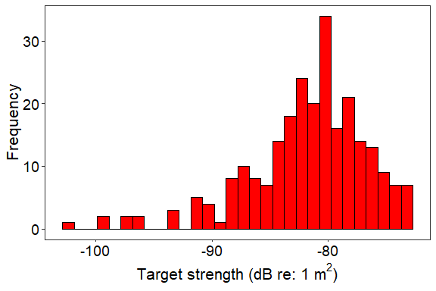
The output of SDWBA.sim(...) is by default a data.frame; however, if only a single aggregate statistic is needed, then SDWBA.sim(..., aggregate=c("mean","median","maximum","minimum")) can be used to generate just the mean, median, maximum, minimum, or any combination of those descriptive statistics.
SDWBA.sim(target_resize, c=c, frequency=freq, phase=pd, g=g, h=h, length=lengths, theta=theta, parallel=T, aggregate=c("mean","median"))
#> Stat TS
#> 2 Mean -79.62122
#> 3 Median -80.56727

Example: TS-Frequency spectrum comparison between curved and non-curved animal
#We will compare the TS-frequency spectra of the same target when it is curved and non-curved
curve = c(T,F) #curved and non-curved
freq <- seq(10,300,1)*1e3 #frequencies to simulate, Hz
theta <- pi/2 #broadside incidence
ts_freq <- SDWBA.sim(target_resize, c=c, frequency=freq, curve=curve, theta=theta, parallel=T)
#And we can plot!
ggplot(data=ts_freq, aes(y=TS,x=frequency*1e-3)) + geom_path(aes(color=curve), size=2) +
theme_bw() + theme(text=element_text(size=16), axis.text=element_text(size=14, color="black"),
panel.grid=element_blank()) +
scale_color_manual(values=c("red","blue"), labels=c("Straight","Curved")) +
labs(y=expression(paste("Target strength (dB re: 1 ",m^2,")")),
x="Frequency (kHz)", color="")
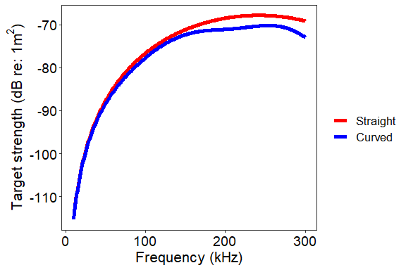

Example: Effect of orientation and body curvature on TS.
#Let's see how body curvature, pc, and orientation, theta, influences TS at 120 kHz
freq <- 120e3
theta <- seq(0,180,5) #degrees, 0 to 180 degrees at 5 degree resolution, or 0 to pi radians
thetar <- degrad(theta, "deg") #convert to radians
curve = T #set animal to be curved
pc <- seq(2.0,8.0,0.25) #curvature
ts_orfreq <- SDWBA.sim(target_resize, c=c, frequency=freq, theta=thetar, curve=curve, pc=pc, parallel=T)
#Now let's plot
require(viridis)
#> Loading required package: viridis
#> Loading required package: viridisLite
ggplot(data=ts_orfreq, aes(x=theta, y=pc, fill=TS)) + geom_tile() + theme_bw() +
theme(text=element_text(size=16), axis.text=element_text(size=14, color="black"),
panel.grid=element_blank()) +
scale_fill_viridis(option="B") +
coord_cartesian(expand=c(0,0)) +
labs(x=expression(paste("Orientation (",theta," radians)")),
y=expression(paste("Radius of curvature (",rho[c],")")),
fill=expression(paste("TS (dB re: 1 ",m^2,")")))
#> Warning in if (!expand) {: the condition has length > 1 and only the first
#> element will be used
#> Warning in if (!expand) {: the condition has length > 1 and only the first
#> element will be used
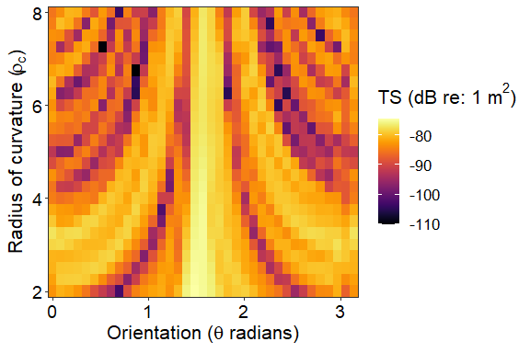

Example: Effect of material properties on TS at four discrete frequencies.
#Let's see how variation in g and h influences a target at 38, 70, 120, 200, 455, and 710 kHz.
freq <- c(38, 70, 120, 200, 455, 710)*1e3 #Hz
g <- seq(1.01,1.06,length.out=25) #g
h <- seq(1.01,1.06,length.out=25) #h
ts_gh <- SDWBA.sim(target_resize, c=c, frequency=freq, g=g, h=h, parallel=T)
#Now let's plot
ts_gh$frequency <- ts_gh$frequency * 1e-3 #convert from Hz to kHz
ts_gh$label <- paste(ts_gh$frequency," kHz",sep="")
ts_gh$label <- factor(ts_gh$label, levels=c("38 kHz","70 kHz","120 kHz","200 kHz","455 kHz","710 kHz"))
ggplot(data=ts_gh, aes(x=g, y=h, fill=TS)) + geom_tile() + theme_bw() +
theme(text=element_text(size=16), axis.text=element_text(size=14, color="black"),
panel.grid=element_blank(), strip.background=element_blank(), strip.text=element_text(size=15),
axis.text.x=element_text(angle=90)) +
scale_fill_viridis(option="B") +
facet_wrap(~label) +
labs(x=expression(paste("g (",rho[animal],"/",rho[seawater],")")),
y=expression(paste("h (",c[animal],"/",c[seawater],")")),
fill=expression(paste("TS (dB re: 1 ",m^2,")")))
