Software Engineering Lab 2

Name: BRANKO
Index: 225080

searchBookByTitle searchBook
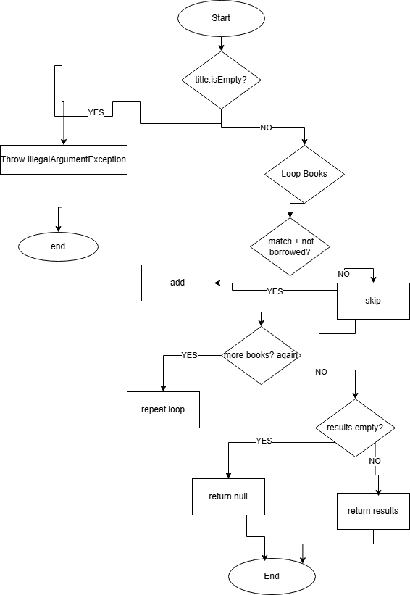
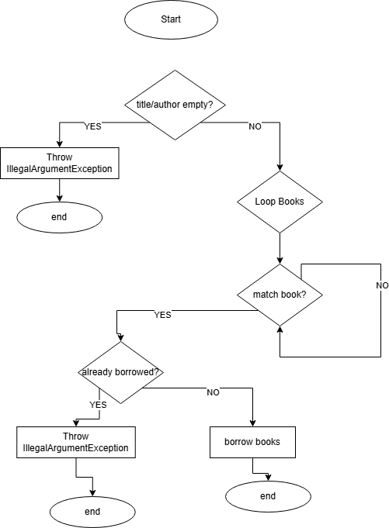

Cyclomatic Complexity

searchBookByTitle
- Number of decision points (P): 4
- Cyclomatic Complexity: V(G) = P + 1 = 5

borrowBook
- Number of decision points (P): 4
- Cyclomatic Complexity: V(G) = P + 1 = 5

Every Statement – searchBookByTitle
The Every Statement criterion is satisfied when each statement in the function is executed at least once.
Test cases used:
- Input is an empty string → triggers IllegalArgumentException.
- Book with matching title exists and is not borrowed → returns a non-empty list.
- No book with the given title exists → function returns null.
These test cases ensure that all statements are executed, including exception handling, loop execution, successful addition to results, and the empty result check.

Every Branch – borrowBook
The Every Branch criterion ensures that each decision branch in the function is executed at least once.
Branches covered:
- Invalid input branch (empty title or author) → throws IllegalArgumentException.
- Successful borrow branch (book exists and is not borrowed).
- Book already borrowed branch → throws RuntimeException.
- Book not found branch → throws RuntimeException.
Each branch in the decision structure is tested, including validation, matching logic, and error handling paths.

Multiple Condition – borrowBook and searchBookByTitle
The Multiple Condition criterion ensures all combinations of boolean sub-conditions are tested.
For borrowBook(title.isEmpty() || author.isEmpty()):
- TT → both inputs empty → exception thrown
- TF → title empty, author valid → exception thrown
- FT → title valid, author empty → exception thrown
- FF → both valid → execution continues to search logic

For searchBookByTitle(book.getTitle().equalsIgnoreCase(title) && !book.isBorrowed()):
- TT → matching title and not borrowed → book added to results
- TF → matching title but already borrowed → skipped
- FT → non-matching title → skipped
- FF → non-matching title and borrowed → skipped
All combinations of sub-conditions are covered to ensure full logical coverage.

