**PROJECT TITLE:** **Exploring Weather Trends**

**INTRODUCTION**

It is widely proven that weather condition has had some significant effect and variation from one countries to the other over centuries ago till now. Before we explore the journey, let me introduce you to my city. I live in Nigeria, in the city of Ibadan. In this project, I will attempt to analyze my local average temperature data in the past 150 years and compare its trend to that of the global average temperature trends.

**OUTLINE**

**The Database Schema**

There are three tables in the database presented to extract the data we need:

* city_list - This contains a list of cities and countries in the database.
* city_data - This contains the average temperatures for each city by year (ºC).
* global_data - This contains the average global temperatures by year (ºC).

**TOOLS:** SQL, Microsoft Excel

To accomplish our aim, I decided to extract Ibadan city data and joined it with global temperature data set using SQL and then Microsoft Excel was used for data cleaning and visualization.

**EXTRACTION:**

The Figure below shows the extraction process:

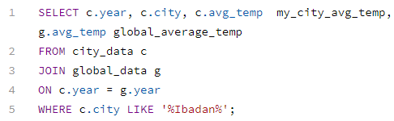

***Fig.1:*** *Data set Extraction process from the database using SQL*

**DATASET**

Our data consist of 158 rows and four columns (Year, city, city average temperature and global average temperature). The year was from 1856 to 2013.

The Figure below shows the first few extracted dataset

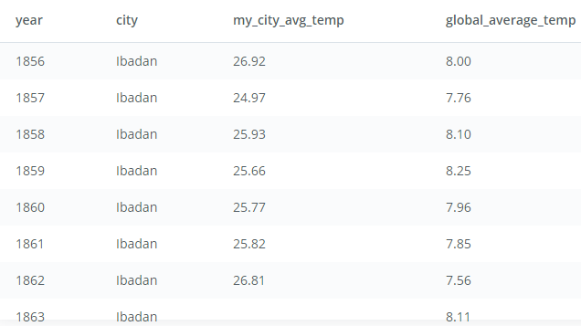

***Fig.2:*** *Result of data pulled out.*

**DATA CLEANING**

Our extracted dataset was cleaned and manipulated using excel tool. The missing values in the city average temperature was fixed using the mean of the total city temperature recorded. However, to get a clear picture of the trend, we use 10 – years moving average.

The moving average is calculated by adding the temperature over a ten years period for and dividing the sum by the total number of periods (10 years).

Our extracted dataset comprise of 158 rows with 10 missing values for the Ibadan city average temperature column. The missing data column was calculated to be 6% of the entire data set which was fixed using of the whole temperature.

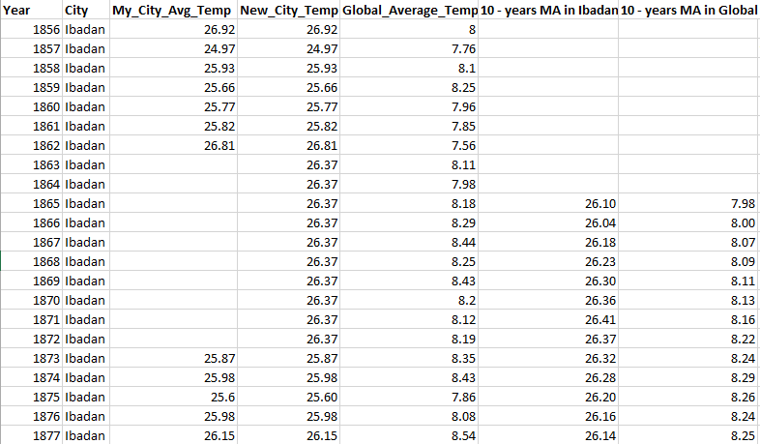

***Fig.3:*** *Dataset used for the visualization*

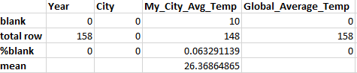

***Fig.4:*** *Data Cleaning Process*

**VISUALIZATION**

The Figure below is the line chart produced by our data using Microsoft Excel tool. The temperature data was from the year 1865 to somewhere above 2010.

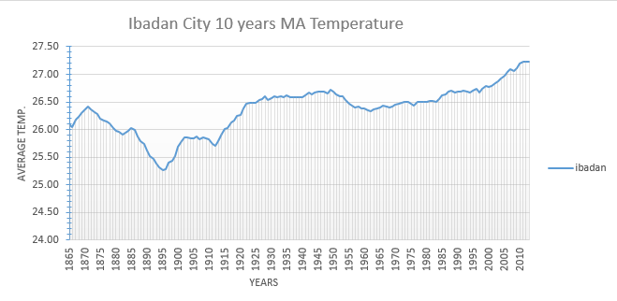***Fig.5:*** *Ibadan 10 – years Moving Average Temperature*

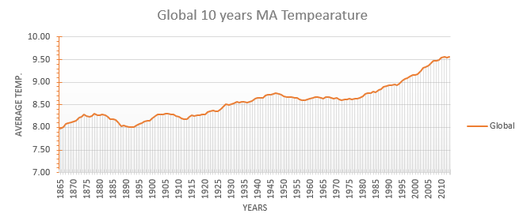

***Fig.6:*** *Overall Global 10 –years Moving Average Temperature*

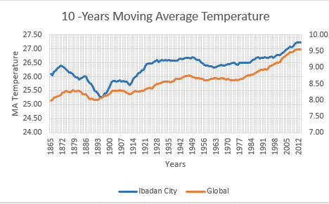

***Fig.7:*** *Ibadan City and Overall Global Moving Average Temperature*

**OBSERVATION**

It could be seen that Ibadan city and the overall global temperature began at around 1865 up to the year 2012.

The following are the similarities in the trends

1. Both cities experienced a hot temperature in the first five years from 1865 to 1870.
2. Over the periods of consideration, both cities temperature was steady at some point and fluctuate.
3. It can be seen that Ibadan city temperature and the overall global temperature experienced higher temperature increase for 55 years (1914 – 1949) before the temperature cool off and remain steady and fluctuate for more than 20 years before another rise began in 1977.
4. The globe and Ibadan city will continue to experience hotness over the next century in which between the years will could see a cool off for likely two years.

The following are the differences observed:

1. Ibadan city experienced a cooler temperature compare to the global world average temperature for more than 20 years after the first five years rise.
2. The Ibadan city was hotter compare to the global temperature from 1914 – 1928, after the 20 years coolness.
3. The overall trend shows that Ibadan will experience higher temperature for a decade than the global average temperature which then follow by coolness for another decade before the next temperature rise.
4. There was also a long period of stability (negligible variation) in the Ibadan city temperature whereas the global average temperature only experience short stability in the average temperature.