ENEL 387 Project Proposal

Brant Geddes

200350415

I plan to design and implement a variable speed drive (VSD) circuit to control the power to a load using a TRIAC. The TRIAC will be responsible for controlling the portion of the incoming AC sine wave that is transferred to the load, and the STM32 will be responsible for taking in information about the high voltage circuit and providing a firing signal to the TRIAC to control the conduction angle. The high voltage equipment will be housed in a separate box and a barrier will be maintained between the STM32F100RB and other low-voltage peripherals using either one of opto-isolators or isolation transformers. The box will be fed from a 120V 15A outlet using SOW cable and will contain a suitable internal fuse/breaker to protect against overcurrent. The test load will be a 60W incandescent bulb with base mounted on the box. A zero-crossing detector circuit will be constructed to detect the voltage zero-crossing and relay this information to the STM32. The firing signal will be generated by the STM32 and delivered to the TRIAC through an isolation and buffering circuit, such as an opto-TRIAC. The firing signal setpoint will be indirectly controlled by an externally mounted device such as a potentiometer. Additional features may include instrumentation mounted in the box in order to relay information about current, voltage, power, or phase angle to the STM32 or a bypass control such as a solid-state relay to unload the TRIAC when operating at full power.

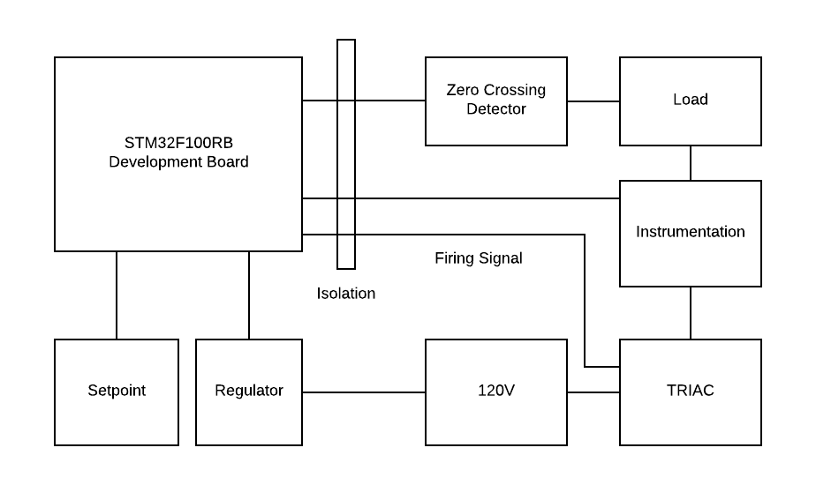

Figure - Proposed Block Diagram of Variable Speed Drive Circuit