ENEL 387

Final Report

Variable Speed Drive

Brant Geddes

200350415

Table of Contents

1. System Information 1

1.1 Description 1

1.2 Diagram 1

2. Design 2

2.1 TRIAC Circuit 2

2.2 Zero-Crossing Module 3

2.3 Instrumentation Circuit 3

2.4 Software 3

2.5 Deviation from Functional Specification 4

3. Testing 5

4. Bill of Materials 6

# 1. System Information

## 1.1 Description

The Variable Speed Drive (VSD) allows the user to control the average voltage delivered to a load using a microprocessor to control the firing angle of a TRIAC. Applications for the VSD include variable heat delivery from a heating element, light dimming applications, and variable motor speed control. The microprocessor system is easily scaled to higher voltage or current applications by replacing the power electronics section with another appropriately rated device. The device also includes a test point to inspect the resulting waveform using a potential transformer. All connections between the microprocessor and the power electronics are isolated magnetically or optically.

## 1.2 Diagram

The basic system components are shown below. The system contains two major sections, the microprocessor section and the power electronics section. The user interface is included in the microprocessor section.

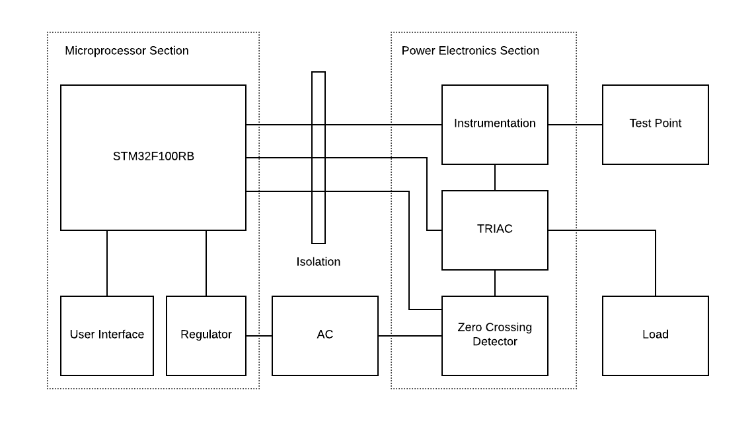

Figure 1 - Block Diagram of VSD

# 2. Design

Building the VSD required the design of several modules, including the selection of the individual components and the design of the zero-crossing circuit, instrumentation circuit, TRIAC firing circuit, and TRIAC high voltage circuit. In addition, all of these components had to be interfaced with the microcontroller and the drivers required to operate these components needed to be designed and tested. The design of the individual components is detailed in the following subsections.

## 2.1 TRIAC Circuit

The TRIAC circuit design was difficult due to the 120VAC required at the TRIAC and the need for isolation between the high voltage and the microcontroller. The isolation was accomplished using a secondary opto-TRIAC, which is an optically isolated TRIAC. The opto-TRIAC has four pins, two input pins that drive an internal LED and two output pins that tie to an internal TRIAC. The internal TRIAC is fired using the low voltage LED, which gives the required isolation between low voltage and high voltage. At the low voltage side the microcontroller output is tied to the opto-TRIAC using a typical LED current limiting circuit. At the high voltage side the opto-TRIAC is tied to the gate of the power TRIAC using a high wattage resistor. The high voltage circuit is designed so that the opto-TRIAC pins are at the same potential as the power TRIAC, so when the TRIAC is idle the voltage across the opto-TRIAC is 120VAC but the current is zero and when the TRIAC is conducting the voltage across the opto-TRIAC is the saturation voltage of the power TRIAC (~0.15V). This means that the resistors only need to be sized to limit the peak current through the opto-TRIAC to a safe amount, but the power dissipation of the resistors is negligible because they only see meaningful current and voltage for a brief moment when the TRIAC is fired. The power dissipation for this moment is large, but the time-average over the whole 8.33ms cycle is very small and the large wattage of the resistors is redundant.

The high voltage circuit is built on a proto-board with sufficient space to hold the two TRIACS and the resistors without risk of a short developing between the 120VAC circuit and the low voltage circuit. In addition, special care was taken to follow creepage/clearance rules for high voltage prototyping. The clearance between two traces is the closest distance between them and relates to the ability of an arc to form between components that are too close. Creepage is the distance between two traces following the surface of the PCB and any obstructions, and relates to the ability of a arc to form between components if a breakdown of the boards insulation occurs. For a 120VAC circuit, it was sufficient to place an unused trace between two 120VAC traces to adhere to the creepage/clearance guidelines.

## 2.2 Zero-Crossing Module

The zero-crossing module is used by the system to sync the TRIAC firing to the AC waveforms zero crossings. The module sends a square wave to the microcontroller with edges that correspond to the AC waveforms positive and negative zero crossing. The microcontroller generates an interrupt on the rising and falling edge of that signal that is used to reset the counter used for the TRIAC firing. The module accomplishes this by first transforming the 120VAC voltage down to ~10VAC using a potential transformer. It then uses a resistor-divider to drop the voltage down to an acceptable level and a single supply op-amp as a comparator to generate the square wave.

## 2.3 Instrumentation Circuit

The instrumentation circuit is responsible for conditioning the output of the CT to a level acceptable for the microcontroller to read. The circuit implements a peak-detector to output a dc value that corresponds to the peak value of the current. The peak value is scaled in the microcontroller using a scaling factor of 0.707. Due to the fact that the output of the TRIAC is not sinusoidal, this circuit was not able to accurately report the waveform and was not implemented in the final project.

Another implementation of this circuit involved a dual-supply Op-Amp used to amplify the output of the CT and a precision rectifier circuit used to cut the negative half of the waveform. This would be sampled by the microcontroller and an average current would be calculated using the individual samples taken during the cycle. This was not implemented in the final project due to the noise associated with the TRIAC. It was found that the calculated value was not accurate and varied over a wide range due to high frequency noise found at the TRIAC output.

## 2.4 Software

The software was designed using a finite state machine model. The FSM transitions are controlled using the pushbuttons and the FSM states control the menu position and the outputs of the device. In the Idle and Faulted state the TRIAC firing logic is disabled while in the Run state the Firing logic is enabled. Certain functions are controlled outside of the states, such as sampling the ADC to get the setpoint value and setting faults.

The Zero-Crossing detector driver relies on an interrupt set to trigger on both rising and falling edges. Inside of the interrupt handler the TRIAC firing logic is synchronized to the AC waveform by resetting the counter value to zero on each zero-crossing. This ensures that the counter used to send the firing pulse always begins counting from the zero-crossing.

The ADC driver works by starting an ADC conversion in the main loop and checking a flag in the main loop to see if the conversion is finished. The flag is set by the ADC interrupt handler when the End-Of-Conversion interrupt is called. The ADC conversions are sampled at the slowest speed possible (~240.5 cycles per conversion) in order to limit the number of ADC interrupts called during the main loop.

The TRIAC firing driver relies on a compare-counter programmed to toggle an output high when the value stored in the compare register is less than the value of the counter. The value stored in the compare register is set using the setpoint value sampled from the ADC. The counter is synchronized to the AC line by the interrupt generated by the zero-crossing detector.

One major difficulty encountered during the software implementation involved the synchronizing of the TRIAC firing circuit to the AC line. An ideal system would be synchronized by an edge detector and be allowed to fire anywhere in the range [0 ms, 8.33 ms]. In the implementation, it was found that this would result in the counter firing the TRIAC early on in the next cycle which would cause the test bulb to flicker. It was found that this is due to the stacking time required by the STM32 when an interrupt is called. By limiting the range that the TRIAC can fire down to ~8.00 ms and turning the firing circuit off for angles above that the problem was fixed.

## 2.5 Deviation from Functional Specification

The project deviates from the original functional specifications in some ways. The largest difference is the absence of the current transformer in the finished product. The originally designed CT conditioning circuit was designed to work with a sinusoidal input waveform, which did not work with the output of the TRIAC. A few other methods were attempted to read the current waveform, such as averaging the values taken across the whole cycle. The alternative methods attempted failed due to how noisy the current waveform is when the TRIAC is firing in the middle of the cycle. In the finished product, the current is approximated using the setpoint percentage and a hard-coded maximum current value.

Due to a lack of current feedback several of the fault codes initially put forth in the functional specs had to be ignored, such as overcurrent, overload, and drive fail. Only half of the suggested drive faults were implemented in the finished product. Finally, the ability for the user to enter a maximum current for the load using the menu and pushbuttons was not implemented due to a lack of current feedback.

# 3. Testing

The testing procedure for this system consisted of several steps, from individual component testing to the full system evaluation. Due to the use of high voltages in the system, special care was taken to design safe testing strategies when testing the individual high-voltage components and the finished system. The initial testing of the individual components involved using the oscilloscope, function generator, power supply, and 120VAC wall supply to build test benches for each component. In this stage, each transformer was connected to 120VAC and the resulting voltage waveform was viewed with the oscilloscope. In addition, the TRIAC and opto-TRIAC were tested by simulated a firing circuit using the function generator and power supply and the output was viewed using the oscilloscope. The testing of the TRIACS was difficult due to the fact that the test equipment was not able to supply enough current to fire the main power TRIAC, so the opto-TRIAC was tested using the test bench and the main TRIAC was tested later using an isolated 45VAC supply.

The next step involved testing modules by constructing them on breadboards and viewing the output on the oscilloscope. The zero-crossing module was constructed on a breadboard and tested by connecting the potential transformer to a 120VAC supply and viewing the low voltage output of the detector on the oscilloscope. The instrumentation circuit was tested by simulating the waveform that would be expected from the CT using the function generator and viewing the result on the oscilloscope. Once the outputs of the individual modules were found to be within the required range, integration testing with the microcontroller began. Each circuit was connected to the microcontroller and debugger was used to test the component drivers. For the zero-crossing detector, a 1 Hz signal was set as the input into the detector and an LED was made to toggle as the interrupt was called. For the TRIAC firing circuit the input of the opto-TRIAC was connected to the microcontroller and the output was connected to a low-voltage test signal. The output of the TRIAC was viewed on the oscilloscope as the setpoint for the firing angle was varied from zero to full.

The full system testing required the use of 120VAC, so a 120VAC isolation transformer with a low amperage fuse was used to feed the high-voltage circuit and a 40W incandescent bulb was used as the test load. The full system testing involved testing the overall operation of the device and properly scaling in the analog inputs. Testing of the menu system and the fault system involved using the debugger to ensure that the code was operating properly during state changes and during faults. A dip switch was used to force fault conditions for testing the fault system.

# 4. Bill of Materials

|  |  |  |  |
| --- | --- | --- | --- |
| Component: | Quantity: | Price: | Total: |
| STM32VL Discovery Board | 1 | $9.95 | $9.95 |
| 16x2 Character LCD | 1 | $15.95 | $15.95 |
| Tactile Button Assortment | 1 | $4.95 | $4.95 |
| Voltage Regulator - 5.0v | 1 | $0.95 | $0.95 |
| Voltage Regulator - 3.3v | 1 | $0.95 | $0.95 |
| 10kΩ Trimpot | 1 | $0.95 | $0.95 |
| LM358N Op-Amp | 2 | $0.95 | $1.90 |
| Screw Terminals | 3 | $0.95 | $2.85 |
| 2x5 Ribbon Cable | 2 | $1.50 | $3.00 |
| 2x5 Ribbon Female | 2 | $0.50 | $1.00 |
| Current Transformer | 1 | $9.95 | $9.95 |
| MOC3020 Opto-TRIAC | 1 | $0.68 | $0.68 |
| QJ6016RH4TP TRIAC | 1 | $3.06 | $3.06 |
| Pomona Test-Jacks | 1 | $2.77 | $2.77 |
| Potential Transformer | 2 | $15.61 | $31.22 |
| Wire-Wrap Socket | 2 | $1.96 | $3.92 |
| 30AWG Wire-Wrap Wire 100' | 1 | $17.62 | $17.62 |
| 1/4" Ready-Rod | 1 | $5.69 | $5.69 |
| 1/4" Particle Board 4x4 | 1 | $10.59 | $10.59 |
| Assorted Hardware | 1 | $10.00 | $10.00 |
| Assorted Components | 1 | $20.00 | $20.00 |
| Proto-Boards | 3 | $5.95 | $17.85 |
| Total: | 31 |  | $175.80 |