**Heuristc Analisys – Adversarial Search**

Author: Bruno Gonçalves de Aquino  
Course: Udacity - Nanodegree in AI – Adversarial Search Project

**Custom_score:**

The best one is simple, this just combine the center_score with the improved_score multiplying both.

There is a modification in the center_score part. It was rewarding the player to stay away the center, I changed it to reward to stay next to the center

**Custom_score_2:**

This one tries to calculate the dominated area of each player, getting the area behind each, considering the players always facing their opponents.

As the first heuristic, this one also lends the improved_score to complement it.

**Custom_score_3:**

This heuristic consists in find the “center of mass” of the blank spaces and then act as the custom_score, rewarding the agent for being closer to this center as possible.

Additionally, I calculated quantity of possible moves of the player minus the possible moves of the opponent, as the improved_score does.

Finally, I multiplied the both to have my heuristic.

**Results Analysis:**

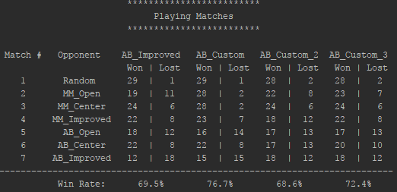

All the results were very close, but the AB_Custom is consistent. I’ve ran the tournament several times, and it won mostly.

It’s a shame that the blank center mass didn’t the best, at least it is nice. Maybe the loop inside slows it, and it is not able to reach deeper trees.