CDet Commissioning Process: Study of Crosstalk
Crosstalk is defined as the undesirable artificial correlation between signals in different channels of the Coordinate Detector. This parasitic correlation is caused by undesirable affects which lead to unwanted events recorded during data acquisition.
The purpose of the crosstalk analysis is to determine what percentage of the data is coming from crosstalk events and how these crosstalk events can be removed. The concern is that crosstalk events will distort the data collected through the commissioning process which will lead to a misrepresentation of the Coordinate Detectors efficiency. This study of crosstalk was conducted only after the charge equalization process was completed.
A crosstalk event could be the result of a few different causes. The first cause of crosstalk is the displacement of optical fibers in relation to the photomultiplier tube (PMT) which leads to leaking of photons into incorrect pixels. This can be correct by implementing precision alignment between the opticals fibers which are 2 mm wide and the PMT pixels which have an area of 4x4 mm. Another cause is the close proximity of the optical fibers which leads to leaking of photons between the individual optical fibers themselves. This can be corrected by improving the system to include sleeves between the fibers which will help avoid contact and therefor reduce the number of photons leaked between fibers. The final cause is capacitive coupling within the electronic operations of the PMT between individual channels. The correction required for this cause is not something easily fixed physically and so requires further analytic investigation.
Study of Crosstalk Probability: ADC Based Approach
Using the ADC data obtained from cosmic ray test runs, the percent crosstalk events in the data can be determined. This is done for each channel in the detector individually. The number of crosstalk events is determined by placing cuts that define a crosstalk event on the data for an individual channel and then taking that number over the total number of events.
% Crosstalk = (# of crosstalk events)/(total # of events)
The first method for this approach looks dominantly at the ADC data obtained from the cosmic ray test runs as it relates to the orientation of the scintillating paddles in the detector. Three cuts were used to get the total number of events. First, the cosmic ray must only trigger an event in the center scintillating paddle being analyzed. This means that the cosmic ray must have an almost completely vertical track going through the center scintillating paddle. An adjacent ADC value signal cut is placed on the two scintillating paddles on either side of the center paddle being analyzed such that the ADC signal values in the two adjacent scintillating paddles are close to zero. Second, the TDC must be triggered by the cosmic ray event so we place a cut on the center analyzed paddle such that the TDC data has recorded a good event with a good TDC signal pulse. Third, the ADC signal in the center analyzed paddle must be a good ADC value such that it is above a certain value used as a base line ADC cut. These three cuts determine the total number of events from each scnitillating paddle in the Coordinate Detector.
The same three cuts were used to get the number of crosstalk events, but a fourth cut was also added. A crosstalk event occurs when a cosmic ray event from the total number of events in the center analyzed paddle also triggers an event in the TDC data for another adjacent paddle. The fourth cut requires that a TDC signal in one or both of the two adjacent scintillating paddles was recorded at the same time as a ADC signal in the center analyzed paddle. These four cuts determine the number of crosstalk events from each scintillating paddle in the Coordinate Detector.
The number of events obtained from these four cuts was then placed over the number of events using just the first three cuts to get the number of crosstalk events over the total number of events for that center analyzed paddle. This ratio defines the percent crosstalk between the center scintillating paddle being analyzed and the scintillating paddles adjacent to the analyzed scintillating paddle. From this first method the channels with the most amount of crosstalk between adjacent scintillating paddles could be determined. This method however, only provides an understanding of how one paddle's crosstalk relates to the paddles on either side. This still did not show how crosstalk from one channel relates to any channel in the whole group of fourteen scintillating paddles. Instead of using the orientation of the paddles, the orientation of the pixels in the multianode photomultipier tube (PMT) can be used to determine crosstalk between different channels in the Coordinate Detector.
The second method also looks dominantly at the ADC data obtained from the comic ray test runs, but now it relates to the orientation of the pixels in the multianode PMT. The same cuts were used to determine the number of total event as in the first method, but the difference is in the fourth cut which determines the number of crosstalk event. A crosstalk event now occurs when an event from the total number of events in the analyzed pixel also triggers an event in the TDC data for any other pixel in the same PMT. The fourth cut on the ADC was that the TDC in another pixel was triggered at the same time as an event in the analyzed pixel. The number obtained from the four cuts was then placed over the number obtained using just the first three cuts to get the number of crosstalk events over the total number of events for that individual paddle. This ratio defines the percent crosstalk between the pixel being analyzed and the other pixels in the PMT.
From this method the channels with the most amount of crosstalk between different pixels of the PMT can be determined. One conclusion from this method was that the highest crosstalk percentages for any analyzed pixel were always between the other pixels closests to the pixel being analyzed as determined by the orientation of the pixels in the PMT.
The ADC Based Approach provides an undestanding as to which channels in the Coordinate Detector produce the largest number of real events which then trigger crosstalk events in all the other channels. However this approach only looks at the real events in certain channels and the percent of real events that trigger crosstalk events in all the other channels. This approach does not provide insight into the number of crosstalk events actually received by one channel from all other channels in the group of fourteen scintillating paddles. In other words, this approach looks at how many real events in one channel generate crosstalk events in all the other channels, but it does not look at how many crosstalk events are received by one channel from all the other channels. To understand how crosstalk events are received by one channel from real events in all the other channels, the TDC Based Approach should be used.
Study of Crosstalk Probability: TDC Based Approach
Using the TDC data obtained from cosmic ray test runs, the percent crosstalk events in the data can be determined. This is done for each channel in the detector individually. The number of crosstalk events is determined by placing cuts that define a crosstalk event on the data for an individual channel and then taking that number over the total number of events.
% Crosstalk = (# of crosstalk events)/(total # of events)
This approach looks dominantly at the TDC data obtained from the cosmic ray test runs as it relates to the data obtained from each channel in the Coordinate Detector. One cut was used to get the total number of events. The cosmic ray must only trigger an event in the channel being analyzed. This means that the cosmic ray must trigger a TDC signal in the analyzed channel. A cut is place on the analyzed channel such that the TDC data has recorded an event, both real or crosstalk. This cut determines the total number of events for the channel being analyzed.
The same cut was used to get the number of crosstalk events, but a second cut was also added. A crosstalk event occurs when an event from the total number of events in the analyzed channel is recorded with a good TDC signal and a close to zero or low ADC signal. The second cut on the TDC requires that a TDC signal is recorded in the analyzed channel at the same time as a low or close to zero ADC signal. These two cuts determine the number of crosstalk events from each channel in the Coordinate Detector.
The TDC Based Approach provides an undestanding as to which channels in the Coordinate Detector are the most suseptable to having crosstalk events occur as an effect of real events in all the other channels of the fourteeen scintillating paddle group. During a study, the TDC Based Approach was applied to all channels of the Coordinate Detector with the PMT high voltages set to 700 V, 725 V, 750 V, 775 V, and 800 V. From this study, the data shows that the percent crosstalk for any given channel increases as the PMT high voltage increases. The study also shows that the percent crosstalk varies among the different channels and PMTs of the Coordinate Detector. For many channels, the crosstalk percentages are too high, with accpetable crosstalk percetanges being below ten percent. Further investigation led to a method for analytically removing crosstalk events from the recorded data which lowered the crosstalk percentages for many channels in the Coordinate Detector.
Oscilloscope Obersvations
The first step in developing an analytic method for removing crosstalk events from the data required an understanding of what makes crosstalk events unique. It was observed using a mutlichannel oscilloscope, that crosstalk events can be visually observed on the oscilloscope as bi-polar charge signals. Typically, a normal event will show a charge signal pulse in just the negative direction. These bi-polar charge signals have simultaneous positive and negative pulses on the oscilloscope which when integrated over would produce an ADC signal value of zero or close to zero. This means that crosstalk events can be uniquely identified by their abnormally low ADC signal values. An example of this observation can be seen in Figure 1.
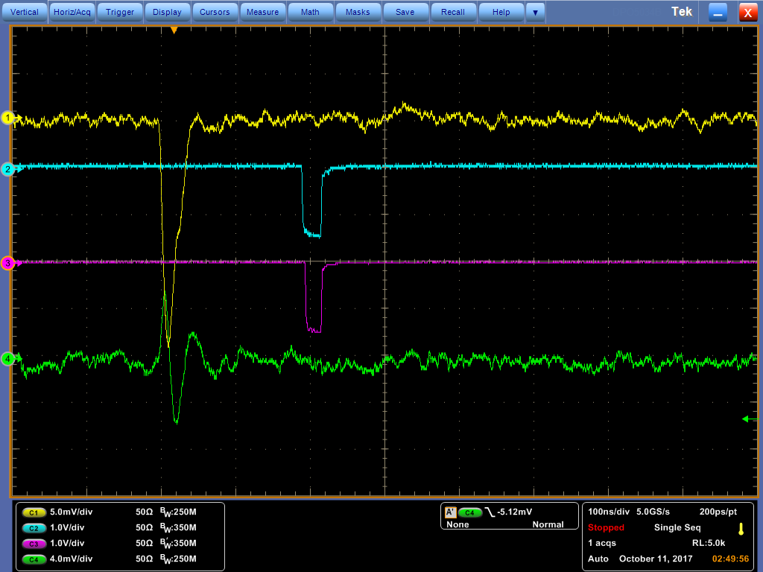
Figure 1
As seen in Figure 1, the ADC signal pulse (green) shows the characteristic bi-polar signal pulse of a crosstalk event that also triggers a TDC signal pulse (purple). This crosstalk event is the result of a real event (yellow) in another channel within the same group of fourteen scintillating paddles. This effect was observed for all channels in the detector and it varied among channels.
Another observation that was made from viewing crosstalk events on the mutlichannel oscilloscope was that a majority of crosstalk events can be identified by TDC signals with small widths between the signals' leading and trailing edges. This means that crosstalk events can be uniquely identified by their abnormally low TDC width values. An example of this oservation can be seen in Figure 2.
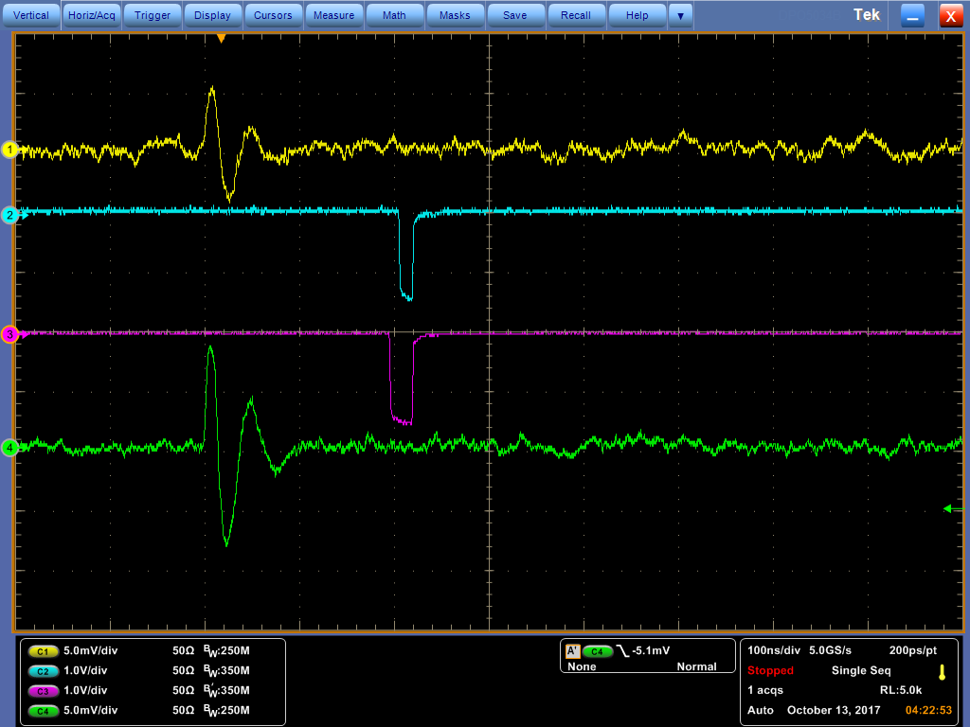
Figure 2
As seen in Figure 2, an ADC signal pulse (yellow) shows the characteristic bi-polar signal pulse of a crosstalk event that also triggers a TDC signal pulse (blue). This TDC signal pulse (blue) is observed to be shorter in width than the TDC signal pulse (purple) of the other crosstalk event (green) shown. The shorter TDC width for crosstalk events was consistantly observed throughout all channels of the Coordinate Detector.
Study of Crosstalk Reduction: TDC Widths
To determining the usefulness of a TDC width cut in analytically removing crosstalk events, a plot of all the TDC widths was required for every event recorded in a single cosmic ray test run by a single analyzed channel. This plot of all TDC widths is then compared with a second plot containing all TDC widths that includes an ADC cut relating to events with high ADC signals. First, a plot of all TDC widths for a single analyzed channel was created and then a second plot of all TDC widths with high ADC signal values was layed over top the first plot. This second plot of TDC widths with high ADC signal values represents all of the good events in the analyzed channel. With these two plots layed over each other, a large spike at the lower TDC widths stuck out that was not covered by the plot of good events. This spike represents a large portion of the crosstalk events that have low TDC widths and low or close to zero ADC signal values. An example of this plot can be seen in Figure 3.
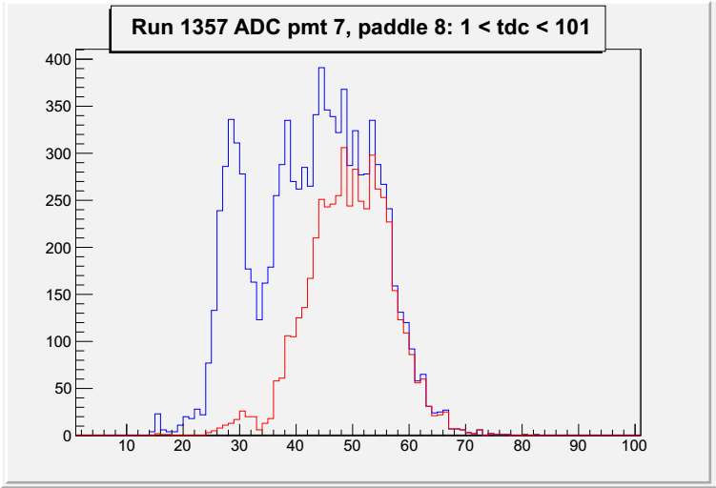

Figure 3
As seen in Figure 3, the plot of TDC widths for good events (red) does not cover the plot of all TDC widths (blue) for all events. The intention is to cut out as much of the blue plot, which represents a large portion of the crosstalk talk events, that is not covered up by the red plot. A large spike can be seen at the lower TDC widths and a TDC width cut can be place somewhere between 34 to 36. This cut will significatnly lower the crosstalk percentage for this individual channel without cutting out to much of the good events represented by the red plot.
From this observation, a TDC width cut was determined to be useful in analytically removing crosstalk events from the data. The TDC width cut was implemented in the calculations of crosstalk percentages to determine the amount of crosstalk reduction before and after application of the new TDC width cut.
Similar to the TDC Based Approach, the implementation of the TDC width cut looks dominantly at the TDC data obtained from the cosmic ray test runs as it relates to the data obtained from each channel in the Coordinate Detector. One cut was used to get the total number of events. A cut is place on the analyzed channel such that the TDC data has recorded an event, both real or crosstalk. This cut determines the total number of events for the channel being analyzed.
The same cut was used to get the number of crosstalk events, but two more cuts were also added. The first of the two added cuts on the TDC data requires that a TDC signal is recorded in the analyzed channel at the same time as a low or close to zero ADC signal. The second of these two added cuts is the TDC width cut. The TDC width cut is determined individually for each channel based on were the TDC width values which correspond to the observed crosstalk spike end and the good event TDC widths begin. These three cuts determine the number of crosstalk events from each channel in the Coordinate Detector.
The crosstalk percentages calculated from the implementation of the TDC width cut into the TDC Based Approach was then compared to the original TDC Based Approach crosstalk percentages. The results of this comparison conclude that the implementation of the TDC width cut into the TDC Based Apprach leads to a significant reduction in crosstalk pecentages across all channels in the Coordinate Detector. An example of this significant crosstalk reduction can be seen in Table 1 and Table 2.

Table 1
Table 2

