Phys 201 Final Exam
December 2008
2 hour and 30 minutes

Professor: Dr. Edward J. Brash

Rules and Regulations:

- Calculators, with memory cleared, are permitted.
- You may bring as many pencils, pens, and erasers with you as you like.
- No other material is permitted.
- The exam consists of 8 questions where you should present full solutions. The full solution questions are worth 10 points each (80 points total).
- You should complete your solutions to the full solution questions on the exam paper itself.
- Your solutions to the full solution problems should, in general, contain a combination of diagrams, equations, and English word sentences explaining your strategy and thought process.
- In any problems involving gravity, use g=9.80m/s², if necessary.

STUDENT NAME: _______________________________________

STUDENT ID NUMBER:__________________________________

SIGNATURE:____________________________________________

1. A person walks first at a constant speed of 5.20 m/s along a straight line from point A to point B and then back along the line from B to A at a constant speed of 3.50 m/s.

(a) What is her average speed over the entire trip?

(b) What is her average velocity over the entire trip?

2. A stone is thrown from the top of a building upward at an angle of 28.0° to the horizontal with an initial speed of 22.7 m/s as shown in the figure. The height of the building is 45.0 m.

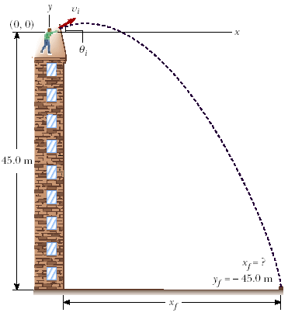

(a) How long does it take the stone to reach the ground?

(b) What is the speed of the stone just before it strikes the ground?

3. A hockey puck on a frozen pond (in Canada, of course) is given an initial speed of 16.0 m/s. If the puck always remains on the ice and slides 102 m before coming to rest, determine the coefficient of kinetic friction between the puck and ice.

4. A curve in a road forms part of a horizontal circle. As a car goes around it at constant speed 14.0 m/s, the total force exerted on the driver has magnitude 115 N. What are the magnitude and direction of the total vector force exerted on the driver if the speed is 17.5 m/s instead?

5. A bead slides without friction around a loop-the-loop as shown in the figure below. The bead is released from a height h = 3.10m, and the radius of the loop is R=1.0m.

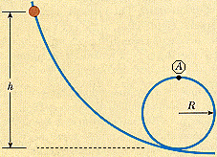

(a) What is the bead's speed at point A?

(b) How large is the normal force on the bead if its mass is 0.0045 kg?

6. An 1786 kg car stopped at a traffic light is struck from the rear by a 967 kg car. The two cars become entangled, moving along the same path as that of the originally moving car. If the smaller car were moving at 27.7 m/s before the collision, what is the velocity of the entangled cars after the collision?

7. A wheel rotates with a constant angular acceleration of 3.19 rad/s².

(a) If the initial angular speed of the wheel is 2.90 rad/s, through what angular displacement does the wheel rotate in 2.00 s?

(b) Through how many revolutions has the wheel turned during this time interval?

(c) What is the angular speed of the wheel at t = 2.00 s?

8. A student sits on a freely rotating stool holding two weights, each of mass 2.94 kg. When his arms are extended horizontally, the weights are 1.04 m from the axis of rotation and he rotates with an angular speed of 0.748 rad/s. The moment of inertia of the student plus stool is 2.94 kg·m² and is assumed to be constant. The student pulls the weights inward horizontally to a position 0.310 m from the rotation axis.

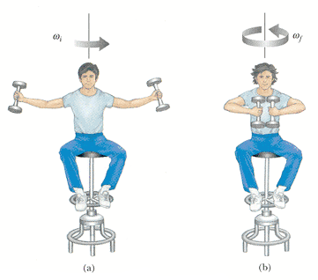

Find the new angular speed of the student.

