Phys 201 Final Exam

December 2012
2 hour and 30 minutes

Professor: Dr. Edward J. Brash

Rules and Regulations:

- Calculators, with memory cleared, are permitted.
- You may bring as many pencils, pens, and erasers with you as you like.
- No other material is permitted.
- The exam consists of two sections. For the first section, which consists of four questions, you must complete THREE of them. For the section section, which consists of five questions, you must complete THREE of them. Thus, a fully completed exam paper consists of SIX questions where you should present full solutions. The full solution questions are worth 10 points each (60 points total).
- You should complete your solutions to the full solution questions on the exam paper itself.
- Your solutions to the full solution problems should, in general, contain a combination of diagrams, equations, and English word sentences explaining your strategy and thought process.
- In any problems involving gravity, use g=9.80m/s², if necessary.

STUDENT NAME: _______________________________________

STUDENT ID NUMBER:__________________________________

QUESTIONS TO BE GRADED – SECTION I:________________

QUESTIONS TO BE GRADED – SECTION II:________________

SIGNATURE:____________________________________________

Section I – Complete THREE of the four questions in this section.

1. A particle moves according to the equation x = 11t ² where x is in meters and t is in seconds.

(a) Find the average velocity for the time interval from 2.00 s to 3.00 s.

(b) Find the average acceleration for the time interval from 2.00 s to 3.00 s.

2. A stone is thrown from the top of a building upward at an angle of 28.0° to the horizontal with an initial speed of 22.7 m/s as shown in the figure. The height of the building is 45.0 m.

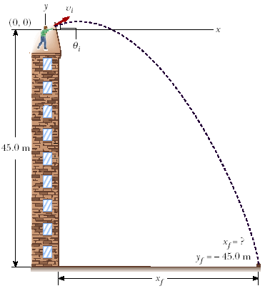

(a) How long does it take the stone to reach the ground?

(b) What is the speed of the stone just before it strikes the ground?

3. A hockey puck on a frozen pond (in Canada, of course) is given an initial speed of 16.0 m/s. If the puck always remains on the ice and slides 102 m before coming to rest, determine the coefficient of kinetic friction between the puck and ice.

4. A block of mass m = 2.00 kg is released from rest at h = 0.400 m from the surface of a table, at the top of a θ = 40.0° incline as shown below. The frictionless incline is fixed on a table of height H = 2.00 m.

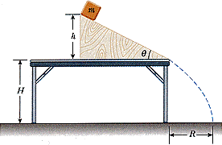

(a) Determine the acceleration of the block as it slides down the incline.

(b) What is the velocity (magnitude and direction) of the block as it leaves the incline?

(c) How far from the table will the block hit the floor?

Section II – Complete THREE of the five questions from this section.

5. A 2.00 kg object placed on a frictionless, horizontal table is connected to a string that passes over a pulley and then is fastened to a hanging 6.00 kg object, as shown in the figure. Find the magnitude of the acceleration of the two objects and the tension in the string.

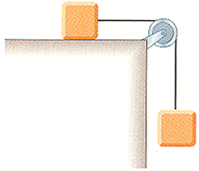

6. An 1786 kg car stopped at a traffic light is struck from the rear by a 967 kg car. The two cars become entangled, moving along the same path as that of the originally moving car. If the smaller car were moving at 27.7 m/s before the collision, what is the velocity of the entangled cars after the collision?

7. A wheel rotates with a constant angular acceleration of 3.19 rad/s².

(a) If the initial angular speed of the wheel is 2.90 rad/s, through what angular displacement does the wheel rotate in 2.00 s?

(b) Through how many revolutions has the wheel turned during this time interval?

(c) What is the angular speed of the wheel at t = 2.00 s?

8. A student sits on a freely rotating stool holding two weights, each of mass 2.94 kg. When his arms are extended horizontally, the weights are 1.04 m from the axis of rotation and he rotates with an angular speed of 0.748 rad/s. The moment of inertia of the student plus stool is 2.94 kg·m² and is assumed to be constant. The student pulls the weights inward horizontally to a position 0.310 m from the rotation axis.

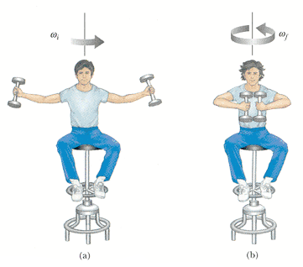

Find the new angular speed of the student.

- A mobile is constructed of light rods, light strings, and beach souvenirs, as shown in the figure. Determine the masses of the following objects, where d₁ = 4.20 cm, d₂ = 5.20 cm, d₃ = 2.70 cm, d₄ = 5.00 cm, d₅ = 2.60 cm, and d₆ = 3.70 cm.

