Phys 201 – Second Midterm Test
Fall 2012
50 minutes

Professor: Dr. Edward J. Brash

Rules and Regulations:

- Calculators, with memory cleared, are permitted.
- You may bring as many pencils, pens, and erasers with you as you like.
- You may bring 1 (one) 8.5“ x 11” piece of paper with formulas (both sides).
- No other material is permitted.
- The exam consists of 3 questions where you should present full solutions. The full solution questions are worth 10 points each (30 points total).
- You should complete your solutions to the full solution questions on the exam paper itself.
- Your solutions to the full solution problems should, in general, contain a combination of diagrams, equations, and English word sentences explaining your strategy and thought process.
- In any problems involving gravity, use g=9.80m/s², if necessary.

STUDENT NAME: _______________________________________

STUDENT ID NUMBER:__________________________________

SIGNATURE:____________________________________________

1. A block is given an initial velocity of 10.0 m/s up a 22.0° incline. The coefficient of kinetic friction between the block and the incline is 0.25. How far up the incline does the block slide before coming (momentarily) to rest?

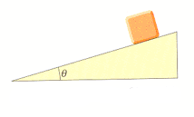

2. A bead slides without friction around a loop-the-loop as shown in the figure below. The bead is released from a height h = 3.10m, and the radius of the loop is R=1.0m.

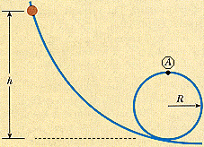

(a) What is the bead's speed at point A?

(b) How large is the normal force on the bead at point A if its mass is 0.0045 kg?

3. In a local bar, a customer slides an empty beer mug down the counter for a refill. The bartender is momentarily distracted and does not see the mug, which slides off the counter and strikes the floor 0.40 m from the base of the counter. The height of the counter is 0.860 m.

(a) With what velocity did the mug leave the counter?

(b) What was the direction of the mug's velocity just before it hit the floor?

