Phys 201 Final Exam
May 2008
2 hour and 30 minutes

Professor: Dr. Edward J. Brash

Rules and Regulations:

- Calculators, with memory cleared, are permitted.
- You may bring as many pencils, pens, and erasers with you as you like.
- No other material is permitted.
- The exam consists of 8 questions where you should present full solutions. The full solution questions are worth 10 points each (80 points total).
- You should complete your solutions to the full solution questions on the exam paper itself.
- Your solutions to the full solution problems should, in general, contain a combination of diagrams, equations, and English word sentences explaining your strategy and thought process.
- In any problems involving gravity, use g=9.80m/s², if necessary.

STUDENT NAME: _______________________________________

STUDENT ID NUMBER:__________________________________

SIGNATURE:____________________________________________

1. A person walks first at a constant speed of 5.20 m/s along a straight line from point A to point B and then back along the line from B to A at a constant speed of 3.50 m/s.

(a) What is her average speed over the entire trip?

(b) What is her average velocity over the entire trip?

2. A ball is tossed from an upper-story window of a building. The ball is given an initial velocity of 9.40 m/s at an angle of 17.0° below the horizontal. It strikes the ground 3.00 s later.

(a) How far horizontally from the base of the building does the ball strike the ground?

(b) Find the height from which the ball was thrown.

3. A block is given an initial velocity of 10.0 m/s up a 22.0° incline. The coefficient of kinetic friction between the block and the incline is 0.25. How far up the incline does the block slide before coming (momentarily) to rest?

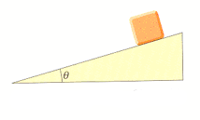

4. A curve in a road forms part of a horizontal circle. As a car goes around it at constant speed 14.0 m/s, the total force exerted on the driver has magnitude 115 N. What are the magnitude and direction of the total vector force exerted on the driver if the speed is 17.5 m/s instead?

5. A bead slides without friction around a loop-the-loop as shown in the figure below. The bead is released from a height h = 3.10m, and the radius of the loop is R=1.0m.

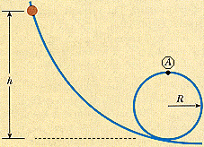

(a) What is the bead's speed at point A?

(b) How large is the normal force on the bead if its mass is 0.0045 kg?

6. A 10.0 g bullet is fired into a stationary block of wood (m = 5.10 kg). The bullet imbeds into the block. The speed of the bullet-plus-wood combination immediately after the collision is 0.606 m/s. What was the original speed of the bullet?

7. A wheel starts from rest and rotates with constant angular acceleration to reach an angular speed of 12.8 rad/s in 2.93 s.

(a) Find the magnitude of the angular acceleration of the wheel.

(b) Find the angle in radians through which it rotates in this time.

8. A student sits on a freely rotating stool holding two weights, each of mass 2.94 kg. When his arms are extended horizontally, the weights are 1.04 m from the axis of rotation and he rotates with an angular speed of 0.748 rad/s. The moment of inertia of the student plus stool is 2.94 kg·m² and is assumed to be constant. The student pulls the weights inward horizontally to a position 0.310 m from the rotation axis.

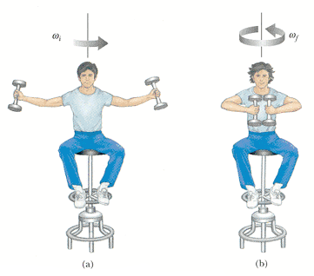

Find the new angular speed of the student.

