**Phys 340 – First Midterm Test**

**1 hour and 15 minutes**

**Professor: Dr. Edward J. Brash**

**Rules and Regulations:**

1. Calculators, with memory cleared, are permitted.
2. You may bring as many pencils, pens, and erasers with you as you like.
3. You may use your notes, as needed.
4. The test consists of three (3) questions where you should present full solutions. The full solution questions are worth 10 points each (30 points total).
5. You should complete your solutions to the full solution questions on the exam paper itself.
6. Your solutions to the full solution problems should, in general, contain a combination of diagrams, equations, and English word sentences explaining your strategy and thought process.
7. Many of the questions involve showing that certain results are true. If you cannot manage to solve one of the question parts directly, you can use the given result of that question part in attempting to solve another question part.

**STUDENT NAME: _______________________________________**

**STUDENT ID NUMBER:__________________________________**

**SIGNATURE:____________________________________________**

* 1. Consider the following three vectors:

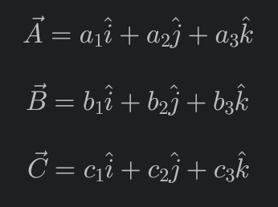

1. Calculate the following quantity:



1. Calculate the following two quantities:

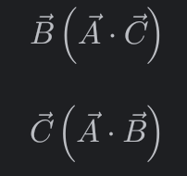

1. By comparison of the results from parts (a) and (b), show that:

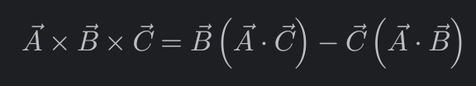

* 1. Consider the following set of coupled first-order differential equations:

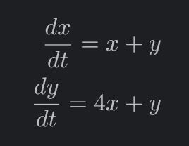

1. Express these equations in matrix form, and show that the eigenvalues of the associated transformation matrix are:

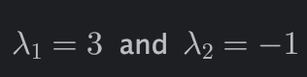

1. Show that the normalized eigenvectors of the transformation are given by:

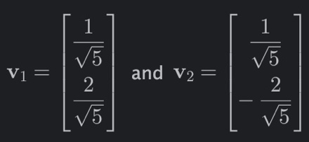

1. Assuming that the initial conditions are:

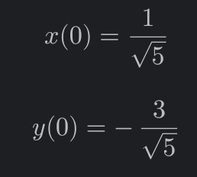

Show that the time dependent solutions for x and y are given by:

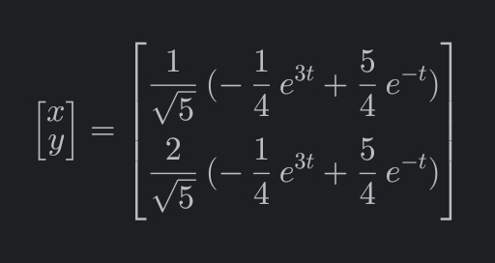

* 1. Consider a thin bar of length, a, positioned with one end at x=0 and the other at x=a. If the density of the bar, along its length, is given by:

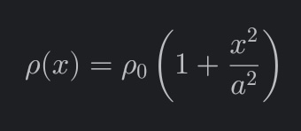

1. Show that the mass of the bar is

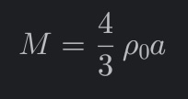

1. Show that the center of mass of the bar is at

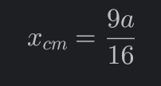

1. Show that the moment of inertia of the bar for rotation around the y-axis is:

