**ENGR 2910: Circuits Analysis I** Instructor: Leo Silbert

Quiz 6: Wednesday, Oct. 13

**Question 1 [10]**

Consider the following circuit below.

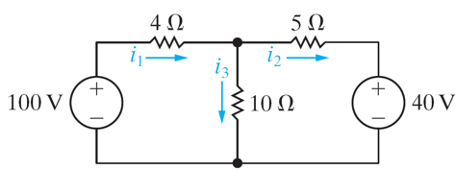

1. Calculate the values of *i1*, *i2*, and *i3* using a KCL at the top essential node, and two KVL equations for the left and right hand loops.
2. Directly on the figure, label the two mesh currents *ia* and *ib* and their directions.
3. Now, write down the values of the two mesh currents (by relating them to the three currents from (i)).