Physics 1320 – Section 101

Module 3 – Chapter 7: Electric Potential Homework

Due 2/3/2022 at 11:15

1. To form a hydrogen atom, a proton is fixed at a point and an electron is brought from far away to a distance of 0.529×10−10m, the average distance between proton and electron in a hydrogen atom. How much work is done?
2. Two parallel conducting plates are separated by 10.0 cm, and one of them is taken to be at zero volts. (a) What is the electric field strength between them, if the potential 8.00 cm from the zero volt plate (and 2.00 cm from the other) is 450 V? (b) What is the voltage between the plates?
3. The electric field in a region is pointed away from the z-axis and the magnitude depends upon the distance *s* from the axis. The magnitude of the electric field is given as $E=\frac{α}{s}$  where α is a constant. Find the potential difference between points $P_{1}$  and $P_{2}$, explicitly stating the path over which you conduct the integration for the line integral.

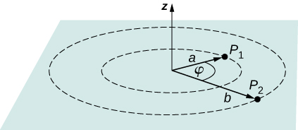

1. In a particular region, the electric potential is given by $V=-xy^{2}z+4xy$. What is the electric field in this region?
2. Shown below are two concentric spherical shells of negligible thicknesses and radii $R_{1}$  and $R_{2}$ . The inner and outer shell carry net charges $q_{1}$  and $q_{2}$  , respectively, where both $q_{1}$  and $q_{2}$  are positive. What is the electric potential in the regions (a) r < $R_{1}$, (b) $R_{1}$ < r < $R_{2}$, and (c) r > $R_{2}$?

