***University Physics Volume II***

**Unit 1: Thermodynamics**

**Chapter 3: The First Law of Thermodynamics**

**Conceptual Questions**

1. Consider these scenarios and state whether work is done by the system on the environment (SE) or by the environment on the system (ES): (a) opening a carbonated beverage; (b) filling a flat tire; (c) a sealed empty gas can expands on a hot day, bowing out the walls.

Solution

a. SE; b. ES; c. ES

1. Is it possible to determine whether a change in internal energy is caused by heat transferred, by work performed, or by a combination of the two?

Solution

Unless the situation is given, you cannot determine whether a change in internal energy is caused by heat transfer, work, or a combination of the two.

1. When a liquid is vaporized, its change in internal energy is not equal to the heat added. Why?

Solution

Some of the energy goes into changing the phase of the liquid to gas.

1. Why does a bicycle pump feel warm as you inflate your tire?

Solution

As you pump a tire, you transfer energy to the air inside the pump. As that air moves into a smaller volume, the air molecules collide more with the walls of the pump. Therefore, the pump feels hotter.

1. Is it possible for the temperature of a system to remain constant when heat flows into or out of it? If so, give examples.

Solution

Yes, as long as the work done equals the heat added there will be no change in internal energy and thereby no change in temperature. When water freezes or when ice melts while removing or adding heat, respectively, the temperature remains constant.

1. What does the first law of thermodynamics tell us about the energy of the universe?

Solution

You cannot get more energy out of a system than you put in.

1. Does adding heat to a system always increase its internal energy?

Solution

If more work is done on the system than heat added, the internal energy of the system will actually decrease.

1. A great deal of effort, time, and money has been spent in the quest for a so-called perpetual-motion machine, which is defined as a hypothetical machine that operates or produces useful work indefinitely and/or a hypothetical machine that produces more work or energy than it consumes. Explain, in terms of the first law of thermodynamics, why or why not such a machine is likely to be constructed.

Solution

According to the first law of thermodynamics, you must put energy into a system to produce work. You can only get work out of it at least from the energy you put into it. Therefore, due to external forces such as friction, motion will eventually stop unless you add additional energy.

1. When a gas expands isothermally, it does work. What is the source of energy needed to do this work?

Solution

The system must be in contact with a heat source that allows heat to flow into the system.

1. If the pressure and volume of a system are given, is the temperature always uniquely determined?

Solution

If you know the amount of gas (number of moles), then the temperature is uniquely determined.

1. It is unlikely that a process can be isothermal unless it is a very slow process. Explain why. Is the same true for isobaric and isochoric processes? Explain your answer.

Solution

Isothermal processes must be slow to make sure that as heat is transferred, the temperature does not change. Even for isobaric and isochoric processes, the system must be in thermal equilibrium with slow changes of thermodynamic variables.

1. How can an object transfer heat if the object does not possess a discrete quantity of heat?

Solution

An object possesses internal energy, not heat. Heat is the transfer of energy.

1. Most materials expand when heated. One notable exception is water between 0 °C and 4 °C, which actually decreases in volume with the increase in temperature. Which is greater for water in this temperature region, *CP* or *CV*?

Solution

Typically *CP* is greater than *CV* because when expansion occurs under constant pressure, it does work on the surroundings. Therefore, heat can go into internal energy and work. Under constant volume, all heat goes into internal energy. In this example, water contracts upon heating, so if we add heat at constant pressure, work is done on the water by surroundings and therefore, *CP* is less than *CV*.

1. Why are there two specific heats for gases *CP* and *CV*, yet only one given for solid?

Solution

Specific heat is the amount of heat we need to raise the temperature of a system. For gases, this depends on what is held constant, whereas solids are incompressible and therefore won’t have these values changing while heating.

1. Is it possible for  to be smaller than unity?

Solution

No, it is always greater than 1.

1. Would you expect  to be larger for a gas or a solid? Explain.

Solution

It takes much more energy to heat a solid at constant pressure, so I would expect gamma to be larger for a solid.

1. There is no change in the internal energy of an ideal gas undergoing an isothermal process since the internal energy depends only on the temperature. Is it therefore correct to say that an isothermal process is the same as an adiabatic process for an ideal gas? Explain your answer.

Solution

An adiabatic process has a change in temperature but no heat flow. The isothermal process has no change in temperature but has heat flow.

1. Does a gas do any work when it expands adiabatically? If so, what is the source of the energy needed to do this work?

Solution

Yes, an adiabatic expansion does work and it comes from an increase in internal energy or temperature.

**Problems**

1. A gas follows  on an isothermal curve, where *p* is the pressure, *V* is the volume, *b* is a constant, and *c* is a function of temperature. Show that a temperature scale under an isochoric process can be established with this gas and is identical to that of an ideal gas.

Solution

 is the temperature scale desired and mirrors the ideal gas if under constant volume.

1. A mole of gas has isobaric expansion coefficient  and isochoric pressure-temperature coefficient  Find the equation of state of the gas.

Solution



1. Find the equation of state of a solid that has an isobaric expansion coefficient and an isothermal pressure-volume coefficient 

Solution



1. A gas at a pressure of 2.00 atm undergoes a quasi-static isobaric expansion from 3.00 to 5.00 L. How much work is done by the gas?

Solution

404 J

1. It takes 500 J of work to compress quasi-statically 0.50 mol of an ideal gas to one-fifth its original volume. Calculate the temperature of the gas, assuming it remains constant during the compression.

Solution

74 K

1. It is found that, when a dilute gas expands quasi-statically from 0.50 to 4.0 L, it does 250 J of work. Assuming that the gas temperature remains constant at 300 K, how many moles of gas are present?

Solution

0.048 mol

1. In a quasi-static isobaric expansion, 500 J of work are done by the gas. If the gas pressure is 0.80 atm, what is the fractional increase in the volume of the gas, assuming it was originally at 20.0 L?

Solution

0.31

1. When a gas undergoes a quasi-static isobaric change in volume from 10.0 to 2.0 L, 15 J of work from an external source are required. What is the pressure of the gas?

Solution

1875 Pa

1. An ideal gas expands quasi-statically and isothermally from a state with pressure p and volume V to a state with volume 4V. Show that the work done by the gas in the expansion is pV(ln 4).

Solution

pVln(4)

1. As shown below, calculate the work done by the gas in the quasi-static processes represented by the paths (a) AB; (b) ADB; (c) ACB; and (d) ADCB.

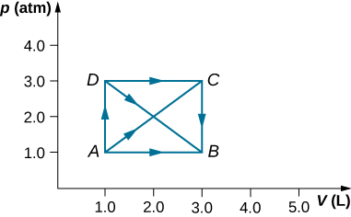

Solution

a. 200 J; b. 400 J; c. 400 J; d. 600 J

1. (a) Calculate the work done on the gas along the closed path shown below. The curved section between R and S is semicircular. (b) If the process is carried out in the opposite direction, what is the work done on the gas?

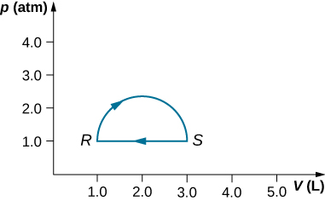

Solution

a. 160 J; b. –160 J

1. An ideal gas expands quasi-statically to three times its original volume. Which process requires more work from the gas, an isothermal process or an isobaric one? Determine the ratio of the work done in these processes.

Solution

isobaric is more work; 1.82 times more work

1. A dilute gas at a pressure of 2.0 atm and a volume of 4.0 L is taken through the following quasi-static steps: (a) an isobaric expansion to a volume of 10.0 L, (b) an isochoric change to a pressure of 0.50 atm, (c) an isobaric compression to a volume of 4.0 L, and (d) an isochoric change to a pressure of 2.0 atm. Show these steps on a pV diagram and determine from your graph the net work done by the gas.

Solution

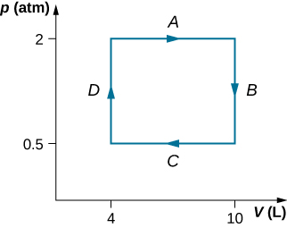; 

1. What is the average mechanical energy of the atoms of an ideal monatomic gas at 300 K?

Solution



1. What is the internal energy of 6.00 mol of an ideal monatomic gas at ?

Solution



1. Calculate the internal energy of 15 mg of helium at a temperature of .

Solution

12 J

1. Two monatomic ideal gases A and B are at the same temperature. If 1.0 g of gas A has the same internal energy as 0.10 g of gas B, what are (a) the ratio of the number of moles of each gas and (b) the ration of the atomic masses of the two gases?

Solution

a. 1:1; b. 10:1

1. The van der Waals coefficients for oxygen are  and . Use these values to draw a van der Waals isotherm of oxygen at 100 K. On the same graph, draw isotherms of one mole of an ideal gas.

Solution

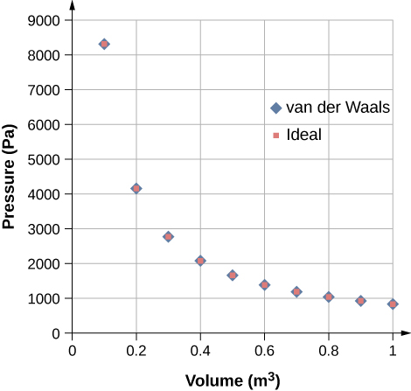

1. Find the work done in the quasi-static processes shown below. The states are given as (p, V ) values for the points in the pV plane: 1 (3 atm, 4 L), 2 (3 atm, 6 L), 3 (5 atm, 4 L), 4 (2 atm, 6 L), 5 (4 atm, 2 L), 6 (5 atm, 5 L), and 7 (2 atm, 5 L).

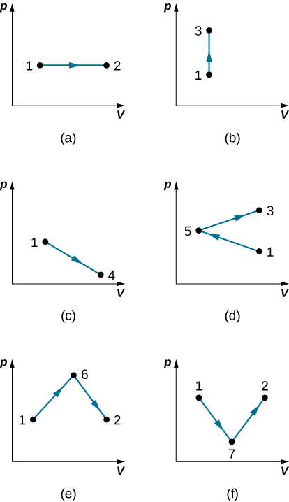

Solution

a. 600 J; b. 0; c. 500 J; d. 200 J; e. 800 J; f. 500 J

1. When a dilute gas expands quasi-statically from 0.50 to 4.0 L, it does 250 J of work. Assuming that the gas temperature remains constant at 300 K, (a) what is the change in the internal energy of the gas? (b) How much heat is absorbed by the gas in this process?

Solution

a. 0; b. 250 J

1. In an expansion of a gas, 500 J of work are done by the gas. If the internal energy of the gas increased by 80 J in the expansion, how much heat does the gas absorb?

Solution

580 J

1. An ideal gas expands quasi-statically and isothermally from a state with pressure p and volume V to a state with volume 4V. How much heat is added to the expanding gas?

Solution

pVln(4)

1. As shown below, if the heat absorbed by the gas along AB is 400 J, determine the quantities of heat absorbed along (a) ADB; (b) ACB; and (c) ADCB.



Solution

a. 600 J; b. 600 J; c. 800 J

1. During the isobaric expansion from A to B represented below, 3,100 J of heat are added to the gas. What is the change in its internal energy?

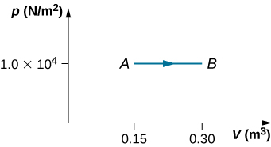

Solution

1,600 J

1. (a) What is the change in internal energy for the process represented by the closed path shown below? (b) How much heat is exchanged? (c) If the path is traversed in the opposite direction, how much heat is exchanged?



Solution

a. 0; b. 160 J; c. –160 J

1. When a gas expands along path AC shown below, it does 400 J of work and absorbs either 200 or 400 J of heat. (a) Suppose you are told that along path ABC, the gas absorbs either 200 or 400 J of heat. Which of these values is correct? (b) Give the correct answer from part (a), how much work is done by the gas along ABC? (c) Along CD, the internal energy of the gas decreases by 50 J. How much heat is exchanged by the gas along this path?

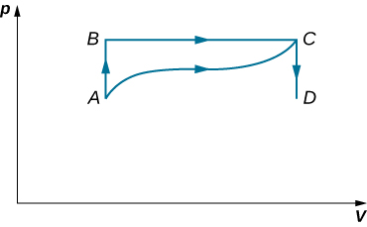

Solution

a. 200 J; b. 600 J; c. 50 J

1. When a gas expands along *AB* (see below), it does 20 J of work and absorbs 30 J of heat. When the gas expands along *AC*, it does 40 J of work and absorbs 70 J of heat. (a) How much heat does the gas exchange along *BC*? (b) When the gas makes the transition from *C* to *A* along *CDA*, 60 J of work are done on it from *C* to *D*. How much heat does it exchange along *CDA*?

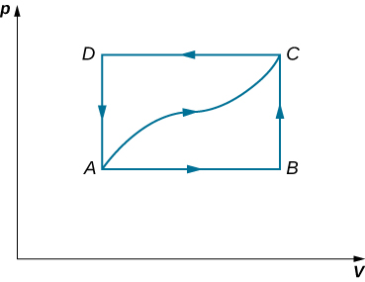

Solution

a. 20 J; b. 90 J

1. A dilute gas is stored in the left chamber of a container whose walls are perfectly insulating (see below), and the right chamber is evacuated. When the partition is removed, the gas expands and fills the entire container. Calculate the work done by the gas. Does the internal energy of the gas change in this process?



Solution

 

1. Ideal gases A and B are stored in the left and right chambers of an insulated container, as shown below. The partition is removed and the gases mix. Is any work done in this process? If the temperatures of A and B are initially equal, what happens to their common temperature after they are mixed?

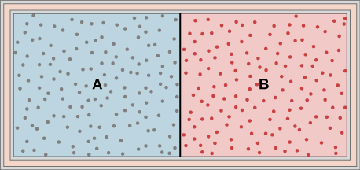

Solution

No work is done and they reach the same common temperature.

1. An ideal monatomic gas at a pressure of 2.0 × 105 N/m2 and a temperature of 300 K undergoes a quasi-static isobaric expansion from 2.0 × 103 to 4.0 × 103 cm3 (a) What is the work done by the gas? (b) What is the temperature of the gas after the expansion? (c) How many moles of gas are there? (d) What is the change in internal energy of the gas? (e) How much heat is added to the gas?

Solution

a. 400 J; b. 600 K; c. 0.16 mol; d. 600 J; e. 600 J

1. Consider the process for steam in a cylinder shown below. Suppose the change in the internal energy in this process is 30 kJ. Find the heat entering the system.

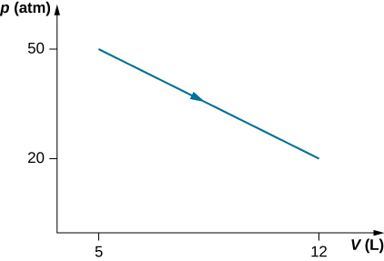

Solution

54,500 J

1. The state of 30 moles of steam in a cylinder is changed in a cyclic manner from a-b-c-a, where the pressure and volume of the states are: a (30 atm, 20 L), b (50 atm, 20 L), and c (50 atm, 45 L). Assume each change takes place along the line connecting the initial and ﬁnal states in the pV plane. (a) Display the cycle in the pV plane. (b) Find the net work done by the steam in one cycle. (c) Find the net amount of heat ﬂow in the steam over the course of one cycle.

Solution

a. Draw V on the x-axis and p on the y-axis. b. 25,300 J; c. 25,300 J

1. A monatomic ideal gas undergoes a quasi-static process that is described by the function , where the starting state is  and the ﬁnal state . Assume the system consists of n moles of the gas in a container that can exchange heat with the environment and whose volume can change freely. (a) Evaluate the work done by the gas during the change in the state. (b) Find the change in internal energy of the gas. (c) Find the heat input to the gas during the change. (d) What are initial and ﬁnal temperatures?

Solution

a. ; b. ; c. the sum of parts (a) and (b); d.  and 

1. A metallic container of ﬁxed volume of  immersed in a large tank of temperature  contains two compartments separated by a freely movable wall. Initially, the wall is kept in place by a stopper so that there are 0.02 mol of the nitrogen gas on one side and 0.03 mol of the oxygen gas on the other side, each occupying half the volume. When the stopper is removed, the wall moves and comes to a ﬁnal position. The movement of the wall is controlled so that the wall moves in inﬁnitesimal quasi-static steps. (a) Find the ﬁnal volumes of the two sides assuming the ideal gas behavior for the two gases. (b) How much work does each gas does on the other? (c) What is the change in the internal energy of each gas? (d) Find the amount of heat that enters or leaves each gas.

Solution

a. 1.0 L, 1.5 L; b. oxygen side: 13.6 J, nitrogen side: *−*13.6 J; c. 0; d. oxygen side: 13.6 J, nitrogen side: *−*13.6 J

1. A gas in a cylindrical closed container is adiabatically and quasi-statically expanded from a state *A* (3 MPa, 2 L) to a state *B* with volume of 6 L along the path  (a) Plot the path in the *pV* plane. (b) Find the amount of work done by the gas and the change in the internal energy of the gas during the process.

Solution

a. 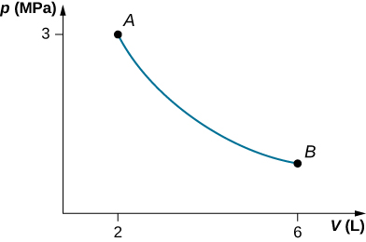; b. 

1. Two moles of a monatomic ideal gas at (5 MPa, 5 L) is expanded isothermally until the volume is doubled (step 1). Then it is cooled isochorically until the pressure is 1 MPa (step 2). The temperature drops in this process. The gas is now compressed isothermally until its volume is back to 5 L, but its pressure is now 2 MPa (step 3). Finally, the gas is heated isochorically to return to the initial state (step 4). (a) Draw the four processes in the pV plane. (b) Find the total work done by the gas.

Solution

a. 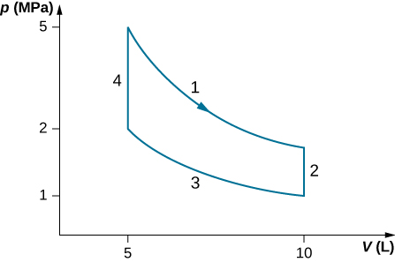; b. 

1. Consider a transformation from point *A* to *B* in a two-step process. First, the pressure is lowered from 3 MPa at point *A* to a pressure of 1 MPa, while keeping the volume at 2 L by cooling the system. The state reached is labeled *C*. Then the system is heated at a constant pressure to reach a volume of 6 L in the state *B*. (a) Find the amount of work done on the *ACB* path. (b) Find the amount of heat exchanged by the system when it goes from *A* to *B* on the *ACB* path. (c) Compare the change in the internal energy when the *AB* process occurs isothermally with the *AB* change through the two-step process on the *ACB* path.

Solution

a. 4000 J; b. −4000 J; c. It does not depend on the process.

1. Consider a cylinder with a movable piston containing n moles of an ideal gas. The entire apparatus is immersed in a constant temperature bath of temperature T kelvin. The piston is then pushed slowly so that the pressure of the gas changes quasi-statically from  to  at constant temperature T. Find the work done by the gas in terms of n, R, T,  and 

Solution



1. An ideal gas expands isothermally along AB and does 700 J of work (see below). (a) How much heat does the gas exchange along AB? (b) The gas then expands adiabatically along BC and does 400 J of work. When the gas returns to A along CA, it exhausts 100 J of heat to its surroundings. How much work is done on the gas along this path?

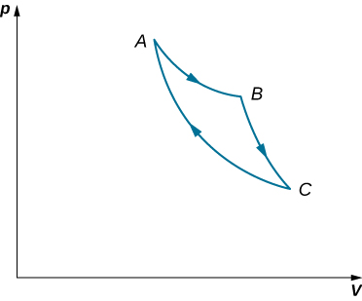

Solution

a. 700 J; b. 500 J

1. Consider the processes shown below for a monatomic gas. (a) Find the work done in each of the processes AB, BC, AD, and DC. (b) Find the internal energy change in processes AB and BC. (c) Find the internal energy difference between states C and A. (d) Find the total heat added in the ADC process. (e) From the information given, can you ﬁnd the heat added in process AD? Why or why not?

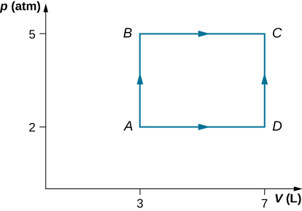

Solution

a.  b.  c.  d.  e. No, because it could have been added during either AD or DC and not enough information is given.

1. Two moles of helium gas are placed in a cylindrical container with a piston. The gas is at room temperature  and under a pressure of  When the pressure from the outside is decreased while keeping the temperature the same as the room temperature, the volume of the gas doubles. (a) Find the work the external agent does on the gas in the process. (b) Find the heat exchanged by the gas and indicate whether the gas takes in or gives up heat. Assume ideal gas behavior.

Solution

a. −3 400 J; b. 3400 J enters the gas

1. An amount of n moles of a monatomic ideal gas in a conducting container with a movable piston is placed in a large thermal heat bath at temperature  and the gas is allowed to come to equilibrium. After the equilibrium is reached, the pressure on the piston is lowered so that the gas expands at constant temperature. The process is continued quasi-statically until the ﬁnal pressure is 4/3 of the initial pressure  (a) Find the change in the internal energy of the gas. (b) Find the work done by the gas. (c) Find the heat exchanged by the gas, and indicate, whether the gas takes in or gives up heat.

Solution

a. 0; b. ; c. , absorbs heat

1. The temperature of an ideal monatomic gas rises by 8.0 K. What is the change in the internal energy of 1 mol of the gas at constant volume?

Solution

100 J

1. For a temperature increase of  at constant volume, what is the heat absorbed by (a) 3.0 mol of a dilute monatomic gas; (b) 0.50 mol of a dilute diatomic gas; and (c) 15 mol of a dilute polyatomic gas?

Solution

a. 370 J; b. 100 J; c. 500 J

1. If the gases of the preceding problem are initially at 300 K, what are their internal energies after they absorb the heat?

Solution

a. 370 J; b. 100 J; c. 500 J

1. Consider 0.40 mol of dilute carbon dioxide at a pressure of 0.50 atm and a volume of 50 L. What is the internal energy of the gas?

Solution

7600 J

1. When 400 J of heat are slowly added to 10 mol of an ideal monatomic gas, its temperature rises by 10 °C. What is the work done on the gas?

Solution

850 J

1. One mole of a dilute diatomic gas occupying a volume of 10.00 L expands against a constant pressure of 2.000 atm when it is slowly heated. If 400.0 J of heat are added in the process, what is its final volume?

Solution

1. 10.57 LA monatomic ideal gas undergoes a quasi-static adiabatic expansion in which its volume is doubled. How is the pressure of the gas changed?

Solution

pressure decreased by 0.31 times the original pressure

1. An ideal gas has a pressure of 0.50 atm and a volume of 10 L. It is compressed adiabatically and quasi-statically until its pressure is 3.0 atm and its volume is 2.8 L. Is the gas monatomic, diatomic, or polyatomic?

Solution

diatomic

1. Pressure and volume measurements of a dilute gas undergoing a quasi-static adiabatic expansion are shown below. Plot ln p vs. V and determine  for this gas from your graph.

|  |  |  |  |  |  |  |  |  |
| --- | --- | --- | --- | --- | --- | --- | --- | --- |
| P (atm) | 20.0 | 17.0 | 14.0 | 11.0 | 8.0 | 5.0 | 2.0 | 1.0 |
| V (L) | 1.0 | 1.1 | 1.3 | 1.5 | 2.0 | 2.6 | 5.2 | 8.4 |

Solution

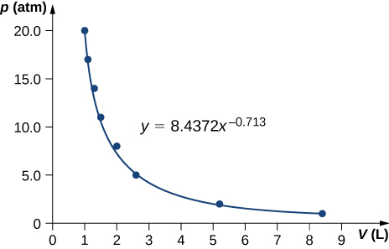; 

1. An ideal monatomic gas at 300 K expands adiabatically and reversibly to twice its volume. What is its final temperature?

Solution

189 K

1. An ideal diatomic gas at 80 K is slowly compressed adiabatically and reversibly to half its volume. What is its final temperature?

Solution

106 K

1. An ideal diatomic gas at 80 K is slowly compressed adiabatically to one-third its original volume. What is its final temperature?

Solution

124 K

1. Compare the charge in internal energy of an ideal gas for a quasi-static adiabatic expansion with that for a quasi-static isothermal expansion. What happens to the temperature of an ideal gas in an adiabatic expansion?

Solution

An adiabatic expansion has less work done and no heat flow, thereby a lower internal energy comparing to an isothermal expansion which has both heat flow and work done. Temperature decreases during adiabatic expansion.

1. The temperature of n moles of an ideal gas changes from  to  in a quasi-static adiabatic transition. Show that the work done by the gas is given by



Solution

derivation

1. A dilute gas expands quasi-statically to three times its initial volume. Is the final gas pressure greater for an isothermal or an adiabatic expansion? Does your answer depend on whether the gas is monatomic, diatomic, or polyatomic?

Solution

Isothermal has a greater final pressure and does not depend on the type of gas.

1. (a) An ideal gas expands adiabatically from a volume of  to . If the initial pressure and temperature were  and 300 K, respectively, what are the ﬁnal pressure and temperature of the gas? Use  for the gas. (b) In an isothermal process, an ideal gas expands from a volume of  to . If the initial pressure and temperature were  and 300 K, respectively, what are the ﬁnal pressure and temperature of the gas?

Solution

a. ; 260 K; b. ; 300 K

1. On an adiabatic process of an ideal gas pressure, volume and temperature change such that  is constant with  for monatomic gas such as helium and  for diatomic gas such as hydrogen at room temperature. Use numerical values to plot two isotherms of 1 mol of helium gas using ideal gas law and two adiabatic processes mediating between them. Use  for your plot.

Solution

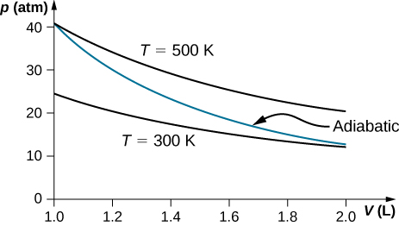

1. Two moles of a monatomic ideal gas such as helium is compressed adiabatically and reversibly from a state (3 atm, 5 L) to a state with pressure 4 atm. (a) Find the volume and temperature of the ﬁnal state. (b) Find the temperature of the initial state of the gas. (c) Find the work done by the gas in the process. (d) Find the change in internal energy of the gas in the process.

Solution

a. , 102.6 K; b. 91.5 K; c.  d. 278 J

**Additional Problems**

1. Consider the process shown below. During steps *AB* and *BC*, 3600 J and 2400 J of heat, respectively, are added to the system. (a) Find the work done in each of the processes *AB*, *BC*, *AD*, and *DC*. (b) Find the internal energy change in processes *AB* and *BC*. (c) Find the internal energy difference between states *C* and *A*. (d) Find the total heat added in the *ADC* process. (e) From the information given, can you find the heat added in process *AD*? Why or why not?



Solution

a. 

b.  c.  d.  e. No, because heat was added for both parts *AD* and *DC*. There is not enough information to figure out how much is from each segment of the path.

1. A car tire contains  of air at a pressure of  (about 32 psi). How much more internal energy does this gas have than the same volume has at zero gauge pressure (which is equivalent to normal atmospheric pressure)?

Solution



1. A helium-filled toy balloon has a gauge pressure of 0.200 atm and a volume of 10.0 L. How much greater is the internal energy of the helium in the balloon than it would be at zero gauge pressure?

Solution

300 J

1. Steam to drive an old-fashioned steam locomotive is supplied at a constant gauge pressure of  (about 250 psi) to a piston with a 0.200-m radius. (a) By calculating , find the work done by the steam when the piston moves 0.800 m. Note that this is the net work output, since gauge pressure is used. (b) Now find the amount of work by calculating the force exerted times the distance traveled. Is the answer the same as in part (a)?

Solution

a. ; b. 

1. A hand-driven tire pump has a piston with a 2.50-cm diameter and a maximum stroke of 30.0 cm. (a) How much work do you do in one stroke if the average gauge pressure is  (about 35 psi)? (b) What average force do you exert on the piston, neglecting friction and gravitational force?

Solution

a. 59.5 J; b. 170 N

1. Calculate the net work output of a heat engine following path *ABCDA* as shown below.

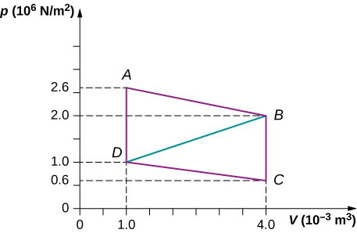

Solution



1. What is the net work output of a heat engine that follows path *ABDA* in the preceding problem with a straight line from *B* to *D*? Why is the work output less than for path *ABCDA*?

Solution



1. Five moles of a monatomic ideal gas in a cylinder at  is expanded isothermally from a volume of 5 L to 10 L. (a) What is the change in internal energy? (b) How much work was done on the gas in the process? (c) How much heat was transferred to the gas?

Solution

a. 0; b. –8,640 J; c. 8,640 J

1. Four moles of a monatomic ideal gas in a cylinder at  is expanded at constant pressure equal to 1 atm until its volume doubles. (a) What is the change in internal energy? (b) How much work was done by the gas in the process? (c) How much heat was transferred to the gas?

Solution

a. 15,000 J; b. 10,000 J; c. 25,000 J

1. Helium gas is cooled from  to  by expanding from 40 atm to 1 atm. If there is 1.4 mol of helium, (a) What is the final volume of helium? (b) What is the change in internal energy?

Solution

a. 33 L; b. –116 J

1. In an adiabatic process, oxygen gas in a container is compressed along a path that can be described by the following pressure in atm as a function of volume V, with : . The initial and ﬁnal volumes during the process were 2 L and 1.5 L, respectively. Find the amount of work done on the gas.

Solution

78 J

1. A cylinder containing three moles of a monatomic ideal gas is heated at a constant pressure of 2 atm. The temperature of the gas changes from 300 K to 350 K as a result of the expansion. Find work done (a) on the gas; and (b) by the gas.

Solution

a. −1250 J; b. +1250 J

1. A cylinder containing three moles of nitrogen gas is heated at a constant pressure of 2 atm. The temperature of the gas changes from 300 K to 350 K as a result of the expansion. Find work done (a) on the gas, and (b) by the gas by using van der Waals equation of state instead of ideal gas law.

Solution

A cylinder containing three moles of nitrogen gas is heated at a constant pressure of 2 atm. a. *−*1220 J; b. +1220 J

1. Two moles of a monatomic ideal gas such as helium is compressed adiabatically and reversibly from a state (3 atm, 5 L) to a state with a pressure of 4 atm. (a) Find the volume and temperature of the ﬁnal state. (b) Find the temperature of the initial state. (c) Find work done by the gas in the process. (d) Find the change in internal energy in the process. Assume  and  for the diatomic ideal gas in the conditions given.

Solution

a.  b.  c.  d. 320 J

1. An insulated vessel contains 1.5 moles of argon at 2 atm. The gas initially occupies a volume of 5 L. As a result of the adiabatic expansion the pressure of the gas is reduced to 1 atm. (a) Find the volume and temperature of the ﬁnal state. (b) Find the temperature of the gas in the initial state. (c) Find the work done by the gas in the process. (d) Find the change in the internal energy of the gas in the process.

Solution

a. 7.6 L, 61.6 K; b. 81.3 K; c. ; d. -367 J

**Challenge Problems**

1. One mole of an ideal monatomic gas occupies a volume of 1.0 × 10–2 m3 at a pressure of 2.0 × 105 N/m2. (a) What is the temperature of the gas? (b) The gas undergoes a quasi-static adiabatic compression until its volume is decreased to 5.0 × 10–3 m3. What is the new gas temperature? (c) How much work is done on the gas during the compression? (d) What is the change in the internal energy of the gas?

Solution

a. 241 K; b. 383 K; c. 1760 J; d. 1760 J

1. One mole of an ideal gas is initially in a chamber of volume 1.0 × 10–2 m3 and at a temperature of 27 °C. (a) How much heat is absorbed by the gas when it slowly expands isothermally to twice its initial volume? (b) Suppose the gas is slowly transformed to the same final state by first decreasing the pressure at constant volume and then expanding it isobarically. What is the heat transferred for this case? (c) Calculate the heat transferred when the gas is transformed quasi-statically to the same final state by expanding it isobarically, then decreasing its pressure at constant volume.

Solution

a. 1700 J; b. 1200 J; c. 2400 J

1. A bullet of mass 10 g is traveling horizontally at 200 m/s when it strikes and embeds in a pendulum bob of mass 2.0 kg. (a) How much mechanical energy is dissipated in the collision? (b) Assuming that *CV* for the bob plus bullet is 3R, calculate the temperature increase of the system due to the collision. Take the molecular mass of the system to be 200 g/mol.

Solution

a. 199 J; b. 0.79 K

1. The insulated cylinder shown below is closed at both ends and contains an insulating piston that is free to move on frictionless bearings. The piston divides the chamber into two compartments containing gases A and B. Originally, each compartment has a volume of 5.0 × 10–2 m3 and contains a monatomic ideal gas at a temperature of 0 °C and a pressure of 1.0 atm. (a) How many moles of gas are in each compartment? (b) Heat Q is slowly added to A so that it expands and B is compressed until the pressure of both gases is 3.0 atm. Use the fact that the compression of B is adiabatic to determine the final volume of both gases. (c) What are their final temperatures? (d) What is the value of Q?

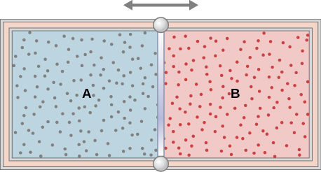

Solution

a. 2.2 mol; b. , ; c. ; d. 30,500 J

1. In a diesel engine, the fuel is ignited without a spark plug. Instead, air in a cylinder is compressed adiabatically to a temperature above the ignition temperature of the fuel; at the point of maximum compression, the fuel is injected into the cylinder. Suppose that air at 20 °C is taken into the cylinder at a volume *V*1 and then compressed adiabatically and quasi-statically to a temperature of  and a volume *V*2. If  what is the ratio *V*1/*V*2? (Note: In an operating diesel engine, the compression is not quasi-static.)

Solution

15:1

This file is copyright 2016, Rice University. All Rights Reserved.