***University Physics Volume II***

**Unit 2: Electricity and Magnetism**

**Chapter 5: Electric Charges and Fields**

**Conceptual Questions**

1. There are very large numbers of charged particles in most objects. Why, then, don’t most objects exhibit static electricity?

Solution

There are mostly equal numbers of positive and negative charges present, making the object electrically neutral.

1. Why do most objects tend to contain nearly equal numbers of positive and negative charges?

Solution

Most objects are in contact with other objects that are good enough conductors to equalize the charges, which is almost everything.

1. A positively charged rod attracts a small piece of cork. (a) Can we conclude that the cork is negatively charged? (b) The rod repels another small piece of cork. Can we conclude that this piece is positively charged?

Solution

a. yes; b. yes

1. Two bodies attract each other electrically. (a) Do they both have to be charged? (b) Answer the same question if the bodies repel one another.

Solution

(a) No. A charged object can attract a neutral object if it can be polarized. See figures 5.2 and 5.3. (b) Yes. If two object repel each other, they both must be charged.

1. How would you determine whether the charge on a particular rod is positive or negative?

Solution

Take an object with a known charge, either positive or negative, and bring it close to the rod. If the known charged object is positive and it is repelled from the rod, the rod is charged positive. If the positively charged object is attracted to the rod, the rod is negatively charged.

1. An eccentric inventor attempts to levitate a cork ball by wrapping it with foil and placing a large negative charge on the ball and then putting a large positive charge on the ceiling of his workshop. Instead, while attempting to place a large negative charge on the ball, the foil flies off. Explain.

Solution

The foil becomes polarized when the large negative charge nears it, producing a negative charge on its inside surface. This induced charge repels the foil off the ball.

1. When a glass rod is rubbed with silk, it becomes positive and the silk becomes negative—yet both attract dust. Does the dust have a third type of charge that is attracted to both positive and negative? Explain.

Solution

No, the dust is attracted to both because the dust particle molecules become polarized in the direction of the silk.

1. Why does a car always attract dust right after it is polished? (Note that car wax and car tires are insulators.)

Solution

The polishing charges the surface of the car and then dust is attracted to it due to polarization charges on the dust particles.

1. Does the uncharged conductor shown below experience a net electric force?

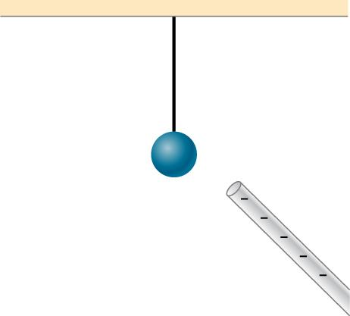

Solution

Yes, polarization charge is induced on the conductor so that the positive charge is nearest the charged rod, causing an attractive force.

1. While walking on a rug, a person frequently becomes charged because of the rubbing between his shoes and the rug. This charge then causes a spark and a slight shock when the person gets close to a metal object. Why are these shocks so much more common on a dry day?

Solution

If water molecules are present, this reduces charge separation because water molecules are polarized. There are fewer water molecules in the air on a dry day, which increases the separation between two charged objects.

1. Compare charging by conduction to charging by induction.

Solution

Charging by conduction is charging by contact where charge is transferred to the object. Charging by induction first involves producing a polarization charge in the object and then connecting a wire to ground to allow some of the charge to leave the object, leaving the object charged.

1. Small pieces of tissue are attracted to a charged comb. Soon after sticking to the comb, the pieces of tissue are repelled from it. Explain.

Solution

Once in contact with the comb, the tissue becomes charged with the same charge as the comb and therefore is repelled.

1. Trucks that carry gasoline often have chains dangling from their undercarriages and brushing the ground. Why?

Solution

This is so that any excess charge is transferred to the ground, keeping the gasoline receptacles neutral. If there is excess charge on the gasoline receptacle, a spark could ignite it.

1. Why do electrostatic experiments work so poorly in humid weather?

Solution

because the air contains more polarized water molecules, which reduces static electricity produced by charged objects

1. Why do some clothes cling together after being removed from the clothes dryer? Does this happen if they’re still damp?

Solution

The dryer charges the clothes. If they are damp, the presence of water molecules suppresses the charge.

1. Can induction be used to produce charge on an insulator?

Solution

No, charges cannot move on an insulator.

1. Suppose someone tells you that rubbing quartz with cotton cloth produces a third kind of charge on the quartz. Describe what you might do to test this claim.

Solution

There are only two types of charge, attractive and repulsive. If you bring a charged object near the quartz, only one of these two effects will happen, proving there is not a third kind of charge.

1. A handheld copper rod does not acquire a charge when you rub it with a cloth. Explain why.

Solution

The rubbing of the cloth does not remove electrons from it.

1. Suppose you place a charge *q* near a large metal plate. (a) If *q* is attracted to the plate, is the plate necessarily charged? (b) If *q* is repelled by the plate, is the plate necessarily charged?

Solution

a. No, since a polarization charge is induced. b. Yes, since the polarization charge would produce only an attractive force.

1. Would defining the charge on an electron to be positive have any effect on Coulomb’s law?

Solution

No, although the direction of the force vector would be reversed in systems with electrons, if all else remained the same.

1. An atomic nucleus contains positively charged protons and uncharged neutrons. Since nuclei do stay together, what must we conclude about the forces between these nuclear particles?

Solution

The force holding the nucleus together must be greater than the electrostatic repulsive force on the protons.

1. Is the force between two fixed charges influenced by the presence of other charges?

Solution

No, but the net force on either fixed charge is influenced by the presence of other charges.

1. When measuring an electric field, could we use a negative rather than a positive test charge?

Solution

Either sign of the test charge could be used, but the convention is to use a positive test charge.

1. During fair weather, the electric field due to the net charge on Earth points downward. Is Earth charged positively or negatively?

Solution

negatively

1. If the electric field at a point on the line between two charges is zero, what do you know about the charges?

Solution

The charges are of the same sign.

1. Two charges lie along the *x*-axis. Is it true that the net electric field always vanishes at some point (other than infinity) along the *x*-axis?

Solution

No, if you have opposite charges with the same amount of charge a distance apart, there is no distance other than infinity where the electric field will be zero.

1. Give a plausible argument as to why the electric field outside an infinite charged sheet is constant.

Solution

At infinity, we would expect the field to go to zero, but because the sheet is infinite in extent, this is not the case. Everywhere you are, you see an infinite plane in all directions.

1. Compare the electric fields of an infinite sheet of charge, an infinite, charged conducting plate, and infinite, oppositely charged parallel plates.

Solution

The infinite sheet of charge has  everywhere. The infinite charged parallel plates have  between them and  everywhere else if they have opposite charges. The field outside an infinite charged conducting plate is .

1. Describe the electric fields of an infinite charged plate and of two infinite, charged parallel plates in terms of the electric field of an infinite sheet of charge.

Solution

The infinite charged plate would have  everywhere. The field would point toward the plate if it were negatively charged and point away from the plate if it were positively charged. The electric field of the parallel plates would be zero between them if they had the same charge, and *E* would be  everywhere else. If the charges were opposite, the situation is reversed, zero outside the plates and  between them.

1. A negative charge is placed at the center of a ring of uniform positive charge. What is the motion (if any) of the charge? What if the charge were placed at a point on the axis of the ring other than the center?

Solution

The motion is null if it were placed at the center. If it were placed on the axis, the charge would move along this axis back and forth in simple harmonic motion.

1. If a point charge is released from rest in a uniform electric field, will it follow a field line? Will it do so if the electric field is not uniform?

Solution

yes; no

1. Under what conditions, if any, will the trajectory of a charged particle not follow a field line?

Solution

In a uniform field, if released from rest or with an initial velocity already pointing along a field line.

1. How would you experimentally distinguish an electric field from a gravitational field?

Solution

At the surface of Earth, the gravitational field is always directed in toward Earth’s center. An electric field could move a charged particle in a different direction than toward the center of Earth. This would indicate an electric field is present.

1. A representation of an electric field shows 10 field lines perpendicular to a square plate. How many field lines should pass perpendicularly through the plate to depict a field with twice the magnitude?

Solution

20 field lines

1. What is the ratio of the number of electric field lines leaving a charge 10*q* and a charge *q*?

Solution

10

1. What are the stable orientation(s) for a dipole in an external electric field? What happens if the dipole is slightly perturbed from these orientations?

Solution

The electric field emanating from the positive charge away from the negative charge points in the same direction as the external electric field. If perturbed a torque is applied to the dipole in order to rotate back to the stable orientation.

**Problems**

1. Common static electricity involves charges ranging from nanocoulombs to microcoulombs.  
   (a) How many electrons are needed to form a charge of –2.00 nC?   
   (b) How many electrons must be removed from a neutral object to leave a net charge of ?

Solution

a. ;

b. 

1. If 1.80  1020 electrons move through a pocket calculator during a full day’s operation, how many coulombs of charge moved through it?

Solution



1. To start a car engine, the car battery moves 3.75  1021 electrons through the starter motor. How many coulombs of charge were moved?

Solution



1. A certain lightning bolt moves 40.0 C of charge. How many fundamental units of charge is this?

Solution



1. A 2.5-g copper penny is given a charge of . (a) How many excess electrons are on the penny? (b) By what percent do the excess electrons change the mass of the penny?

Solution

a. ;

b. , 

1. A 2.5-g copper penny is given a charge of . (a) How many electrons are removed from the penny? (b) If no more than one electron is removed from an atom, what percent of the atoms are ionized by this charging process?

Solution

a. 

b. atomic mass of copper atom times ;

number of atoms in penny ;



1. Suppose a speck of dust in an electrostatic precipitator has  protons in it and has a net charge of –5.00 nC (a very large charge for a small speck). How many electrons does it have?

Solution





1. An amoeba has 1.00  1016 protons and a net charge of 0.300 pC. (a) How many fewer electrons are there than protons? (b) If you paired them up, what fraction of the protons would have no electrons?

Solution

a. ;

b. 

1. A 50.0-g ball of copper has a net charge of . What fraction of the copper’s electrons has been removed? (Each copper atom has 29 protons, and copper has an atomic mass of 63.5.)

Solution

atomic mass of copper atom times ;

number of copper atoms ;

number of electrons equals 29 times number of atoms or ; 

1. What net charge would you place on a 100-g piece of sulfur if you put an extra electron on 1 in  of its atoms? (Sulfur has an atomic mass of 32.1 u.)

Solution

number of sulfur atoms is ;

Number of extra electrons is  or 

1. How many coulombs of positive charge are there in 4.00 kg of plutonium, given its atomic mass is 244 and that each plutonium atom has 94 protons?

Solution

;

;



1. Two point particles with charges  and  are held in place by 3-N forces on each charge in appropriate directions.   
   (a) Draw a free-body diagram for each particle.   
   (b) Find the distance between the charges.

Solution

a. 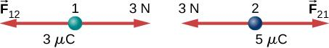

b. 

1. Two charges  and  are ﬁxed 1 m apart, with the second one to the right. Find the magnitude and direction of the net force on a *−*2-nC charge when placed at the following locations:   
   (a) halfway between the two   
   (b) half a meter to the left of the  charge   
   (c) half a meter above the  charge in a direction perpendicular to the line joining the two ﬁxed charges

Solution

a. charge 1 is ; charge 2 is ,  to the left,

 to the right,

 to the right;

b.  to the right,

 to the right,

 to the right,

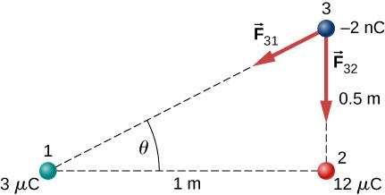;

c. ,

,





1. In a salt crystal, the distance between adjacent sodium and chloride ions is  What is the force of attraction between the two singly charged ions?

Solution



1. Protons in an atomic nucleus are typically 10–15 m apart. What is the electric force of repulsion between nuclear protons?

Solution



1. Suppose Earth and the Moon each carried a net negative charge –*Q*. Approximate both bodies as point masses and point charges.   
   (a) What value of *Q* is required to balance the gravitational attraction between Earth and the Moon?   
   (b) Does the distance between Earth and the Moon affect your answer? Explain.   
   (c) How many electrons would be needed to produce this charge?

Solution

a. ;

b. No, since both force laws use an inverse square of the distance.

c. 

1. Point charges  and  are placed 1.0 m apart. What is the force on a third charge  placed midway between  and ?

Solution



1. Where must  of the preceding problem be placed so that the net force on it is zero?

Solution

Let *x* be the distance from  that  is placed. The magnitude of both forces due to  and  must equal zero. The distance  is 

,

,

The solution is 3.41 m, since at this location the force vectors are opposite. The other solution corresponds to where the magnitudes of the force vectors are the same but their directions are both to the right.

1. Two small balls, each of mass 5.0 g, are attached to silk threads 50 cm long, which are in turn tied to the same point on the ceiling, as shown below. When the balls are given the same charge *Q*, the threads hang at  to the vertical, as shown below. What is the magnitude of *Q*? What are the signs of the two charges?

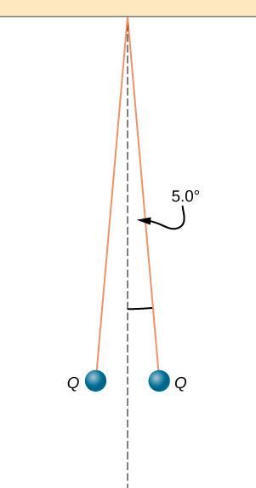

Solution

The tension is .   
The horizontal component of the tension is ,

.

The charges can be positive or negative, but both have to be the same sign.

1. Point charges  and  are located at  and . What is the force of  on ?

Solution

 is the vector from  to  with magnitude squared:  in the direction  since it’s a repulsive force.

1. The net excess charge on two small spheres (small enough to be treated as point charges) is *Q*. Show that the force of repulsion between the spheres is greatest when each sphere has an excess charge *Q*/2. Assume that the distance between the spheres is so large compared with their radii that the spheres can be treated as point charges.

Solution

Let the charge on one of the spheres be *nQ*, where *n* is a fraction between 0 and 1. In the numerator of Coulomb’s law, the term involving the charges is  This is equal to . Finding the maximum of this term gives 

1. Two small, identical conducting spheres repel each other with a force of 0.050 N when they are 0.25 m apart. After a conducting wire is connected between the spheres and then removed, they repel each other with a force of 0.060 N. What is the original charge on each sphere?

Solution

 where *q* is the charge on each sphere after the wire is attached and removed;  where  is in microcoulombs.

Solving the quadratic equation gives  which are the charges on the two spheres before the wire is connected.

1. A charge  is placed at the point *P* shown below. What is the force on *q*?

L:\Clients\Connexions\CONNEX140021_University_Physics\03_Art_Development\Ch22_Electric_Fields_and_Charges\99_Current Art\JPEG\CNX_UPhysics_22_03_Prob12_img.jpg

Solution

Define right to be the positive direction and hence left is the negative direction, then

1. What is the net electric force on the charge located at the lower right-hand corner of the triangle shown here?

Solution

The *x*-component is zero: ,



1. Two fixed particles, each of charge 5.0  10–6 C, are 24 cm apart. What force do they exert on a third particle of charge –2.5  10–6 C that is 13 cm from each of them?

Solution

The particles form triangle of sides 13, 13, and 24 cm. The *x*-components cancel, whereas there is a contribution to the *y*-component from both charges 24 cm apart. The *y*-axis passing through the third charge bisects the 24-cm line, creating two right triangles of sides 5, 12, and 13 cm.

 in the negative *y*-direction since the force is attractive. The net force from both charges is .

1. The charges *q*1 = 2.0  10–7 C, *q*2 = –4.0  10–7 C, and *q*3 = –1.0  10–7 C, are placed at the corners of the triangle shown below. What is the force on *q*1?

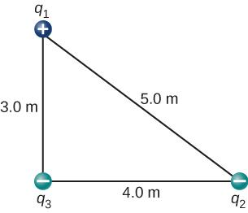

Solution







1. What is the force on the charge *q* at the lower-right-hand corner of the square shown here?

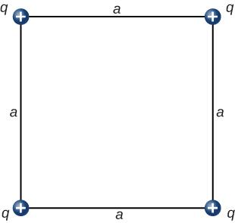

Solution

The diagonal is  and the components of the force due to the diagonal charge has a factor 



1. Point charges  and  are fixed at  and  What is the force of ?

Solution

The vector from  to  is  with its magnitude squared

 in the direction of 

since it is an attractive force.

1. A particle of charge 2.0  10–8 C experiences an upward force of magnitude 4.0  10–6 N when it is placed in a particular point in an electric field.   
   (a) What is the electric field at that point?   
   (b) If a charge *q* = –1.0  10–8 C is placed there, what is the force on it?

Solution

a.  up;

b. down

1. On a typical clear day, the atmospheric electric field points downward and has a magnitude of approximately 100 N/C. Compare the gravitational and electric forces on a small dust particle of mass 2.0  10–15 g that carries a single electron charge. What is the acceleration (both magnitude and direction) of the dust particle?

Solution

,

,

,

toward the center of Earth

1. Consider an electron that is 10–10 m from an alpha particle (*q* = 3.2  10–19 C).   
   (a) What is the electric field due to the alpha particle at the location of the electron?   
   (b) What is the electric field due to the electron at the location of the alpha particle?   
   (c) What is the electric force on the alpha particle? On the electron?

Solution

a. ;

b. ;

c.  on alpha particle;

 on electron

1. Each of the balls shown below carries a charge *q* and has a mass *m*. The length of each thread is *l*, and at equilibrium, the balls are separated by an angle  How does  vary with *q* and *l*? Show that  satisfies 

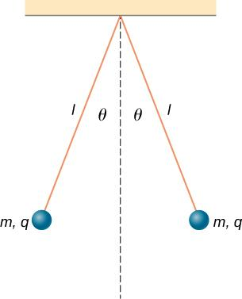

Solution

Let *T* be the tension in the thread. Then .   
The horizontal component of the tension is  or .

1. What is the electric field at a point where the force on a  charge is 

Solution



1. A proton is suspended in the air by an electric field at the surface of Earth. What is the strength of this electric field?

Solution

,



1. The electric field in a particular thundercloud is  What is the acceleration of an electron in this field?

Solution





1. A small piece of cork whose mass is 2.0 g is given a charge of  What electric field is needed to place the cork in equilibrium under the combined electric and gravitational forces?

Solution

,



1. If the electric field is  at a distance of 50 cm from a point charge *q*,what is the value of *q*?

Solution



1. What is the electric field of a proton at the first Bohr orbit for hydrogen  What is the force on the electron in that orbit?

Solution

,



1. (a) What is the electric field of an oxygen nucleus at a point that is 10–10 m from the nucleus? (b) What is the force this electric field exerts on a second oxygen nucleus placed at that point?

Solution

a. ;

b. 

1. Two point charges, *q*1 = 2.0  10–7 C and *q*2 = –6.0  10–8 C, are held 25.0 cm apart. (a) What is the electric field at a point 5.0 cm from the negative charge and along the line between the two charges? (b)What is the force on an electron placed at that point?

Solution

a. ;

b. 

1. Point charges  and  are placed 1.0 m apart. (a) What is the electric field at a point midway between them? (b) What is the force on a charge situated there?

Solution

If the  is to the right of  the electric field vector from both charges point to the right.

a. ;

b. 

1. Can you arrange the two point charges *q*1 = 2.0  10–6 C and *q*2 = 4.0  10–6 C along the *x*-axis so that  at the origin?

Solution

Yes, put  and  to the right of the origin, so the electric field vectors cancel at the origin. You could put  at 1 m and  at  m, for example. The magnitudes of  and  are equal and have opposite vector directions at the origin.

1. Point charges *q*1 = *q*2 = 4.0  10–6 C are fixed on the *x*-axis at *x* = –3.0 m and *x* = 3.0 m.What charge *q* must be placed at the origin so that the electric field vanishes at *x* = 0, *y* = 3.0 m?

Solution

There is  right triangle geometry. The *x*-components of the electric field at  cancel. The *y*-components give .

At the origin we have a negative charge of magnitude



1. A thin conducting plate 1.0 m on the side is given a charge of –2.0  10–6 C. An electron is placed 1.0 cm above the center of the plate. What is the acceleration of the electron?

Solution





1. Calculate the magnitude and direction of the electric field 2.0 m from a long wire that is charged uniformly at 

Solution



1. Two thin conducting plates, each 25.0 cm on a side, are situated parallel to one another and 5.0 mm apart. If 1011 electrons are moved from one plate to the other, what is the electric field between the plates?

Solution



1. The charge per unit length on the thin rod shown below is  What is the electric field at the point *P*? (*Hint*: Solve this problem by first considering the electric field  at *P* due to a small segment *dx* of the rod, which contains charge  Then find the net field by integrating  over the length of the rod.)

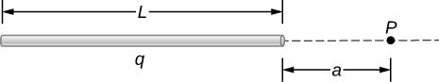

Solution



1. The charge per unit length on the thin semicircular wire shown below is What is the electric field at the point *P*?

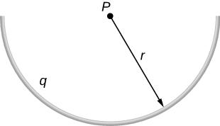

Solution

The *y*-component of  is nonzero. The *x*-component due to *dq* cancels from symmetry. The angle  makes with the *y*-axis is  such that ,



1. Two thin parallel conducting plates are placed 2.0 cm apart. Each plate is 2.0 cm on a side; one plate carries a net charge of  and the other plate carries a net charge of  What is the charge density on the inside surface of each plate? What is the electric field between the plates?

Solution



1. A thin conducting plate 2.0 m on a side is given a total charge of . (a) What is the electric field above the plate? (b) What is the force on an electron at this point? (c) Repeat these calculations for a point 2.0 cm above the plate. (d) When the electron moves from 1.0 to 2,0 cm above the plate, how much work is done on it by the electric field?

Solution

a.  toward the plate; b.  c. same as (a) and (b); d. work equals force times distance 

1. A total charge *q* is distributed uniformly along a thin, straight rod of length *L* (see below). What is the electric field at 

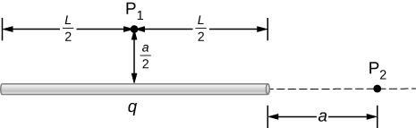

Solution

At : 

At  Put the origin at the end of *L*.



1. Charge is distributed along the entire *x*-axis with uniform density  How much work does the electric field of this charge distribution do on an electron that moves along the *y*-axis from 

Solution

, 

1. Charge is distributed along the entire *x*-axis with uniform density  and along the entire *y*-axis with uniform density  Calculate the resulting electric field at (a)  and (b) 

Solution

a. ; b. 

1. A rod bent into the arc of a circle subtends an angle  at the center *P* of the circle (see below). If the rod is charged uniformly with a total charge *Q*, what is the electric field at *P*?

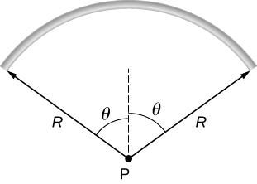

Solution

Let  so . Let the variable of integration be  with limits .

,



1. A proton moves in the electric field  (a) What are the force on and the acceleration of the proton? (b) Do the same calculation for an electron moving in this field.

Solution

a. ,

;

b. ,



1. An electron and a proton, each starting from rest, are accelerated by the same uniform electric field of 200 N/C. Determine the distance and time for each particle to acquire a kinetic energy of 

Solution

electron ,

, ;

proton ,

, 

1. A spherical water droplet of radius  carries an excess 250electrons. What vertical electric field is needed to balance the gravitational force on the droplet at the surface of the earth?

Solution

,



1. A proton enters the uniform electric field produced by the two charged plates shown below. The magnitude of the electric field is 4.0  105 N/C, and the speed of the proton when it enters is 1.5  107 m/s.What distance *d* has the proton been deflected downward when it leaves the plates?

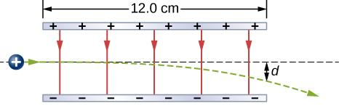

Solution





1. Shown below is a small sphere of mass 0.25 g that carries a charge of  The sphere is attached to one end of a very thin silk string 5.0 cm long. The other end of the string is attached to a large vertical conducting plate that has a charge density of  What is the angle that the string makes with the vertical?

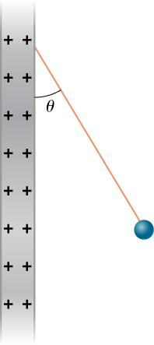

Solution

 



This is independent of the length of the string.

1. Two infinite rods, each carrying a uniform charge density  are parallel to one another and perpendicular to the plane of the page. (See below.) What is the electrical field at 

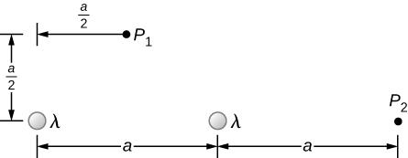

Solution

 

 

1. Positive charge is distributed with a uniform densityalong the positive *x*-axis from  along the positive *y*-axis from  and along a 90° arc of a circle of radius *r*, as shown below. What is the electric field at *O*?

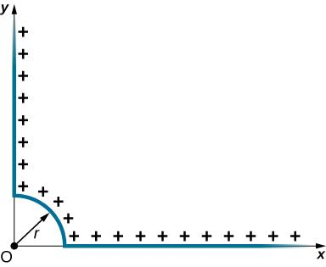

Solution

circular arc ,

,

,

;

*y*-axis: ;   
*x*-axis: ,

 

1. From a distance of 10 cm, a proton is projected with a speed of  directly at a large, positively charged plate whose charge density is  (See below.) (a)Does the proton reach the plate? (b) If not, how far from the plate does it turn around?

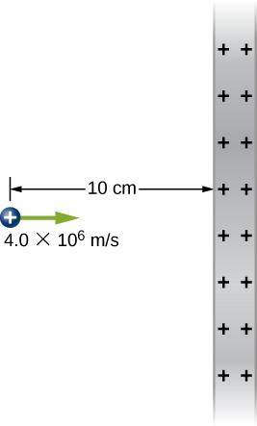

Solution

,



,

,

It turns around 3 cm in front of the plate.

1. A particle of mass *m* and charge –*q* moves along a straight line away from a fixed particle of charge *Q*. When the distance between the two particles is *r*0, –*q* is moving with a speed *v*0. (a) Use the work-energy theorem to calculate the maximum separation of the charges. (b) What do you have to assume about *v*0 to make this calculation? (c) What is the minimum value of *v*0 such that –*q* escapes from *Q*?

Solution

a. , ; b.  is negative; therefore, , 

1. Which of the following electric ﬁeld lines are incorrect for point charges? Explain why.

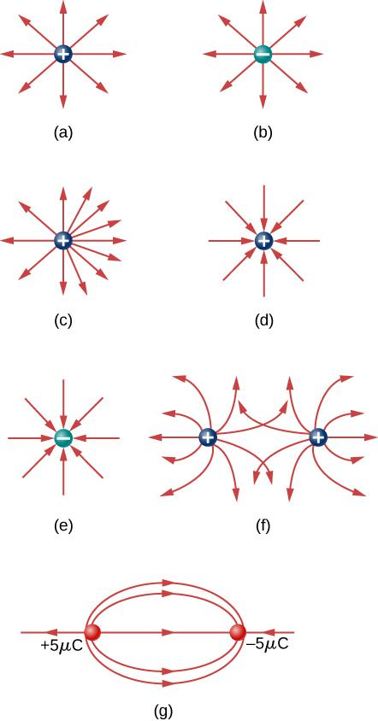

Solution

b. field lines converge on a negative point charge; c. field line density is asymmetrical, it should be symmetric about the point charge; d. field lines diverge from a positive point charge; f. field lines do not intersect; g. the outer field line does not seem to emanate or terminate on a point charge, field lines must start and end on charges

1. In this exercise, you will practice drawing electric ﬁeld lines. Make sure you represent both the magnitude and direction of the electric ﬁeld adequately. Note that the number of lines into or out of charges is proportional to the charges.   
   (a) Draw the electric ﬁeld lines map for two charges  and  situated 5 cm from each other.   
   (b) Draw the electric ﬁeld lines map for two charges  and  situated 5 cm from each other.   
   (c) Draw the electric ﬁeld lines map for two charges  and  situated 5 cm from each other.

Solution

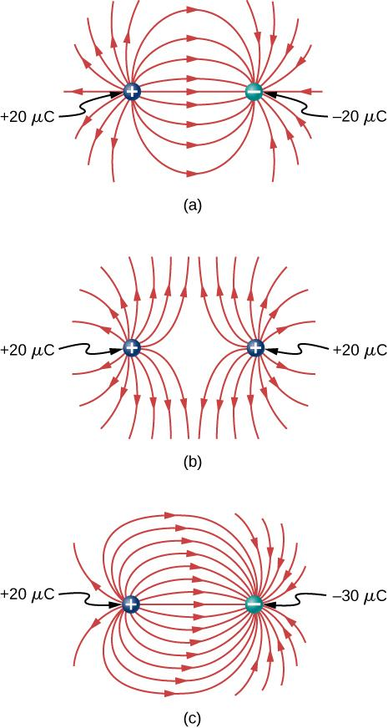

1. Draw the electric ﬁeld for a system of three particles of charges   and  ﬁxed at the corners of an equilateral triangle of side 2 cm.

Solution

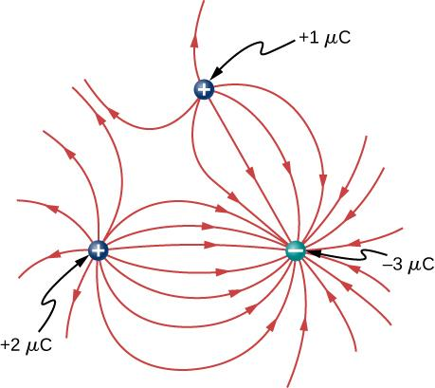

1. Two charges of equal magnitude but opposite sign make up an electric dipole. A quadrupole consists of two electric dipoles that are placed anti-parallel at two edges of a square as shown.

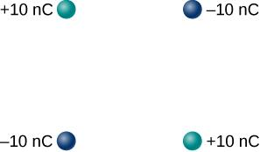

Draw the electric ﬁeld of the charge distribution.

Solution

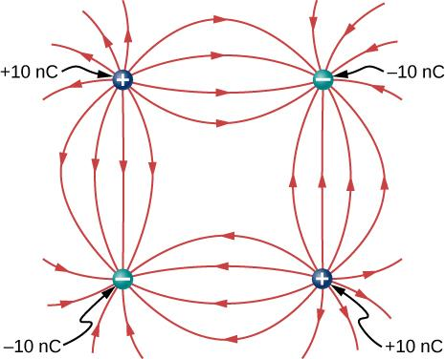

1. Suppose the electric field of an isolated point charge decreased with distance as  rather than as 1/*r*2. Show that it is then impossible to draw continous field lines so that their number per unit area is proportional to *E*.

Solution

The number of field lines/unit area  is proportional to the electric field at *r*.  or , which means the number of field lines/unit area depends on *r*, which cannot be the case since field lines must be continuous.

1. Consider the equal and opposite charges shown below. (a) Show that at all points on the *x*-axis for which  (b) Show that at all points on the *y*-axis for which 

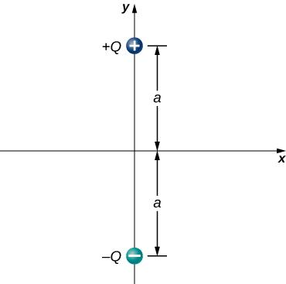

Solution

,



,







1. (a) What is the dipole moment of the configuration shown above? If , (b) what is the torque on this dipole with an electric field of  (c) What is the torque on this dipole with an electric field of  (d) What is the torque on this dipole with an electric field of 

Solution

a. ;

b. ;

c. ; d. 

1. A water molecule consists of two hydrogen atoms bonded with one oxygen atom. The bond angle between the two hydrogen atoms is 104° (see below). Calculate the net dipole moment of a hypothetical water molecule where the charge at the oxygen molecule is −2e and at each hydrogen atom is +e. The net dipole moment of the molecule is the vector sum of the individual dipole moment between the two O-Hs. The separation O-H is 0.9578 angstroms.

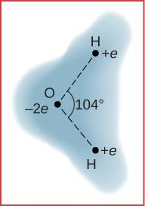

Solution



**Additional Problems**

1. Point charges and  are located at  and . What is the force of 

Solution

The vector from  to  is  with its magnitude squared:

 in the direction opposite of  since it is a repulsive force.

1. What is the force on the  charge shown below?

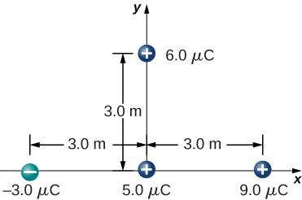

Solution

,



1. What is the force on the  charge placed at the center of the square shown below?

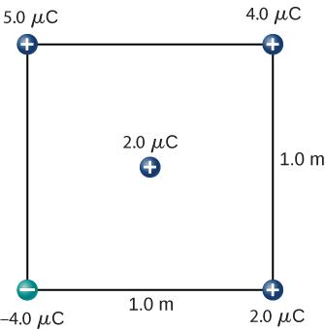

Solution

,

,



1. Four charged particles are positioned at the corners of a parallelogram as shown below. If  and  what is the net force on *q*?

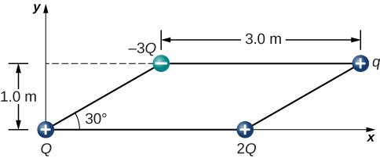

Solution

Charges *Q* and *q* form a right triangle of sides 1 m and  Charges 2*Q* and *q* form a right triangle of sides 1 m and 



,



1. A charge *Q* is fixed at the origin and a second charge *q* moves along the *x*-axis, as shown below. How much work is done on *q* by the electric force when *q* moves from 

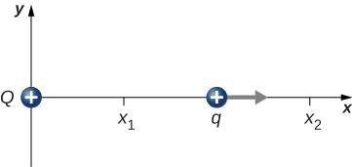

Solution



1. A charge  is released from rest when it is 2.0 m from a fixed charge  What is the kinetic energy of *q* when it is 1.0 m from *Q*?

Solution

,



1. What is the electric field at the midpoint *M* of the hypotenuse of the triangle shown below?

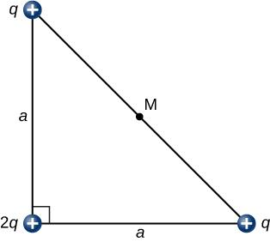

Solution

The electric field from the two charges *q* at opposite ends of the hypotenuse cancel. The *E*-field is due to the charge at the origin:



1. Find the electric field at *P* for the charge configurations shown below.

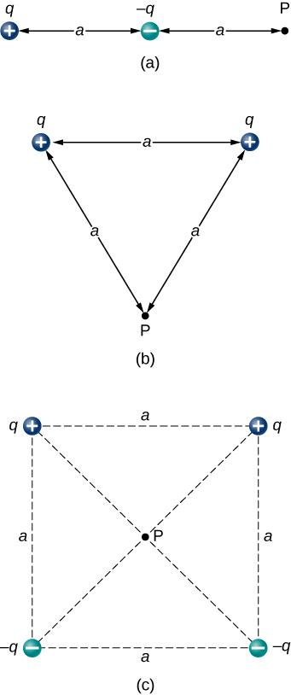

Solution

a. ; b. ;

c. 

1. (a) What is the electric field at the lower-right-hand corner of the square shown below? (b) What is the force on a charge *q* placed at that point?

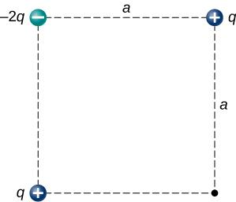

Solution

,



1. Point charges are placed at the four corners of a rectangle as shown below:  and  What is the electric field at *P*?

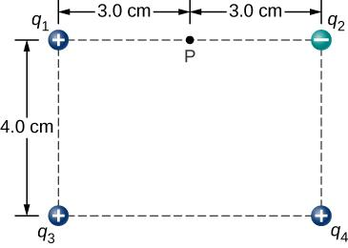

Solution











1. Three charges are positioned at the corners of a parallelogram as shown below. (a) If  what is the electric field at the unoccupied corner? (b) What is the force on a charge placed at this corner?

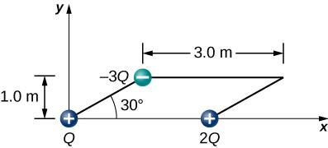

Solution

Charges *Q* and *q* form a right triangle of sides 1 m and  Charges 2*Q* and *q* form a right triangle of sides 1 m and 

,

,



,

,



1. A positive charge *q* is released from rest at the origin of a rectangular coordinate system and moves under the influence of the electric field  What is the kinetic energy of *q* when it passes through 

Solution

,



1. A particle of charge –*q* and mass *m* is placed at the center of a uniformaly charged ring of total charge *Q* and radius *R*. The particle is displaced a small distance along the axis perpendicular to the plane of the ring and released. Assuming that the particle is constrained to move along the axis, show that the particle oscillates in simple harmonic motion with a frequency 

Solution

The expression for the electric field at a point *P* along the axis perpendicular to the plane of the ring is  For  and suppressing the vector notation we have  The force on the charge  is . This equation is of the form , which is the force of a spring with k being the spring constant, . Thus, the small charge oscillates about the origin in simple harmonic motion. The angular frequency of a sping is . Substituting the expression for *k*, we find.

1. Charge is distributed uniformly along the entire *y*-axis with a density  and along the positive *x*-axis from  with a density  What is the force between the two distributions?

Solution

Electric field of wire at *x*: , 

1. The circular arc shown below carries a charge per unit length  where  is measured from the *x*-axis. What is the electric field at the origin?

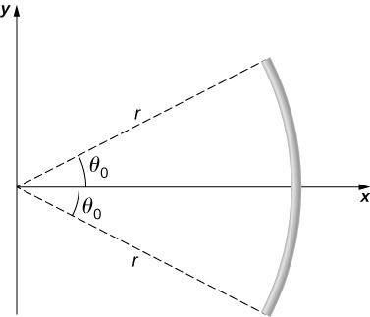

Solution





1. Calculate the electric field due to a uniformly charged rod of length *L*, aligned with the *x*-axis with one end at the origin; at a point *P* on the *z*-axis.

Solution

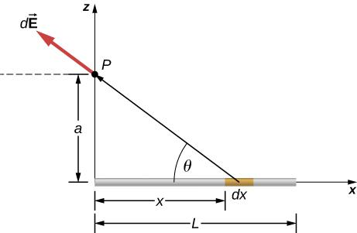

,

,

,

,

Substituting *z* for *a*, we have:



1. The charge per unit length on the thin rod shown below is  What is the electric force on the point charge *q*? Solve this problem by first considering the electric force  on *q* due to a small segment  of the rod, which contains charge  Then, find the net force by integrating  over the length of the rod.

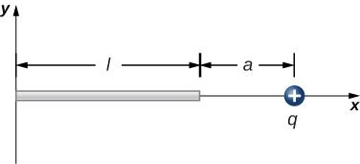

Solution



1. The charge per unit length on the thin rod shown here is  What is the electric force on the point charge *q*? (See the preceding problem.)

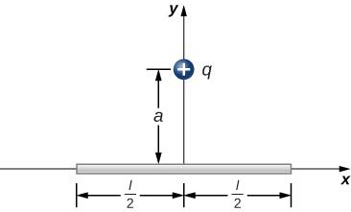

Solution

There is a net force only in the *y*-direction. Let  be the angle the vector from *dx* to *q* makes with the *x*-axis. The components along the *x*-axis cancel due to symmetry, leaving the *y*-component of the force.

,





1. The charge per unit length on the thin semicircular wire shown below is  What is the electric force on the point charge *q*? (See the preceding problems.)

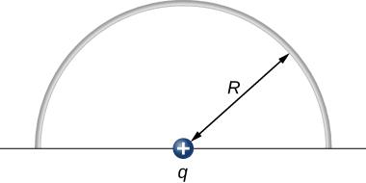

Solution

 where is the angle *R* makes with the *y*-axis. The components along the *x*-axis cancel due to symmetry when integrating along the arc length *s*.



This file is copyright 2016, Rice University. All Rights Reserved.