***University Physics Volume II***

**Unit 2: Electricity and Magnetism**

**Chapter 7: Electric Potential**

**Conceptual Questions**

1. Would electric potential energy be meaningful if the electric field were not conservative?

Solution

No. We can only define potential energies for conservative fields.

1. Why do we need to be careful about work done *on* the system versus work done *by* the system in calculations?

Solution

They are equal in magnitude, but differ by a minus sign.

1. Does the order in which we assemble a system of point charges affect the total work done?

Solution

No, though certain orderings may be simpler to compute.

1. Discuss how potential difference and electric field strength are related. Give an example.

Solution

The greater the potential difference between two points, the stronger the electric field in that region. The classic example is two parallel plates, held at different potentials.

1. What is the strength of the electric field in a region where the electric potential is constant?

Solution

The electric field strength is zero because electric potential differences are directly related to the field strength. If the potential difference is zero, then the field strength must also be zero.

1. If a proton is released from rest in an electric field, will it move in the direction of increasing or decreasing potential? Also answer this question for an electron and a neutron. Explain why.

Solution

proton, decreasing; electron, increasing; neutron, stays still

1. Voltage is the common word for potential difference. Which term is more descriptive, voltage or potential difference?

Solution

Potential difference is more descriptive because it indicates that it is the difference between the electric potential of two points.

1. If the voltage between two points is zero, can a test charge be moved between them with zero net work being done? Can this necessarily be done without exerting a force? Explain.

Solution

If a test charge is moved from one point to the other, the net work will be zero. It will be necessary to apply a force if the electric field between the two points is not zero, but positive work will be done over some portion of the path and an (equal magnitude) negative work will be done over the remainder of the path.

1. What is the relationship between voltage and energy? More precisely, what is the relationship between potential difference and electric potential energy?

Solution

They are very similar, but potential difference is a feature of the system; when a charge is introduced to the system, it will have a potential energy which may be calculated by multiplying the magnitude of the charge by the potential difference.

1. Voltages are always measured between two points. Why?

Solution

Voltage, like potential energy, is specified with respect to an arbitrary baseline. It is only differences in potential (and potential energy) that are physically relevant.

1. How are units of volts and electron-volts related? How do they differ?

Solution

An electron-volt is a volt multiplied by the charge of an electron. Volts measure potential difference, electron-volts are a unit of energy.

1. Can a particle move in a direction of increasing electric potential, yet have its electric potential energy decrease? Explain

Solution

Yes, if it has a negative charge.

1. Compare the electric dipole moments of charges ** separated by a distance *d* and charges  separated by a distance *d*/2.

Solution

The second has 1/4 the dipole moment of the first.

1. Would Gauss’s law be helpful for determining the electric field of a dipole? Why?

Solution

No, there is not a useable symmetry.

1. In what region of space is the potential due to a uniformly charged sphere the same as that of a point charge? In what region does it differ from that of a point charge?

Solution

The region outside of the sphere will have a potential indistinguishable from a point charge; the interior of the sphere will have a different potential.

1. Can the potential of a nonuniformly charged sphere be the same as that of a point charge? Explain.

Solution

Yes, if we are concerned with the potential in the region outside of the sphere and the charge distribution is spherically symmetrical.

1. If the electric field is zero throughout a region, must the electric potential also be zero in that region?

Solution

No. It will be constant, but not necessarily zero.

1. Explain why knowledge of  is not sufficient to determine *V*(*x*,*y*,*z*). What about the other way around?

Solution

We need to define a reference level for the potential, which is information not automatically contained in . However, knowledge of the potential is adequate to calculate .

1. If two points are at the same potential, are there any electric field lines connecting them?

Solution

no

1. Suppose you have a map of equipotential surfaces spaced 1.0 V apart. What do the distances between the surfaces in a particular region tell you about the strength of the  in that region?

Solution

The closer the spacing, the stronger the .

1. Is the electric potential necessarily constant over the surface of a conductor?

Solution

No; it might not be at electrostatic equilibrium.

1. Under electrostatic conditions, the excess charge on a conductor resides on its surface. Does this mean that all of the conduction electrons in a conductor are on the surface?

Solution

No; many are still in the interior, keeping it electrically neutral.

1. Can a positively charged conductor be at a negative potential? Explain.

Solution

Yes. It depends on where the zero reference for potential is. (Though this might be unusual.)

1. Can equipotential surfaces intersect?

Solution

By definition, no, because they will be at different potentials.

1. Why are the metal support rods for satellite network dishes generally grounded?

Solution

So that lightning striking them goes into the ground instead of the television equipment.

1. (a) Why are fish reasonably safe in an electrical storm? (b) Why are swimmers nonetheless ordered to get out of the water in the same circumstance?

Solution

a. For practical purposes, they are inside a conductor in this circumstance; b. humans must stay near enough to the surface that they would be on the surface of the conductor, and hence subject to harm

1. What are the similarities and differences between the processes in a photocopier and an electrostatic precipitator?

Solution

They both make use of static electricity to stick small particles to another surface. However, the precipitator has to charge a wide variety of particles, and is not designed to make sure they land in a particular place.

1. About what magnitude of potential is used to charge the drum of a photocopy machine? A web search for “xerography” may be of use.

Solution

6 kV is typical

**Problems**

1. Consider a charge  fixed at a site with another charge  (charge , mass  moving in the neighboring space. (a) Evaluate the potential energy of  when it is 4.0 cm from  (b) If  starts from rest from a point 4.0 cm from  what will be its speed when it is 8.0 cm from ? (*Note:*  is held fixed in its place.)

Solution

a. 

b. 

1. Two charges  and  are placed symmetrically along the *x*-axis at . Consider a charge  of charge  and mass 10.0 mg moving along the *y*-axis. If  starts from rest at  what is its speed when it reaches 

Solution

Note that, due to symmetry, we may look at one leg of the triangle formed by these three charges, and double the result:



1. To form a hydrogen atom, a proton is fixed at a point and an electron is brought from far away to a distance of  the average distance between proton and electron in a hydrogen atom. How much work is done?

Solution



1. (a) What is the average power output of a heart defibrillator that dissipates 400 J of energy in 10.0 ms? (b) Considering the high-power output, why doesn’t the defibrillator produce serious burns?

Solution

a. The power is the work divided by the time, so the average power is

; b. A defibrillator does not cause serious burns because the skin conducts electricity well at high voltages, like those used in defibrillators. The gel used aids in the transfer of energy to the body, and the skin doesn’t absorb the energy, but rather, lets it pass through to the heart.

1. Find the ratio of speeds of an electron and a negative hydrogen ion (one having an extra electron) accelerated through the same voltage, assuming non-relativistic final speeds. Take the mass of the hydrogen ion to be 

Solution



1. An evacuated tube uses an accelerating voltage of 40 kV to accelerate electrons to hit a copper plate and produce X-rays. Non-relativistically, what would be the maximum speed of these electrons?

Solution



1. Show that units of V/m and N/C for electric field strength are indeed equivalent.

Solution



1. What is the strength of the electric field between two parallel conducting plates separated by 1.00 cm and having a potential difference (voltage) between them of ?

Solution



1. The electric field strength between two parallel conducting plates separated by 4.00 cm is . (a) What is the potential difference between the plates? (b) The plate with the lowest potential is taken to be zero volts. What is the potential 1.00 cm from that plate and 3.00 cm from the other?

Solution

a.;

b. 

1. The voltage across a membrane forming a cell wall is 80.0 mV and the membrane is 9.00 nm thick. What is the electric field strength? (The value is surprisingly large, but correct.) You may assume a uniform electric field.

Solution



1. Two parallel conducting plates are separated by 10.0 cm, and one of them is taken to be at zero volts. (a) What is the electric field strength between them, if the potential 8.00 cm from the zero volt plate (and 2.00 cm from the other ) is 450 V? (b) What is the voltage between the plates?

Solution

a. ;

b. 

1. Find the maximum potential difference between two parallel conducting plates separated by 0.500 cm of air, given the maximum sustainable electric field strength in air to be .

Solution



1. An electron is to be accelerated in a uniform electric field having a strength of  (a) What energy in keV is given to the electron if it is accelerated through 0.400 m? (b) Over what distance would it have to be accelerated to increase its energy by 50.0 GeV?

Solution

a. 

b. 

1. Use the definition of potential difference in terms of electric ﬁeld to deduce the formula for potential difference between  and  for a point charge located at the origin. Here *r* is the spherical radial coordinate.

Solution



1. The electric ﬁeld in a region is pointed away from the z-axis and the magnitude depends upon the distance *s* from the axis. The magnitude of the electric field is given as  where  is a constant. Find the potential difference between points , explicitly stating the path over which you conduct the integration for the line integral.

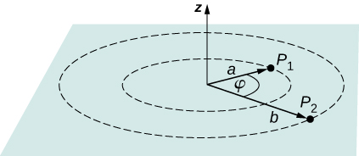

Solution

One possibility is to stay at constant radius and go along the arc from  to , which will have zero potential due to the path being perpendicular to the electric field. Then integrate from *a* to *b*: 

1. Singly charged gas ions are accelerated from rest through a voltage of 13.0 V. At what temperature will the average kinetic energy of gas molecules be the same as that given these ions?

Solution



1. A 0.500-cm-diameter plastic sphere, used in a static electricity demonstration, has a uniformly distributed 40.0-pC charge on its surface. What is the potential near its surface?

Solution



1. How far from a  point charge is the potential 100 V? At what distance is it 

Solution



1. If the potential due to a point charge is  at a distance of 15.0 m, what are the sign and magnitude of the charge?

Solution



The charge is positive because the potential is positive.

1. In nuclear fission, a nucleus splits roughly in half. (a) What is the potential  from a fragment that has 46 protons in it? (b) What is the potential energy in MeV of a similarly charged fragment at this distance?

Solution

a. ;

b. 

1. A research Van de Graaff generator has a 2.00-m-diameter metal sphere with a charge of 5.00 mC on it. Assume the potential energy is zero at a reference point infinitely far away from the Van de Graaff. (a) What is the potential near its surface? (b) At what distance from its center is the potential 1.00 MV? (c) An oxygen atom with three missing electrons is released near the Van de Graaff generator. What is its kinetic energy in MeV when the atom is at the distance found in part b?

Solution

a. ;

b. ;

c. 

1. An electrostatic paint sprayer has a 0.200-m-diameter metal sphere at a potential of 25.0 kV that repels paint droplets onto a grounded object.

(a) What charge is on the sphere? (b) What charge must a 0.100-mg drop of paint have to arrive at the object with a speed of 10.0 m/s?

Solution

a. ;

b. 

1. (a) What is the potential between two points situated 10 cm and 20 cm from a point charge? (b) To what location should the point at 20 cm be moved to increase this potential difference by a factor of two?

Solution

**;a. Relative to origin, find the potential at each point and then calculate the difference.

;

b. To double the potential difference, move the point from 20 cm to infinity; the potential at 20 cm is halfway between zero and that at 10 cm.

1. Find the potential at points  in the diagram due to the two given charges.

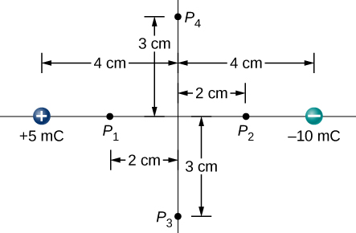

Solution

Apply  in triplicate. , , 

1. Two charges  are separated by 4.0 cm on the *z*-axis symmetrically about origin, with the positive one uppermost. Two space points of interest  are located 3.0 cm and 30 cm from origin at an angle  with respect to the *z*-axis. Evaluate electric potentials at  in two ways: (a) Using the exact formula for point charges, and (b) using the approximate dipole potential formula.

Solution

a. 

and ;

b.  and 

1. (a) Plot the potential of a uniformly charged 1-m rod with 1 C/m charge as a function of the perpendicular distance from the center. Draw your graph from . (b) On the same graph, plot the potential of a point charge with a 1-C charge at the origin. (c) Which potential is stronger near the rod? (d) What happens to the difference as the distance increases? Interpret your result.

Solution

a. and b.

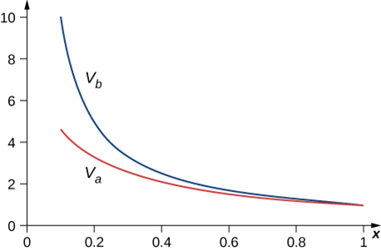

c. the point charge; d. They become similar, at distances where the magnitude of the charge matters far more than the configuration.

1. Throughout a region, equipotential surfaces are given by . The surfaces are equally spaced with . What is the electric field in this region?

Solution

The problem is describing a uniform field, so  in the –*z*-direction.

1. In a particular region, the electric potential is given by  What is the electric field in this region?

Solution

Apply  with  to get 

1. Calculate the electric field of an infinite line charge, throughout space.

Solution

Apply  with  to the potential calculated earlier,   as expected.

1. Two very large metal plates are placed 2.0 cm apart, with a potential difference of 12 V between them. Consider one plate to be at 12 V, and the other at 0 V. (a) Sketch the equipotential surfaces for 0, 4, 8, and 12 V. (b) Next sketch in some electric field lines, and confirm that they are perpendicular to the equipotential lines.

Solution

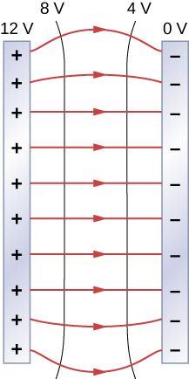

1. A very large sheet of insulating material has had an excess of electrons placed on it to a surface charge density of . (a) As the distance from the sheet increases, does the potential increase or decrease? Can you explain why without any calculations? Does the location of your reference point matter? (b) What is the shape of the equipotential surfaces? (c) What is the spacing between surfaces that differ by 1.00 V?

Solution

a. increases; the constant (negative) electric field has this effect, the reference point only matters for magnitude; b. they are planes parallel to the sheet; c. 0.006 m/V

1. A metallic sphere of radius 2.0 cm is charged with  charge, which spreads on the surface of the sphere uniformly. The metallic sphere stands on an insulated stand and is surrounded by a larger metallic spherical shell, of inner radius 5.0 cm and outer radius 6.0 cm. Now, a charge of  is placed on the inside of the spherical shell, which spreads out uniformly on the inside surface of the shell. If potential is zero at inﬁnity, what is the potential of (a) the spherical shell, (b) the sphere, (c) the space between the two, (d) inside the sphere, and (e) outside the shell?

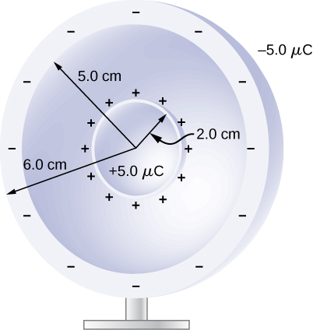

Solution

a. 0 because there is no electric field outside of the shell;

b. ; c. 

d. same as the surface; e. 0

1. Two large charged plates of charge density  face each other at a separation of 5.0 mm. (a) Find the electric potential everywhere. (b) An electron is released from rest at the negative plate; with what speed will it strike the positive plate?

Solution

a. from the previous chapter, the electric field has magnitude  in the region between the plates and zero outside; defining the negatively charged plate to be at the origin and zero potential, with the positively charged plate located at  in the *z*-direction,  so the potential is 0 for   for   for 

b. 

1. A long cylinder of aluminum of radius *R* meters is charged so that it has a uniform charge per unit length on its surface of .

(a) Find the electric ﬁeld inside and outside the cylinder. (b) Find the electric potential inside and outside the cylinder. (c) Plot electric ﬁeld and electric potential as a function of distance from the center of the rod.

Solution

a. Inside *E* must be 0  due to being a conductor; outside  while outside is  from the previous chapter; b. Choosing zero potential to be at   while inside is ;

c. 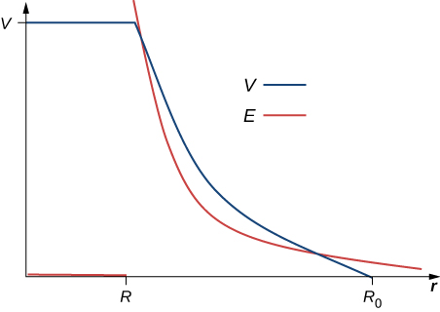

1. Two parallel plates 10 cm on a side are given equal and opposite charges of magnitude  The plates are 1.5 mm apart. What is the potential difference between the plates?

Solution



1. The surface charge density on a long straight metallic pipe is . What is the electric potential outside and inside the pipe? Assume the pipe has a diameter of 2*a*.

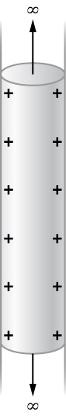

Solution

 from the previous chapter outside the pipe and zero inside. Choosing zero potential to be at   while inside is 

1. Concentric conducting spherical shells carry charges *Q* and –*Q*, respectively. The inner shell has negligible thickness. What is the potential difference between the shells?

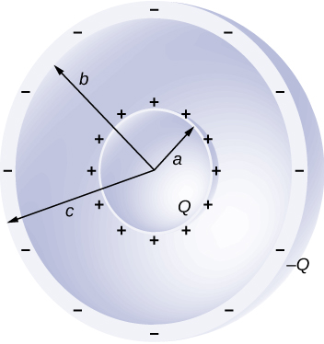

Solution

In the region  , and *E* is zero elsewhere; hence, the potential difference is .

1. Shown below are two concentric spherical shells of negligible thicknesses and radii  and  The inner and outer shell carry net charges  and  respectively, where both  and  are positive. What is the electric potential in the regions (a)  (b)  and (c) 

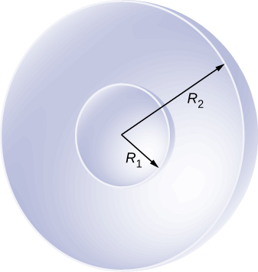

Solution

This will work best in reverse order: c. ; b. First integrate from infinity to  to get , then integrate  from  to *r* and add to get . a. This is the same as at the surface of the inner shell: 

1. A solid cylindrical conductor of radius *a* is surrounded by a concentric cylindrical shell of inner radius *b*. The solid cylinder and the shell carry charges *Q* and –*Q*, respectively. Assuming that the length *L* of both conductors is much greater than *a* or *b*, what is the potential difference between the two conductors?

Solution

From previous results , note that *b* is a very convenient location to define the zero level of potential: 

1. (a) What is the electric field 5.00 m from the center of the terminal of a Van de Graaff with a 3.00-mC charge, noting that the field is equivalent to that of a point charge at the center of the terminal? (b) At this distance,what force does the field exert on a  charge on the Van de

Graaff’s belt?

Solution

a. ; b. 

1. (a) What is the direction and magnitude of an electric field that supports the weight of a free electron near the surface of Earth? (b) Discuss what the small value for this field implies regarding the relative strength of the gravitational and electrostatic forces.

Solution

a. ;

The electric field is towards the surface of Earth. b. The coulomb force is much stronger than gravity.

1. A simple and common technique for accelerating electrons is shown in the below image, where there is a uniform electric field between two plates. Electrons are released, usually from a hot filament, near the negative plate, and there is a small hole in the positive plate that allows the electrons to continue moving. (a) Calculate the acceleration of the electron if the field strength is . (b) Explain why the electron will not be pulled back to the positive plate once it moves through the hole.

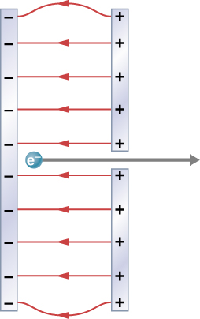

Solution

a. ;

b. There is no field outside the plates.

1. In a Geiger counter, a thin metallic wire at the center of a metallic tube is kept at a high voltage with respect to the metal tube. Ionizing radiation entering the tube knocks electrons off gas molecules or sides of the tube that then accelerate towards the center wire, knocking off even more electrons. This process eventually leads to an avalanche that is detectable as a current. A particular Geiger counter has a tube of radius *R* and the inner wire of radius *a* is at a potential of  volts with respect to the outer metal tube. Consider a point *P* at a distance *s* from the center wire and far away from the ends. (a) Find a formula for the electric ﬁeld at a point *P* inside using the infinite wire approximation. (b) Find a formula for the electric potential at a point *P* inside. (c) Use and find the value of the electric field at a point 1.00 cm from the center.

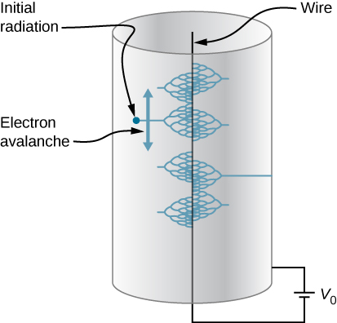

Solution

We know from the Gauss’s law chapter that the electric field for an infinite line charge is , and from earlier in this chapter that the potential of a wire-cylinder system of this sort is  by integration. We are not given , but we are given a fixed ; thus, we know that  and hence . We may substitute this back in to find a. ; b. ; c. 

1. The practical limit to an electric field in air is about . Above this strength, sparking takes place because air begins to ionize. (a) At this electric field strength, how far would a proton travel before hitting the speed of light (ignore relativistic effects)? (b) Is it practical to leave air in particle accelerators?

Solution

a. ;

b. No, it is impractical in air. A proton would collide with an air molecule before it could travel this far.

1. To form a helium atom, an alpha particle that contains two protons and two neutrons is fixed at one location, and two electrons are brought in from far away, one at a time. The first electron is placed at  from the alpha particle and held there while the second electron is brought to  from the alpha particle on the other side from the first electron. See the final configuration below. (a) How much work is done in each step? (b) What is the electrostatic energy of the alpha particle and two electrons in the final configuration?

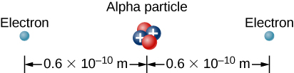

Solution

a. ;

b. 

1. Find the electrostatic energy of eight equal charges  each fixed at the corners of a cube of side 2 cm.

Solution

Follow the procedure in the example Assembling Four Positive Charges; 92.3 J

1. The probability of fusion occurring is greatly enhanced when appropriate nuclei are brought close together, but mutual Coulomb repulsion must be overcome. This can be done using the kinetic energy of high-temperature gas ions or by accelerating the nuclei toward one another. (a) Calculate the potential energy of two singly charged nuclei separated by  (b) At what temperature will atoms of a gas have an average kinetic energy equal to this needed electrical potential energy?

Solution

a. ; b. 

1. A bare helium nucleus has two positive charges and a mass of . (a) Calculate its kinetic energy in joules at  of the speed of light. (b) What is this in electron-volts? (c) What voltage would be needed to obtain this energy?

Solution

a. ; b. ; c. 

1. An electron enters a region between two large parallel plates made of aluminum separated by a distance of 2.0 cm and kept at a potential difference of 200 V. The electron enters through a small hole in the negative plate and moves toward the positive plate. At the time the electron is near the negative plate, its speed is  Assume the electric ﬁeld between the plates to be uniform, and find the speed of electron at (a) 0.10 cm, (b) 0.50 cm, (c) 1.0 cm, and (d) 1.5 cm from the negative plate, and (e) immediately before it hits the positive plate.

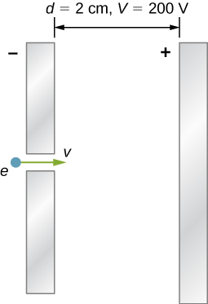

Solution

a. ; b. ; c. ; d. ; e. 

1. How far apart are two conducting plates that have an electric field strength of  between them, if their potential difference is 15.0 kV?

Solution



1. (a) Will the electric field strength between two parallel conducting plates exceed the breakdown strength of dry air, which is , if the plates are separated by 2.00 mm and a potential difference of  is applied? (b) How close together can the plates be with this applied voltage?

Solution

a. ; b. 

1. Membrane walls of living cells have surprisingly large electric fields across them due to separation of ions. What is the voltage across an 8.00-nm-thick membrane if the electric field strength across it is 5.50 MV/m? You may assume a uniform electric field.

Solution



1. A double charged ion is accelerated to an energy of 32.0 keV by the electric field between two parallel conducting plates separated by 2.00 cm. What is the electric field strength between the plates?

Solution



1. The temperature near the center of the Sun is thought to be 15 million degrees Celsius () (or kelvin). Through what voltage must a singly charged ion be accelerated to have the same energy as the average kinetic energy of ions at this temperature?

Solution



1. A lightning bolt strikes a tree, moving 20.0 C of charge through a potential difference of . (a) What energy was dissipated? (b) What mass of water could be raised from  to the boiling point and then boiled by this energy? (c) Discuss the damage that could be caused to the tree by the expansion of the boiling steam.

Solution

a. ;

b. ;

c. The expansion of the steam upon boiling can literally blow the tree apart.

1. What is the potential  from a proton (the average distance between the proton and electron in a hydrogen atom)?

Solution



1. (a) A sphere has a surface uniformly charged with 1.00 C. At what distance from its center is the potential 5.00 MV? (b) What does your answer imply about the practical aspect of isolating such a large charge?

Solution

a. ;

b. A 1-C charge is a very large amount of charge; a sphere of 1.80 km is impractical.

1. What are the sign and magnitude of a point charge that produces a potential of –2.00 V at a distance of 1.00 mm?

Solution



1. In one of the classic nuclear physics experiments at the beginning of the twentieth century, an alpha particle was accelerated toward a gold nucleus, and its path was substantially deflected by the Coulomb interaction. If the energy of the doubly charged alpha nucleus was 5.00 MeV, how close to the gold nucleus (79 protons) could it come before being deflected?

Solution

The alpha particle approaches the gold nucleus until its original energy is converted to potential energy. , so



(Size of gold nucleus is about ).

**Additional Problems**

1. A 12.0-V battery-operated bottle warmer heats 50.0 g of glass,  of baby formula, and  of aluminum from  to . (a) How much charge is moved by the battery? (b) How many electrons per second flow if it takes 5.00 min to warm the formula? (*Hint:* Assume that the specific heat of baby formula is about the same as the specific heat of water.)

Solution

a. Assume that specific heat for baby formula is approximately the specific heat for water, so that 

;

b. Let *N* equal the number of electrons needed to move the charge, and *t* be the time necessary to move the charge. Then



1. A battery-operated car uses a 12.0-V system. Find the charge the batteries must be able to move in order to accelerate the 750 kg car from rest to 25.0 m/s, make it climb a high hill, and finally cause it to travel at a constant 25.0 m/s while climbing with  force for an hour.

Solution



1. (a) Find the voltage near a 10.0 cm diameter metal sphere that has 8.00 C of excess positive charge on it. (b) What is unreasonable about this result? (c) Which assumptions are responsible?

Solution

a. ; b. This voltage is very high, much greater than the breakdown voltage of air. A 10.0 cm diameter sphere could never maintain this voltage; it would discharge. cC. An 8.00-C charge is more charge than can reasonably be accumulated on a sphere of that size.

1. A uniformly charged half-ring of radius 10 cm is placed on a nonconducting table. It is found that 3.0 cm above the center of the half-ring the potential is –3.0 V with respect to zero potential at infinity. How much charge is in the half-ring?

Solution



1. A glass ring of radius 5.0 cm is painted with a charged paint such that the charge density around the ring varies continuously given by the following function of the polar angle  Find the potential at a point 15 cm above the center.

Solution

You need to integrate around the circle to get the total charge; the integral of  over a circle is . 

1. A CD disk of radius () is sprayed with a charged paint so that the charge varies continually with radial distance *r* from the center in the following manner: **.

Find the potential at a point 4 cm above the center.

Solution



1. (a) What is the final speed of an electron accelerated from rest through a voltage of 25.0 MV by a negatively charged Van de Graff terminal? (b) What is unreasonable about this result? (c) Which assumptions are responsible?

Solution

a. ;

b. This velocity is far too great. It is faster than the speed of light. c. The assumption that the speed of the electron is far less than that of light and that the problem does not require a relativistic treatment produces an answer greater than the speed of light.

1. A large metal plate is charged uniformly to a density of . How far apart are the equipotential surfaces that represent a potential difference of 25 V?

Solution

Recall from the previous chapter that the electric field  is uniform throughout space, and that for uniform fields we have  for the relation. Thus, we get  for the distance between 25-V equipotentials.

1. Your friend gets really excited by the idea of making a lightning rod or maybe just a sparking toy by connecting two spheres as shown in the below figure, and making ** so small that the electric field is greater than the dielectric strength of air, just from the usual 150 V/m electric field near the surface of the Earth. If  is 10 cm, how small does ** need to be, and does this seem practical? (*Hint:* recall the calculation for electric field at the surface of a conductor from Gauss’s Law.)

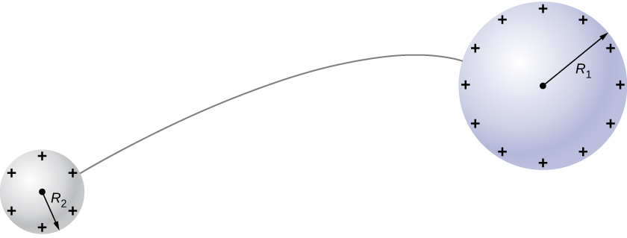

Solution

 and  may be combined to give  which leads us to , which is considerably smaller than most wires, and may be small enough to call into question the assumptions used in calculating the electric field near the surface of a conductor.

1. (a) Find limit of the potential of a finite uniformly charged rod and show that it coincides with that of a point charge formula. (b) Why would you expect this result?

Solution

a. Take the result from the example Potential of a Line of Charge, divide both the numerator and the denominator by *x*, take the limit of that, and then apply a Taylor expansion to the resulting log to get: ; b. which is the result we expect, because at great distances, this should look like a point charge of **

1. A small spherical pith ball of radius 0.50 cm is painted with a silver paint and then  of charge is placed on it. The charged pith ball is put at the center of a gold spherical shell of inner radius 2.0 cm and outer radius 2.2 cm. (a) Find the electric potential of the gold shell with respect to zero potential at inﬁnity. (b) How much charge should you put on the gold shell if you want to make its potential 100 V?

Solution

a. ; b. () C

1. Two parallel conducting plates, each of cross-sectional area , are 2.0 cm apart and uncharged. If  electrons are transferred from one plate to the other, (a) what is the potential difference between the plates? (b) What is the potential difference between the positive plate and a point 1.25 cm from it that is between the plates?

Solution

a. ;

b. 

1. A point charge of  is placed at the center of an uncharged spherical conducting shell of inner radius 6.0 cm and outer radius 9.0 cm. Find the electric potential at (a)  (b)  (c) 

Solution

This will work best in reverse order; c.  by integrating from infinity; b. Note that inside the shell must have the same potential as the surfaces; if we define zero to be at infinity, this means that . a. Integrate from the inner surface of the shell to 4cm, and add the 5 kV: .

1. Earth has a net charge that produces an electric field of approximately 150 N/C downward at its surface. (a) What is the magnitude and sign of the excess charge, noting the electric field of a conducting sphere is equivalent to a point charge at its center? (b) What acceleration will the field produce on a free electron near Earth’s surface? (c) What mass object with a single extra electron will have its weight supported by this field?

Solution

a. ;

b. ;

c. 

1. Point charges of  are placed 0.500 m apart.

(a) At what point along the line between them is the electric field zero?

(b) What is the electric field halfway between them?

Solution

a. ;

b. 

1. What can you say about two charges , if the electric field one-fourth of the way from  is zero?

Solution

If the electric field is zero ¼ from the way of , then we know from

; the charge  is 9 times larger than .

1. Calculate the angular velocity  of an electron orbiting a proton in the hydrogen atom, given the radius of the orbit is . You may assume that the proton is stationary and the centripetal force is supplied by Coulomb attraction.

Solution



1. An electron has an initial velocity of  in a uniform  electric field. The field accelerates the electron in the direction opposite to its initial velocity. (a) What is the direction of the electric field? (b) How far does the electron travel before coming to rest? (c) How long does it take the electron to come to rest? (d) What is the electron’s velocity when it returns to its starting point?

Solution

a. The field is in the direction of the electron’s initial velocity.

b. 

c. 

d. 

**Challenge Problems**

1. Three  and three  ions are placed alternately and equally spaced around a circle of radius 50 nm. Find the electrostatic energy stored.

Solution

Follow the procedure in the example Assembling Four Positive Charges, where the distances between charges will be 50, , or 100 nm; 

1. Look up (presumably online, or by dismantling an old device and making measurements) the magnitude of the potential deflection plates (and the space between them) in an ink jet printer. Then look up the speed with which the ink comes out the nozzle. Can you calculate the typical mass of an ink drop?

Solution

Answers will vary. This appears to be proprietary information, and ridiculously difficult to find. Speeds will be 20 m/s or less, and there are claims of  grams for the mass of a drop.

1. Use the electric field of a finite sphere with constant volume charge density to calculate the electric potential, throughout space. Then check your results by calculating the electric field from the potential.

Solution

From the Gauss’s law chapter, we know that the electric field of this system is

; so the potential outside is simply that of a point charge: , which, when we apply  in spherical coordinates, becomes



as expected. For the potential inside, we first integrate from infinity to the surface of the sphere to get , then we integrate from the surface to a point *r* in the interior; this gives us , from which we can calculate the electric field as



1. Calculate the electric field of a dipole throughout space from the potential.

Solution

Apply  with  to the potential calculated earlier,  with  and assume that the axis of the dipole is aligned with the *z*-axis of the coordinate system. Thus, the potential is .

Hence, 

This file is copyright 2016, Rice University. All Rights Reserved.