***University Physics Volume II***

**Unit 2: Electricity and Magnetism**

**Chapter 14: Inductance**

**Conceptual Questions**

1. Show that  and  which are both expressions for self-inductance, have the same units.

Solution



1. A 10-H inductor carries a current of 20 A. Describe how a 50-V emf can be induced across it.

Solution

The current must change 5 A/s to induce a 50-V emf.

1. The ignition circuit of an automobile is powered by a 12-V battery. How are we able to generate large voltages with this power source?

Solution

The induced current from the 12-V battery goes through an inductor, generating a large voltage.

1. When the current through a large inductor is interrupted with a switch, an arc appears across the open terminals of the switch. Explain.

Solution

The arc is the current caused by the induced emf from the changing current. If this induced emf is larger than the dielectric breakdown of air, a spark occurs, along with a loud noise.

1. Does self-inductance depend on the value of the magnetic flux? Does it depend on the current through the wire? Correlate your answers with the equation 

Solution

Self-inductance is proportional to the magnetic flux and inversely proportional to the current. However, since the magnetic flux depends on the current *I*, these effects cancel out. This means that the self-inductance does not depend on the current. If the emf is induced across an element, it does depend on how the current changes with time.

1. Would the self-inductance of a 1.0 m long, tightly wound solenoid differ from the self-inductance per meter of an infinite, but otherwise identical, solenoid?

Solution

The loops at the end of a solenoid have less magnetic field lines, thereby less flux and self-inductance than an infinite solenoid.

1. Discuss how you might determine the self-inductance per unit length of a long, straight wire.

Solution

Consider the ends of a wire a part of an *RL* circuit and determine the self-inductance from this circuit.

1. The self-inductance of a coil is zero if there is no current passing through the windings. True or false?

Solution

False, self-inductance is a property of the circuit element regardless of current flow.

1. How does the self-inductance per unit length near the center of a solenoid (away from the ends) compare with its value near the end of the solenoid?

Solution

The magnetic field will flare out at the end of the solenoid so there is less flux through the last turn than through the middle of the solenoid.

1. Show that  has units of energy.

Solution



1. Use Lenz’s law to explain why the initial current in the *RL* circuit the figure below (b) is zero.

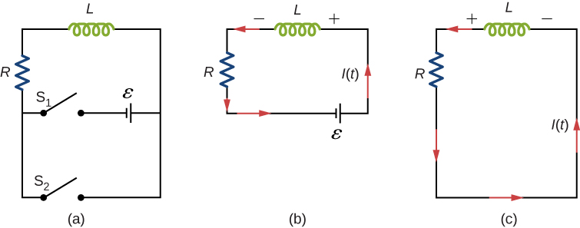

Solution

As current flows through the inductor, there is a back current by Lenz’s law that is created to keep the net current at zero amps, the initial current.

1. When the current in the *RL* circuit of the figure below (b) reaches its final value  what is the voltage across the inductor? Across the resistor?



Solution

The voltage across the inductor is zero; the voltage across the resistor is.

1. Does the time required for the current in an *RL* circuit to reach any fraction of its steady-state value depend on the emf of the battery?

Solution

no

1. An inductor is connected across the terminals of a battery. Does the current that eventually flows through the inductor depend on the internal resistance of the battery? Does the time required for the current to reach its final value depend on this resistance?

Solution

yes; yes

Use the following figure for questions 15-17.



1. At what time is the voltage across the inductor of the *RL* circuit of image b at a maximum?

Solution

At , or when the switch is first thrown.

1. In the simple *RL* circuit of image b, can the emf induced across the inductor ever be greater than the emf of the battery used to produce the current?

Solution

no

1. If the emf of the battery of image b is reduced by a factor of 2, by how much does the steady-state energy stored in the magnetic field of the inductor change?

Solution

1/4

1. A steady current flows through a circuit with a large inductive time constant. When a switch in the circuit is opened, a large spark occurs across the terminals of the switch. Explain.

Solution

The change in current causes an induced emf and if that induced emf is larger than the dielectric breakdown of air, a spark occurs.

1. Describe how the currents through  shown below vary with time after switch S is closed.

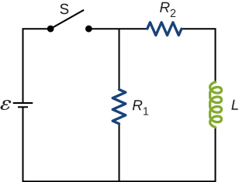

Solution

Initially,  and , and after a long time has passed,  and .

1. Discuss possible practical applications of *RL* circuits.

Solution

Any situation where a signal or charging needs to be read from something external to the circuit.

1. Do Kirchhoff’s rules apply to circuits that contain inductors and capacitors?

Solution

yes

1. Can a circuit element have both capacitance and inductance?

Solution

yes

1. In an *LC* circuit, what determines the frequency and the amplitude of the energy oscillations in either the inductor or capacitor?

Solution

The amplitude of energy oscillations depend on the initial energy of the system. The frequency in a *LC* circuit depends on the values of inductance and capacitance.

1. When a wire is connected between the two ends of a solenoid, the resulting circuit can oscillate like an *RLC* circuit. Describe what causes the capacitance in this circuit.

Solution

The capacitance is created by the delay in charges from one side of the solenoid to the other.

1. Describe what effect the resistance of the connecting wires has on an oscillating *LC* circuit.

Solution

This creates an *RLC* circuit that dissipates energy, causing oscillations to decrease in amplitude slowly or quickly depending on the value of resistance.

1. Suppose you wanted to design an *LC* circuit with a frequency of 0.01 Hz. What problems might you encounter?

Solution

A small resistance will cause the circuit to dampen out.

1. A radio receiver uses an *RLC* circuit to pick out particular frequencies to listen to in your house or car without hearing other unwanted frequencies. How would someone design such a circuit?

Solution

You would have to pick out a resistance that is small enough so that only one station at a time is picked up, but big enough so that the tuner doesn’t have to be set at exactly the correct frequency. The inductance or capacitance would have to be varied to tune into the station however practically speaking, variable capacitors are a lot easier to build in a circuit.

**Problems**

1. When the current in one coil changes at a rate of 5.6 A/s, an emf of  is induced in a second, nearby coil. What is the mutual inductance of the two coils?

Solution



1. An emf of  is induced in a coil while the current in a nearby coil is decreasing at a rate of 2.7 A/s. What is the mutual inductance of the two coils?

Solution



1. Two coils close to each other have a mutual inductance of 32 mH. If the current in one coil decays according to , where  and , what is the emf induced in the second coil immediately after the current starts to decay? At 

Solution

320 V, 43.3 V

1. A coil of 40 turns is wrapped around a long solenoid of cross-sectional area  The solenoid is 0.50 m long and has 500 turns. (a) What is the mutual inductance of this system? (b) The outer coil is replaced by a coil of 40 turns whose radius is three times that of the solenoid. What is the mutual inductance of this configuration?

Solution

a. ; b. 

1. A 600-turn solenoid is 0.55 m long and 4.2 cm in diameter. Inside the solenoid, a small  single-turn rectangular coil is fixed in place with its face perpendicular to the long axis of the solenoid. What is the mutual inductance of this system?

Solution



1. A toroidal coil has a mean radius of 16 cm and a cross-sectional area of ; it is wound uniformly with 1000 turns. A second toroidal coil of 750 turns is wound uniformly over the first coil. Ignoring the variation of the magnetic field within a toroid, determine the mutual inductance of the two coils.

Solution



1. A solenoid of  turns has length  and radius , and a second smaller solenoid of  turns has length  and radius . The smaller solenoid is placed completely inside the larger solenoid so that their long axes coincide. What is the mutual inductance of the two solenoids?

Solution



1. An emf of 0.40 V is induced across a coil when the current through it changes uniformly from 0.10 to 0.60 A in 0.30 s. What is the self-inductance of the coil?

Solution

0.24 H

1. The current shown in part (a) below is increasing, whereas that shown in part (b) is decreasing. In each case, determine which end of the inductor is at the higher potential.

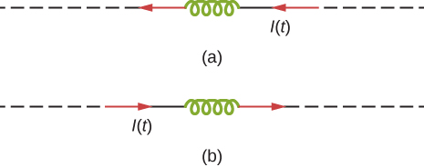

Solution

a. right-hand side; b. right-hand side

1. What is the rate at which the current though a 0.30-H coil is changing if an emf of 0.12 V is induced across the coil?

Solution

0.4 A/s

1. When a camera uses a flash, a fully charged capacitor discharges through an inductor. In what time must the 0.100-A current through a 2.00-mH inductor be switched on or off to induce a 500-V emf?

Solution



1. A coil with a self-inductance of 2.0 H carries a current that varies with time according to . Find an expression for the emf induced in the coil.

Solution



1. A solenoid 50 cm long is wound with 500 turns of wire. The cross-sectional area of the coil is  What is the self-inductance of the solenoid?

Solution



1. A coil with a self-inductance of 3.0 H carries a current that decreases at a uniform rate. What is the emf induced in the coil? Describe the polarity of the induced emf.

Solution

0.15 V. This is the same polarity as the emf driving the current.

1. The current *I(t)* through a 5.0-mH inductor varies with time, as shown below. The resistance of the inductor is . Calculate the voltage across the inductor at .

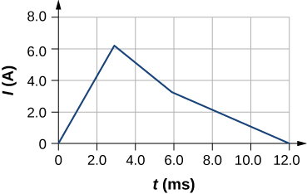

Solution

–10 V, 5 V, 2.5 V

1. A long, cylindrical solenoid with 100 turns per centimeter has a radius of 1.5 cm. (a) Neglecting end effects, what is the self-inductance per unit length of the solenoid? (b) If the current through the solenoid changes at the rate 5.0 A/s, what is the emf induced per unit length?

Solution

a. 0.089 H/m; b. 0.44 V/m

1. Suppose that a rectangular toroid has 2000 windings and a self-inductance of 0.040 H. If, what is the ratio of its outer radius to its inner radius?

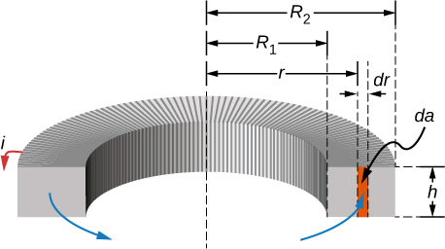

Solution

1.6

1. What is the self-inductance per meter of a coaxial cable whose inner radius is 0.50 mm and whose outer radius is 4.00 mm?

Solution



1. At the instant a current of 0.20 A is flowing through a coil of wire, the energy stored in its magnetic field is  What is the self-inductance of the coil?

Solution

0.3 H

1. Suppose that a rectangular toroid has 2000 windings and a self-inductance of 0.040 H. If, what is the current flowing through a rectangular toroid when the energy in its magnetic field is 

Solution

0.01 A

1. Solenoid *A* is tightly wound while solenoid *B* has windings that are evenly spaced with a gap equal to the diameter of the wire. The solenoids are otherwise identical. Determine the ratio of the energies stored per unit length of these solenoids when the same current flows through each.

Solution

1/4

1. A 10-H inductor carries a current of 20 A. How much ice at  could be melted by the energy stored in the magnetic field of the inductor? (*Hint*: Use the value  for ice.)

Solution

6.0 g

1. A coil with a self-inductance of 3.0 H and a resistance of  carries a steady current of 2.0 A. (a) What is the energy stored in the magnetic field of the coil? (b) What is the energy per second dissipated in the resistance of the coil?

Solution

a. 6.0 J; b. 400 W

1. A current of 1.2 A is flowing in a coaxial cable whose outer radius is five times its inner radius. What is the magnetic field energy stored in a 3.0-m length of the cable?

Solution

a. 6.0 J; b. 400 W

1. In the following figure,   and  Determine (a) the time constant of the circuit, (b) the initial current through the resistor, (c) the final current through the resistor, (d) the current through the resistor when  and (e) the voltages across the inductor and the resistor when 



Solution

a. 0.0040 s; b. 0 A; c. 2.4 A; d. 2.1 A; e. 1.6 V

1. For the circuit shown below, , , and . After steady state is reached with closed and  open,  is closed and immediately thereafter   is opened. Determine (a) the current through *L* at, (b) the current through *L* at , and (c) the voltages across *L* and *R1* at . *R1* = *R2* = *R*.

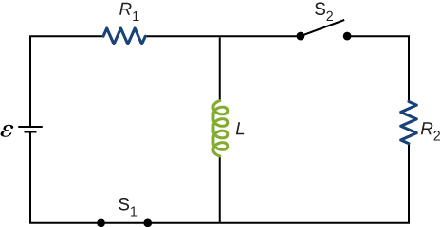

Solution

a. 4.0 A; b. 2.4 A; c. on *R*: ; on *L*: 

1. The current in the *RL* circuit shown here increases to  of its steady-state value in 2.0 s. What is the time constant of the circuit?

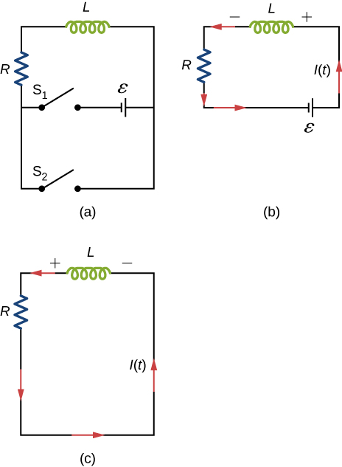

Solution

3.9 s

1. How long after switch  is thrown does it take the current in the circuit shown to reach half its maximum value? Express your answer in terms of the time constant of the circuit.

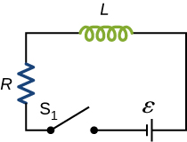

Solution



1. Examine the circuit shown below in part (a). Determine *dI/dt* at the instant after the switch is thrown in the circuit of (a), thereby producing the circuit of (b). Show that if *I* were to continue to increase at this initial rate, it would reach its maximum  in one time constant.

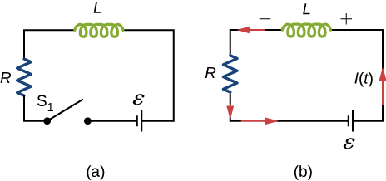

Solution



1. The current in the *RL* circuit shown below reaches half its maximum value in 1.75 ms after the switch is thrown. Determine (a) the time constant of the circuit and (b) the resistance of the circuit if .

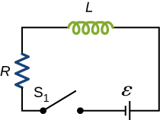

Solution

a. 2.52 ms; b. 

1. Consider the circuit shown below. Find  when (a) the switch S is first closed, (b) after the currents have reached steady-state values, and (c) at the instant the switch is reopened (after being closed for a long time).

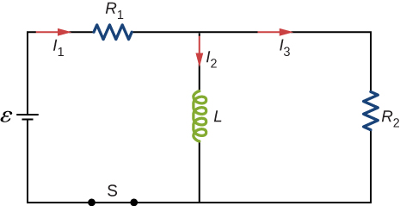

Solution

a. ; b. ;

c. 

1. For the circuit shown below, , , and . Find the values of  (a) immediately after switch S is closed, (b) a long time after S is closed, (c) immediately after S is reopened, and (d) a long time after S is reopened.

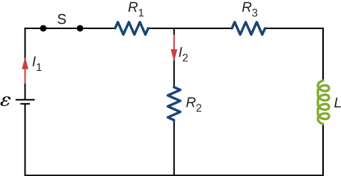

Solution

a. ; b. ; c. ; d. 

1. For the circuit shown below, find the current through the inductor  after the switch is reopened.

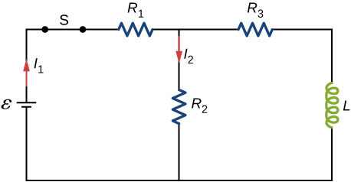

Solution

0.33 A

1. Show that for the circuit shown below, the initial energy stored in the inductor, , is equal to the total energy eventually dissipated in the resistor, .

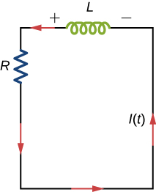

Solution

proof

1. A 5000-pF capacitor is charged to 100 V and then quickly connected to an 80-mH inductor. Determine (a) the maximum energy stored in the magnetic field of the inductor, (b) the peak value of the current, and (c) the frequency of oscillation of the circuit.

Solution

a. ; b. 0.025 A; c. 7960 Hz

1. The self-inductance and capacitance of an *LC* circuit are 0.20 mH and 5.0 pF. What is the angular frequency at which the circuit oscillates?

Solution



1. What is the self-inductance of an *LC* circuit that oscillates at 60 Hz when the capacitance is ?

Solution

0.70 H

1. In an oscillating *LC* circuit, the maximum charge on the capacitor is  and the maximum current through the inductor is 8.0 mA. (a) What is the period of the oscillations? (b) How much time elapses between an instant when the capacitor is uncharged and the next instant when it is fully charged?

Solution

a.; b. 

1. The self-inductance and capacitance of an oscillating *LC* circuit are  respectively. (a) What is the frequency of the oscillations? (b) If the maximum potential difference between the plates of the capacitor is 50 V, what is the maximum current in the circuit?

Solution

a. 1100 Hz; b. 0.35 A

1. In an oscillating *LC* circuit, the maximum charge on the capacitor is **. Determine the charge on the capacitor and the current through the inductor when energy is shared equally between the electric and magnetic fields. Express your answer in terms of **, *L*, and *C*.

Solution



1. In the circuit shown below,  is opened and  is closed simultaneously. Determine (a) the frequency of the resulting oscillations, (b) the maximum charge on the capacitor, (c) the maximum current through the inductor, and (d) the electromagnetic energy of the oscillating circuit.

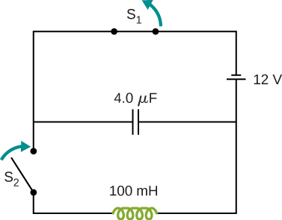

Solution

a. 250 Hz; b. ; c. ; d. 

1. An *LC* circuit in an AM tuner (in a car stereo) uses a coil with an inductance of 2.5 mH and a variable capacitor. If the natural frequency of the circuit is to be adjustable over the range 540 to 1600 kHz (the AM broadcast band), what range of capacitance is required?

Solution



1. In an oscillating *RLC* circuit,  What is the angular frequency of the oscillations?

Solution

390 rad/s

1. In an oscillating *RLC* circuit with  how much time elapses before the amplitude of the oscillations drops to half its initial value?

Solution

6.9 ms

1. What resistance *R* must be connected in series with a 200-mH inductor and a 10F capacitor of the resulting *RLC* oscillating circuit is to decay to  of its initial value of charge in 50 cycles? To  of its initial value in 50 cycles?

Solution

a. –0.624 ; b. 6.22 

**Additional Problems**

1. Show that the self-inductance per unit length of an infinite, straight, thin wire is infinite.

Solution

Let *a* equal the radius of the long, thin wire, *r* the location where the magnetic field is measured, and *R* is the upper limit of the problem where we will take *R* as it approaches infinity.

proof



1. Two long, parallel wires carry equal currents in opposite directions. The radius of each wire is *a*, and the distance between the centers of the wires is *d*. Show that if the magnetic flux within the wires themselves can be ignored, the self-inductance of a length *l* of such a pair of wires is

.

(*Hint*: Calculate the magnetic flux through a rectangle of length *l* between the wires and then use .)

Solution



1. A small, rectangular single loop of wire with dimensions *l*, and *a* is placed, as shown below, in the plane of a much larger, rectangular single loop of wire. The two short sides of the larger loop are so far from the smaller loop that their magnetic fields over the smaller fields over the smaller loop can be ignored. What is the mutual inductance of the two loops?

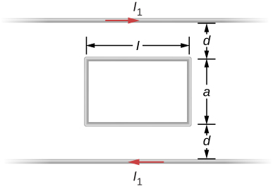

Solution



1. Suppose that a cylindrical solenoid is wrapped around a core of iron whose magnetic susceptibility is x. Using , show that the self-inductance of the solenoid is given by 

where l is its length, A its cross-sectional area, and N its total number of turns.

Solution

proof

1. A solenoid with  turns/m has an iron core placed in it whose magnetic susceptibility is . (a) If a current of 2.0 A flows through the solenoid, what is the magnetic field in the iron core? (b) What is the effective surface current formed by the aligned atomic current loops in the iron core? (c) What is the self-inductance of the filled solenoid?

Solution

a. 100 T; b. 2 A; c. 0.50 H

1. A rectangular toroid with inner radius , outer radius , height , and  turns is filled with an iron core of magnetic susceptibility . (a) What is the self-inductance of the toroid? (b) If the current through the toroid is 2.0 A, what is the magnetic field at the center of the core? (c) For this same 2.0-A current, what is the effective surface current formed by the aligned atomic current loops in the iron core?

Solution

a. ; b. 78 T; c. 2.57 A

1. The switch S of the circuit shown below is closed at . Determine (a) the initial current through the battery and (b) the steady-state current through the battery.

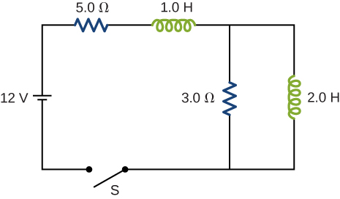

Solution

a. 0 A; b. 2.4 A

1. In an oscillating *RLC* circuit, . Initially, the capacitor has a charge of  and the current is zero. Calculate the charge on the capacitor (a) five cycles later and (b) 50 cycles later.

Solution

a. ; b. 

1. A 25.0-H inductor has 100 A of current turned off in 1.00 ms. (a) What voltage is induced to oppose this? (b) What is unreasonable about this result? (c) Which assumption or premise is responsible?

Solution

a. ; (b) The voltage is so extremely high that arcing would occur and the current would not be reduced so rapidly. (c) It is not reasonable to shut off such a large current in such a large inductor in such an extremely short time.

**Challenge Problems**

1. A coaxial cable has an inner conductor of radius a, and outer thin cylindrical shell of radius b. A current *I* flows in the inner conductor and returns in the outer conductor. The self-inductance of the structure will depend on how the current in the inner cylinder tends to be distributed. Investigate the following two extreme cases. (a) Let current in the inner conductor be distributed only on the surface and find the self-inductance. (b) Let current in the inner cylinder be distributed uniformly over its cross-section and find the self-inductance. Compare with your results in (a).

Solution

a. ; b. ; comparing results only adds an additional term

1. In a damped oscillating circuit the energy is dissipated in the resistor. The *Q*-factor is a measure of the persistence of the oscillator against the dissipative loss. (a) Prove that for a lightly damped circuit the energy, *U*, in the circuit decreases according to the following equation.

, where  .

(b) Using the definition of the *Q*-factor as energy divided by the loss over the next cycle, prove that *Q*-factor of a lightly damped oscillator as defined in this problem is



(*Hint:* For (b), to obtain *Q*, divide *E* at the beginning of one cycle by the change  over the next cycle.)

Solution

proof

1. The switch in the circuit shown below is closed at . Find currents through (a) , (b) , and (c) the battery as function of time.

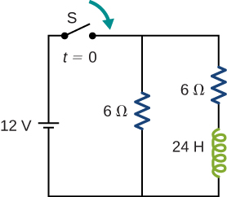

Solution

a. ; b. ; c. 

1. A square loop of side a = 2 cm is placed b = 1 cm from a long wire carrying a current that varies with time at a constant rate of 3 A/s as shown below. (a) Use Ampère’s law and find the magnetic field. (b) Determine symbolically the magnetic flux through the loop. (c) If the loop has a resistance of , how much induced current flows in the loop?

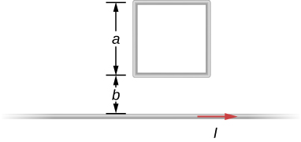

Solution

a.  b. ; c. 4.4 nA

This file is copyright 2016, Rice University. All Rights Reserved.