***University Physics Volume II***

**Unit 2: Electricity and Magnetism**

**Chapter 16: Electromagnetic Waves**

**Conceptual Questions**

1. Explain how the displacement current maintains the continuity of current in a circuit containing a capacitor.

Solution

The current into the capacitor to change the electric field between the plates is equal to the displacement current between the plates.

1. Describe the field lines of the induced magnetic field along the edge of the imaginary horizontal cylinder shown below if the cylinder is in a spatially uniform electric field that is horizontal, pointing to the right, and increasing in magnitude.

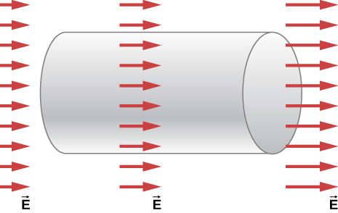

Solution

The magnetic field lines follow the circular circumference of a cross-section of the cylinder. The direction is the one that the right-hand rule would give for a current from left to right to maintain the continuity of a real current that charges parallel plates to produce the increasing *E* field.

1. Why is it much easier to demonstrate in a student lab that a changing magnetic field induces an electric field than it is to demonstrate that a changing electric field produces a magnetic field?

Solution

The first demonstration requires simply observing the current produced in a wire that experiences a changing magnetic field. The second demonstration requires moving electric charge from one location to another, and therefore involves electric currents that generate a changing electric field. The magnetic fields from these currents are not easily separated from the magnetic field that the displacement current produces.

1. If the electric field of an electromagnetic wave is oscillating along the *z*-axis and the magnetic field is oscillating along the *x*-axis, in what possible direction is the wave traveling?

Solution

along the *y*-axis in either the +*y*-or –*y*-direction

1. In which situation shown below will the electromagnetic wave be more successful in inducing a current in the wire? Explain.

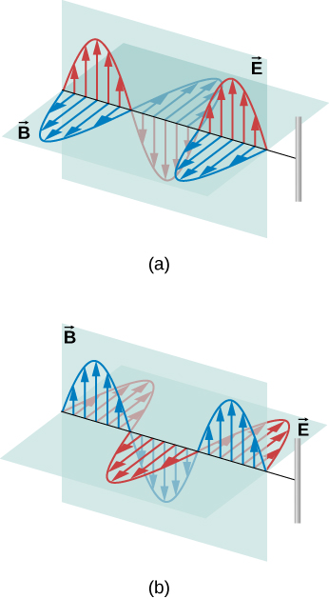

Solution

in (a), because the electric field is parallel to the wire, accelerating the electrons

1. In which situation shown below will the electromagnetic wave be more successful in inducing a current in the loop? Explain.

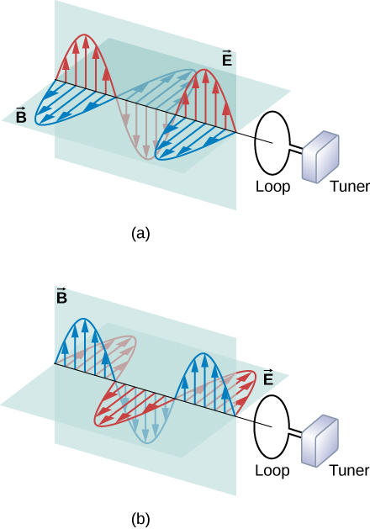

Solution

The magnetic field in (a) is normal to the surface of the loop, and therefore produces the maximum rate of change of magnetic flux through the loop, and according to Faraday’s law, the strongest induced emf.

1. Under what conditions might wires in a circuit where the current flows in only one direction emit electromagnetic waves?

Solution

A steady current in a dc circuit will not produce electromagnetic waves. If the magnitude of the current varies while remaining in the same direction, the wires will emit electromagnetic waves, for example, if the current is turned on or off.

1. Shown below is the interference pattern of two radio antennas broadcasting the same signal. Explain how this is analogous to the interference pattern for sound produced by two speakers. Could this be used to make a directional antenna system that broadcasts preferentially in certain directions? Explain.

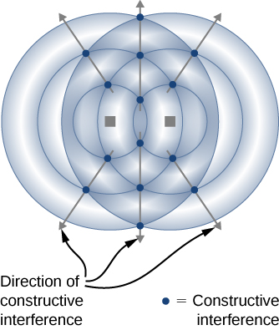

Solution

It is similar insofar as the areas where the two wave patterns are in phase interfere constructively to produce a stronger signal while those  out of phase interfere destructively. Radio broadcasters can (and do) use antennas in this way to try to have the maxima in the interference pattern occur in locations they most prefer the signal to reach.

1. When you stand outdoors in the sunlight, why can you feel the energy that the sunlight carries, but not the momentum it carries?

Solution

The amount of energy (about ) is can quickly produce a considerable change in temperature, but the light pressure (about ) is much too small to notice.

1. How does the intensity of an electromagnetic wave depend on its electric field? How does it depend on its magnetic field?

Solution

It is directly proportional to the maximum *E* field squared, and to the maximum *B* field squared

1. What is the physical significance of the Poynting vector?

Solution

It has the magnitude of the energy flux and points in the direction of wave propagation. It gives the direction of energy flow and the amount of energy per area transported per second.

1. A 2.0-mW helium-neon laser transmits a continuous beam of red light of cross-sectional area . If the beam does not diverge appreciably, how would its rms electric field vary with distance from the laser? Explain.

Solution

Because the beam does not diverge, its cross-sectional area and therefore its intensity remain roughly constant. Therefore, its rms electric field would remain roughly constant.

1. Why is the radiation pressure of an electromagnetic wave on a perfectly reflecting surface twice as large as the pressure on a perfectly absorbing surface?

Solution

The force on a surface acting over time ** is the momentum that the force would impart to the object. The momentum change of the light is doubled if the light is reflected back compared with when it is absorbed, so the force acting on the object is twice as great.

1. Why did the early Hubble Telescope photos of Comet Ison approaching Earth show it to have merely a fuzzy coma around it, and not the pronounced double tail that developed later (see below)?

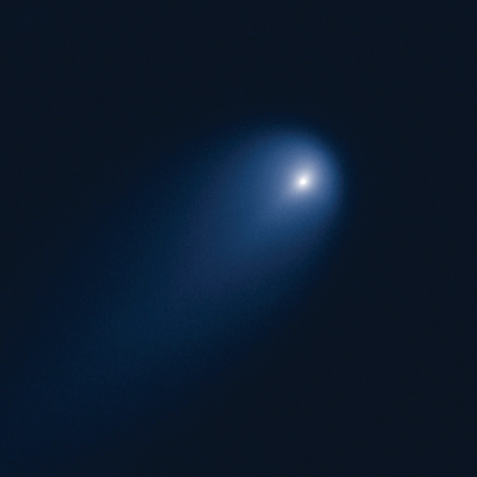

Solution

Both the radiation pressure and the solar wind, which together produce the comet double tail, decrease with increasing distance from the Sun.

1. (a) If the electric field and magnetic field in a sinusoidal plane wave were interchanged, in which direction relative to before would the energy propagate?(b) What if the electric and the magnetic fields were both changed to their negatives?

Solution

a. According to the right hand rule, the direction of energy propagation would reverse. b. This would leave the vector , and therefore the propagation direction, the same.

1. Compare the speed, wavelength, and frequency of radio waves and X-rays traveling in a vacuum.

Solution

Their speed is the same. X-rays have shorter wavelengths than radio waves and higher frequencies.

1. Accelerating electric charge emits electromagnetic radiation. How does this apply in each case: (a) radio waves, (b) infrared radiation.

Solution

a. Radio waves are generally produced by alternating current in a wire or an oscillating electric field between two plates; b. Infrared radiation is commonly produced by heated bodies whose atoms and the charges in them vibrate at about the right frequency.

1. Compare and contrast the meaning of the prefix “micro” in the names of SI units in the term *microwaves*.

Solution

For SI units, “micro” means specifically a factor of  times the unit it precedes. In microwaves, it refers not to a specific small number but just to the idea that the wavelengths are small compared to (other) radio waves.

1. Part of the light passing through the air is scattered in all directions by the molecules comprising the atmosphere. The wavelengths of visible light are larger than molecular sizes, and the scattering is strongest for wavelengths of light closest to sizes of molecules.

(a) Which of the main colors of light is scattered the most? (b) Explain why this would give the sky its familiar background color at midday.

Solution

a. blue; b. Light of longer wavelengths than blue passes through the air with less scattering, whereas more of the blue light is scattered in different directions in the sky to give it is blue color.

1. When a bowl of soup is removed from a microwave oven, the soup is found to be steaming hot, whereas the bowl is only warm to the touch. Discuss the temperature changes that have occurred in terms of energy transfer.

Solution

The microwaves can transfer energy by reorienting the highly polar molecules such as water. The soup contains water and absorbs energy more effectively from the microwaves than the ceramic material in the bowl, which does not contain water.

1. Certain orientations of a broadcast television antenna give better reception than others for a particular station. Explain.

Solution

A typical antenna has a stronger response when the wires forming it are orientated parallel to the electric field of the radio wave.

1. What property of light corresponds to loudness in sound?

Solution

intensity of the light

1. Is the visible region a major portion of the electromagnetic spectrum?

Solution

No, it is very narrow and just a small portion of the overall electromagnetic spectrum.

1. Can the human body detect electromagnetic radiation that is outside the visible region of the spectrum?

Solution

Yes. For example, if you stand near a hot oven, or a campfire, or other heated object, but away from any currents of heated air, you can still feel the heat emitted as electromagnetic waves mainly in the infrared range.

1. Radio waves normally have their *E* and *B* fields in specific directions, whereas visible light usually has its *E* and *B* fields in random and rapidly changing directions that are perpendicular to each other and to the propagation direction. Can you explain why?

Solution

Visible light is typically produced by changes of energies of electrons in randomly oriented atoms and molecules. Radio waves are typically emitted by an ac current flowing along a wire, that has fixed orientation and produces electric fields pointed in particular directions.

1. Give an example of resonance in the reception of electromagnetic waves.

Solution

Tuning a radio station to a particular station. The *RLC* circuit responds strongly to frequencies near the one intended that are near a resonance but not to other frequencies.

1. Illustrate that the size of details of an object that can be detected with electromagnetic waves is related to their wavelength, by comparing details observable with two different types (for example, radar and visible light).

Solution

Radar can observe objects the size of an airplane and uses radio waves of about 0.5 cm in wavelength. Visible light can be used to view single biological cells and has wavelengths of about .

1. In which part of the electromagnetic spectrum are each of these waves:

(a) *f* = 10.0 kHz , (b) , (c) , (d) 0.30 nm

Solution

a. radio waves; b. visible light; c. microwaves; d. X-rays

1. In what range of electromagnetic radiation are the electromagnetic waves emitted by power lines in a country that uses 50-Hz ac current?

Solution

ELF radio waves

1. If a microwave oven could be modified to merely tune the waves generated to be in the infrared range instead of using microwaves, how would this affect the uneven heating of the oven?

Solution

The hot spots, which are antinodes from interference, would be too close together to cause uneven heating.

1. A leaky microwave oven in a home can sometimes cause interference with the homeowner’s WiFi system. Why?

Solution

The frequency of 2.45 GHz of a microwave oven is close to the specific frequencies in the 2.4 GHz band used for WiFi.

1. When a television news anchor in a studio speaks to a reporter in a distant country, there is sometimes a noticeable lag between when the anchor speaks in the studio and when the remote reporter hears it and replies. Explain what causes this delay.

Solution

Only a small part of delay results from the speed of light, because a signal traveling at speed *c* can encircle Earth several times in one second. Most of the delay is from processing and buffering the signal.

**Problems**

1. Show that the magnetic field at a distance *r* from the axis of two circular parallel plates, produced by placing charge *Q*(*t*) on the plates is

.

Solution



1. Express the displacement current in a capacitor in terms of the capacitance and the rate of change of the voltage across the capacitor.

Solution



1. A potential difference  is maintained across a parallel-plate capacitor with capacitance *C* consisting of two circular parallel plates. A thin wire with resistance *R* connects the centers of the two plates, allowing charge to leak between plates while they are charging.

(a) Obtain expressions for the leakage current  in the thin wire. Use these results to obtain an expression for the current  in the wires connected to the capacitor.

(b) Find the displacement current in the space between the plates from the changing electric field between the plates.

(c) Compare  with the sum of the displacement current  and resistor current between the plates, and explain why the relationship you observe would be expected.

Solution

a. ; b. ;

c. ; which is the sum of  and  consistent with how the displacement current maintaining the continuity of current.

1. Suppose the parallel-plate capacitor shown below is accumulating charge at a rate of 0.010 C/s. What is the induced magnetic field at a distance of 10 cm from the capacitator?

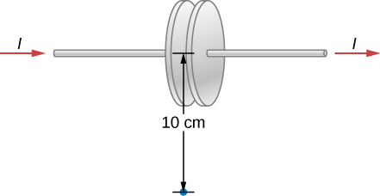

Solution

The induced magnetic field from the displacement current is the same as if the real current flowed through the capacitor, because the displacement maintains continuity of the total (real + displacement) current: .

Note that the answer is independent of the capacitance.

1. The potential difference *V*(*t*) between parallel plates shown above is instantaneously increasing at a rate of  What is the displacement current between the plates if the separation of the plates is 1.00 cm and they have an area of ?

Solution



1. A parallel-plate capacitor has a plate area of  and a separation of 0.0100 m. What must be must be the angular frequency ** for a voltage  with  to produce a maximum displacement induced current of 1.00 A between the plates?

Solution

 or 

1. The voltage across a parallel-plate capacitor with area  and separation varies sinusoidally as , where *t* is in seconds. Find the displacement current between the plates.

Solution



1. The voltage across a parallel-plate capacitor with area *A* and separation *d* varies with time *t* as , where *a* is a constant. Find the displacement current between the plates.

Solution



1. If the Sun suddenly turned off, we would not know it until its light stopped coming. How long would that be, given that the Sun is  away?

Solution

499 s

1. What is the maximum electric field strength in an electromagnetic wave that has a maximum magnetic field strength of  (about 10 times Earth’s magnetic field)?

Solution

150 kV/m

1. An electromagnetic wave has a frequency of 12 MHz. What is its wavelength in vacuum?

Solution

25 m

1. If electric and magnetic field strengths vary sinusoidally in time at frequency 1.00 GHz, being zero at , then  and . (a) When are the field strengths next equal to zero? (b) When do they reach their most negative value? (c) How much time is needed for them to complete one cycle?

Solution

a. at  b. ; c. 

1. The electric field of an electromagnetic wave traveling in vacuum is described by the following wave function:



where *k* is the wavenumber in rad/m, *x* is in m, *t* is in s.

Find the following quantities:

(a) amplitude

(b) frequency

(c) wavelength

(d) the direction of the travel of the wave

(e) the associated magnetic field wave

Solution

a. 5.00 V/m; b. ; c. 31.4 cm; d. toward the +*x*-axis;

e. 

1. A plane electromagnetic wave of frequency 20 GHz moves in the positive *y*-axis direction such that its electric field is pointed along the *z*-axis. The amplitude of the electric field is 10 V/m. The start of time is chosen so that at , the electric field has a value 10 V/m at the origin. (a) Write the wave function that will describe the electric field wave. (b) Find the wave function that will describe the associated magnetic field wave.

Solution

a. ;

b.  (*y* in m and *t* in s)

1. The following represents an electromagnetic wave traveling in the direction of the positive *y*-axis: .

The wave is passing through a wide tube of circular cross-section of radius *R* whose axis is along the *y*-axis. Find the expression for the displacement current through the tube.

Solution



1. While outdoors on a sunny day, a student holds a large convex lens of radius 4.0 cm above a sheet of paper to produce a bright spot on the paper that is 1.0 cm in radius, rather than a sharp focus. By what factor is the electric field in the bright spot of light related to the electric field of sunlight leaving the side of the lens facing the paper?

Solution

4

1. A plane electromagnetic wave travels northward. At one instant, its electric field has a magnitude of 6.0 V/m and points eastward. What are the magnitude and direction of the magnetic field at this instant?

Solution

The magnetic field is downward, and it has magnitude .

1. The electric field of an electromagnetic wave is given by

.

Write the equations for the associated magnetic field and Poynting vector.

Solution

; the instantaneous Poynting vector is  and the average Poynting vector is **.

1. A radio station broadcasts at a frequency of 760 kHz. At a receiver some distance from the antenna, the maximum magnetic field of the electromagnetic wave detected is .

(a) What is the maximum electric field? (b)What is the wavelength of the electromagnetic wave?

Solution

a.  b. 394 m

1. The filament in a clear incandescent light bulb radiates visible light at a power of 5.00 W. Model the glass part of the bulb as a sphere of radius  and calculate the amount of electromagnetic energy from visible light inside the bulb.

Solution

Conceptual approach: The light from the filament takes time  to leave the bulb. During that time the energy released by the filament, and still in the bulb, was .

Equation-based solution: The intensity at distance *r* is . Then the integrated energy inside is , giving the same result as before.

1. At what distance does a 100-W lightbulb produce the same intensity of light as a 75-W lightbulb produces 10 m away? (Assume both have the same efficiency for converting electrical energy in the circuit into emitted electromagnetic energy.)

Solution

11.5 m

1. An incandescent light bulb emits only 2.6 W of its power as visible light. What is the rms electric field of the emitted light at a distance of 3.0 m from the bulb?

Solution

**

1. A 150-W lightbulb emits 5% of its energy as electromagnetic radiation. What is the magnitude of the average Poynting vector 10 m from the bulb?

Solution



1. A small helium-neon laser has a power output of 2.5 mW. What is the electromagnetic energy in a 1.0-m length of the beam?

Solution





1. At the top of Earth’s atmosphere, the time-averaged Poynting vector associated with sunlight has a magnitude of about .

(a) What are the maximum values of the electric and magnetic fields for a wave of this intensity? (b) What is the total power radiated by the sun? Assume that the Earth is  from the Sun and that sunlight is composed of electromagnetic plane waves.

Solution



1. The magnetic field of a plane electromagnetic wave moving along the *z* axis is given by , where  and 

(a)Write an expression for the electric field associated with the wave. (b) What are the frequency and the wavelength of the wave? (c) What is its average Poynting vector?

Solution

a. ; b. , 200 m; c. 

1. What is the intensity of an electromagnetic wave with a peak electric field strength of 125 V/m?

Solution



1. Assume the helium-neon lasers commonly used in student physics laboratories have power outputs of 0.500 mW. (a) If such a laser beam is projected onto a circular spot 1.00 mm in diameter, what is its intensity? (b) Find the peak magnetic field strength. (c) Find the peak electric field strength.

Solution

a. ; b. ; c. 693 V/m

1. An AM radio transmitter broadcasts 50.0 kW of power uniformly in all directions. (a) Assuming all of the radio waves that strike the ground are completely absorbed, and that there is no absorption by the atmosphere or other objects, what is the intensity 30.0 km away? (*Hint:* Half the power will be spread over the area of a hemisphere.) (b) What is the maximum electric field strength at this distance?

Solution

a. ; b. 

1. Suppose the maximum safe intensity of microwaves for human exposure is taken to be . (a) If a radar unit leaks 10.0 W of microwaves (other than those sent by its antenna) uniformly in all directions, how far away must you be to be exposed to an intensity considered to be safe? Assume that the power spreads uniformly over the area of a sphere with no complications from absorption or reflection. (b) What is the maximum electric field strength at the safe intensity? (Note that early radar units leaked more than modern ones do. This caused identifiable health problems, such as cataracts, for people who worked near them.)

Solution

a. ; b. 

1. A 2.50-m-diameter university communications satellite dish receives TV signals that have a maximum electric field strength (for one channel) of  (see below). (a) What is the intensity of this wave? (b) What is the power received by the antenna? (c) If the orbiting satellite broadcasts uniformly over an area of  (a large fraction of North America), how much power does it radiate?

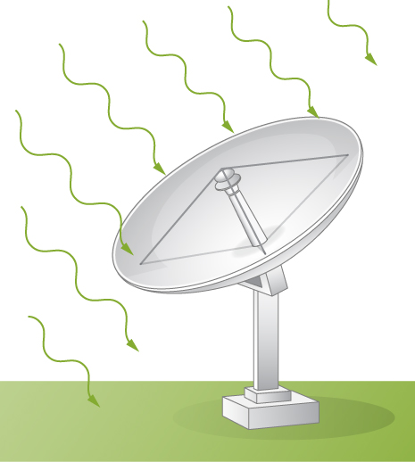

Solution

a. ; b. ; c. 1.12 W

1. Lasers can be constructed that produce an extremely high intensity electromagnetic wave for a brief time—called pulsed lasers. They are used to initiate nuclear fusion, for example. Such a laser may produce an electromagnetic wave with a maximum electric field strength of  for a time of 1.00 ns. (a) What is the maximum magnetic field strength in the wave? (b) What is the intensity of the beam? (c) What energy does it deliver on an  area?

Solution

a. 333 T; b. ; c. 13.3 kJ

1. A 150-W lightbulb emits 5% of its energy as electromagnetic radiation. What is the radiation pressure on an absorbing sphere of radius 10 m that surrounds the bulb?

Solution



1. What pressure does light emitted uniformly in all directions from a 100-W incandescent light bulb exert on a mirror at a distance of 3.0 m, if 2.6 W of the power is emitted as visible light?

Solution

**

1. A microscopic spherical dust particle of radius and mass  is moving in outer space at a constant speed of 30 cm/sec. A wave of light strikes it from the opposite direction of its motion and gets absorbed. Assuming the particle accelerates opposite to the motion uniformly to zero speed in one second, what is the average electric field amplitude in the light?

Solution



1. A Styrofoam spherical ball of radius 2 mm and mass  is to be suspended by the radiation pressure in a vacuum tube in a lab. How much intensity will be required if the light is completely absorbed the ball?

Solution



1. Suppose that  for sunlight at a point on the surface of Earth is . (a) If sunlight falls perpendicularly on a kite with a reflecting surface of area , what is the average force on the kite due to radiation pressure? (b) How is your answer affected if the kite material is black and absorbs all sunlight?

Solution

a.  b. it is reduced to half the pressure, 

1. Sunlight reaches the ground with an intensity of about . A sunbather has a body surface area of  facing the sun while reclining on a beach chair on a clear day. (a) how much energy from direct sunlight reaches the sunbather’s skin per second? (b) What pressure does the sunlight exert if it is absorbed?

Solution

a. 800 W; b. 

1. Suppose a spherical particle of mass *m* and radius *R* in space absorbs light of intensity *I* for time *t*. (a) How much work does the radiation pressure do to accelerate the particle from rest in the given time it absorbs the light? (b) How much energy carried by the electromagnetic waves is absorbed by the particle over this time based on the radiant energy incident on the particle?

Solution

a.

1. How many helium atoms, each with a radius of about 31 pm, must be placed end to end to have a length equal to one wavelength of 470 nm blue light?

Solution

15,200

1. If you wish to detect details of the size of atoms (about 0.2 nm) with electromagnetic radiation, it must have a wavelength of about this size. (a) What is its frequency? (b) What type of electromagnetic radiation might this be?

Solution

a. ; b. X-rays

1. Find the frequency range of visible light, given that it encompasses wavelengths from 380 to 760 nm.

Solution

 to 

1. (a) Calculate the wavelength range for AM radio given its frequency range is 540 to 1600 kHz. (b) Do the same for the FM frequency range of 88.0 to 108 MHz.

Solution

a. The wavelength range is 187 m to 556 m. b. The wavelength range is 2.78 m to 3.41 m.

1. Radio station WWVB, operated by the National Institute of Standards and Technology (NIST) from Fort Collins, Colorado, at a low frequency of 60 kHz, broadcasts a time synchronization signal whose range covers the entire continental US. The timing of the synchronization signal is controlled by a set of atomic clocks to an accuracy of  and repeats every 1 minute. The signal is used for devices, such as radio-controlled watches, that automatically synchronize with it at preset local times. WWVB’s long wavelength signal tends to propagate close to the ground.

(a) Calculate the wavelength of the radio waves from WWVB.

(b) Estimate the error that the travel time of the signal causes in synchronizing a radio controlled watch in Norfolk, Virginia, which is 1570 mi (2527 km) from Fort Collins, Colorado.

Solution

a. ; b. 

1. An outdoor WiFi unit for a picnic area has a 100-mW output anda range of about 30 m. What output power would reduce its range to 12 m for use with the same devices as before? Assume there are no obstacles in the way and that microwaves into the ground are simply absorbed.

Solution



1. The prefix “mega” (M) and “kilo” (k), when referring to amounts of computer data, refer to factors of 1024 or rather than 1000 for the prefix *kilo*, and  rather than 1,000,000 for the prefix *Mega* (M). If a wireless (WiFi ) router transfers 150 Mbps of data, how many bits per second is that in decimal arithmetic?

Solution



1. A computer user finds that his wireless router transmits data at a rate of 75 Mbps (megabits per second). Compare the average time to transmit one bit of data with the time difference between the wifi signal reaching an observer’s cell phone directly and by bouncing back to the observer from a wall 8.00 m past the observer.

Solution

time for  difference in travel time is 

1. (a) The ideal size (most efficient) for a broadcast antenna with one end on the ground is one-fourth the wavelength () of the electromagnetic radiation being sent out. If a new radio station has such an antenna that is 50.0 m high, what frequency does it broadcast most efficiently? Is this in the AM or FM band? (b) Discuss the analogy of the fundamental resonant mode of an air column closed at one end to the resonance of currents on an antenna that is one-fourth their wavelength.

Solution

a. ; b. The resonant frequencies for an air column closed at one end are  where  Thus, the resonance of currents on an antenna that is 1/4 their wavelength is analogous to the fundamental resonant mode of an air column closed at one end, since the tube also has a length equal to 1/4 the wavelength of the fundamental oscillation.

1. What are the wavelengths of (a) X-rays of frequency  (b)Yellow light of frequency  (c)Gamma rays of frequency 

Solution

a.  b.  c. 

1. For red light of , what are *f*, **,and *k*?

Solution



1. A radio transmitter broadcasts plane electromagnetic waves whose maximum electric field at a particular location is What is the maximum magnitude of the oscillating magnetic field at that location? How does it compare with Earth's magnetic field?

Solution

 the non-oscillating geomagnetic field of 25–65  is much larger

1. (a) Two microwave frequencies authorized for use in microwave ovens are: 915 and 2450 MHz. Calculate the wavelength of each. (b) Which frequency would produce smaller hot spots in foods due to interference effects?

Solution

a. An electromagnetic wave with 900 MHz frequency has 0.33 m wavelength, a 2450 MHz electromagnetic wave has 0.122 m wave length. b. The microwave with the smaller wavelength would produce hot spots that are closer together and smaller in foods, so the 2450 MHz.

1. During normal beating, the heart creates a maximum 4.00-mV potential across 0.300 m of a person’s chest, creating a 1.00-Hz electromagnetic wave. (a) What is the maximum electric field strength created? (b) What is the corresponding maximum magnetic field strength in the electromagnetic wave? (c) What is the wavelength of the electromagnetic wave?

Solution

a. ; b. ; c. 

1. Distances in space are often quoted in units of light-years, the distance light travels in 1 year. (a) How many meters is a light-year? (b) How many meters is it to Andromeda, the nearest large galaxy, given that it is  ly away? (c) The most distant galaxy yet discovered is  ly away. How far is this in meters?

Solution

a. ; b. ; c. 

1. A certain 60.0-Hz ac power line radiates an electromagnetic wave having a maximum electric field strength of 13.0 kV/m. (a) What is the wavelength of this very-low-frequency electromagnetic wave? (b) What type of electromagnetic radiation is this wave (b) What is its maximum magnetic field strength?

Solution

a. ; b. radio wave; c. 

1. (a) What is the frequency of the 193-nm ultraviolet radiation used in laser eye surgery? (b) Assuming the accuracy with which this electromagnetic radiation can ablate (reshape) the cornea is directly proportional to wavelength, how much more accurate can this UV radiation be than the shortest visible wavelength of light?

Solution

a. ; b. UV radiation is 97% more accurate than the shortest wavelength of visible light.

**Additional Problems**

1. In a region of space, the electric field is pointed along the *x*-axis, but its magnitude changes as described by



where *t* is in nanoseconds and *x* is in cm. Find the displacement current through a circle of radius 3 cm in the  plane at .

Solution



1. A microwave oven uses electromagnetic waves of frequency to heat foods. The waves reflect from the inside walls of the oven to produce an interference pattern of standing waves whose antinodes are hot spots that can leave observable pit marks in some foods. The pit marks are measured to be 6.0 cm apart. Use the method employed by Heinrich Hertz to calculate the speed of electromagnetic waves this implies.

Solution

The antinodes are half a wavelength apart, so  and 

1. Galileo proposed measuring the speed of light by uncovering a lantern and having an assistant a known distance away uncover his lantern when he saw the light from Galileo’s lantern, and timing the delay. How far away must the assistant be for the delay to equal the human reaction time of about 0.25 s?

Solution

, which is much greater than Earth’s circumference

1. Show that the wave equation in one dimension



is satisfied by any doubly differentiable function of either the form  or .

Solution



Hence,

.

Substitute –*v* for *v* to obtain the result for *f*(*x + vt*).

1. On its highest power setting, a microwave oven increases the temperature of 0.400 kg of spaghetti by  in 120 s. (a) What was the rate of energy absorption by the spaghetti, given that its specific heat is ? Assume the spaghetti is perfectly absorbing. (b) Find the average intensity of the microwaves, given that they are absorbed over a circular area 20.0 cm in diameter. (c) What is the peak electric field strength of the microwave? (d) What is its peak magnetic field strength?

Solution

a. 564 W; b. ; c. ; d. 

1. A certain microwave oven projects 1.00 kW of microwaves onto a 30-cm-by-40-cm area. (a) What is its intensity in ? (b) Calculate the maximum electric field strength  in these waves. (c) What is the maximum magnetic field strength ?

Solution

a. ;

b. ;

c. 

1. Electromagnetic radiation from a 5.00-mW laser is concentrated on a  area. (a) What is the intensity in ? (b) Suppose a 2.00-nC electric charge is in the beam. What is the maximum electric force it experiences? (c) If the electric charge moves at 400 m/s, what maximum magnetic force can it feel?

Solution

a. ; b. ; c. 

1. A 200-turn flat coil of wire 30.0 cm in diameter acts as an antenna for FM radio at a frequency of 100 MHz. The magnetic field of the incoming electromagnetic wave is perpendicular to the coil and has a maximum strength of . (a) What power is incident on the coil? (b) What average emf is induced in the coil over one-fourth of a cycle? (c) If the radio receiver has an inductance of , what capacitance must it have to resonate at 100 MHz?

Solution

a. ; b. ; c. 

1. Suppose a source of electromagnetic waves radiates uniformly in all directions in empty space where there are no absorption or interference effects. (a) Show that the intensity is inversely proportional to , the distance from the source squared. (b) Show that the magnitudes of the electric and magnetic fields are inversely proportional to *r*.

Solution

a. ; b. 

1. A radio station broadcasts its radio waves with a power of 50,000 W. What would be the intensity of this signal if it is received on a planet orbiting Proxima Centuri, the closest star to our Sun, at 4.243 ly away?

Solution



1. The Poynting vector describes a flow of energy whenever electric and magnetic fields are present. Consider a long cylindrical wire of radius *r* with a current *I* in the wire, with resistance *R* and voltage *V*. From the expressions for the electric field along the wire and the magnetic field around the wire, obtain the magnitude and direction of the Poynting vector at the surface. Show that it accounts for an energy flow into the wire from the fields around it that accounts for the Ohmic heating of the wire.

Solution



1. The Sun’s energy strikes Earth at an intensity of . Assume as a model approximation that all of the light is absorbed. (Actually, about 30% of the light intensity is reflected out into space.)

(a) Calculate the total force that the Sun’s radiation exerts on Earth.

(b) Compare this to the force of gravity between the Sun and Earth.

Earth’s mass is 

Solution

a.  b. Gravitational force is  which is much larger.

1. If a *Lightsail* spacecraft were sent on a Mars mission, by what ratio of the final force to the initial force would its propulsion be reduced when it reached Mars?

Solution

0.431

1. Lunar astronauts placed a reflector on the Moon’s surface, off which a laser beam is periodically reflected. The distance to the Moon is calculated from the round-trip time. (a) To what accuracy in meters can the distance to the Moon be determined, if this time can be measured to 0.100 ns? (b) What percent accuracy is this, given the average distance to the Moon is 384,400 km?

Solution

a. ; b. 

1. Radar is used to determine distances to various objects by measuring the round-trip time for an echo from the object. (a) How far away is the planet Venus if the echo time is 1000 s? (b) What is the echo time for a car 75.0 m from a highway police radar unit? (c) How accurately (in nanoseconds) must you be able to measure the echo time to an airplane 12.0 km away to determine its distance within 10.0 m?

Solution

a. ; b. ; c. 33 ns

1. Calculate the ratio of the highest to lowest frequencies of electromagnetic waves the eye can see, given the wavelength range of visible light is from 380 to 760 nm. (Note that the ratio of highest to lowest frequencies the ear can hear is 1000.)

Solution

a. 2.0

1. How does the wavelength of radio waves for an AM radio station broadcasting at 1030 KHz compare with the wavelength of the lowest audible sound waves (of 20 Hz). The speed of sound in air at  is about 343 m/s.

Solution



**Challenge Problems**

1. A parallel-plate capacitor with plate separation *d* is connected to a source of emf that places a time-dependent voltage *V*(*t*) across its circular plates of radius  and area  (see below).

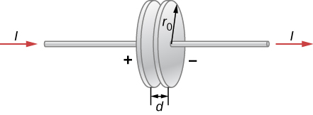

(a) Write an expression for the time rate of change of energy inside the capacitor in terms of *V*(*t*) and *dV*(*t*)/*dt*.

(b) Assuming that *V*(*t*) is increasing with time, identify the directions of the electric field lines inside the capacitor and of the magnetic field lines at the edge of the region between the plates, and then the direction of the Poynting vector  at this location.

(c) Obtain expressions for the time dependence of *E*(*t*), for *B*(*t*) from the displacement current, and for the magnitude of the Poynting vector at the edge of the region between the plates.

(d) From , obtain an expression in terms of *V*(*t*) and *dV*(*t*)/*dt* for the rate at which electromagnetic field energy enters the region between the plates.

(e) Compare the results of parts (a) and (d) and explain the relationship between them.

Solution

a. ; b. The lines of the magnetic field are circular around the edge of region between the plates. The lines of the *E* field are from one plate to the other. The direction of  is radially inward into the region between the plates from outside. c. ; ; ; d. Integrate by multiplying by the surface area  around the edge bounding the separation of the plates, to obtain the total flux of *S* into the region between the plates as

; e. The integrated energy flux into the region between the plates in (d) is equal to the time rate of change of energy between the plates in (a). The energy stored between the plates increases at rate equal to the rate that the fields around the capacitor carry energy into the region.

1. A particle of cosmic dust has a density  (a) Assuming the dust particles are spherical and light absorbing, and are at the same distance as Earth from the Sun, determine the particle size for which radiation pressure from sunlight is equal to the Sun’s force of gravity on the dust particle. (b) Explain how the forces compare if the particle radius is smaller. (c) Explain what this implies about the sizes of dust particle likely to be present in the inner solar system compared with outside the Oort cloud.

Solution

a. The mass of the dust particle of radius *r* is

.

The force of gravity from the Sun of mass *M* and distance *R* on it is then

.

The force from the radiation pressure is .

Equate the two expressions for the force to find when the two are of equal magnitude

,

.

Substituting, , solar mass .

;

b. The radiation pressure is greater than the Sun’s gravity if the particle size is smaller, because the gravitational force varies as the radius cubed while the radiation pressure varies as the radius squared. c. The radiation force outward implies that particles smaller than this are less likely to be near the Sun than outside the range of the Sun’s radiation pressure.

This file is copyright 2016, Rice University. All Rights Reserved.