CENTRAL NEW MEXICO COMMUNITY COLLEGE (CNM)

SCHOOL OF BUSINESS, HOSPITALITY, AND TECHNOLOGY (BHT)

COURSE SYLLABUS Fall 26
Dates TBD

COURSE ID-NUMBER: CSCI 2720 COURSE TITLE: Quantum Hardware
COURSE SECTION #: 101 COURSE CRN#: TBD
CLASS TIME: TBD CLASS LOCATION/LINK: FUSE CR202
COURSE CREDITS: 4 MODE OF INSTRUCTION: F2F
PRE-REQUISITE: ENGT 2020 Laser and Photonics
INSTRUCTOR: Brian Rashap PREFERRED PRONOUNS: he/him/his
TELEPHONE: 505-850-6352
E-MAIL: brashap@cnm.edu
OFFICE HOUR LOCATION/LINK: FUSE CR202 TBD

Texts & Supplies
Required text: N/A
Supplies: None, all will be provided

Course Description
An intermediate course that will create an understanding of quantum information system hardware, provide hands-on experience with quantum systems, and explore quantum phenomena. Students will learn about quantum superposition and entanglement, and how these phenomena can be used to create quantum bits (qubits) and gates. They will explore how measurements effect quantum systems. The students will get hands-on experience creating entangled pairs of single photons, trapping/exciting neural atoms, and quantum sensing.

Student Learning Outcomes
Students completing this course should be able to:
- Describe and build apparatuses to demonstrate quantum phenomena of superposition and entanglement.
- Describe the properties of a Qubit and differences between neutral atom, trapped ion, photonic, superconducting, and spin Qubits.
- Demonstrate the ability to configure and tune a magneto-optical trap to create a Qubit and induce Rabi flopping.
- Describe the principles of and demonstrate operation of a Diamond NV quantum sensor.

Attendance/Tardy/Withdrawal/Drop Policies
Student’s attendance will be tracked by Brightspace and classroom presence, and signing into zoom for attendance.
Students enrolled for credit or audit are expected to attend all class sessions. Instructors will take attendance. To avoid interrupting or distracting the class, students are expected to be prompt for each class. Class will begin promptly at the time scheduled.
Students with 2 weeks of absences or non-participation may be dropped from a course. Students must demonstrate a record of course participation that is based on academically related activities to demonstrate “attendance” in the course. The minimum academically related activity for course participation will be outlined in each course syllabus.
Website: https://www.cnm.edu/depts/enrollment/academic-records/academic-standards/attendance

- Students who have not turned in the first week’s assignments and have not contacted the instructor may be dropped from the course.
- Students who miss two consecutive class meetings in the first week may be dropped from the course.
Students dropped from a course for non-attendance will be notified at their CNM e-mail address and will also be dropped from co-requisite courses. Students who believe they were dropped by mistake must contact the instructor within two business days of receipt of the drop notification. A student should not assume he/she will be dropped automatically. It is the student’s responsibility to drop/withdraw from the course in order to avoid a grade of “F.”
Students auditing a class must meet course prerequisites, are expected to attend all class sessions, but are not required to complete assignments. Audit Courses are not eligible for Financial Aid. Students are required to notify the instructor of their Audit status to avoid being dropped. To change your grade mode visit Academic Records. Website: https://www.cnm.edu/student-resources/academic-records/academic-records-list/grade-mode

If the CNM District is affected by snow or other weather that can make travel dangerous, the most efficient ways to receive information on whether the college is closed or delayed is the "AttentionCNM" emergency text messaging system, the weather line at 224-4SNO (4766) and the CNM website.
Important dates, deadlines and the last day to drop this course can be found here. Website: https://www.cnm.edu/student-resources/class-schedule/important-dates-and-deadlines

Grading
The following will be used to determine  your grade in this course: |  | The following scale is used to assign course grades:
Assessments | Points/Percent | Grade Scale
Lab Assignments | 70% | Percentage | Grade
Quizzes | 15% | 90-100 | A
Final Exam | 15% | 80-89 | B
Total | 100% | 70-79 | C
 |  | 60-69 | D
 |  | Below 60 | F

Note: A final grade of “D” or “F” is not acceptable for this course if it is required for graduation or as a prerequisite for other courses. A final grade of “D” or “F” requires repeating this course.
The final exam must be taken and must have at least a 60% on it to pass this class.
Rubric Total:
Rubric provided with the assignment.

Late/Make-up/Re-take Policies
Makeup Quizzes/Exams
- No makeup allowed after 1 week.
Late Assignments
- Late assignments after two weeks will not be accepted.

ALL LATE WORK IS DUE 2 WEEKS BEFORE THE END OF THE SEMESTER!
SO MUST BE RECEIVED BY NOVEMBER 26TH 2025!

Grading Return Policy Timeline
I will return most graded assignments within 7-14 days of the due date (when items are turned in time). These grades will be reflected in Brightspace in a timely manner – within 14 days.

Course Codes & Policies
Course Communication
All official email communication to students, originating from CNM, will be sent to a student’s assigned CNM email account in myCNM or within Brightspace at https://mycourses.cnm.edu. By becoming a student at CNM, students agree to follow the CNM technology use policies. Website: https://www.cnm.edu/depts/office-of-general-counsel
Student Behavior and Academic Integrity
Students are expected to behave in a professional and honest manner. Students are responsible for understanding and adhering to the CNM codes and policies that govern and prescribe acceptable student behavior and academic integrity Website: https://www.cnm.edu/depts/dean-of-students/academic-integrity-policy.
The codes and policies of this course are governed by the Student Code of Conduct Website: http://www.cnm.edu/depts/dean-of-students/student-code-of-conduct.
If a student demonstrates behavior that is a violation of the Code of Conduct, the incident will be reported to the Dean of Students for further disciplinary action Website: http://www.cnm.edu/depts/dean-of-students.
The use of generative artificial intelligence tools (e.g., Chat GPT) must be consistent with the instructor’s stated course policy.
Student Behavior and Academic Integrity
Students are expected to behave in a professional and honest manner. Students are responsible for understanding and adhering to the CNM codes and policies that govern and prescribe acceptable student behavior and academic integrity Website: https://www.cnm.edu/depts/dean-of-students/academic-integrity-policy.
The codes and policies of this course are governed by the Student Code of Conduct Website: http://www.cnm.edu/depts/dean-of-students/student-code-of-conduct.
If a student demonstrates behavior that is a violation of the Code of Conduct, the incident will be reported to the Dean of Students for further disciplinary action Website: http://www.cnm.edu/depts/dean-of-students.
The use of generative artificial intelligence tools (e.g., Chat GPT) must be consistent with the instructor’s stated course policy.
Professionalism
Professionalism will be maintained in the classroom to better prepare the student for the real-world workforce.
Professionalism consists of:
responsibility,
commitment to excellence,
respect for others,
honesty and integrity,
and care and compassion.
This is a college course, as such all students will be treated as adults. It is YOUR responsibility to ask for help or additional assistance. I am here to facilitate your learning of the material, but it is your responsibility to make the effort to learn it.
AI Policy
Use of AI -- This course’s policy for AI is that you must APA cite it with in a comment!
Emergency Procedures
An emergency is any situation requiring immediate action to prevent dire consequences, usually an immediate threat to life, limb, or property. To report an emergency, call 911 from any CNM phone. If a CNM phone is not available, call 224-3001 from a cell or pay phone, or see the emergency procedures site. Website: https://www.cnm.edu/depts/security/emergency-procedures
Electronic Devices in Class
Electronic devices are only allowed as considered appropriate by your instructor.
Smoke Free Campus
The use of tobacco products, including chewing tobacco and e-cigarettes, is limited to the designated smoking areas, and banned from all other areas. Website: https://www.cnm.edu/about-cnm/smoke-free-campus/designated-smoking-areas
Being impaired while on CNM property due to marijuana use, or the use of alcohol or any other banned substance, is strictly prohibited. Students who violate this Student Code of Conduct policy may be subject to disciplinary action up to and including expulsion. Click here to view the Student Code of Conduct. Website: https://www.cnm.edu/depts/student-support/dean-of-students/the-student-handbook
PaperCut
PaperCut is part of the college’s sustainability efforts and provides students with a printing allowance.

Student Resources/Advisement/Graduation
CNM Information Technology Services (ITS)
For technical support on all CNM computers, printers, email, passwords, networks, myCNM, you may contact ITS at 224-HELP or ITS Service Desk (itshelp@cnm.edu). Brightspace support is available 24/7. You can request help at any time while logged in to Brightspace. Help is available through the “Get Help” icon on the bottom right of the screen. Support is available through chat, email, and phone. If you need immediate service, use the chat or phone options.
Accessibility and Accommodations for Students with Disabilities
CNM is committed to accessible learning environments that meet the needs of its diverse students. If you anticipate or experience any barriers to learning, discuss your concerns with the instructor or Accessibility Services as soon as possible. Accessibility Services supports faculty in designing accessible learning environments and assists students who have disabilities with accommodations to remove barriers where they exist.
Students with disabilities are invited to get started with Accessibility Services by filling out the “First Time Request for Accessibility Services” on the website https://cnm.edu/depts/accessibility-services or by contacting Accessibility Services for more information (505) 224-3259, DRC@cnm.edu. Direct link to request form: https://cnm-accommodate.symplicity.com/public_accommodation/
Title IX
Central New Mexico Community College (CNM) does not discriminate based on sex and prohibits sex discrimination in any educational program or activity it operates, in compliance with Title IX. This includes admissions and employment. For inquiries regarding the application of Title IX, contact CNM's Title IX Coordinators or the Office of Civil Rights. The college’s Title IX nondiscrimination policy and grievance procedures are available on the CNM Title IX Policy and Procedures webpage: https://www.cnm.edu/about-cnm/title-ix-policy-and-procedures.

TRIO
Student Support Services (SSS) is a USDE federally funded grant program that serves first-generation, and/or low-income and/or college students with a documented disability. TRIO SSS provides tutoring, academic, and community support for students who are working on an associate degree and plan to transfer to a university. For more information and to apply go to https://www.cnm.edu/depts/trio or call (505) 224-4375.
Veteran Services
We appreciate the services provided by our Armed Forces and want to make sure eligible students are aware of their benefits and the services that are available. Information about these benefits and services can be accessed at the veterans site Website: https://www.cnm.edu/student-resources/veterans/veterans-resource-center

Wellness CNM
Wellness CNM is here to provide free and low-cost services and resources to our students, supporting mental health and economic needs. If you would like counseling or case management support, or are concerned for a fellow student, please reach out. Reports can be made anonymously. Website: www.cnm.edu/mentalhealth Phone: (505) 224-4755 Email: wellness@cnm.edu . If you are experiencing a mental health emergency, please dial 988.
The Learning and Computer Center (TLCc)
Tutoring from CNM's The Learning and Computer Center (TLCc) is available online and in person. Website: http://www.cnm.edu/depts/tutoring for more information. Microsoft Teams groups have been created by TLCc to help students with specialized BHT computer classes: SB OCL Tutoring.
Academic Advisors
There are Academic Advisors who support the School of Business, Hospitality, and Technology (BHT) programs. These advisors specialize in the programs offered through BHT and are available to help you in planning your schedule, evaluating your program of studies, and completing graduation audits/checklists. It is highly recommended that students meet with an academic advisor at least once a term to discuss your program of study and review your degree plan.
In addition to academic support, your academic advisor can provide students with campus and community support, and with balancing school, family, and work schedules. They are available to coach students on time management and test taking strategies. They can be contacted about any life changes or challenges that are getting in the way of student success. Website: https://www.cnm.edu/depts/student-services/advisement/appointment-scheduler

Student Workforce Success--CNM
The CNM Student Workforce Success team connects students to work opportunities throughout their educational journey. They have many resources and services to help you navigate work-based learning opportunities (internships, apprenticeships, practicums, clinicals, work study, field experience, service learning, and more). They also provide career and job placement services to support you with career pathway guidance, job preparation help (résumé writing, cover letters, interview skills, job searches, and more), and employment opportunities by connecting you to employers who are hiring now and looking for candidates just like you to join their companies and organizations. Website: https://www.cnm.edu/workforce-community/student-workforce-success

Career Technical Education Courses (CTE) 10 Year Rule
All career and technical education (CTE) courses used to meet program requirements must have a grade of C or better, and all general education courses must have a minimum grade of D. CTE courses (including courses in business, information technology, hospitality, health sciences, teacher education, and skilled trades) that are more than ten years old may not be accepted for credit, due to changing technologies, trends, and professional demands. CTE courses taken ten or more years prior will not apply to program requirements unless they have been approved by the instructional school in which the course was offered and processed by the instructional school in which the program is offered. Website: https://www.cnm.edu/depts/enrollment/academic-records/transcripts/coursework-and-residency-requirements

Graduation
Commit to graduate! Graduating with an associate’s degree or certificate will make you more employable and will increase your earning potential for a lifetime. Getting your degree or certificate is your reward for the hard work and dedication you put into your studies at CNM. Prepare for your Graduation — CNM Website: https://www.cnm.edu/depts/student-support/student-activities-office/graduation

Course Evaluations
Students will receive a Course Evaluation notification within Brightspace near the end of the term. This is an opportunity for students to evaluate the course and the instructor to help continuously improve the course.

Syllabus and Tentative Class Schedule
The syllabus and class schedule are subject to change by the instructor. Changes will be made with as much advance notice as possible.

Student Acknowledgment
(Please return to instructor at next regularly scheduled class meeting.)

I have read and understand the Course Syllabus. The Course Syllabus is designed to assist with my learning and enhance my opportunities for student success.
Course Name: | CSCI 2720 | Section #: | 101 | CRN #: | TBD
Instructor Name: | Brian Rashap | Office Hours: | TBA
Phone #: |  | CNM Email:
Alternative Phone #: |  | Alternative Email:
CNM ID #: |  | Student  Signature:

Schedule of Topics (tentative)

Schedule | Instructional Unit (IU) | Science Practical Activities (SPA)
Week 1 | Introduction to Quantum and basic linear algebra | Lab Safety
Week 2 | Superposition, Quantum Gates | Lab: Bloch Sphere
Weeks 3 | Entanglement | Lab: Bell’s Inequality
Weeks 3-4 | Particle/Wave Dual Nature of Light, Polarization, and Quantum Eraser | ThorLabs Quantum Eraser (1)
Weeks 5-6 | Quantum Measurements | ThorLabs Bomb Tester (2)
Week 7 | Cryogenics | Lab: Cryogenics
Week 8 | Superconducting and Spin Qubits | Lab: Spin
Weeks 9-10 | Laser Cooling | ThorLabs Optical Tweezer Kit (3)
Week 10 | Atomic, Molecular, and Optical Qubits | Lab: Photonics
Week 11-12 | Neutral Atom QIS Operations | Lab: QuLL Rb-85 MOT
Week 13-14 | Quantum Sensors: Diamond NV | Lab: QickDawg Quantum Microscope (4)
Week 15 | Conclusion | Lab: Practical System Design

NOTE: The ThorLabs Quantum Optics Kit (5) can be used in place of the Quantum Eraser and Bomb Test Demonstration Kits.

- ThorLabs Quantum Eraser
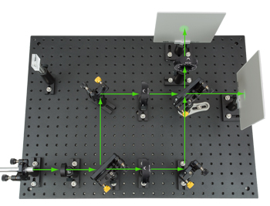

- ThorLabs Bomb Tester

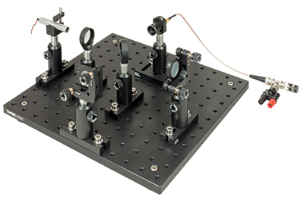

- ThorLabs Optical Tweezers

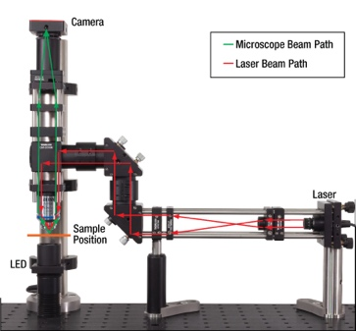

- QickDawg Quantum Microscope

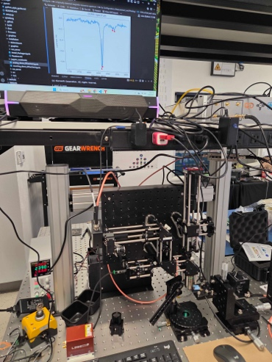

- ThorLabs Quantum Optics Kit
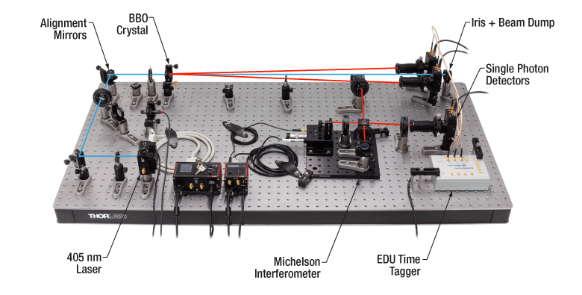

Reminder!:
Anything that requires manual grading will be calculated as a 0 till we go in and grade it!

