Jaden,

Central New Mexico Community College, in partnership with the Elevate Quantum Workforce Initiative and the State of New Mexico are excited to be offering a Quantum Educators Workshop for faculty from across the nation. We would love to have you instruct a Quantum Key Distribution module on the second day of the workshop. The focus of the workshop will be to introduce STEM faculty at 2-year and 4-year institutions to ways of introducing Quantum Information Science and Technology topics in existing undergraduate courses. Your experience will be very valuable to our faculty attendees!

The workshop will be held June 3-4 at CNM's Workforce Training Center, 5600 Eagle Rock Ave NE, Albuquerque, NM 87113. Your session would span ~1.5 hours, tentatively scheduled for Thursday morning. We anticipate ~30-50 faculty attendees from predominantly undergraduate institutions. Ideally, your session would include an introduction to quantum science, based on what has worked for you in similar workshops and in your experience teaching undergraduate students. CNM will provide a $2500 stipend at the conclusion of the workshop which you can use to cover travel/lodging expense, as well as your time/expertise.

We are looking forward to having you participate in the workshop.

Sincerely,

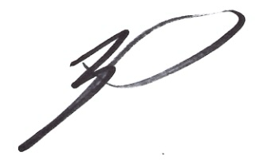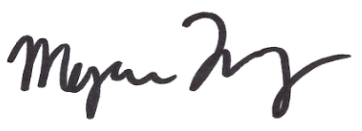
Brian Rashap, PhD Megan Ivory, PhD
Quantum Education Lead Quantum Research Scientist
Central New Mexico Community College Sandia National Labs

