Flights: Jan 30: ABQ->LGA, Feb 2: JFK->DEN, Feb 3: DEN->ABQ
Rental Car (Denver) vs Uber Costs (No Car needed in NYC, will take public transit)
Hotel Denver (Feb 2)

Brian Rashap
DOB: 4/3/1968
Known Traveler Number: 985406531
Address: 1300 Camino Ecuestre NE, Albuquerque, NM 87107
Delta Skymiles: 6274710489
Southwest Rapid Rewards: 1006750194
Hertz Gold: 34119949 (need car in Denver – in the past I had to book it myself to take advantage of the Gold account. Which I don’t mind doing.)
Hilton Honors Account: 334042357

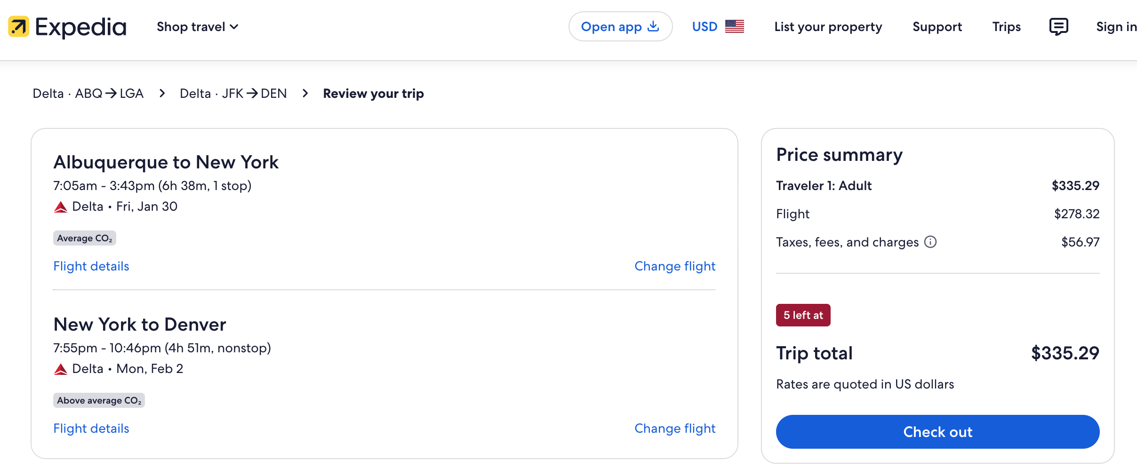
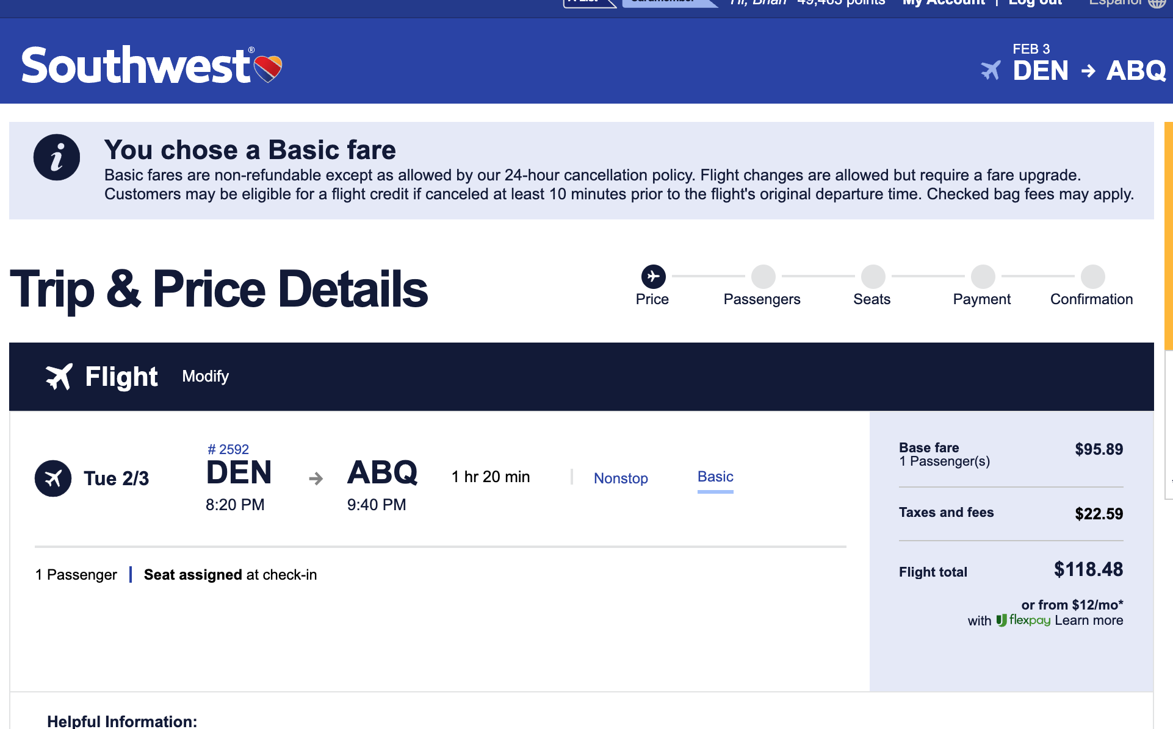

RENTAL CAR:
Hertz Gold: 34119949 (need car in Denver – in the past I had to book it myself to take advantage of the Gold account. Which I don’t mind doing.)
Cheapest Option
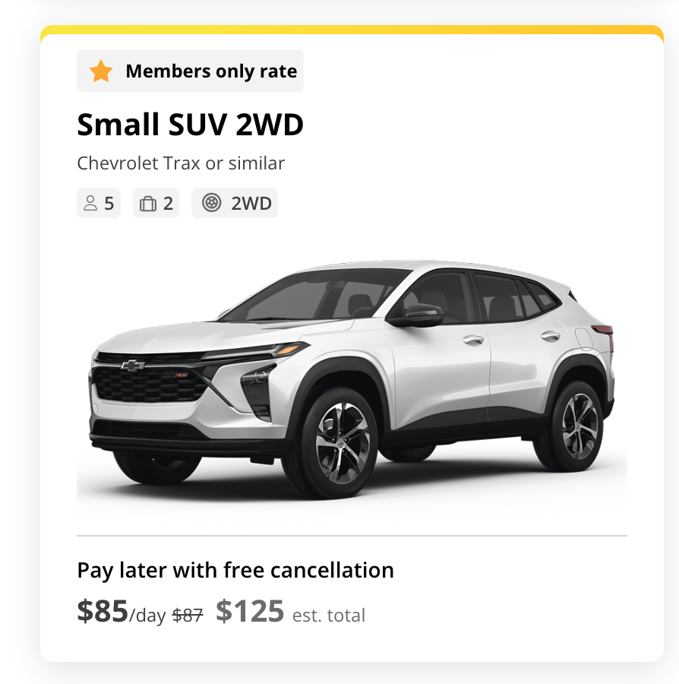
Uber Alternative
DEN to Quantinuum is $60, so back and forth to airport is same as car. However, my plans are DEN->Hotel->Quantinuum->Vescent->Emily Griffith->DEN. So, it would be significantly more expensive.

Hotel – Embassy Suites Denver International Airport
Hilton Honors Account: 334042357

