CNM Quantum Technician Bootcamp – Weekly Schedule (Sample)
Below is the weekly schedule for the Quantum Technician Bootcamp based on the Spring 2026 cohort. The specific schedule will vary slights from semester-to-semester based on normal variation in time needed for hands-on assignments, availability of guest speakers and professional development topics. It is provides to give a rough element of the topics/assignments that should be completed each week.
Week 1:
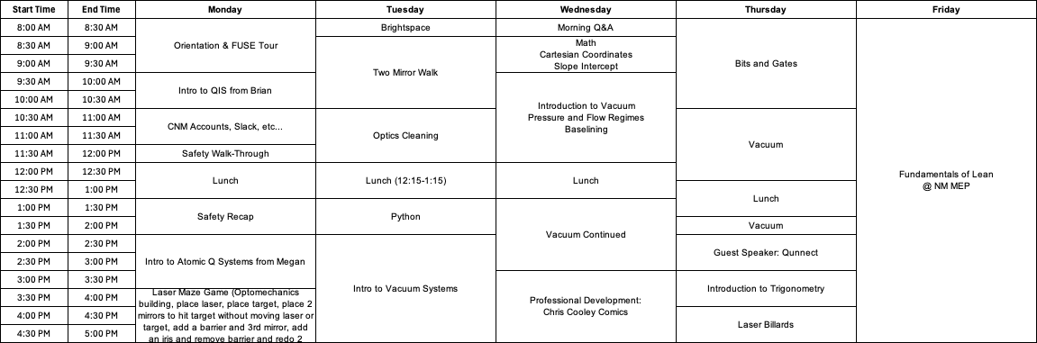
Week 2:
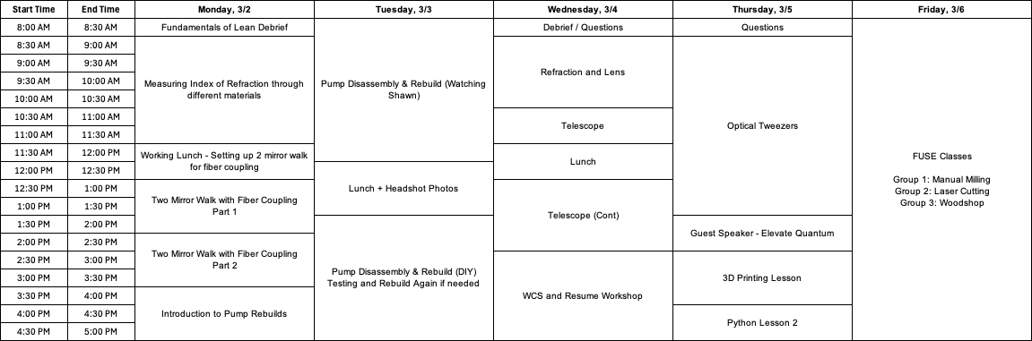
Week 3:
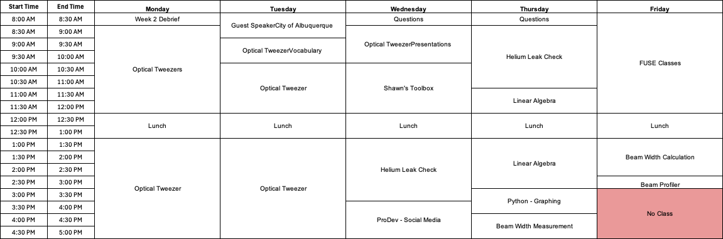

Week 4:
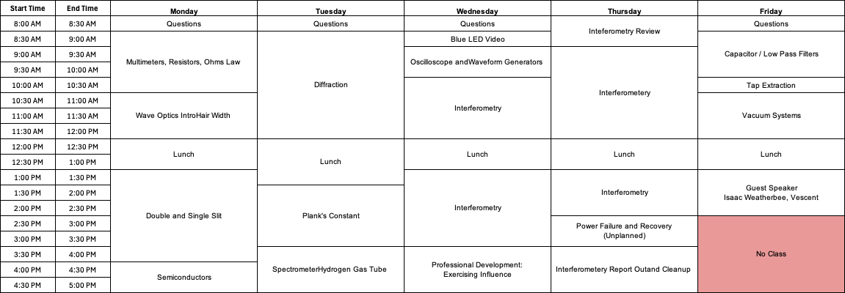
Week 5:

