Draft - 15wk – Syllabus – ENGT 1020 - Optics

Co-requisite: MATH 1220 – College Algebra

# General Information

| General Information | Items |
| --- | --- |
| Instructor Name: |  |
| Email: |  |
| Office Location: |  |
| Office Phone: |  |
| Office Hours: |  |
| Course Number: |  |
| Section Number: |  |
| Semester & Year: |  |
| Credit Hours: |  |
| Campus/Rooms: |  |
| Meeting Time: |  |

## Course Description

An introductory course dealing with terminology and techniques in the use of analytical and laboratory methods for planning, executing and evaluating arrangements using components such as mirrors, prisms, thin and thick lenses, diffusers, stops, and various types of light sources. Reflection, refraction, dispersion, image formation and aberrations are studied with emphasis on the ray concept of light.

## Required Materials

**No Required Textbook, all readings will be provided by instructor.**

## Course Student Learning Outcomes

1. Describe the properties of the electromagnetic spectrum
2. Describe the function of the various optical components: prisms, gratings, positive/negative lens, convex/concave mirrors.
3. Analyze optical systems for basic characteristics: focal length, numerical aperture, magnification, image location using the ray method of optics
4. Analyze the use of spectrometers, interferometers, diffraction gratings using wave optics.

## Assessments

## Schedule of Topics (tentative)

|  |  |  |
| --- | --- | --- |
| **Schedule** | **Instructional Unit (IU)** | **Science Practical Activities (SPA)** |
| Week 1 | Introduction to Optics | Lab Safety and Handling of Optical Components |
| Weeks 1-2 | Reflection and Refraction: Prisms, Waveguides, and Dispersion | RSpec Explorer Spectrometer** |
| Weeks 3-4 | Focusing, Imaging, and the Paraxial Approximation | ThorLabs Microscopy Education Kit* – Optical Imaging 1 Experiments |
| Week 5-6 | Thin Lens | Lab: Thin Lens |
| Week 6-7 | Think Lens and Compound Lens | Lab: Compound Lens |
| Week 8 | Apertures, Stops, Pupils, Windows | Lab: Aperatures |
| Week 9-10 | Mirrors: Convex, Concave | Lab: Geometric Optics and Mirros |
| Week 11 | Cameras: Focusing, Resolution, and Contrast | ThorLabs Microscopy Education Kit* – Optical Imaging 2 Experiments |
| Week 12 | Aberrations | ThorLabs Microscopy Education Kit* – Aberrations and Illuminations |
| Week 12 | Microscopy / Telescopes | Lab: build a microscope and telescope |
| Week 13 | Darkfield Imaging | ThorLabs Microscopy Education Kit* – Conjugate Planes and Darkfield Imaging |
| Week 14 | Spectra and Filters | ThorLabs Microscopy Education Kit* – Spectra and Filters |
| Week 15 | Conclusion | Lab: Practical System Design |

* ThorLabs Microscopy Education Kit

** RSpec Explorer

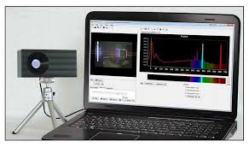

Draft - 15wk – Syllabus – ENGT 2020 – Lasers and Photonics

Pre-requisite: ENGT 1020 - Optics

# General Information

| General Information | Items |
| --- | --- |
| Instructor Name: |  |
| Email: |  |
| Office Location: |  |
| Office Phone: |  |
| Office Hours: |  |
| Course Number: |  |
| Section Number: |  |
| Semester & Year: |  |
| Credit Hours: |  |
| Campus/Rooms: |  |
| Meeting Time: |  |

## Course Description

An intermediate course stressing laser and photonic applications in science and industry. Students will learn p principles of laser operation, construction and technology. Students will learn about optical fibers and how to couple free-space lasers to single-mode and multi-mode fibers. Optical measurements will be studied with an emphasis on optical loss, coupling efficiency, and spectroscopy. The principles of various types of optical detectors and their application will also be studied.

## Required Materials

**No Required Textbook, all readings will be provided by instructor.**

## Course Student Learning Outcomes

1. Differentiate between the classifications of lasers and applicable safety needs
2. Categorize laser modes, beam profile, interference, and coherence.
3. Explain the contrasting properties of optical fibers
4. Demonstrate the ability to build apparatuses to couple free-space lasers to optical fibers, to measure optical properties of materials through interference patterns, and to measure concentration using absorption spectroscopy.

## Assessments

## Schedule of Topics (tentative)

|  |  |  |
| --- | --- | --- |
| **Schedule** | **Instructional Unit (IU)** | **Science Practical Activities (SPA)** |
| Week 1 | Introduction to Lasers and Atomic Energy Levels | Laser Safety |
| Week 2 | Beam Properties: laser modes, beam profile, and coherence. | Lab: Beam characterization |
| Weeks 3-4 | Interferometry | Lab: Double slit experiment  ThorLabs Michelson Interferometer*: measuring index of refraction and thermal expansion |
| Week 5 | Polarization – polarizers, half/quarter wave plates | Lab: Polarization |
| Weeks 6-7 | Optical intensity. Single-mode and multi-mode optical fibers | Lab: Free-space to optical fiber coupling  Lab: Optical fiber splicing |
| Week 8-9 | Optical detectors: photodiode, photomultiplier tubes, avalanche photodiodes, infrared detectors | Lab: Optical detectors |
| Week 10 | Optical spectra and emission spectroscopy | Lab: Spectrometry |
| Week 11-12 | Absorption Spectroscopy | ThorLabs Time Resolved Absorption Spectroscopy**: concentration measurement |
| Week 13 | Optical Tweezers | ThorLabs Optical Tweezers**: trapping microbeads |
| Week 14 | Industrial Applications of Laser and Photonics | Lab: Laser Cutting (at FUSE Makerspace) |
| Week 15 | Conclusion | Lab: Practical System Design |

* ThorLabs Michelson Interferometer

** ThorLabs Time Resolved Absorption Spectroscopy

*** ThorLabs Optical Tweezers

Draft - 15wk – Syllabus – CSCI Quantum Hardware

Pre-requisite: CSCI 2720 Quantum Hardware

# General Information

| General Information | Items |
| --- | --- |
| Instructor Name: |  |
| Email: |  |
| Office Location: |  |
| Office Phone: |  |
| Office Hours: |  |
| Course Number: |  |
| Section Number: |  |
| Semester & Year: |  |
| Credit Hours: |  |
| Campus/Rooms: |  |
| Meeting Time: |  |

## Course Description

An intermediate course that will create an understanding of quantum information system hardware, provide hands-on experience with quantum systems, and explore quantum phenomena. Students will learn about quantum superposition and entanglement, and how these phenomena can be used to create quantum bits (qubits) and gates. They will explore how measurements effect quantum systems. The students will get hands-on experience creating entangled pairs of single photons, trapping/exciting neural atoms, and quantum sensing.

## Required Materials

**No Required Textbook, all readings will be provided by instructor.**

## Course Student Learning Outcomes

1. Describe and build apparatuses to demonstrate quantum phenomena of superposition and entanglement.
2. Describe the properties of a Qubit and differences between neutral atom, trapped ion, photonic, superconducting, and spin Qubits.
3. Demonstrate the ability to configure and tune a magneto-optical trap to create a Qubit and induce Rabi flopping.
4. Describe the principles of and demonstrate operation of a Diamond NV quantum sensor.

## Assessments

## Schedule of Topics (tentative)

|  |  |  |
| --- | --- | --- |
| **Schedule** | **Instructional Unit (IU)** | **Science Practical Activities (SPA)** |
| Week 1 | Introduction to Quantum and basic linear algebra | Lab Safety |
| Week 2 | Superposition, Quantum Gates | Lab: Bloch Sphere |
| Weeks 3 | Entanglement | Lab: Bell’s Inequality |
| Weeks 3-4 | Particle/Wave Dual Nature of Light, Polarization, and Quantum Eraser | ThorLabs Quantum Eraser (1) |
| Weeks 5-6 | Quantum Measurements | ThorLabs Bomb Tester (2) |
| Week 7 | Cryogenics | Lab: Cryogenics |
| Week 8 | Superconducting and Spin Qubits | Lab: Spin |
| Weeks 9-10 | Laser Cooling | ThorLabs Optical Tweezer Kit (3) |
| Week 10 | Atomic, Molecular, and Optical Qubits | Lab: Photonics |
| Week 11-12 | Neutral Atom QIS Operations | Lab: QuLL Rb-85 MOT |
| Week 13-14 | Quantum Sensors: Diamond NV | Lab: QickDawg Quantum Microscope (4) |
| Week 15 | Conclusion | Lab: Practical System Design |

**NOTE: The ThorLabs Quantum Optics Kit (5) can be used in place of the Quantum Eraser and Bomb Test Demonstration Kits.**

1. ThorLabs Quantum Eraser

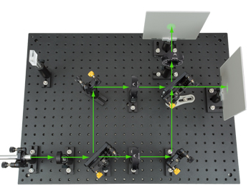

1. ThorLabs Bomb Tester

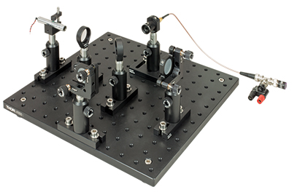

1. ThorLabs Optical Tweezers

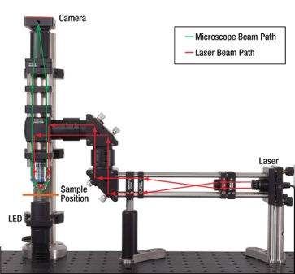

1. QickDawg Quantum Microscope

1. ThorLabs Quantum Optics Kit

