

**COURSE SYLLABUS**

|  |  |  |  |  |
| --- | --- | --- | --- | --- |
| **Course Name:** | **Quantum Technician Bootcamp** | | **Lumens**  **Class ID:** | **TBD** |
| **Class Day(s):** | **Monday - Friday** | **Class Location:** | **FUSE Makerspace** | |
| **Class Time:** | **8:00am – 5:00pm** | |  | |
| **Pre-requisite:** | **(none)** | |  | |
| **Instructor:** | **Brian Rashap, Ph.D., Megan Ivory, Ph.D.** | |  | |
| **Web Address:** | **http://deepdivecoding.com/quantum** | |  | |

# Texts & Supplies

1. **Textbooks: not required for this course.**
2. **Participant Guide: Students will need to participate in class and complete projects on-time.**

# Course Description

In Deep Dive’s new Quantum Technician bootcamp, you will learn to solve complex, real-world problems that conventional technology can’t solve. We will teach you the fundamentals of quantum science, quantum technology, and quantum physics so that you are prepared for a high-tech manufacturing position in the semiconductor, solar manufacturing, and opto-electronics industries

# Student Learning Outcomes

Upon successful completion of the course the participant will be able to accomplish the following:

1. Optics:
2. Describe the properties of the electromagnetic spectrum
3. Describe the function of the various optical components: prisms, gratings, positive/negative lens, convex/concave mirrors.
4. Analyze optical systems for basic characteristics: focal length, numerical aperture, magnification, image location using the ray method of optics
5. Analyze the use of spectrometers, interferometers, diffraction gratings using wave optics

1. Lasers and Photonics:
2. Differentiate between the classifications of lasers and applicable safety needs
3. Categorize laser modes, beam profile, interference, and coherence.
4. Explain the contrasting properties of optical fibers
5. Demonstrate the ability to build apparatuses to couple free-space lasers to optical fibers, to measure optical properties of materials through interference patterns, and to measure concentration using absorption spectroscopy.
6. Ultra-High Vacuum Systems
   1. Assembly and operation of ultra-high vacuum systems
   2. Vacuum pumps and gauges
   3. Contamination and outgassing
   4. Leak detection

1. Quantum Hardware:
2. Describe and build apparatuses to demonstrate quantum phenomena of superposition and entanglement.
3. Describe the properties of a Qubit and differences between neutral atom, trapped ion, photonic, superconducting, and spin Qubits.
4. Demonstrate the ability to configure and tune a magneto-optical trap to create a Qubit and induce Rabi flopping.
5. Describe the principles of and demonstrate operation of a Diamond NV quantum sensor.
6. Applicable Mathematics
   1. Perform functional arithmetic and graphical analysis of liner, polynomial, exponential, logarithmic, and periodic functions, including composition, inverse functions, domain/range, intercepts, asymptotes, end-states.
   2. Perform calculations (arithmetically and graphically) utilizing vectors, including adding, dot products, and cross productions.
   3. Utilize the properties of trigonometric functions to calculate relationships between angle and sides of right triangles. Analyze periodic functions to determine amplitude, frequency, phase, and bias. Communicate the applications to ray-optics.
   4. Apply the concepts of linear algebra (2x2 matrices, determinant, transformations) to 2-dimensional vectors. Communicate how linear transforms can modify quantum states.
   5. Utilize statistics to calculate probability and probability distributions of random events in physical systems.
   6. Solve contextual problems by identifying the appropriate type of mathematics given the context and creating a formula based on the information given.
   7. Communicate mathematical information using proper notation and verbal explanations.

1. Model-based Problem Solving
   1. Problem segmentation
   2. Model development and validation
   3. Solution development and validation
   4. Standardization

# Attendance/Tardy/Withdrawal/Drop Policies

The participant is expected to be in class for every class session over the course of the 10 weeks. Students missing more than 10% of the course for unexcused absences and/or being consistently tardy will be placed on a Student Success Plan. Failure to successfully complete the Success Plan criteria will result in the student being dropped from the course. Excused absences must have approval of the Lead Instructor ahead of time.

# Grading

**Letter grades are not awarded for CNM Ingenuity’s** non-credit classes. A final grade of Complete, Incomplete or No Show will appear on the participant’s CNM Ingenuity transcript.

In order to pass the course, students must:

1. Achieve an overall average above 75%.
2. Pass a final practice exam which will include vacuum and optical system troubleshooting, optical aligment, and short presentation on a quantum concept

# Course Codes & Policies

**Student Behavior:**

As a member of this classroom, participants are responsible for understanding and adhering to the CNM codes and policies that govern and prescribe acceptable student behavior. The codes and policies of this course are governed by the Academic Policies found on the Student Code of Conduct accessed at: <https://www.cnm.edu/depts/dean-of-students/student-code-of-conduct>

# Student Resources/Advisement/Graduation

A CNM Achievement Coach is available to all CNM students and participants. The Achievement Coach's main job is to help students find the answers to questions concerning classes and issues involving college and life. The Achievement Coach helps with the following: program and course information, campus and community support, balancing school, family and work, life changes and obstacles. Ask your Instructor or Program Coordinator for more information about making an appointment with an Achievement Coach.

# Tentative Class Schedule

**Syllabus & Class Schedule:** The syllabus and class schedule are subject to change by the instructor. Changes will be made with as much advance notice as possible. Detailed Topic Areas:

OPTICS:

|  |  |
| --- | --- |
| **Instructional Unit (IU)** | **Science Practical Activities (SPA)** |
| Introduction to Optics | Lab Safety and Handling of Optical Components |
| Reflection and Refraction: Prisms, Waveguides, and Dispersion | RSpec Explorer Spectrometer (2) |
| Focusing, Imaging, and the Paraxial Approximation | ThorLabs Microscopy Education Kit (1) – Optical Imaging 1 Experiments |
| Thin Lens | Lab: Thin Lens |
| Think Lens and Compound Lens | Lab: Compound Lens |
| Apertures, Stops, Pupils, Windows | Lab: Aperatures |
| Mirrors: Convex, Concave | Lab: Geometric Optics and Mirros |
| Cameras: Focusing, Resolution, and Contrast | ThorLabs Microscopy Education Kit (1) – Optical Imaging 2 Experiments |
| Aberrations | ThorLabs Microscopy Education Kit (1) – Aberrations and Illuminations |
| Microscopy / Telescopes | Lab: build a microscope and telescope |
| Darkfield Imaging | ThorLabs Microscopy Education Kit (1) – Conjugate Planes and Darkfield Imaging |
| Spectra and Filters | ThorLabs Microscopy Education Kit (1) – Spectra and Filters |
| Conclusion | Lab: Practical System Design |

LASERS / PHOTONICS:

|  |  |
| --- | --- |
| **Instructional Unit (IU)** | **Science Practical Activities (SPA)** |
| Introduction to Lasers and Atomic Energy Levels | Laser Safety |
| Beam Properties: laser modes, beam profile, and coherence. | Lab: Beam characterization |
| Interferometry | Lab: Double slit experiment  ThorLabs Michelson Interferometer (3): measuring index of refraction and thermal expansion |
| Polarization – polarizers, half/quarter wave plates | Lab: Polarization |
| Optical intensity. Single-mode and multi-mode optical fibers | Lab: Free-space to optical fiber coupling  Lab: Optical fiber splicing |
| Optical detectors: photodiode, photomultiplier tubes, avalanche photodiodes, infrared detectors | Lab: Optical detectors |
| Optical spectra and emission spectroscopy | Lab: Spectrometry |
| Absorption Spectroscopy | ThorLabs Time Resolved Absorption Spectroscopy (4) concentration measurement |
| Optical Tweezers | ThorLabs Optical Tweezers (5): trapping microbeads |
| Industrial Applications of Laser and Photonics | Lab: Laser Cutting (at FUSE Makerspace) |
| Conclusion | Lab: Practical System Design |

ULTRA-HIGH VACUUM SYSTEMS

Most of the below utilizes the Edwards Vacuum Training System (10)

|  |  |
| --- | --- |
| **Instructional Unit (IU)** | **Science Practical Activities (SPA)** |
| Foundations of Vacuum Technology |  |
| Vacuum Pump Technologies – Displacement:   * Backing Pumps - Wet vs Dry * Turbomolecular Pumps |  |
| Vacuum Pump Technologies – Capture: Cryogenic and Ion |  |
| Vacuum Measurement   * Pirani Gauges * Ion Gauges |  |
| Vacuum System Safety including Lock-out Tag-out (LOTO) of electrical and mechanical hazards |  |
| Vacuum System Assembly |  |
| Vacuum System Contamination |  |
| Leak Detection |  |
| High Vacuum vs Ultra-High Vacuum |  |

QUANTUM HARDWARE

|  |  |
| --- | --- |
| **Instructional Unit (IU)** | **Science Practical Activities (SPA)** |
| Introduction to Quantum | Lab Safety |
| Superposition, Quantum Gates | Lab: Bloch Sphere |
| Entanglement | Lab: Bell’s Inequality |
| Particle/Wave Dual Nature of Light, Polarization, and Quantum Eraser | ThorLabs Quantum Optics Kit (9) or  ThorLabs Quantum Eraser (6) |
| Quantum Measurements | ThorLabs Quantum Optics Kit (9) or  ThorLabs Bomb Tester (7) |
| Cryogenics | Lab: Cryogenics |
| Superconducting and Spin Qubits | Lab: Spin |
| Laser Cooling | ThorLabs Optical Tweezer Kit (5) |
| Atomic, Molecular, and Optical Qubits | Lab: Photonics |
| Neutral Atom QIS Operations | Lab: QuLL Rb-85 MOT |
| Quantum Sensors: Diamond NV | Lab: QickDawg Quantum Microscope (8) |
| Conclusion | Lab: Practical System Design |

APPLICABLE MATHEMATICS

|  |  |
| --- | --- |
| **Instructional Unit (IU)** | **Science Practical Activities (SPA)** |
| College Algebra Functions:   * Cartesian Coordinate System and Graphing * Linear Functions * The circle |  |
| College Algebra Transformations:   * Recognizing basic functions * Translation, Stretching, Reflection * Rate of Change * Algebraic Functions |  |
| College Algebra Polynomials   * Quadratic * Polynomials and Zeroes |  |
| College Algebra Rational Functions:   * Definition * Graphing |  |
| College Exponentials and Logarithms   * Definitions * Graphing |  |
| Vectors:   * Graphing * Adding * Dot and Cross Product |  |
| Trigonometry:   * Unit Circle * Radians * Trigonometric functions * Sine waves – amplitude, frequency, phase |  |
| Linear Algebra   * 2x2 Matrix * Determinant * Transformations |  |
| Statistics:   * Probability |  |

***Experimental Apparatus:***

(1) ThorLabs Microscopy Education Kit

(2) RSpec Explorer

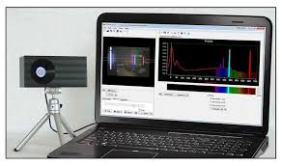

(3) ThorLabs Michelson Interferometer

(4) ThorLabs Time Resolved Absorption Spectroscopy

(5) ThorLabs Optical Tweezers

(6) ThorLabs Quantum Eraser

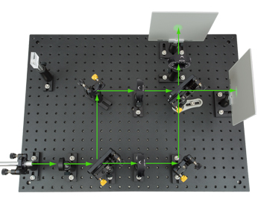

1. ThorLabs Bomb Tester

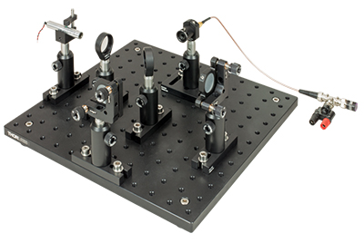

1. QickDawg Quantum Microscope

1. ThorLabs Quantum Optics Kit

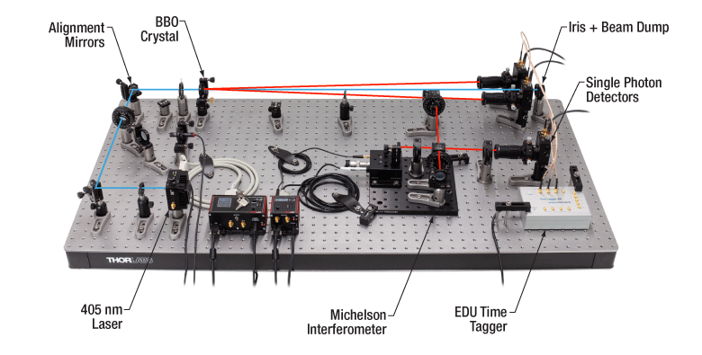

1. Edwards Vacuum Training System

***Career Readiness and Success Coaching Schedule:***

|  |  |  |
| --- | --- | --- |
| **Week** | **Topic – Job Seeker Track** | **Times** |
| 1 | Professionals Toolbox, soft skills, advantages of Deep Dive, CNM Resources and Imposter Syndrome | Wednesday 1:00 to 2:30 |
| Photographs – headshots | Wednesday 3:30 to 5:00 |
| 2 | Success Coaching with Sue | Wednesday 3:30 to 5:00 |
| 3 | Building a Network in the Tech Community with LinkedIn | Wednesday 3:30 to 5:00 |
| 4  5 | Team Building Workshop – Forbidden Island | Wednesday 3:30 to 5:00 |
| Success Coaching with Sue | Wednesday 3:30 to 5:00 |
| 6 | Resume Building Workshop | Wednesday 3:30 to 5:00 |
| 7 | Resume Review | Wednesday 3:30 to 5:00 |
| 8 | Interview Workshop | Wednesday 3:30 to 5:00 |
| 9 | Success Coaching with Sue | Wednesday 3:30 to 5:00 |
| 10 | Employer Roundtable / Student Presentations | Friday Week 10 |
|  |  |  |

## FUSE Makerspace Classes

Use of FUSE Makerspace equipment / software is an integral part of the Rapid Prototyping training. Once registered for the bootcamp, students will be able to register for the FUSE Woodshop and Epilog Laser Cutting workshops. These need to be completed before the 2nd week of class. If due to timing of registration and class offerings, the bootcamp participant can’t complete the classes before the deadline, they should immediately reach out to the bootcamp instructor to review options.

Please note, FUSE Makerspace workshops are often full. Being a “No Show” for a workshop that you have registered for impact other students. Completion of the Woodshop and Epilog Laser Cutting workshops is a requirement of graduation and the students will need to register for a class(s) at their own expense.

At times, grants are available to allow IoT participants to take additional FUSE Makerspace workshops. The intent of this to provide additional prototyping skills to be utilized for capstone projects. Therefore, when this funding is available, additional classes need to be taken before the 9th week of the bootcamp.

|  |  |  |
| --- | --- | --- |
| **Fuse Class** |  | **When** |
| Metal Shop | Prior to Week 2 |  |
| Laser Cutting | Prior to Week 2 |  |
| Bambu 3D Printer | Week 2 during class |  |

Note - Students will have a complementary membership to the FUSE Makerspace during the Bootcamp. They are encouraged to learn to utilize other equipment at the Makerspace. Workshops range in price from $69 to $159 each.

## Guest Speakers

Each week, the class will have a guest speaker that will expose the students to various IoT skills, careers, and opportunities.

***Electronic Devices in Class***

All cellular telephones should be turned off or switched to silent or vibrate mode. They should only be used when required (i.e., two factor authentication). Earbuds are not to be worn in class.

## Academic Integrity Policy (full policy can be found at https://www.cnm.edu/depts/student-support/dean-ofstudents/academic-integrity-policy)

As an institute of higher learning, Central New Mexico Community College (CNM) requires that students conduct themselves with honesty and integrity in all academic exercises. As much as it is a student’s responsibility to conduct themselves with honesty and integrity, so too is the institution responsible for providing a fair and equitable process for addressing behavior that falls outside of the academic integrity policy.

**Plagiarism** – Use of another person’s or of a group’s words or ideas without clearly acknowledging the source of that information, resulting in their false representation as one’s own individual work. More specifically, to avoid plagiarizing, a student or other writer must give credit when they use:

* another person’s idea, opinion, or theory
* any facts, statistics, graphs, drawing—any pieces of information—that are not common knowledge
* quotations of another person’s actual spoken or written words
* paraphrases of another person’s spoken or written words
* another person’s data, solutions, or calculations without permission and/or recognition of the source, including the act of accessing another person’s computerized files without authorization

Plagiarism may be either deliberate or unwitting; that is, it is the responsibility of a college student to know what constitutes plagiarism so that ignorance is not a legitimate defense against a charge of plagiarism.

**Use of AI** **–** The use of AI tools, in whole or in part, is solely at the discretion of the instructor.

"AI use" refers to the employment of artificial intelligence technologies and tools by students. This includes, but is not limited to, generative artificial intelligence (such as ChatGPT or image-generators), machine learning algorithms, natural language processing tools, AI-based problem-solving software, and automated content generation platforms (such as essay-writing tools or coding assistants).

While there is a place for the uses of generative AI and/or a coding assistant have their place in the Internet of Things’ industries, they are not allowed in the IoT bootcamp as they have been seen to diminish the learning outcomes. Other uses of AI may be permitted during the course with pre-approval of the instructor. In these cases, the use of AI must be acknowledged/cited as would any other source and not presented as original work.