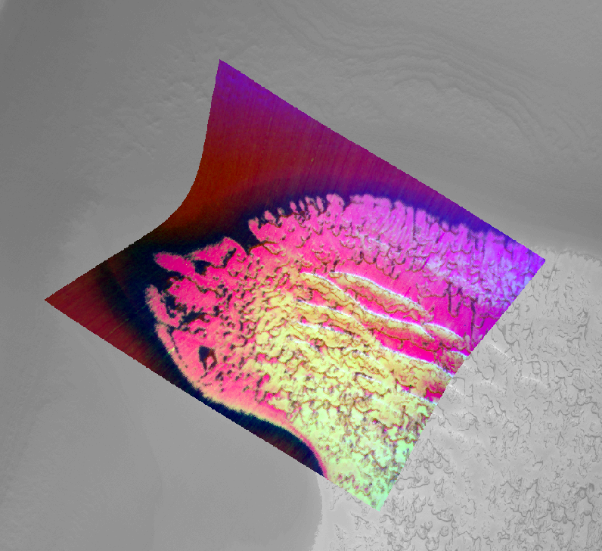**Abstract**

# **Predicting Ice Characteristics of Mars’ South Polar Deposits using Point-Centered DenseNet Regression**

|  |
| --- |
| Brandon Rasmussen  California Institute of Technology  brasmuss@caltech.edu |

*Understanding cycling of H2O and CO2 in the Martian polar terranes requires high resolution analysis of surface composition and physical characteristics. Here, I present a deep learning method to predict useful spectral parameters derived from infrared imagery in order to characterize ices using only greyscale imagery. The method shows promise for increasing spatial and temporal resolution of currently available maps by orders of magnitude.*

# **Introduction**

The Mars Reconnaissance Orbiter [1] has been collecting data from orbit since 2006. In this time, it has collected and relayed far more data than all previous Mars orbiters combined, blanketing the planet in high spatial resolution imagery of multiple types. The Compact Reconnaissance Imaging Spectrometer for Mars (CRISM) [2] is an infrared push-broom style imaging spectrometer which covers the wavelength range of ~.4 to 3.92 microns with 544 channels (throughout this paper I will use “band” and “channel” interchangeably to refer to the third dimension of any image cube), and is designed primarily to characterize surface materials. It operates in multiple imaging modes, with spatial resolution ranging from ~18m to ~200m in multi-spectral mapping modes. CRISM collected infrared data in the 1-3.92 micron range in its highest resolution FRT mode from 2006-2012 to build a catalog of over 10000 10x10km images, with data quality decaying from 2009-2012 before a failed gimbal led to a revisiting and redesigning of imaging modes. Paired with these spectral images are data from multiple other sensors and cameras, with the Context Camera [3] (CTX)[4] and HiRISE [4] providing spatially overlapping high resolution greyscale and color (respectively) imagery to complement CRISM’s spectral images.

These tools give scientists the ability to perform geological investigations at a fine scale from orbit. However, they have also built an invaluable, well-curated dataset of overlapping geospatial information which presents an opportunity for exploring previously unquantified relationships through deep learning.

Figure 1: A false color infrared CRISM image overlaying a greyscale CTX image. CRISM’s targeted mode results in ~18m pixels, while CTX imagery has ~6m pixels. In this color combination, coarse-grained CO2 ice is shown in yellow, while finer grained CO2 ice and CO2-H2O ice combinations and pure/dust-heavy H2O ice are in black to red colors.

This paper will focus on a single task within this framework, but is meant as a foundation for further work with multi-sensor data fusion and machine learning on Mars.

The prediction of ice composition and grain size is important for understanding the formation mechanisms of the Martian south pole and for understanding atmospheric cycling on the planet [5]. The atmosphere is primarily CO2 and a significant amount exists frozen out as ice in both seasonal and more permanent layers. Radar imaging has shown that thick layers of CO2 ice exist in the predominately water ice cap and their formation mechanisms are not fully understood [6], [7]. How do these layers form in the presence of multiple environmental forcings which make them unstable over long periods of time? Understanding the modern cycling and preservation and/or sublimation of the CO2 will help to answer this and many other questions.

To monitor the distribution and characteristics of ice at the fine scale required to analyze small scale mass-wasting processes and how they interact with the freezing and sublimation of CO2, high spatial resolution imagery is required. Unlike most geological investigations, temporal resolution is also extremely important as surfaces change rapidly in Mars’ polar regions. The work presented here decomposes CRISM infrared imagery into a series of useful single band images (spectral parameters) derived from the spectra which are commonly used by Mars polar scientists to characterize ices (i.e. [8]). I then attempt to predict the spectral parameters with an extracted, higher spatial resolution greyscale image representing the spectrum (a single CRISM pixel) and a small neighborhood around it. It is hypothesized that the strongly varying optical properties of water ice, dust, and CO2 ice will correlate between the visible (greyscale imagery) and infrared (CRISM imagery). Results show that useful parameters can be predicted with high confidence using only the greyscale imagery and data derived directly from the greyscale imagery. This presents the opportunity to increase spatial coverage, temporal resolution, and spatial resolution of currently available maps of ice characteristics by orders of magnitude.

## **Past Work**

There has been extensive work mapping the poles of Mars with CRISM and its predecessor OMEGA. However, the majority of efforts have been at the large spatial scale with coarse spatial resolution of 100m or greater, often employing more rigorous radiative transfer modeling to map larger scale trends (i.e. [8], [9], [10]). Finer scale CRISM studies at or near the south pole are few (i.e. [11]), but a large body of work in morphological mapping and erosive process modeling with CTX and HiRISE has been developed (i.e. [12], [13]). These studies are often aided by more qualitative CRISM mapping at high resolution, and have illuminated the need for high spatial resolution in compositional mapping in the south polar region.

This work is motivated primarily by Earth remote sensing studies which have successfully predicted continuous valued targets from geospatial imagery using deep learning. Simple CNNs have been used in conjunction with airborne infrared spectral imagery to quantify harmful cyanobacteria, and successfully predict in-situ measurements despite a very small sample size [14]. Crop and forest biomass has been estimated using only RGB or multispectral imagery in a variety of settings, and deep learning approaches have been shown to outperform other ML methods such as random forest and support vector machines [15]–[17]. These tasks are the most similar to the work presented here, but differ in several important ways.

Deep learning using orbital imagery from Mars is quickly becoming more common. Landform semantic segmentation and image classification have been tackled at both the individual project level, and at the database service level [18], [19]. CNNs have been used for change detection in image pairs, both in the south pole and elsewhere [20]. GANs and have been used for endmember identification and mineral mapping with CRISM [21], and neural networks have been used for atmospheric correction and surface temperature retrieval [22].

Differing from all the approaches outlined above, I attempt to directly predict calculatable parameters from collocated infrared imagery using only greyscale, visible imagery. Where most other studies are limited by a dataset of labeled training data, this method is only limited by the number of overlapping images taken close together in time, where each image pair can generate ~ 200,000 unique training samples. The number of pairs at the south pole is around 1,000, meaning hundreds of millions of samples can potentially be generated, generously sampling landscape diversity, imaging geometry, illumination conditions, atmospheric effects, and time-varying noise profiles of both instruments.

1. **Methods**

Input Generation

For initial experiments, data were extracted from a single CTX image (greyscale imagery, ~5056x41000 pixels, 1 channel, 8bit) and a single CRISM Full-Resolution Targeted (FRT) long-wave image (~1-3.92 microns, ~640x360 pixels, 430 channels, float32). Later experiments involved a merged set of samples from three image pairs, all taken in the southern summer and hand-picked to be good examples of diverse target spectral parameters. Both imagery types were downloaded directly from the Planetary Data System and are freely available. Table 1 shows image IDs for the 6 images used throughout this project.

|  |  |
| --- | --- |
| FRT Image ID | CTX Image ID |
| FRT00008517 | **P12_005773_0849_XN_84S045W** |
| FRT00008744 | **P12_005862_0934_XI_86S057W** |
| FRT000083F2 | **P12_005728_0938_XI_86S002W** |

Table 1: IDs of all images used in this project. They can be downloaded or previewed at <https://ode.rsl.wustl.edu/mars/>

The CRISM images were run through a standard processing pipeline using ENVI software to reduce systematic image-column dependent noise, and stochastic noise. This included an atmospheric removal step which is performed by using an empirically optimized atmospheric transmission spectrum produced by the “volcano scan” algorithm. This reduces the effect of atmospheric CO2 on the extracted spectra in each pixel. The images were then photometrically corrected before being map-projected.

Four different spectral parameters were calculated from the pre-processed CRISM images, producing 4 single band images per image. These are standard parameters (described in [23]) used for visually estimating surface composition and characteristics and are computationally cheap. The parameters are mathematically described below and visualized in Figure 2. These are the target values being predicted by the network as described in the Training and Prediction section. The first parameter calculated was ICER1_2:

Where BD1435 and BD1500_2 are defined as:

Here, BD refers to “Band Depth” of an absorption feature centered at a specific wavelength, and R refers to reflectivity at a specific wavelength, estimated as a mean over a narrow neighborhood around the specified value (here the values are in nanometers, i.e. micron*1000). This parameter is used in all experiments as it robustly differentiates CO2 and H2O ice, is insensitive to dust contamination, and gives a rough qualitative estimate of grain size in endmember cases.

Where RC2600 is the value of a continuum line from R2456 to R2530, evaluated at 2600 nm (2.6 microns). This parameter is valuable for estimating CO2 ice grain size, and also differentiates from dust/soil and H2O ice with values greater than zero.

The final two parameters were R1080 and R1506. R1080 was calculated as an easily learnable target, as all expected materials should have similar reflectivites in the CTX band (.5-.8 microns), and it is the closest wavelength in the longwave images not susceptible to significant noise at detector edges. R1506 was calculated as it is near the center of the main water ice absorption being assessed through these parameters and allows for decoupling the H2O band depth from the ratio in ICER1_2.

Figure 2: Approximate illustration of spectral parameters for a single spectrum (i.e. single CRISM image pixel).

CTX imagery was lightly pre-processed using USGS ISIS3 software to remove even-odd detector artifacts. After retrieving spacecraft navigation information using SPICE [24], ISIS3 was used to calculate multiple geometric and illumination parameters characterizing the spatial relationships of the sun, the spacecraft, and each pixel in the CTX image. These parameters are shown in Table 2. These parameters were concatenated together to form an 8 band “backplane” image the same size as each respective CTX image.

After map projection, offsets of up to 150 meters were still apparent in each geo-referenced CTX-CRISM pair. Each CRISM and CTX image pair were co-registered by hand using ENVI software. This was done by generating ~ 24 ground control point pairs per image pair using obvious visual features in each image, and performing an RMSE-minimizing 2nd degree polynomial transform to “warp” the images. The coregistered image pairs were randomly geographically sampled and single (or multiple) spectral parameters for a single pixel were extracted along with a

|  |  |
| --- | --- |
| Backplane Band | **Description** |
| Phase Angle | Angle between the sun and the spacecraft at a point on the surface. |
| Local Emission Angle | The local emission angle is the angle between the spacecraft and a vector drawn perpendicular to the planet's surface |
| Local Incidence Angle | The local incidence angle is the angle between the sun and a vector drawn perpendicular to the planet's surface (surface normal). |
| Sun Azimuth | A clockwise angle from a point of origin to the direction of the Sun |
| Spacecraft Azimuth | A clockwise angle from a point of origin to the direction of the Spacecraft. |
| Off-Nadir Angle | From the spacecraft, the Off Nadir is the angle between the nadir vector (subspacecraft vector) and the look vector |
| Sub-Spacecraft Ground Azimuth | The Ground azimuth to the SubSpacecraft point (where the look vector from the spacecraft intercepts the target body) is obtained by taking true North (90 deg Latitude) and finding the clockwise angle to the subspacecraft latitude and longitude point |
| Sub-Solar Ground Azimuth | The Ground azimuth to the SubSolar point is obtained by taking true North (90 deg Latitude) and finding the clockwise angle to the subsolar latitude and longitude point. |

Table 2: Bands produced in the CTX “Backplane” image. All values are in degrees.

Training and Prediction

Spectral parameters were predicted using two different CNN architectures across several different experiments described in the next section. Data were normalized to values between 0 and 1 using a separate range scaling for each band of the respective image. For visualization purposes, data dimensionality was reduced by taking the mean of the CTX image in each sample and plotting the parameter values versus the resulting CTX albedo. Simple polynomial fits were calculated for single image pair and multiple image pair datasets. Histograms of the spectral parameter data were inspected to ensure a broad distribution, and larger image extracts were compared between the CRISM and CTX imagery to ensure proper co-registration. The two datasets were either 200,000 samples for a single image pair, or 600,000 for three image pairs.

Data were split into 85% train, 15% validation, and 10,000 test samples for each experiment. A simple two convolutional layer followed by two linear layer model was first test, followed by a slightly modified DenseNet architecture [25] with an additional linear layer at the end of the network, 2x2 convolutional dense blocks, 2x2 max pooling blocks, and a growth rate of either 16 or 48 depending on the experiment. Training was performed using PyTorch on a GTX 1660TI gpu with a batch size of 500. A multiplicative step learning rate scheduler with an initial learning rate of 1 and a step of .7 was used and models were trained for 30 epochs.

For prediction, geographic coordinates are extracted from a downsampled 18m CTX image (the same spatial resolution as the CRISM pixels used in training) and predictors are extracted from a full resolution image. A prediction is generated for each pixel and an image is reconstructed using the associated pixel indices, resulting in 18m resolution images of either one or four bands depending on the model and experiment.

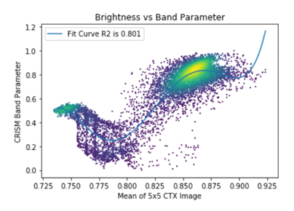

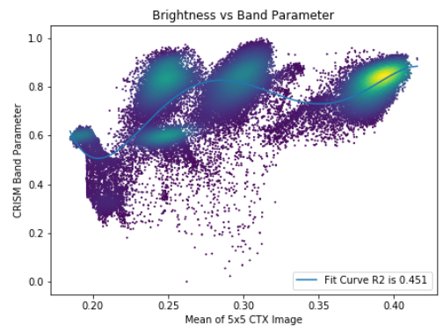

Figure 3: CTX brightness values versus ICER1_2 from a random subset of single image dataset (above) and the three image dataset (below). Color signifies point density. The complexity of this space will continue to increase as more pairs are added.

# **4.** **Experiments and Results**

Initially, a single CTX-CRISM pair dataset was used as a more simple case. This means illumination conditions are similar throughout the samples and the regression problem is simplified (see Figure 3). The DenseNet outperformed the simple CNN architecture in the initial testing and was used in all subsequent experiments. Initially, only CTX imagery was used (i.e. no backplane data) to predict only ICER1_2. This resulted in an R2 score of .842, beating the polynomial fit by ~.04. Adding in the backplane data did not significantly improve the results in the single image case. 5x5,7x7, and 9x9 CTX extracts were tested and did not show significant differences. 7x7 images were used for the rest of the experiments and final results.

Moving to the full three image dataset emphasized the importance of the backplane data and the limitations of the greyscale imagery with no contextual information. Initial fits using only the greyscale imagery still greatly outperformed the simple polynomial fit with an R2 score of .63 for fitting of the ICER1_2 parameter. However, including backplane images resulted in an R2_score of .915 and a mean squared error of .00145 utilizing the full dataset. R2 scores ranged from .663 using 3% of the 600,000 samples to .915.

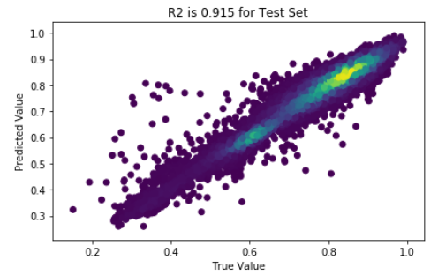

Figure 4: True ICER1_2 value versus predicted values for the full dataset.

|  |  |
| --- | --- |
| Dataset Percentage | R2_Score |
| 3 | 0.663 |
| 10 | 0.799 |
| 30 | 0.874 |
| 100 | 0.915 |

Table 3: ICER1_2 prediction R2 scores for the test set trained on different subsets of the full three image dataset, with backplane data included.

Finally, all four band parameters were predicted utilizing the full dataset and backplane data with encouraging but imperfect results (Figure 5). Maximum R2 scores were for

ICER2_2 at .878, with R1506 as low as .794.

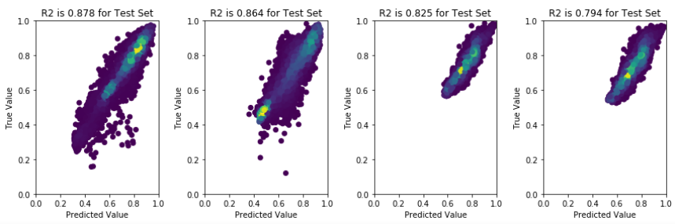

# 

Figure 5: Multi-regression results for all four parameters using the full dataset. Table below shows results for different subsets with columns in order of the corresponding image panels above.

# **5.** **Discussion and Conclusion**

Both the single and multi-regression experiments show interesting trends. In multi-regression, the spectral parameter closest to CTX wavelengths (R1080) was expected to produce the highest R2 score. However, it was consistently the third lowest, only above R1506. This could be due to water ice’s weak absorption near 1.2 microns causing more variability than originally expected, but is more likely due to the greater amount of stochastic noise in the lower wavelengths of the CRISM images. In single regression of ICER1_2, backplane data significantly improves the network’s ability to learn.

It was expected that larger scale terrain information would be needed to parameterize the unique erosive features produced in some areas of the cap, but these results show that this extra step may not be needed. The results are already as good as can be expected for single regression considering the rather high noise level in CRISM imagery, the spatial resolution limitation for calculating the local angles in the backplane imagery (~100-150m at the poles), and with the additional issues discussed below.

These experiments were under rather idealized circumstances. These images are from different orbits so the spacecraft-planet surface coordinate system is considerably different in each case. The sun position, however, is similar due to the images being taken only a few weeks apart, at similar times of day, and being near the pole. A greater range of incidence angles and emission angles need to be sampled for better generalization.

The backplane imagery does not provide any additional atmospheric information, so atmospheric aerosols could be a large problem in some CTX imagery when it comes to prediction. Clouds or suspended dust can cover portions of (or the entire) image, leading to modified reflectance

values which the backplane data will not account for. Future work will include Tile2Vec embedding of CTX imagery to capture systematic areas of brightening or darkening in the full image [26], and included dust opacity measurements from Mars Climate Sounder [27] for each image pair.

The added context of the backplane data greatly increasing model accuracy is encouraging. Because the backplane data can be calculated directly from any CTX image, this means that the model should generalize well to the entire south polar cap with additional image pairs covering the full space. The accurate prediction of ICER1_2 values alone is exciting and could prove to be very useful for the community.

# **References**

[1] R. W. Zurek and S. E. Smrekar, “An overview of the Mars Reconnaissance Orbiter (MRO) science mission,” *Journal of Geophysical Research: Planets*, Feb. 2018, doi: 10.1029/2006JE002701@10.1002/(ISSN)2169-9100.MARSROM1.

[2] S. Murchie *et al.*, “Compact Reconnaissance Imaging Spectrometer for Mars (CRISM) on Mars Reconnaissance Orbiter (MRO),” *Journal of Geophysical Research: Planets*, vol. 112, no. E5, 2007, doi: 10.1029/2006JE002682.

[3] M. C. Malin *et al.*, “Context Camera Investigation on board the Mars Reconnaissance Orbiter,” *J. Geophys. Res.*, vol. 112, no. E5, p. E05S04, May 2007, doi: 10.1029/2006JE002808.

[4] A. S. McEwen *et al.*, “Mars Reconnaissance Orbiter’s High Resolution Imaging Science Experiment (HiRISE),” *Journal of Geophysical Research: Planets*, Feb. 2018, doi: 10.1029/2005JE002605@10.1002/(ISSN)2169-9100.MARSROM1.

[5] I. B. Smith *et al.*, “The Holy Grail: A road map for unlocking the climate record stored within Mars’ polar layered deposits,” *Planetary and Space Science*, vol. 184, p. 104841, May 2020, doi: 10.1016/j.pss.2020.104841.

[6] P. B. Buhler, A. P. Ingersoll, S. Piqueux, B. L. Ehlmann, and P. O. Hayne, “Coevolution of Mars’s atmosphere and massive south polar CO 2 ice deposit,” *Nature Astronomy*, vol. 4, no. 4, pp. 364–371, Apr. 2020, doi: 10.1038/s41550-019-0976-8.

[7] C. J. Bierson *et al.*, “Stratigraphy and evolution of the buried CO2 deposit in the Martian south polar cap,” *Geophysical Research Letters*, vol. 43, no. 9, pp. 4172–4179, 2016, doi: 10.1002/2016GL068457.

[8] A. J. Brown, W. M. Calvin, P. C. McGuire, and S. L. Murchie, “Compact Reconnaissance Imaging Spectrometer for Mars (CRISM) south polar mapping: First Mars year of observations,” *Journal of Geophysical Research: Planets*, vol. 115, no. E2, 2010, doi: 10.1029/2009JE003333.

[9] S. Douté *et al.*, “South Pole of Mars: Nature and composition of the icy terrains from Mars Express OMEGA observations,” *Planetary and Space Science*, vol. 55, no. 1, pp. 113–133, Jan. 2007, doi: 10.1016/j.pss.2006.05.035.

[10] S. Piqueux, C. S. Edwards, and P. R. Christensen, “Distribution of the ices exposed near the south pole of Mars using Thermal Emission Imaging System (THEMIS) temperature measurements,” *Journal of Geophysical Research: Planets*, vol. 113, no. E8, 2008, doi: 10.1029/2007JE003055.

[11] S. Cull *et al.*, “Seasonal H2O and CO2 ice cycles at the Mars Phoenix landing site: 1. Prelanding CRISM and HiRISE observations,” *Journal of Geophysical Research: Planets*, vol. 115, no. E4, 2010, doi: 10.1029/2009JE003340.

[12] P. C. Thomas, P. B. James, W. M. Calvin, R. Haberle, and M. C. Malin, “Residual south polar cap of Mars: Stratigraphy, history, and implications of recent changes,” *Icarus*, vol. 203, no. 2, pp. 352–375, Oct. 2009, doi: 10.1016/j.icarus.2009.05.014.

[13] P. C. Thomas, W. M. Calvin, P. Gierasch, R. Haberle, P. B. James, and S. Sholes, “Time scales of erosion and deposition recorded in the residual south polar cap of Mars,” *Icarus*, vol. 225, no. 2, pp. 923–932, Aug. 2013, doi: 10.1016/j.icarus.2012.08.038.

[14] J. Pyo *et al.*, “A convolutional neural network regression for quantifying cyanobacteria using hyperspectral imagery,” *Remote Sensing of Environment*, vol. 233, p. 111350, Nov. 2019, doi: 10.1016/j.rse.2019.111350.

[15] T. Chang, B. P. Rasmussen, B. G. Dickson, and L. J. Zachmann, “Chimera: A Multi-Task Recurrent Convolutional Neural Network for Forest Classification and Structural Estimation,” *Remote Sensing*, vol. 11, no. 7, p. 768, Jan. 2019, doi: 10.3390/rs11070768.

[16] L. Dong *et al.*, “Application of Convolutional Neural Network on Lei Bamboo Above-Ground-Biomass (AGB) Estimation Using Worldview-2,” *Remote Sensing*, vol. 12, no. 6, p. 958, Jan. 2020, doi: 10.3390/rs12060958.

[17] J. Ma *et al.*, “Estimating above ground biomass of winter wheat at early growth stages using digital images and deep convolutional neural network,” *European Journal of Agronomy*, vol. 103, pp. 117–129, Feb. 2019, doi: 10.1016/j.eja.2018.12.004.

[18] L. F. Palafox, C. W. Hamilton, S. P. Scheidt, and A. M. Alvarez, “Automated detection of geological landforms on Mars using Convolutional Neural Networks,” *Computers & Geosciences*, vol. 101, pp. 48–56, Apr. 2017, doi: 10.1016/j.cageo.2016.12.015.

[19] K. L. Wagstaff, Y. Lu, A. Stanboli, K. Grimes, T. Gowda, and J. Padams, “Deep Mars: CNN Classification of Mars Imagery for the PDS Imaging Atlas,” in *Thirty-Second AAAI Conference on Artificial Intelligence*, Apr. 2018, Accessed: Jun. 05, 2020. [Online]. Available: https://www.aaai.org/ocs/index.php/AAAI/AAAI18/paper/view/16040.

[20] A. R. D. Putri, P. Sidiropoulos, and J.-P. Muller, “Deep Learning-Based Anomaly Detection to Find Changes over the Martian South Pole,” p. 2.

[21] M. Parente, Y. Itoh, and A. Saranathan, “New CRISM Data Products for Improved Characterization and Analysis of the Mars2020 Landing Site,” in *IGARSS 2019 - 2019 IEEE International Geoscience and Remote Sensing Symposium*, Jul. 2019, pp. 4911–4914, doi: 10.1109/IGARSS.2019.8899313.

[22] L. He, R. E. Arvidson, and J. A. O’Sullivan, “Retrieving Single Scattering Albedos and Temperatures from CRISM Hyperspectral Data Using Neural Networks,” vol. 2082, p. 6052, Apr. 2018.

[23] C. E. Viviano‐Beck *et al.*, “Revised CRISM spectral parameters and summary products based on the currently detected mineral diversity on Mars,” *Journal of Geophysical Research: Planets*, vol. 119, no. 6, pp. 1403–1431, 2014, doi: 10.1002/2014JE004627.

[24] C. H. Acton, “Ancillary data services of NASA’s Navigation and Ancillary Information Facility,” *Planetary and Space Science*, vol. 44, no. 1, pp. 65–70, Jan. 1996, doi: 10.1016/0032-0633(95)00107-7.

[25] G. Huang, Z. Liu, L. van der Maaten, and K. Q. Weinberger, “Densely Connected Convolutional Networks,” *arXiv:1608.06993 [cs]*, Jan. 2018, Accessed: Jun. 07, 2020. [Online]. Available: http://arxiv.org/abs/1608.06993.

[26] N. Jean, S. Wang, A. Samar, G. Azzari, D. Lobell, and S. Ermon, “Tile2Vec: Unsupervised representation learning for spatially distributed data,” *arXiv:1805.02855 [cs, stat]*, May 2018, Accessed: Jun. 07, 2020. [Online]. Available: http://arxiv.org/abs/1805.02855.

[27] D. J. McCleese *et al.*, “Mars Climate Sounder: An investigation of thermal and water vapor structure, dust and condensate distributions in the atmosphere, and energy balance of the polar regions,” *Journal of Geophysical Research: Planets*, Feb. 2018, doi: 10.1029/2006JE002790@10.1002/(ISSN)2169-9100.MARSROM1.