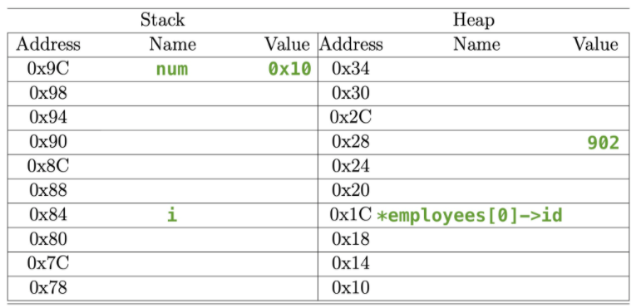

|  |  |
| --- | --- |
|  |  |
| E1 | 0x94 |
| E1.id | 0x10 |
| E1.name | “Amy” |
| Employees | 0x14 |
| Employees[1] | 0x94 |
|  | 3 |
|  |  |
|  |  |
|  |  |

|  |  |
| --- | --- |
|  |  |
|  |  |
| *employees[2]->name | “Cam” |
| *employees[2]->id[0] |  |
| *employees[0]->name | “Bob” |
| *employees[0]->id[0] | 900 |
|  | 0x20 |
| *employees[2] | 0x28 |
| *employees[0] | 0x1C |
| *num | 234 |