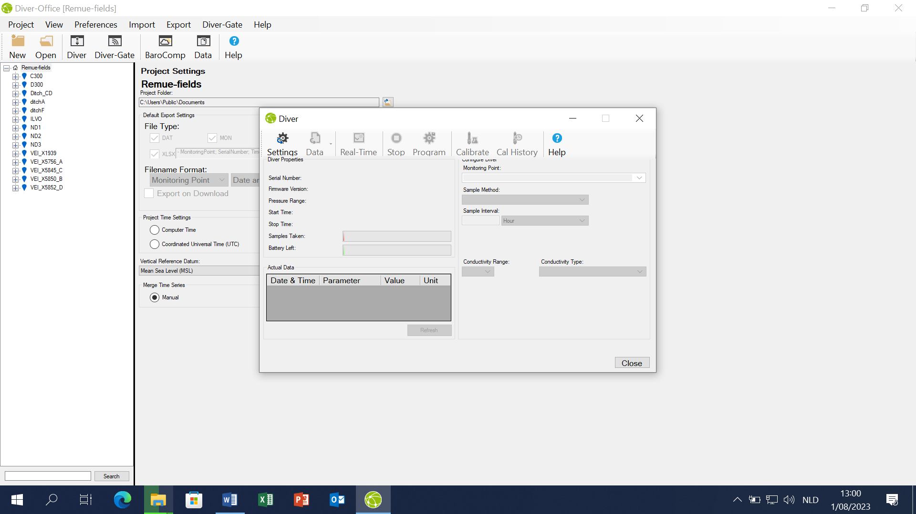s

1. Data, then collect the data
2. Click on diver

By “program” you can change the program of the diver like how often to take samples etc

For data collection just use the steps of 1 and 2