Instructions to execute files:
Dataset.py Part_1.py Part_2.py
Dataset.py creates train and test datasets from the initial dataset and stores them in data folder.
Part_1.py contains modules for creation of Neural Networks according to the specifications.
Output:
Part 1A:
Final Training Accuracy = 91.66666666666666%
Final Test Accuracy = 85.71428571428571%
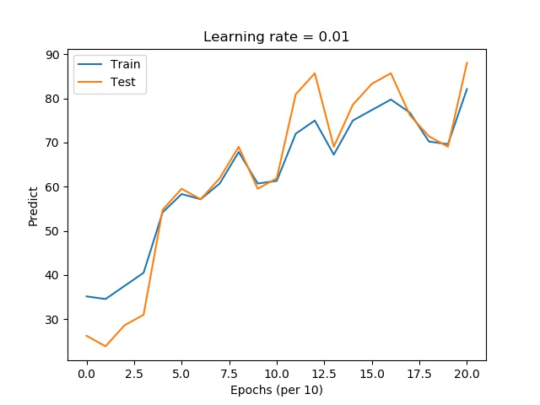

Part 1B:
Final Training Accuracy = 92.85714285714286%
Final Test Accuracy = 88.09523809523809%
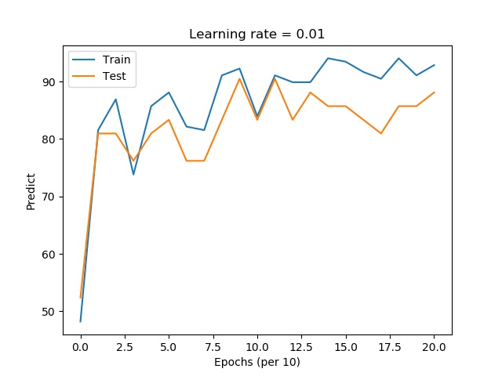

Part_2.py contains modules for creation of Multilayer Perceptron classifier using sklearn library according to the specifications given in the problem.
Output:
Part 2 Specification 1A:
Final Training Accuracy = 86.90476190476191%
Final Training Accuracy = 78.57142857142857%

Part 2 Specification 1B:
Final Training Accuracy = 94.64285714285714%
Final Training Accuracy = 85.71428571428571%

